K8s

1. creating pod by pulling image from docker hub

2. Deployement

- creating yaml file using dry run

- manual autoscaling

-Horizontal pod autoscaller

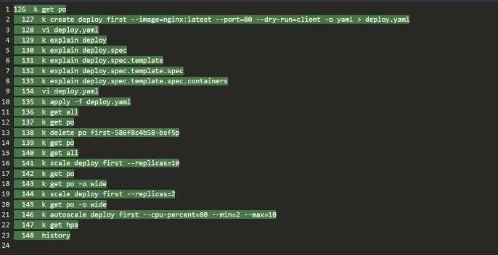

-roll out

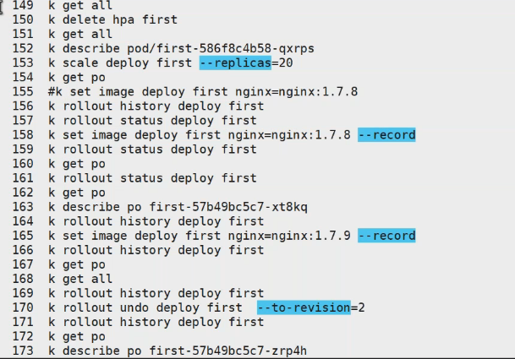

Service:

Scheduling:

Labels

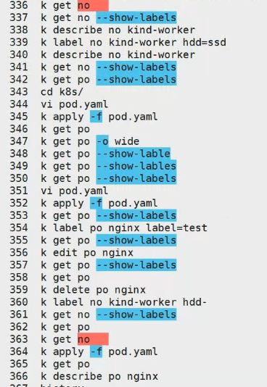

NodeAffinity:

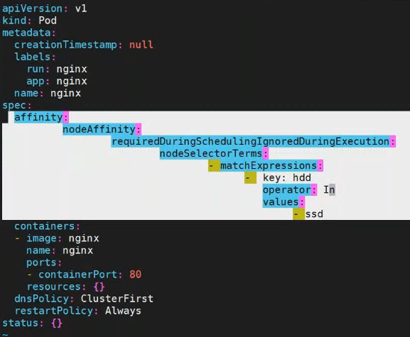

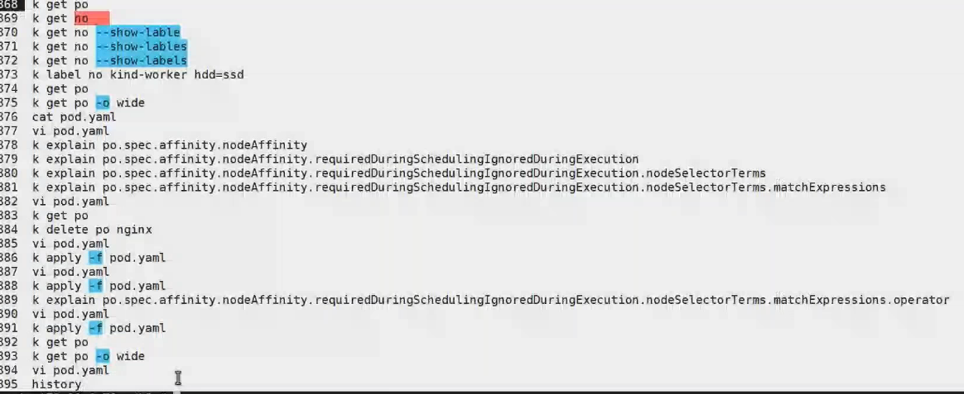

Taint and Toleration:

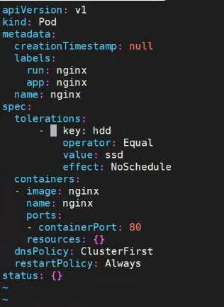

$ kubectl taint no kind-worker hdd=ssd:NoSchedule

$ kubectl cordon kind-worker2

**Deamonset**