FRONT-END DEVELOPMENT

ASSIGNMENT – 1

STUDENT DETAILS

Student Name: MADHAN RAJ M
Year: II
College Code: asbruap
College Name: PPG COLLEGE OF ARTS AND SCIENCE
Department: Computer Science
Semester: IV
Roll No:2422k0026
NMID:asbruap2422k0026
Date:09/03/2026
Project Title: Simple Event Registration Page

- Assignment and Assumptions

1.1 Assignment

The proposed assignment is to design and develop a Simple Event Registration Page using HTML, CSS, and JavaScript.

The web page allows users to register for an event by entering their personal information and selecting event preferences.
The main tasks included in this project are:

- Display event details

- Create a registration form

- Collect participant information

- Allow users to select events

- Submit registration details

- Display registered participants in a table.

1.3 Purpose

The purpose of this assignment is to understand the fundamentals of Front-End Web Development.

- Through this project, students learn:

- How to create web pages using HTML

- How to design layouts using CSS

- How to add interactivity using JavaScript

- How to create and handle forms

This assignment also improves problem-solving skills and practical web development know it.

2.Problem Statement

Many events require participants to register before attending. Manual registration can be time-consuming and difficult to manage.

This project solves the problem by creating an online event registration page where users can quickly enter their details and register for the event.

The system allows organizers to easily view participant information in a structured format.

3.Expected Features

3.1 Event Title and Description

Event Title: Web Development Workshop

Description:
This workshop is organized for students who are interested in learning web development. The event covers the basics of HTML, CSS, and JavaScript. Participants will gain practical knowledge and hands-on experience in building simple web pages.

3.2Event Information & Registration Form Section

This section contains the event information and registration form where users can enter their personal details.

The form collects the following information:

Personal Information

Name : MADHAN RAJ M

Email : 24bsccs027.cas@ppg.edu.in

Phone Number : 8220672192

Date of Birth : 19/12/2006

Gender : Male

Event Selection: web Development Workshop

Participants can choose the event they want to attend.

Example:

- Web Development Workshop
- UI/UX Design Seminar
- JavaScript Bootcamp

Additional Details :
Participants can select the mode of participation:
- Online
- Offline
Declaration :
Participants must confirm that the information provided is correct.

Form Controls :
The form contains the following buttons:
- Submit Button
- Reset Button

3.3 Registered Participants Section

This section displays registered participant details in a table.

Name | Email | Phone | Event | Mode
Madhan | Madhan@gmail.com | 9876543210 | Web Development workshop | Offline

This table helps organizers track the list of registered participants.

3.4Footer Section

The footer section contains contact information and support details.
Copyright:
© 2026 Department of Computer Science, PPG College Of arts and science. All Rights Reserved.

4. Implementation Steps

The project was developed using the following steps:

- Created the basic web page structure using HTML.

- Added event details and registration form fields.

- Designed the page layout using CSS.

- Added input fields for user information.

- Created a table to display registered participants.

- Used JavaScript to handle form submission and validation.

- Tested the webpage to ensure proper functionality.

5.Technologies Used
The following technologies were used to develop the project:

HTML
- Used to create the structure of the web page

6.Output

The output of this project is a working event registration webpage that allows users to enter their details and register for an event.

Screenshot :
- Event Registration Form

- Registered Participants Table

- Final Webpage Layout

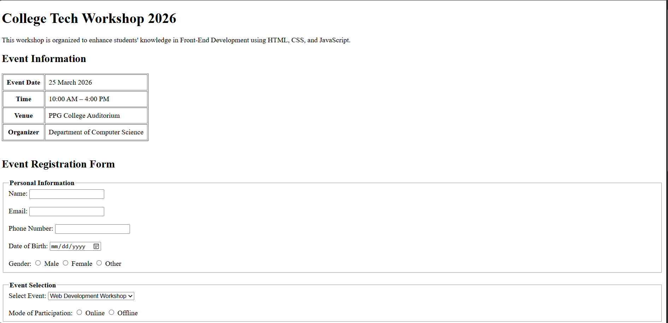
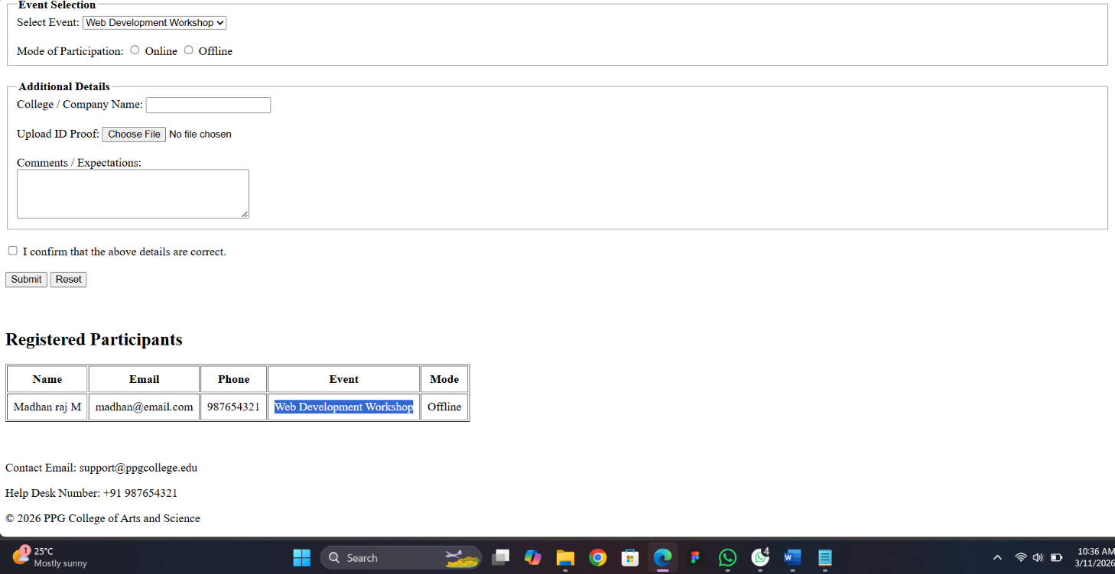

7.Learning Outcome

After completing this assignment, the following skills were gained:

- Understanding of HTML page structure

- Designing layouts using CSS

- Creating interactive forms

- Basic knowledge of JavaScript

- Experience in developing a simple web application.

8.Conclusion

The Simple Event Registration Page was successfully developed using HTML, CSS, and JavaScript.

The project allows users to enter their personal details and register for an event easily. This assignment helped in learning the basics of front-end development and building interactive web page.

