Course Recommendation Modifications
Users will have some details about course but don’t know which course to be taken so this algorithm will take description from user and based on description will recommend course. CHATGPT is a text based algorithm so to get recommendation we need to input some description as text
SCREEN SHOTS
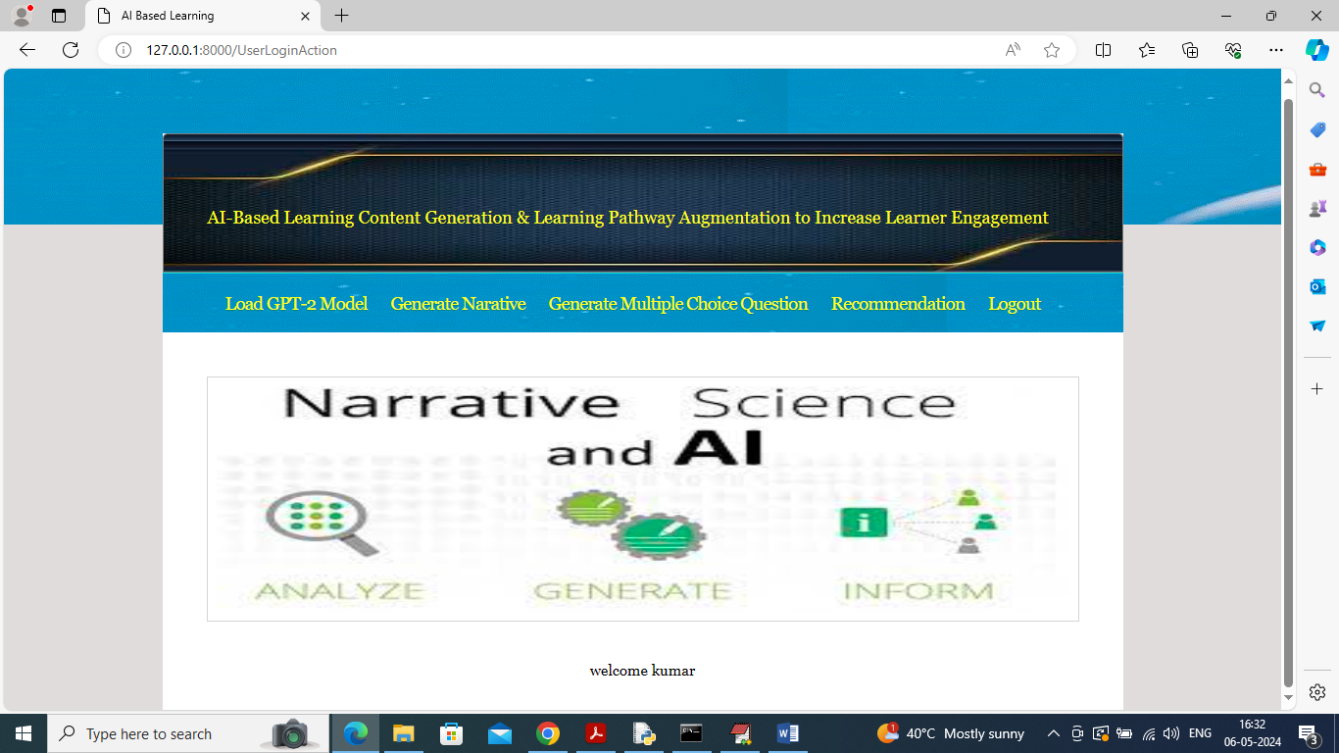
In above screen click on ‘Recommendation’ link to get below page
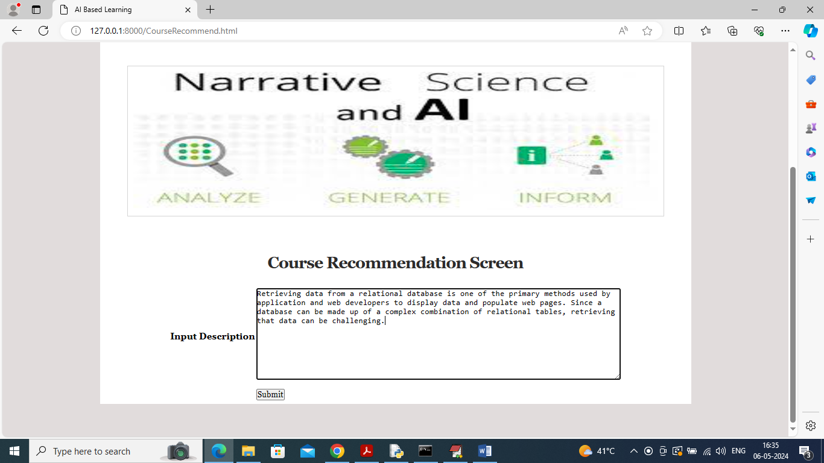
In above screen user will enter some description of text which will indicate what must course should contains and then press button to get below page
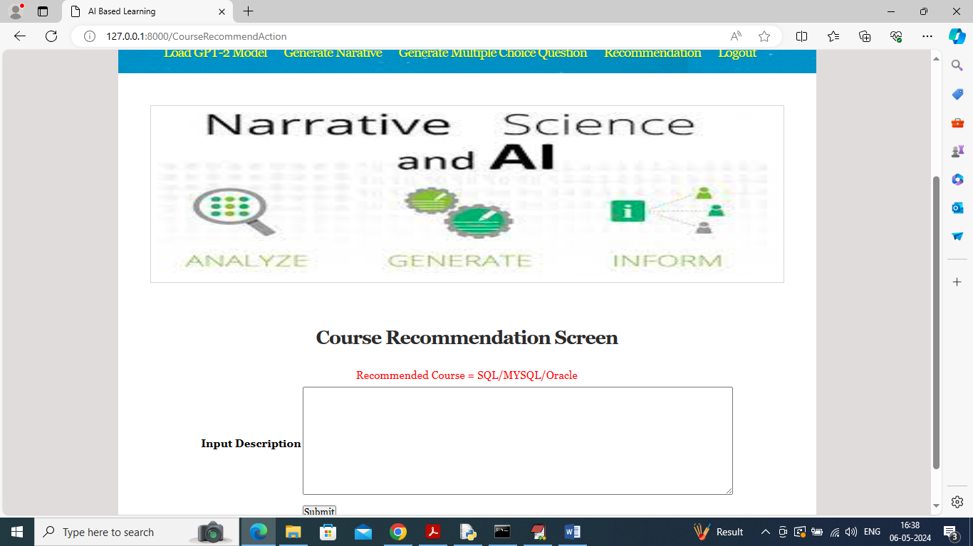
In above screen based on user entered description algorithm recommended course is ‘SQL/MYSQL/ORACLE’. Similarly you can enter some description and get recommendation.
Note description of course you can see inside ‘testData.csv’ file. Below is another example
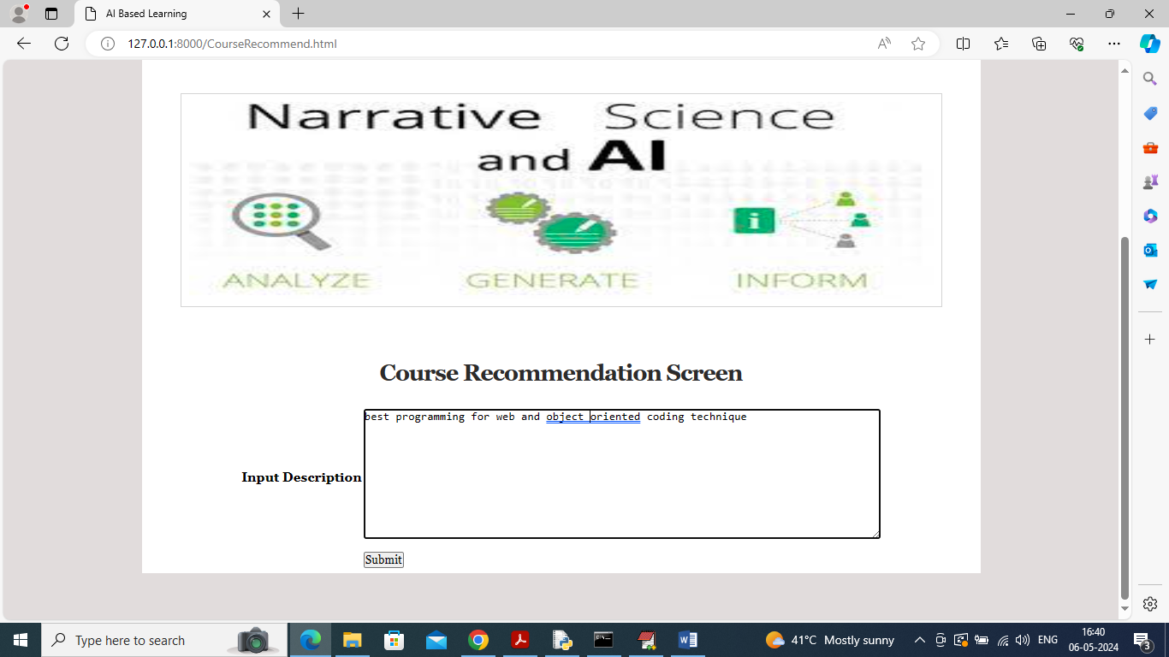
In above screen entered some data and below is the recommendation
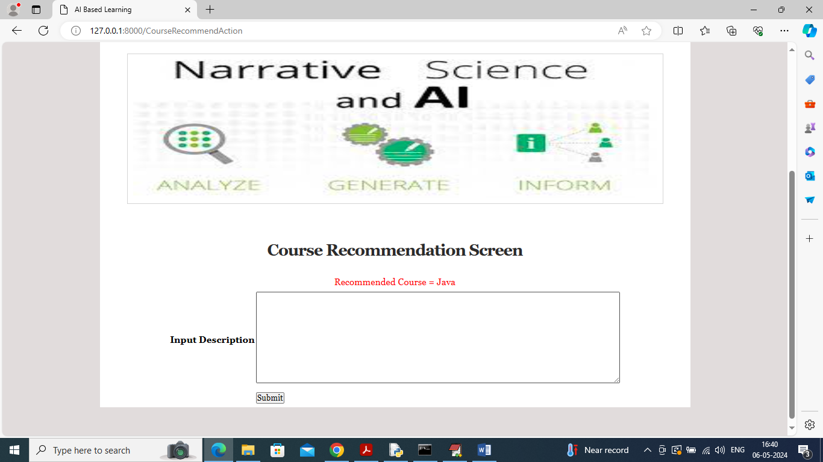
In above screen course recommended as java

