AI-Based Learning Content Generation & Learning Pathway Augmentation to Increase Learner Engagement
In online students often find difficulty in understanding course material because of availability of large volume of data so author of this paper employing AI-Based Chat-GPT2 tool to generate two different contents from available data such as short Narrative content and multiple choice question so by reading short Narrative students can easily understand concept.
To train GPT2 author has used pre-trained BERT models which can be used to generative Narrative and MCQ questions.
To implement this project we have designed following web based modules
- New User Sign up: user can sign up with the application by using this module
- User Login: user can login to system
- Load GPT-2 Model: can be used to generate and load GPT models for content Narrative and MCQ question
- Generate Narrative: in this module user will enter some text and then GPT2 will give short Narrative for given text
- Generate Multiple Choice Question: in this module user will enter some para or description and then enter related question and then GPT2 will generate all possible MCQ options.
To run project double click on ‘run.bat’ file to get below screen
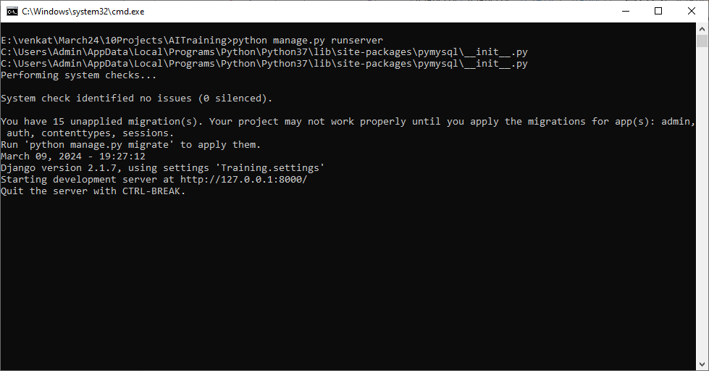
In above screen python web server started and now open browser and enter URL as http://127.0.0.1:8000/index.html and press enter key to get below page
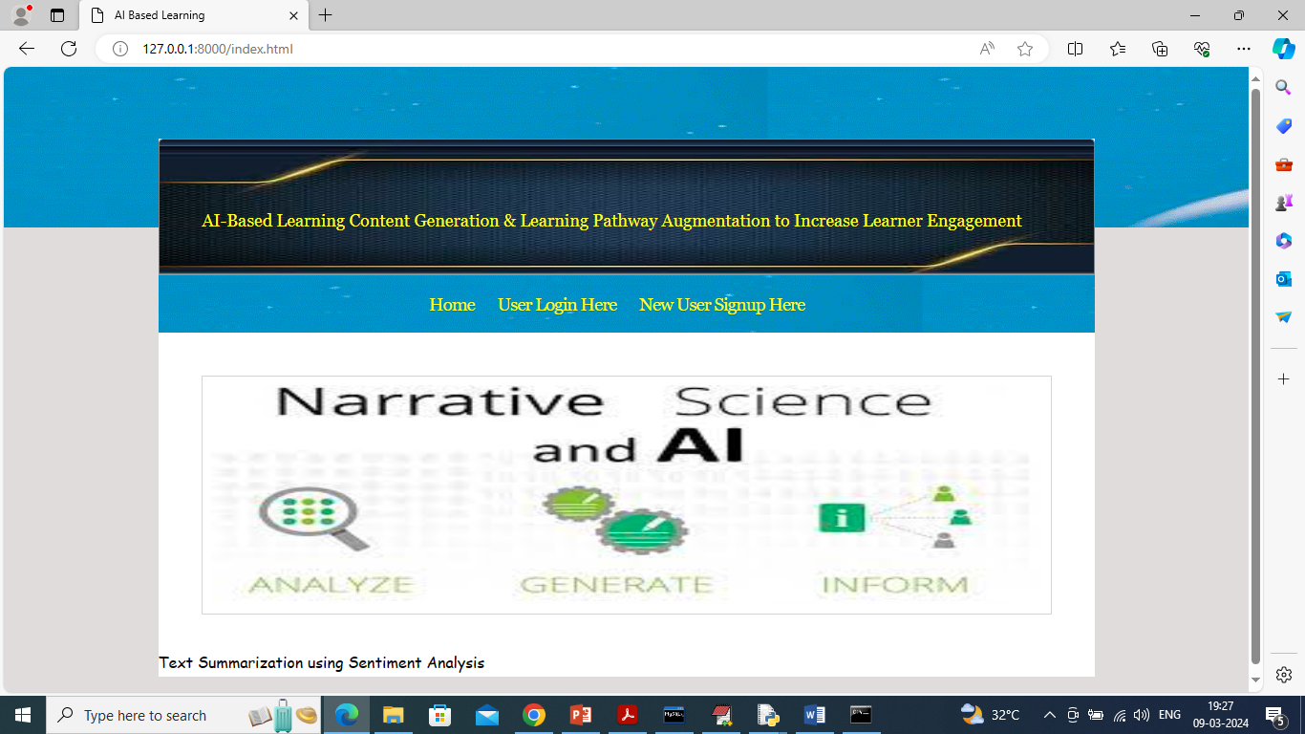
In above screen user can click on ‘New User Signup Here’ link to get below page
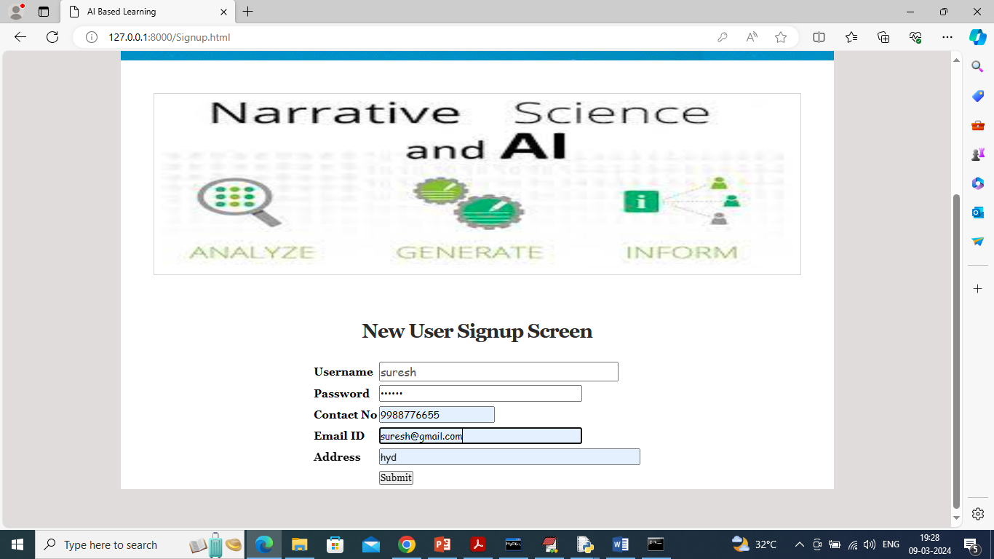
In above screen user entering sign up details and then press button to get below page
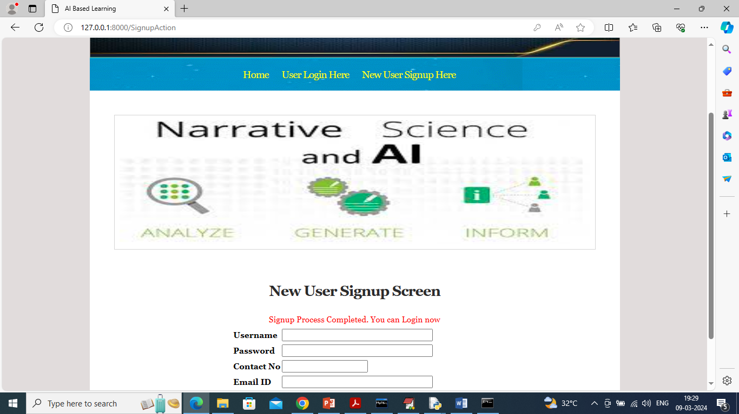
In above screen sign up details completed and now click on ‘User Login’ link to get below page
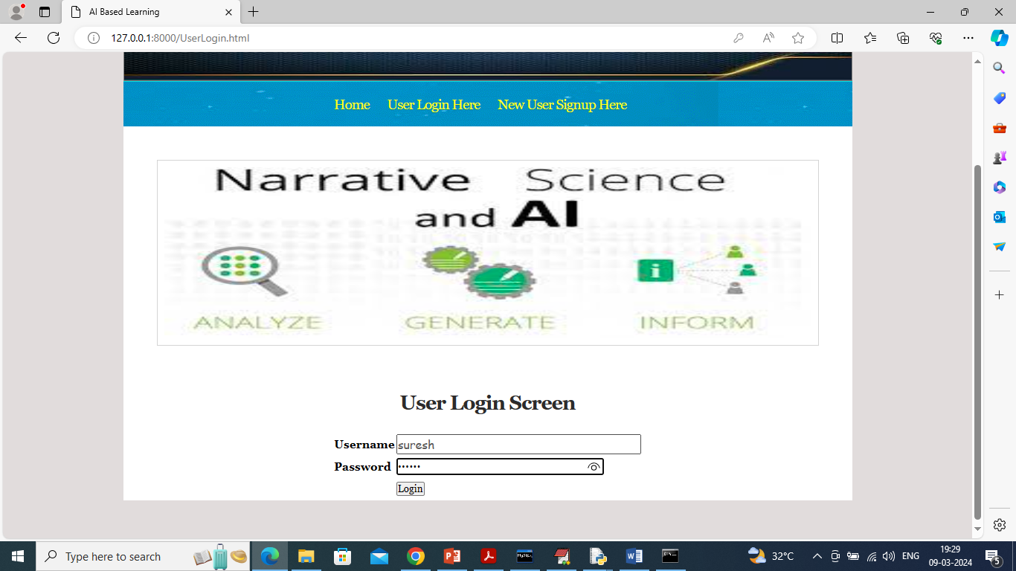
In above screen user is login and after login will get below page
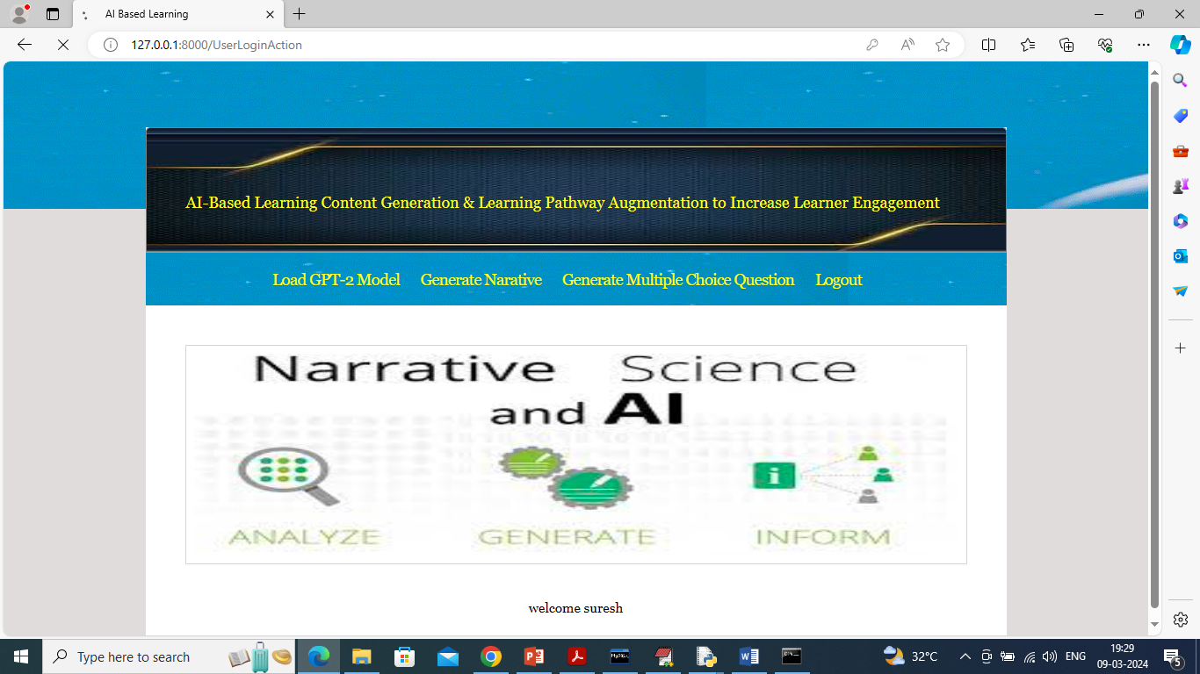
In above screen user can click on ‘Load GPT-2 Model’ link to load model and get below page
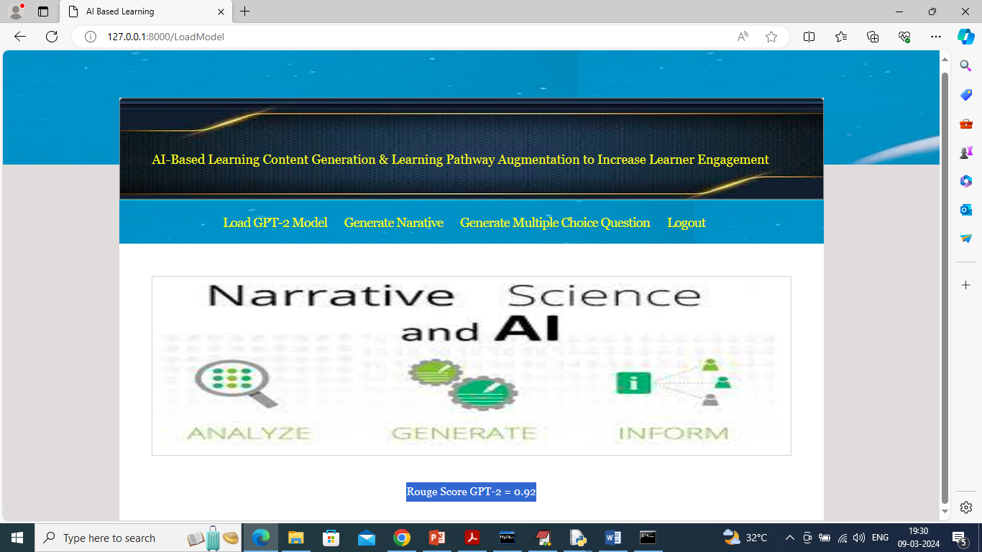
In above screen GPT-2 model loaded and this model will be applied on test narrative to calculate rouge score which represents accuracy between test narrative data and predicted narrative data and GPT-2 got 92% rouge score and now click on ‘Generate Narrative’ link to get below page
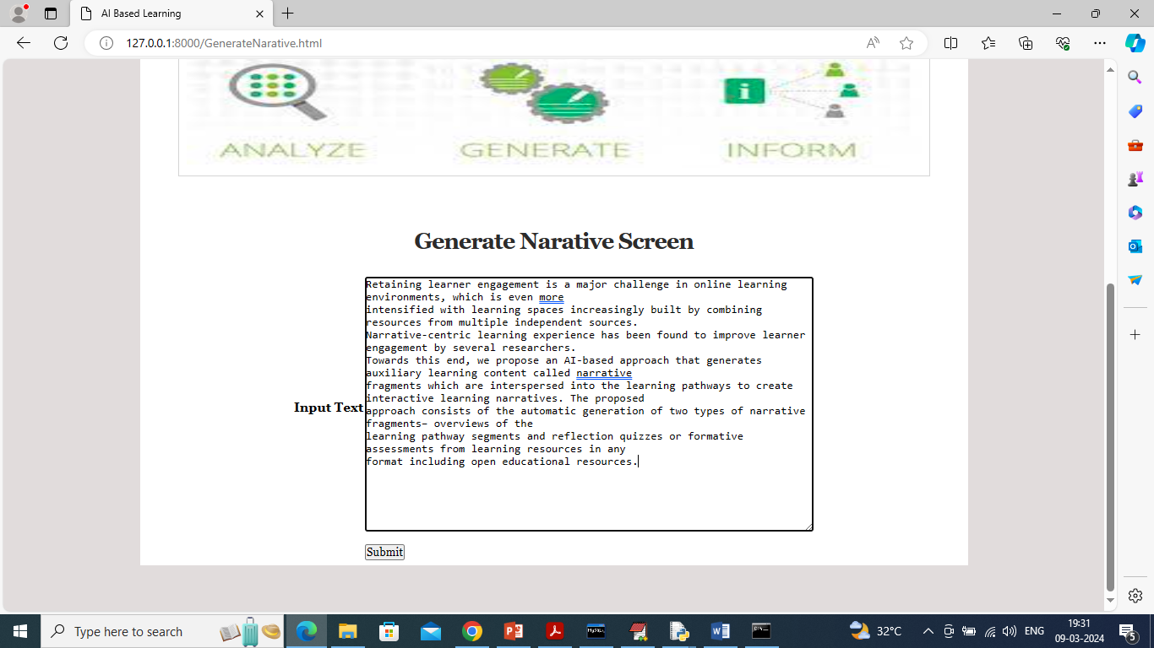
In above screen enter some text para and then click button to get below short narrative from above text
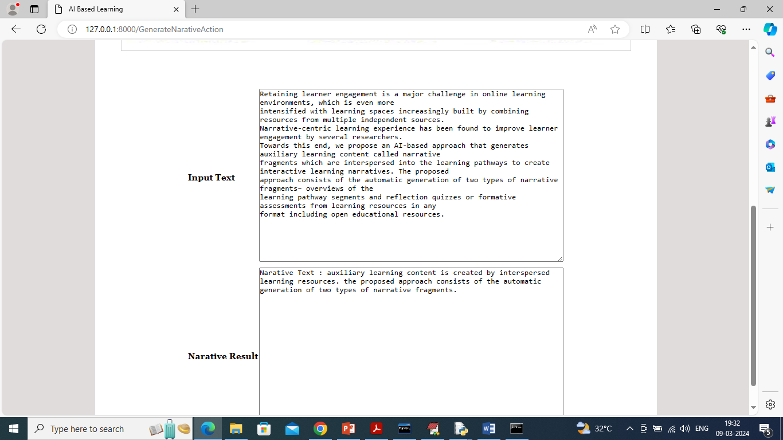
In above screen in first box can see original text and in second box can see short Narrative main description from original text which student find easy to understand and similarly you can enter any text and get narration and now click on ‘Generate Multiple Choice Question’ link to get below screen
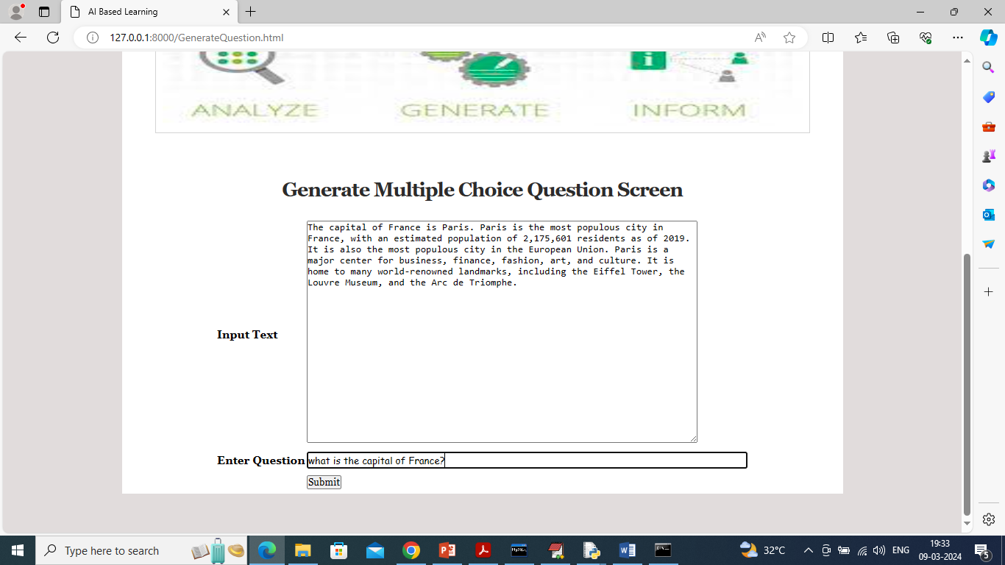
In above screen I gave some text para and then enter some question and then press button to generated below MCQ options
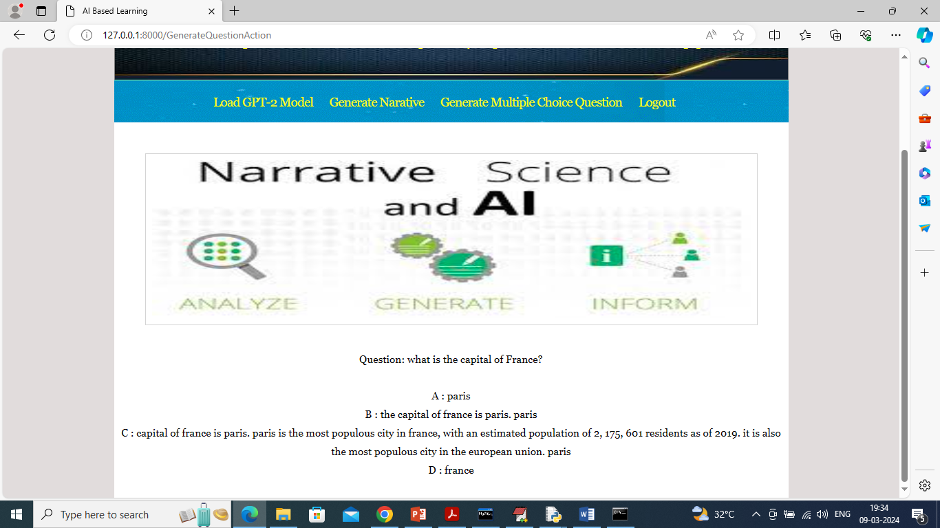
In above screen in first line we can see the question and then can see 4 generated MCQ options. Similarly enter some text and question and then GPT-2 will generate MCQ options.

