**Snowflake Data Loading using all File Formats**

<https://uaubrbj-yb48348.snowflakecomputing.com/console#/internal/worksheet>

SAARA

Saaranya@123

# 1.FLAT FILES or HUMAN READABLE FILES using CSV,PSV,TSV and Compression gzip files :

## 1.1 CSV - Using Snowflake WebUI

### Loading with good data

### When comma,double quotes in data

### Date and Timestamp issues

### Special Character Data Loading

### Column Count Mismatch & Data Loading

### Null Handling Into Snowflake

### Duplicate Data Loading

## 1.2 CSV - Using Snowsql CLI

## 1.3 CSV - Using External Storage (AWS S3,Azure,GCP)

## CSV - Using Snowflake WebUI

### Loading with good data

Query to create table with all data types which includes number,varchar,date,Boolean, timestamp_ltz

**create** **or** **replace** transient **table** customer_csv (

customer_pk number(38,0),

salutation varchar(10),

first_name varchar(20),

last_name varchar(30),

gender varchar(1),

marital_status varchar(1),

day_of_birth date,

birth_country varchar(60),

email_address varchar(50),

city_name varchar(60),

zip_code varchar(10),

country_name varchar(20),

gmt_timezone_offset number(10,2),

preferred_cust_flag boolean,

registration_time timestamp_ltz(9)

);

Why creating as Transient table instead of temporary and permanent ?

Transient tables are similar to permanent tables with the key difference that the fail-safe storage is not applicable to transient tables.   
Because transient tables do not have a Fail-safe period, they provide a good option for managing the cost of large tables used to store transformation data. However, with an underlying risk that data cannot be recovered after the Time Travel retention period passes. Temporary tables do not support some standard features such as cloning.

Table CUSTOMER_CSV created successfully.

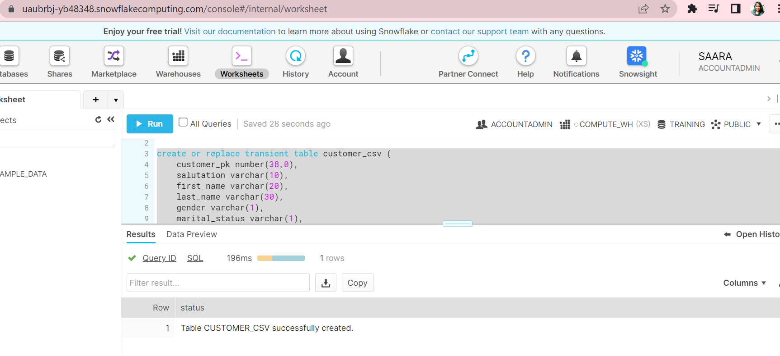

Query to create file format:

**create** **or** **replace** file format customer_csv_ff

**type** **=** 'csv'

compression **=** 'none'

field_delimiter **=** ','

skip_header **=** 1 ;

Same using WebUI Classic Console :

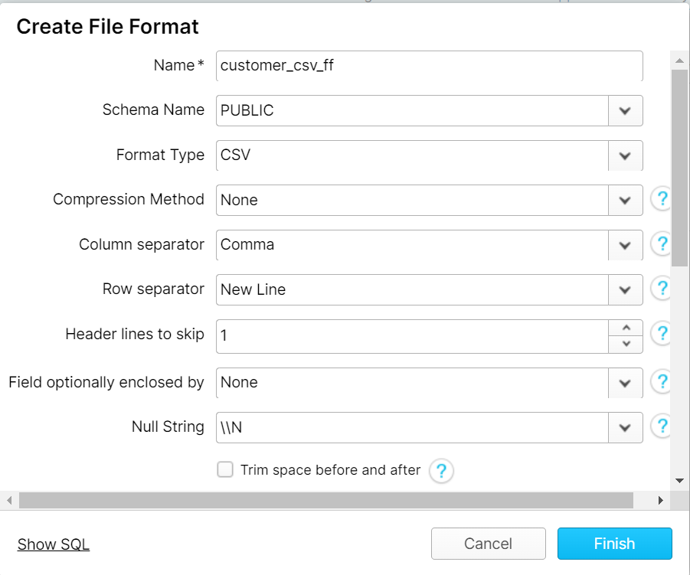

File format Created successfully:

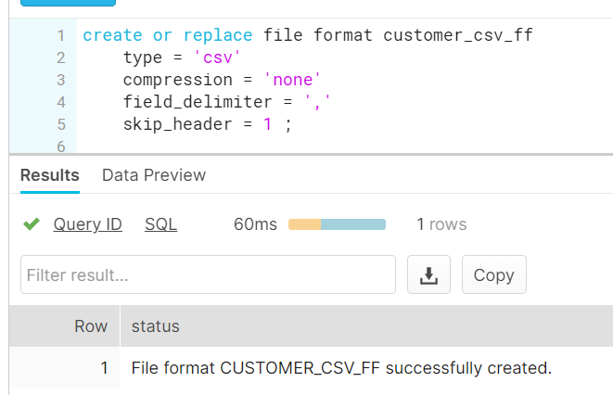

Now loading starts:

Count is zero before loading:

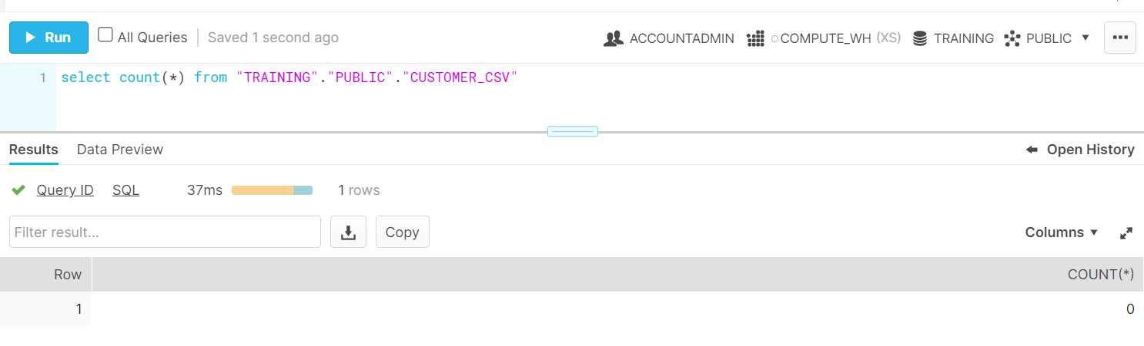

Using WebUI :

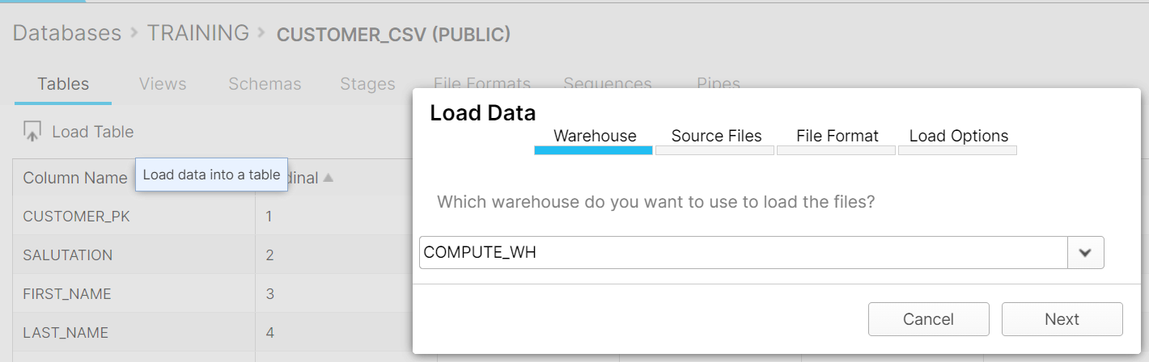

Choose file from local drive :

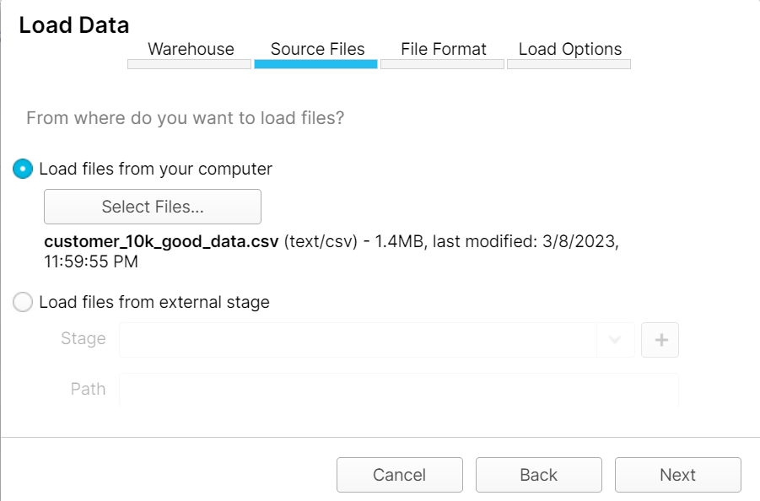

Choose file format :

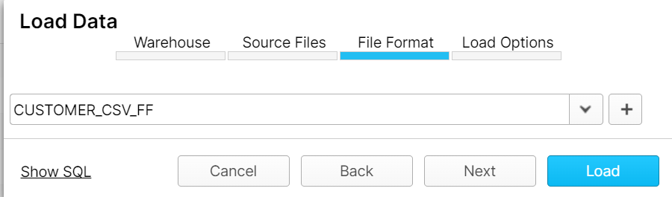

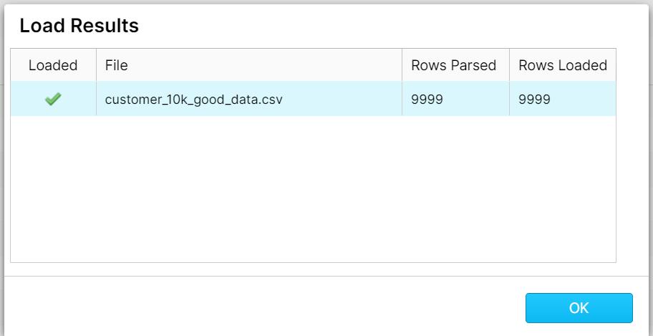

9999 records loaded successfully to table(excluding header)

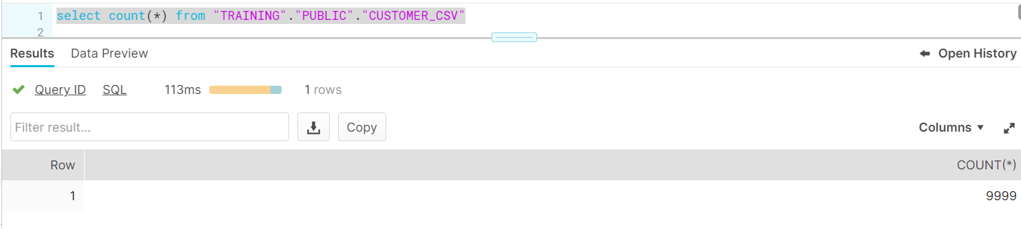

### When comma,double quotes in data

Now add comma in the data file:

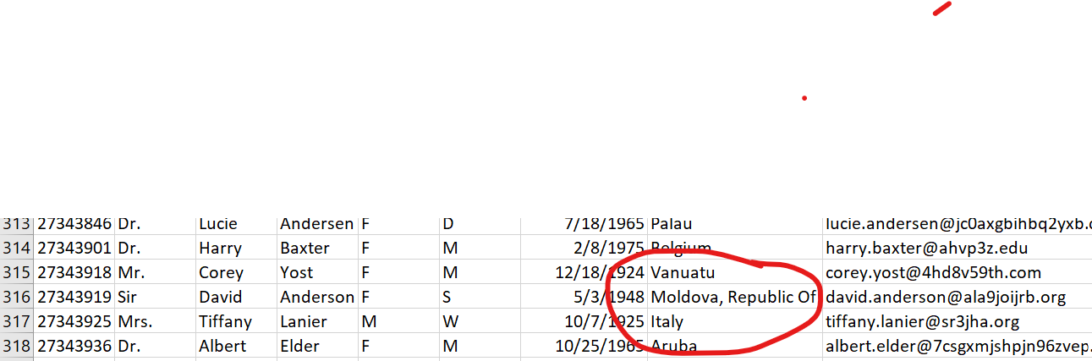

Change file format with field_optionally_enclosed_by = '\042'

create or replace file format customer_csv_ff2

type = 'csv'

compression = 'none'

field_delimiter = ','

field_optionally_enclosed_by = '\042'

skip_header = 1 ;

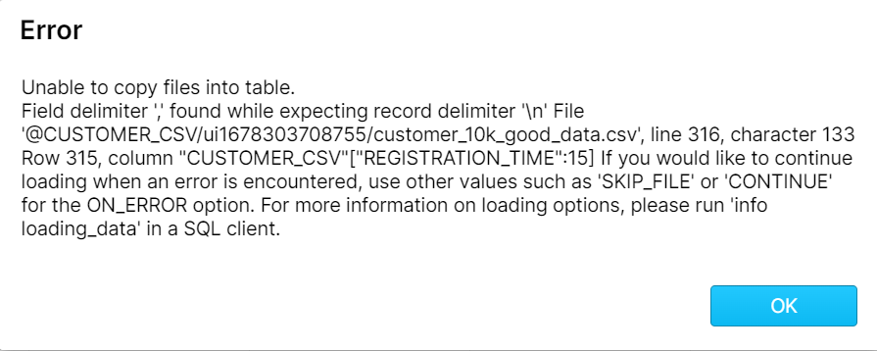

Loading after updating file format :

Choose new file format from the drop down below :

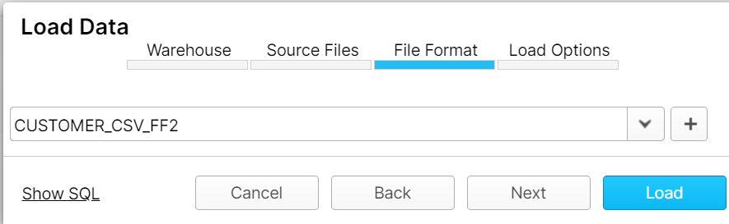

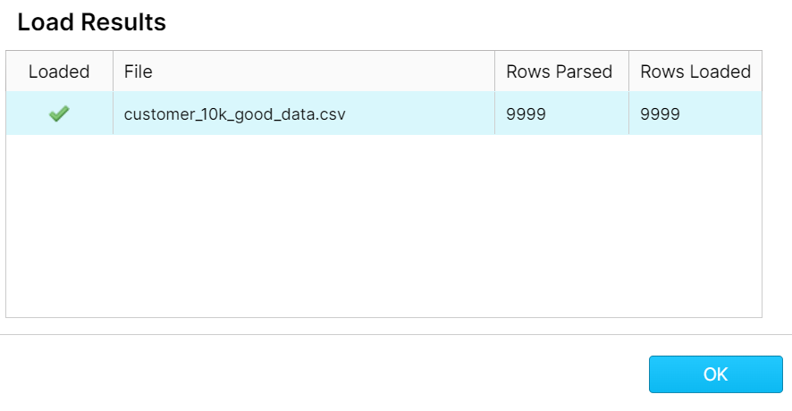

Date and Timestamp issues :

*-- Step-01 : lets start with a table called bookings*

*-- it has 5 columns, accomodate data typles like date, time, datetime & timestamp.*

**create** **or** **replace** transient **table** bookings(

booking_id number,

booking_dt date,

booking_time time,

booking_dt_time datetime,

booking_timestamp timestamp

);

*-- csv file format call csv_ff with standard paramters.*

*-- no additional paramter for date and time is used to*

*-- see how does it work with default settings.*

**create** **or** **replace** file format csv_ff

**type** **=** 'csv'

compression **=** 'none'

field_delimiter **=** ','

record_delimiter **=** '\n'

skip_header **=** 1

field_optionally_enclosed_by **=** '\042';

Input File :

|  |  |  |  |  |
| --- | --- | --- | --- | --- |
| booking_id | booking_dt | booking_time | booking_dt_time | booking_timestamp |
| 1 | 8/29/2022 | 23:59:59 | 8/29/2022 23:59 | 2022-08-29 23:59:59 +01:00 |
| 2 | 9/29/2022 | 23:59:59 | 9/29/2022 23:59 | 2022-09-29 23:59:59 +02:00 |
| 3 | 10/29/2022 | 23:59:59 | 10/29/2022 23:59 | 2022-10-29 23:59:59 +03:00 |
| 4 | 11/29/2022 | 23:59:59 | 11/29/2022 23:59 | 2022-11-29 23:59:59 +04:00 |
| 5 | 12/29/2022 | 23:59:59 | 12/29/2022 23:59 | 2022-12-29 23:59:59 +05:00 |

PUT file://<file_path>/01-bookings-std.csv @BOOKINGS/ui1678706575840

COPY INTO "TRAINING"."PUBLIC"."BOOKINGS" FROM @/ui1678706575840 FILE_FORMAT = '"TRAINING"."PUBLIC"."CSV_FF"' ON_ERROR = 'ABORT_STATEMENT' PURGE = TRUE;

There is no timestamp for milli and nano seconds in the field BOOKING_DT_TIME and BOOKING_TIMESTAMP in input file, but the table is loaded with milli and nano seconds by default.

Alter statement to change timestamp in session:

**alter** **session** **set** TIMESTAMP_NTZ_OUTPUT_FORMAT **=** 'YYYY-MM-DD HH24:MI:SS.FF9';

## Loading a TSV File using WebUI:

Same customer table created with name _tsv :

create or replace transient table customer_tsv (

customer_pk number(38,0),

salutation varchar(10),

first_name varchar(20),

last_name varchar(30),

gender varchar(1),

marital_status varchar(1),

day_of_birth date,

birth_country varchar(60),

email_address varchar(50),

city_name varchar(60),

zip_code varchar(10),

country_name varchar(20),

gmt_timezone_offset number(10,2),

preferred_cust_flag boolean,

registration_time timestamp_ltz(9)

);

Query for file format :

Though the file type is csv ,field delimiter is \t

**create** **or** **replace** file format customer_tsv_ff

**type** **=** 'csv'

compression **=** 'none'

field_delimiter **=** '\t'

field_optionally_enclosed_by **=** '\042'

skip_header **=** 1 ;

Choose CSV file format :

## Loading a PSV File using WebUI:

Same customer table created with name _psv :

create or replace transient table customer_psv (

customer_pk number(38,0),

salutation varchar(10),

first_name varchar(20),

last_name varchar(30),

gender varchar(1),

marital_status varchar(1),

day_of_birth date,

birth_country varchar(60),

email_address varchar(50),

city_name varchar(60),

zip_code varchar(10),

country_name varchar(20),

gmt_timezone_offset number(10,2),

preferred_cust_flag boolean,

registration_time timestamp_ltz(9)

);

PSV File format:

**create** **or** **replace** file format customer_psv_ff

**type** **=** 'csv'

compression **=** 'none'

field_delimiter **=** '|'

field_optionally_enclosed_by **=** '\042'

skip_header **=** 1 ;

Loaded Successfully :

Loading using JSON File :

Basic Structure of a JSON file :

|  |  |
| --- | --- |
| 1  2  3  4 | - <KEY>:<VALUE> Data is in key/value pairs  - Data is separated by commas  - Objects are enclosed in curly braces ({})  - Arrays are enclosed in square brackets ([]) |

Created one Publicly accessible S3 bucket :

Load using Parquet File :

create or replace table cities

(

continent varchar default null,

country varchar default null,

city variant default null

);

Create file format and stage:

create or replace file format parquet_ff type ='parquet';

Create or replace stage parquet_stage file_format = parquet_ff;

put file://C:\Users\X024271\cities.parquet @parquet_stage;

copy into cities from (select $1:continent::varchar,$1:country:name::varchar,$1:country:city::variant from @parquet_stage/cities.parquet);

Parquet File Loaded successfully.

Unloading Parquet file :

In snowsql:

copy into @parquet_stage/out/parquet_ from

(

select continent,country,c.value::string as city from cities

,lateral flatten(input => city)c

) file_format =(type ='parquet')

header =true;

select t.$1 from @parquet_stage/out/t;

