J SIVA SANKAR REDDY - 192211356 CSA0763 – COMPUTER NETWORKS

1. Configuration of Network Devices using Packet Tracer (Hub, Switch, Ethernet, Broadcast)

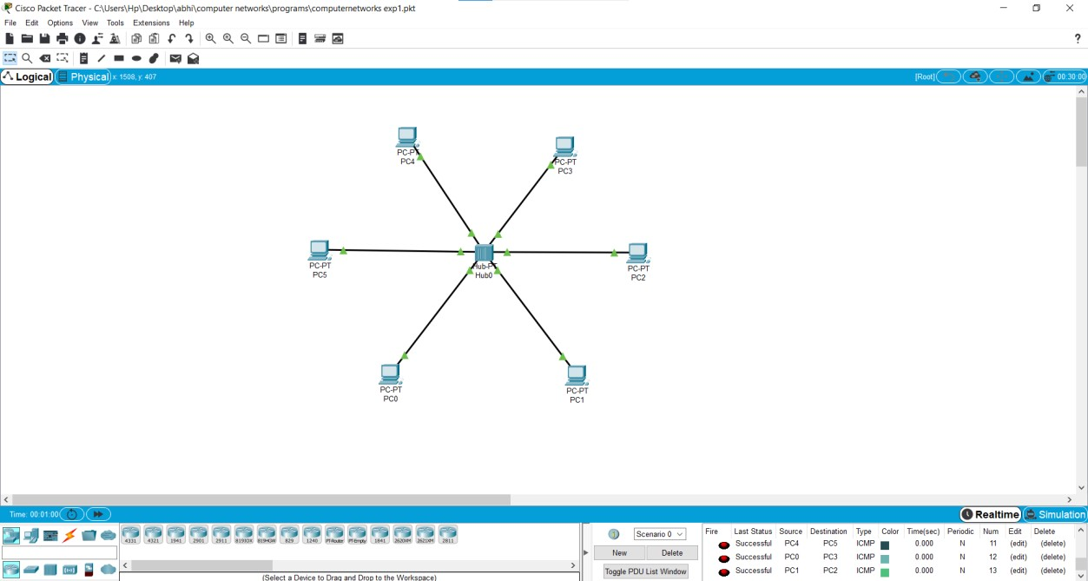

1. Configuration of Topologies using Packet Tracer (Star, Mesh, Tree,)

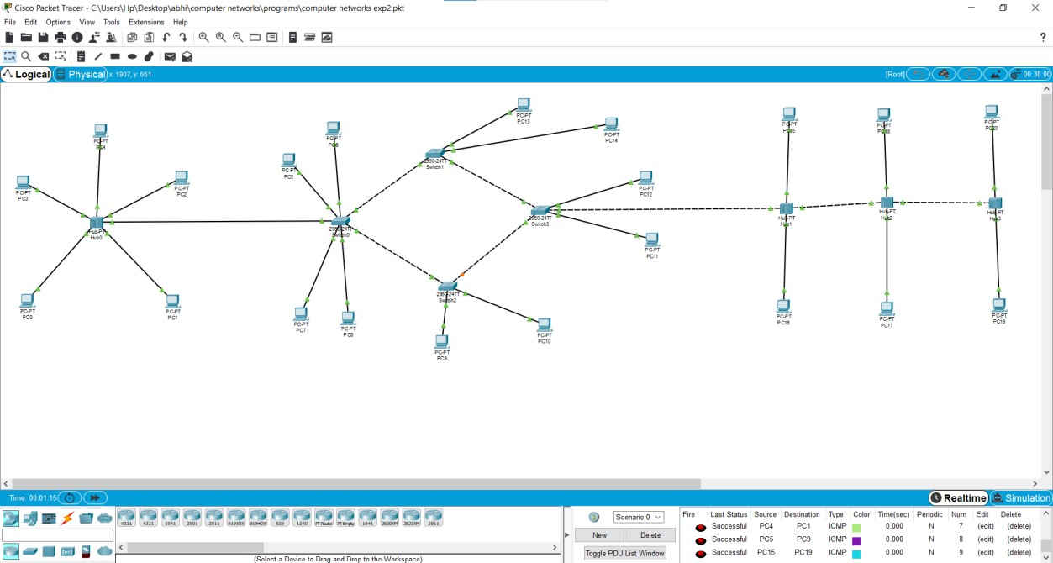

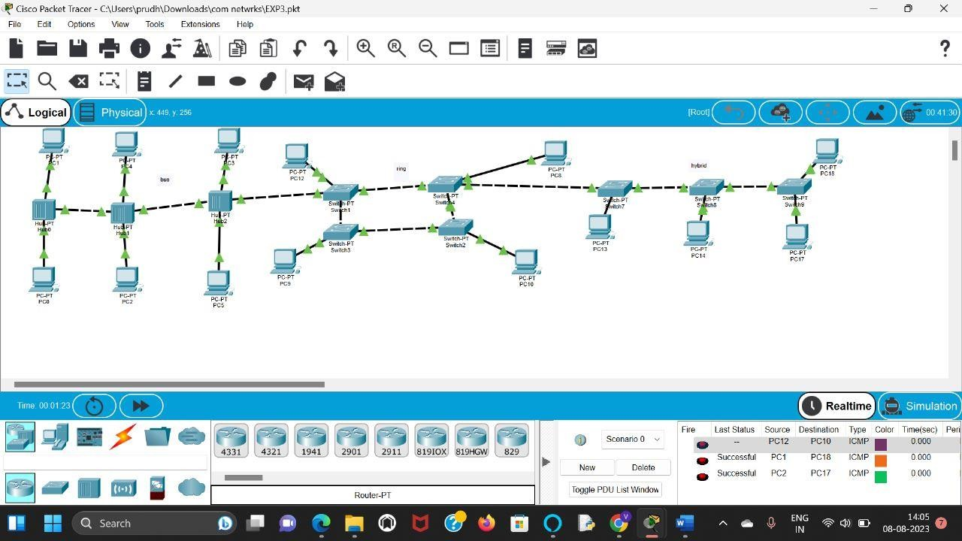

**4.** Data Link Layer Traffic Simulation using Packet Tracer Analysis of CSMA/CD& CSMA/CA

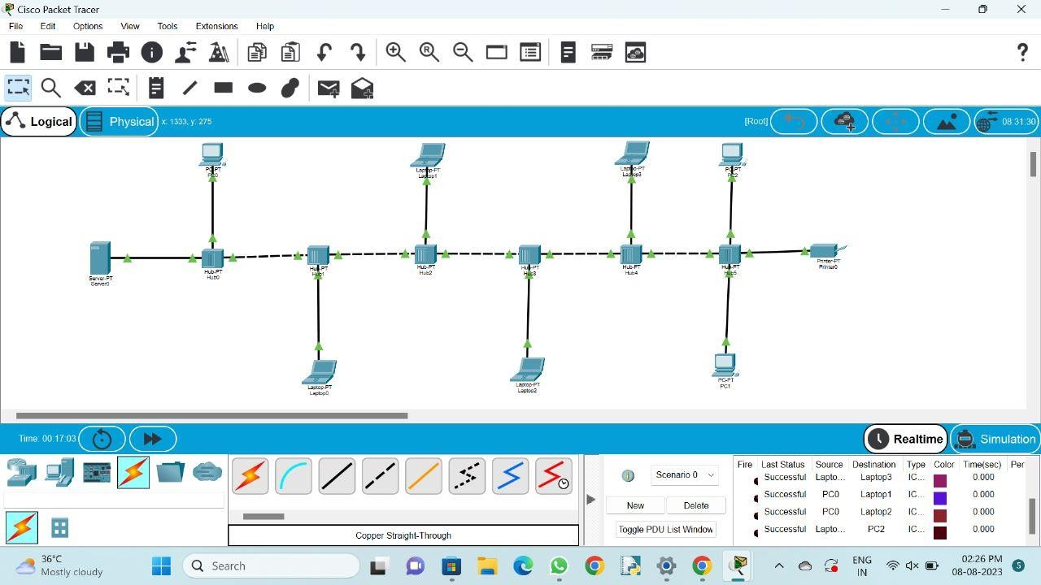

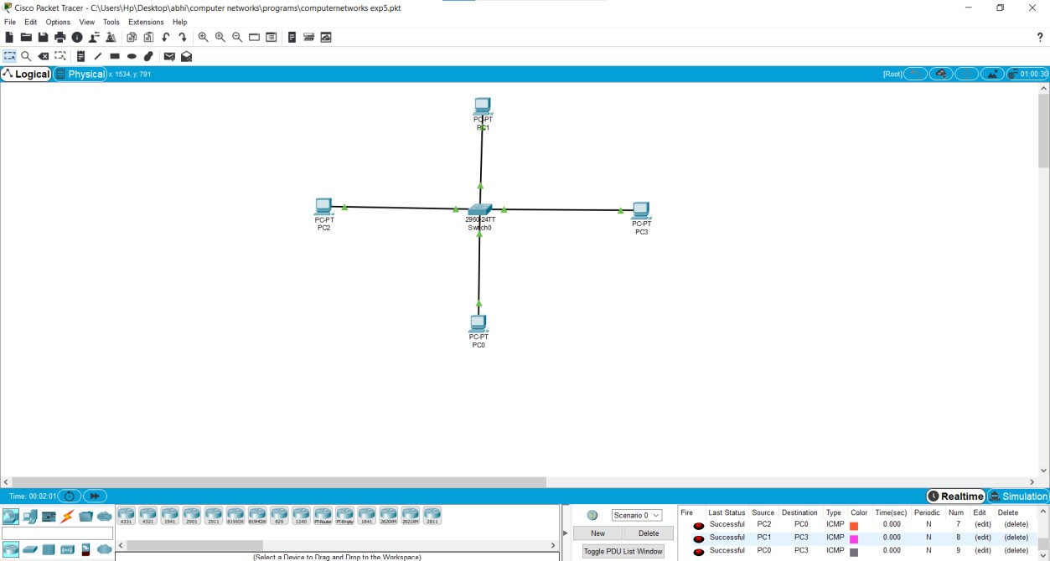

**6.** Static Routing using Packet Tracer

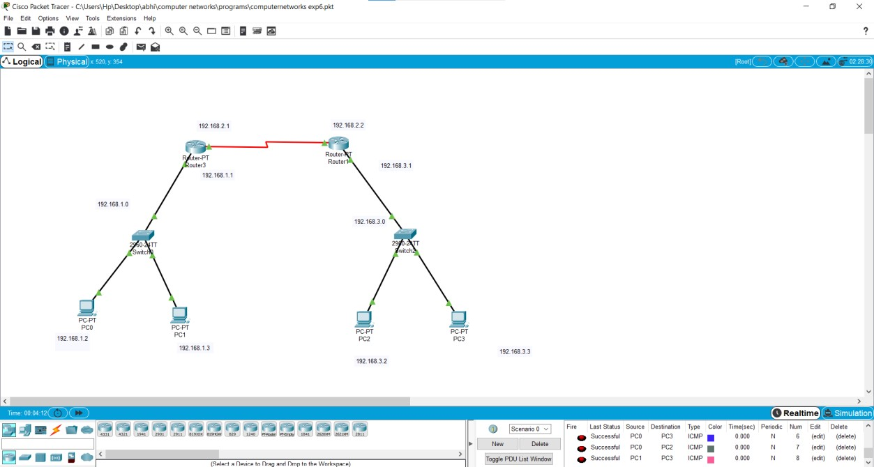

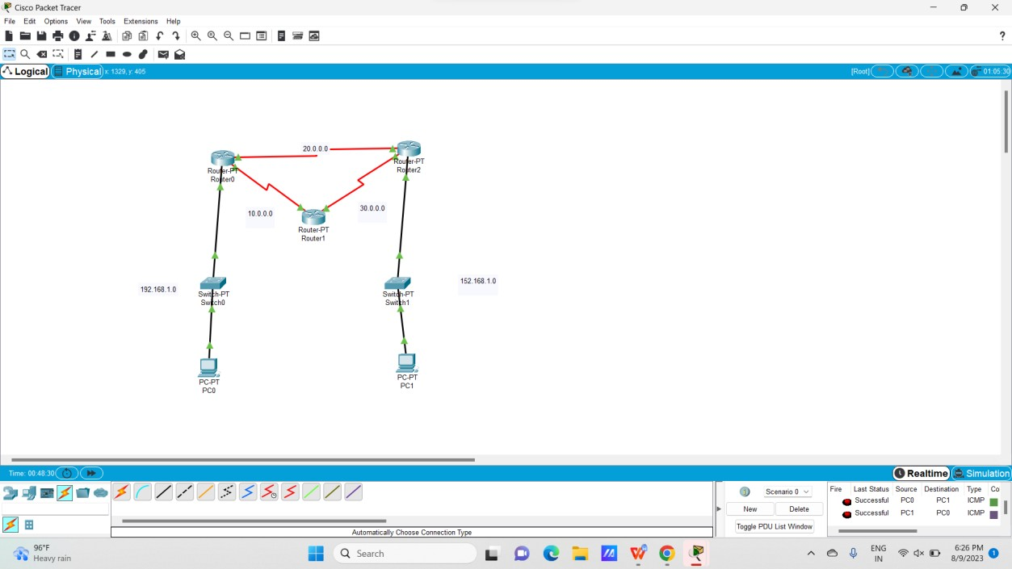

**8.** Subnetting – Class C Addressing

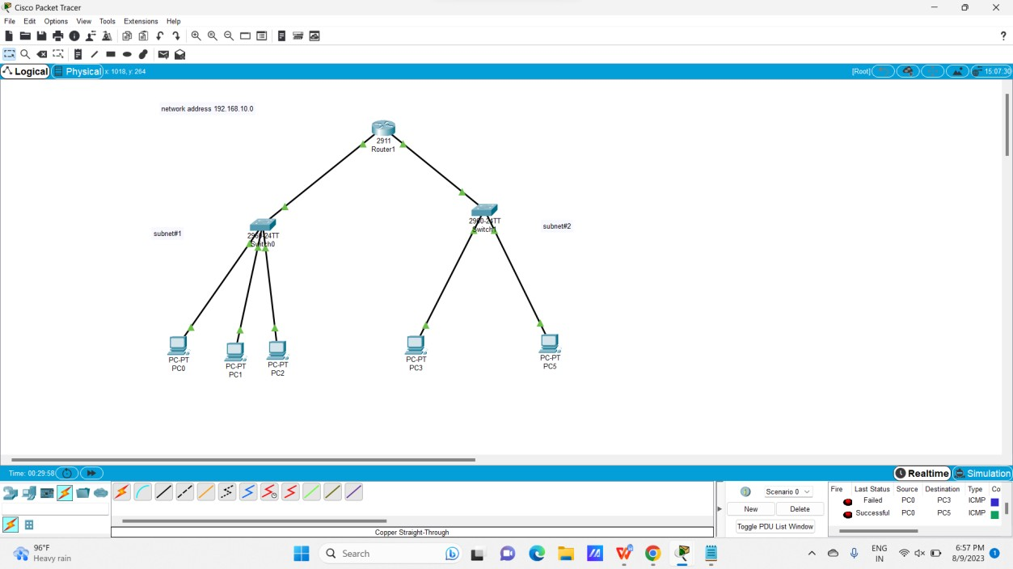

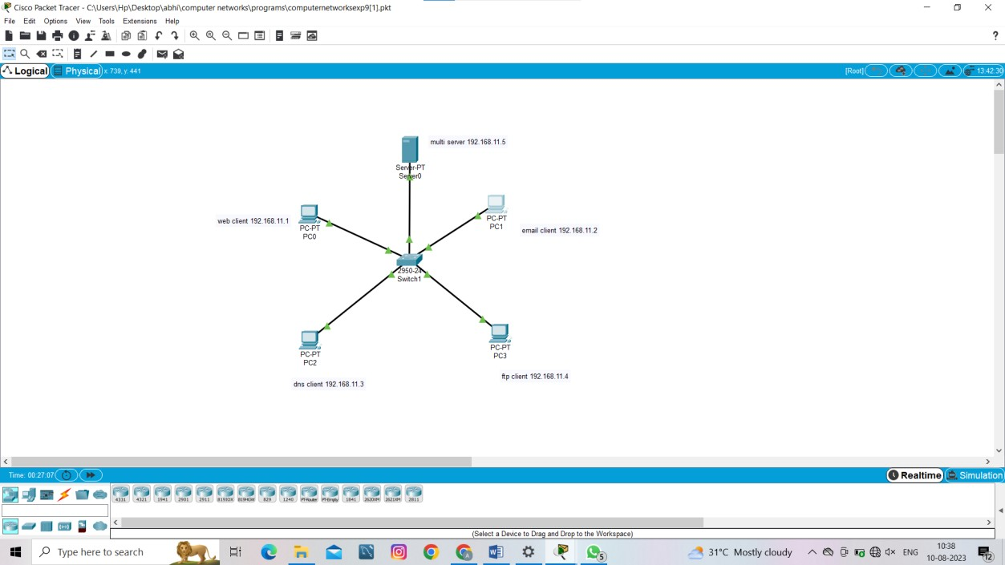

**10.** TCP, UDP Exploration Solution

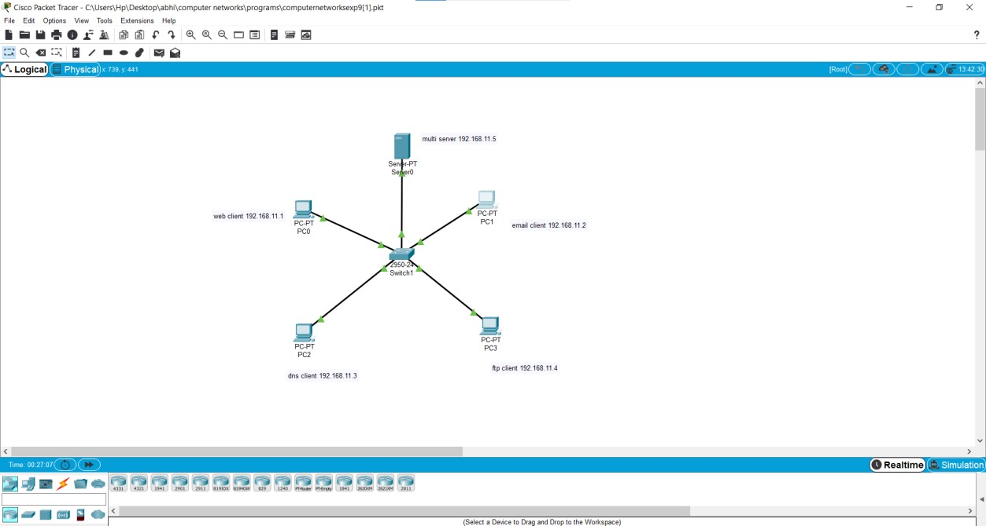

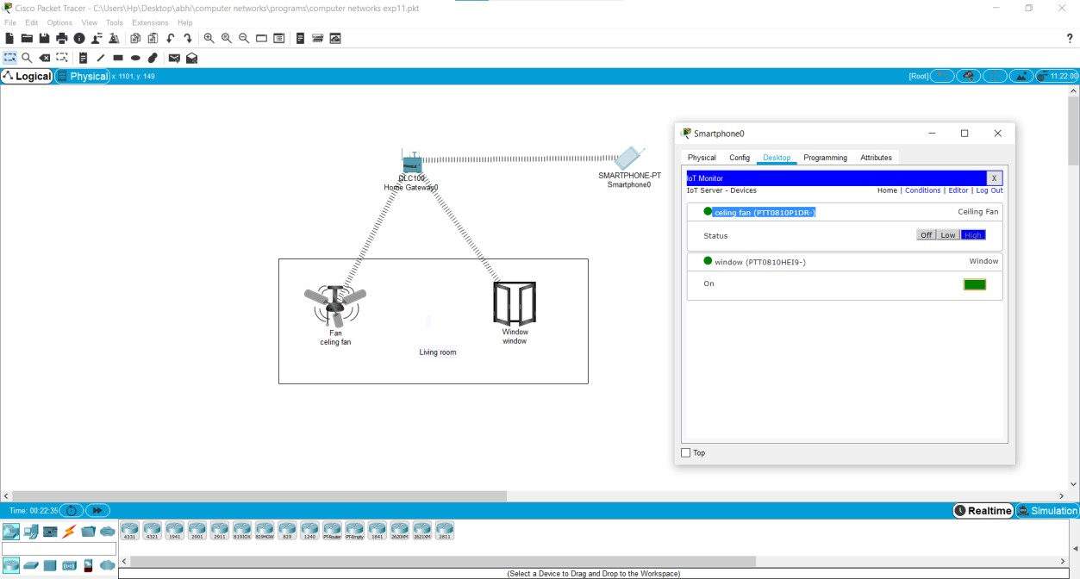

**12.** Smart Garden in Cisco Packet Tracer

