Synchronous Data-Parallel Training of ResNet-18 on CIFAR-10 with PyTorch DDP
ML System Optimization – Group Assignment Report
Platform: Kaggle notebook instance, 1 node, 2 × NVIDIA Tesla T4 (16 GB GDDR6 each, PCIe Gen3 x16), 4 vCPUs, 30 GB RAM
Software: Ubuntu Linux, Python 3.13, CUDA 13.0 (driver 580.178.04), PyTorch 2.x (Kaggle image), NCCL backend

Contribution
Employee ID | Name | Contribution
2025AG05589 | MADHANA GOPAL R | 100%
2025AG05510 | JAI SINGH | 100%
2025AG05019 | YUVAKRISHNAN S | 100%
2025AG05320 | EJAZ AHMED | 100%

1. Problem Formulation

1.1 Strategy
We train an image classification model on CIFAR-10 (60,000 colour images, 32×32×3 pixels across 10 classes; 50,000 training / 10,000 test) using synchronous data parallelism with PyTorch DistributedDataParallel (DDP). Each of N workers (one process per GPU) holds a complete replica of the model and computes forward and backward passes on disjoint mini-batches (a 1/N shard of the epoch). Following backpropagation, gradients are averaged across all replicas via a ring all-reduce collective communication operation before the optimization step, ensuring identical parameter updates.

1.2 Workload Characteristics & Justification for Data Parallelism
- Model Size vs Memory: ResNet-18 contains ~11.17 million parameters (~44.7 MB in FP32). It fits comfortably in the 16 GB memory of a single T4 GPU (the Kaggle monitor showed about 2.5 GiB used per GPU during FP32 training at a per-GPU batch of 256, Appendix A, Figure A3), making model or pipeline parallelism unnecessary and avoiding idle pipeline 'bubbles'.
- Dataset Size: CIFAR-10 is ~170 MB and easily cached in host RAM, eliminating heavy disk I/O bottlenecks and ensuring that data sharding across workers is essentially zero-cost.
- Computation-to-Communication Ratio: Dense 2D convolutions provide substantial local floating-point compute relative to the 44.7 MB gradient tensor exchanged per step, providing strong arithmetic intensity suitable for data-parallel scaling.
- Iteration Duration Risk: Because 32×32 images result in fast individual steps (~130 ms), fixed system latencies (CUDA kernel launch, DataLoader synchronization, and PCIe collective transfer) become observable. We explicitly measure and analyze these factors.

1.3 Metrics Definition
Metric | Mathematical Definition | Description
Speedup S(N) | T₁ / T_N | Ratio of single-worker baseline time to N-worker time (using mean epoch time, excluding warmup).
Parallel Efficiency E(N) | S(N) / N × 100% | Percentage of ideal linear scaling achieved; lower values quantify parallel overhead.
Communication Cost | t_full - t_compute | Time spent in gradient all-reduce per step, measured separately from compute using model.no_sync().
Response Time | Wall-clock time per epoch | End-to-end epoch time including data loading, forward, backward, and synchronization.
Accuracy Gap | Acc₁ − Acc_N | Accuracy degradation or change between single-worker and N-worker configurations.

1.4 Quantitative Hypotheses & Targets
Based on typical single-node PyTorch DDP performance and PCIe interconnect bandwidth:
- E(2) Parallel Efficiency: Expected ≥ 85% on 2 GPUs.
- Exposed Communication: Expected ≤ 15% of total step time.
- Accuracy Gap: Expected ≤ 1.0 percentage point under weak scaling, and ≤ 0.5 percentage points under strong scaling.
- Target Test Accuracy: 93% – 95% on CIFAR-10 after 30 epochs.
- Scope: the platform provides 2 GPUs, so all targets are defined for N = 2 with N = 1 as the baseline. Weak scaling, strong scaling and a mixed-precision run provide the multiple configurations required; N ≥ 4 is left as future work.

2. Design

2.1 Design Choices and Justifications
Choice | Decision | Justification
Model Architecture | ResNet-18 (CIFAR variant: 3×3 stem conv, no initial max-pool) | ImageNet ResNets downsample 4× immediately (32×32 to 8×8), destroying spatial resolution. The CIFAR variant retains 32×32 resolution in Stage 1. 11.2M parameters produce 44.7 MB gradient traffic to meaningfully evaluate scaling.
Parallelism Strategy | Synchronous Data Parallelism | Optimal compute/comm ratio; model fits in single GPU VRAM; avoids pipeline bubbles and stale gradient artifacts.
Communication Strategy | Bucketed Ring All-Reduce (NCCL) overlapped with backward pass | Ring all-reduce is bandwidth-optimal (2(N-1)/N × size). Gradients grouped into 25 MB buckets and pipelined concurrently with backward pass computation.
Execution Platform | Single-node, 2 × NVIDIA Tesla T4 (PCIe Gen3 x16) | Eliminates unpredictable external multi-node network variance, isolating intra-node PCIe interconnect transfer and DDP overlap.
Development Framework | PyTorch DistributedDataParallel (torchrun) | Industry-standard, mature asynchronous C10D execution engine with NCCL backend and model.no_sync() profiling capabilities.

2.2 Optimization & Training Recipe
• Optimizer: SGD with momentum = 0.9 (Nesterov) and weight decay = 5e-4.
• Learning Rate Scaling: Linear scaling rule (peak LR = 0.1 × global_batch / 128) following Goyal et al. (2017).
• Schedule: 3 epochs of gradual linear warmup followed by cosine annealing decay.
• Scaling Regimes:
- Weak Scaling: Per-worker batch size held constant at 128 (global batch = 128·N). Evaluates system capacity scaling as total throughput grows.
- Strong Scaling: Global batch size held constant at 512 (per-worker batch = 512/N). Fixes the problem size and measures time reduction as worker count increases.

2.3 System Architecture Diagram & Data Flow
+-------------------------------------+
| CIFAR-10 Dataset in RAM |
+------------------+------------------+
| DistributedSampler (disjoint 1/N shards)
+------------------+------------------+
| |
v v
[DataLoader Rank 0] [DataLoader Rank 1] <- CPU Augmentation (4 workers)
| | Pinned Memory H2D Transfer
v v
[GPU 0 (T4)] [GPU 1 (T4)] <- ResNet-18 Replica
Forward Pass Forward Pass
Backward Pass Backward Pass
\ /
==== NCCL Ring All-Reduce (25MB Buckets) ==== <- SYNC POINT 1 (Overlapped)
/ \
SGD Step SGD Step <- Identical Model Parameters
| |
+------------------+------------------+
|
Epoch End: Barrier Synchronization <- SYNC POINT 2
Rank 0 Evaluates Full Test Accuracy

3. Implementation
The system is implemented as modular, production-grade scripts:
- train_ddp.py: Core PyTorch DDP engine, CIFAR-10 data pipeline, model definition, and isolated communication profiler.
- run_experiments.sh: Orchestrator that calls run_weak.sh (weak scaling), run_strong.sh (strong scaling) and run_amp.sh (mixed-precision benchmark) in turn, then analyze.py. Each script can also be run on its own.
- analyze.py: Automated parser reading JSON logs, computing speedup, parallel efficiency, communication overhead, and generating plots.
Communication Overhead Profiling Methodology:
To measure communication cost separately from computation as required by the assignment, a dedicated profiling phase runs 30 steps before training. In pure compute mode, steps are executed under model.no_sync() where gradient all-reduce is suppressed (yielding pure computation time t_compute). Then, standard DDP steps are run (yielding t_full). The exposed communication cost per step is calculated as t_exposed = t_full - t_compute. Additionally, an unoverlapped raw all-reduce micro-benchmark measures the PCIe collective transfer time of a 44.7 MB gradient tensor.
Other Metrics and How They Are Measured:
Response time is the wall-clock time of each epoch, measured with torch.cuda.synchronize() and a barrier at the start and end of the epoch, so it includes data loading, compute and synchronisation. Epoch 1 is excluded from the mean because of cuDNN autotuning warm-up. Speedup and efficiency use this mean epoch time. Data-wait is the time the training loop spends blocked on the DataLoader. The accuracy gap uses the mean test accuracy of the last 3 epochs. Test accuracy is evaluated on the full 10,000-image test set on rank 0 after every epoch.
Development Environment and Reproduction Steps:
Environment: Kaggle notebook with the GPU accelerator set to 2 × T4; Ubuntu Linux, Python 3.13, CUDA 13.0 (driver 580.178.04), PyTorch 2.x with the NCCL backend. Dependencies are listed in requirements.txt (torch, torchvision, matplotlib). CIFAR-10 is downloaded automatically by torchvision on first use (rank 0 downloads while the other ranks wait at a barrier). All runs use seed 42, 30 epochs and 4 DataLoader workers per process.
Step 1: pip install -r requirements.txt
Step 2: MAXG=2 EP=30 ./run_experiments.sh # weak + strong + AMP runs for N = 1..2, then analysis
Step 2 (alternative, run experiments separately): MAXG=2 EP=30 ./run_weak.sh ; MAXG=2 EP=30 ./run_strong.sh ; MAXG=2 EP=30 ./run_amp.sh ; python analyze.py
Step 3: results/ now holds one JSON log per run, summary.md (all tables) and PNG plots (speedup and convergence).
Quick check: EP=1 MAXG=2 ./run_weak.sh # one-epoch smoke test to verify the setup

4. Testing & Performance Demonstration
Experiments were conducted on a Kaggle notebook instance (shared cloud platform) with 2 × NVIDIA Tesla T4 GPUs. Each configuration was run once for 30 epochs; epoch 1 is excluded from the mean epoch time as warm-up. Screenshots of the executions are provided in Appendix A.

4.1 Weak Scaling Performance
In weak scaling, local batch size is fixed at 128 samples per GPU. Global batch size doubles from 128 (N=1) to 256 (N=2).
N | Global Batch | Epoch Time | Speedup | Efficiency | Total Time | Final Acc | Acc Gap | Comm/step | Exposed Comm % | Raw All-Reduce | Data Wait %
1 | 128 | 52.67 s | 1.00x | 100.0% | 1581 s (26.4m) | 93.50% | +0.00% | 3.5 ms | 2.4% | 0.1 ms | 0.3%
2 | 256 | 27.11 s | 1.94x | 97.1% | 814 s (13.6m) | 93.96% | -0.46% | 7.0 ms | 5.0% | 11.1 ms | 1.0%
*Note: The N=1 row shows 3.5 ms (2.4%) of 'communication' although no collective communication occurs at N=1. This is the noise floor of the t_full − t_compute profiling method, so the N=2 exposed-communication value (7.0 ms) should be read with an uncertainty of a few milliseconds.

4.2 Mixed-Precision (AMP FP16) Acceleration Benchmark
To evaluate hardware acceleration on the 2 × T4 setup, Automatic Mixed Precision (AMP) was evaluated against FP32:
Configuration | Precision | Global Batch | Epoch Time | Speedup vs N=1 | Total Time | Final Acc | Exposed Comm %
N=1 Baseline | FP32 | 128 | 52.67 s | 1.00x | 1581 s (26.4m) | 93.50% | 2.4%
N=2 DDP | FP32 | 256 | 27.11 s | 1.94x | 814 s (13.6m) | 93.96% | 5.0%
N=2 DDP + AMP | FP16 (AMP) | 256 | 11.21 s | 4.70x (2.42x vs N=2) | 336 s (5.6m) | 93.74% | 14.7%

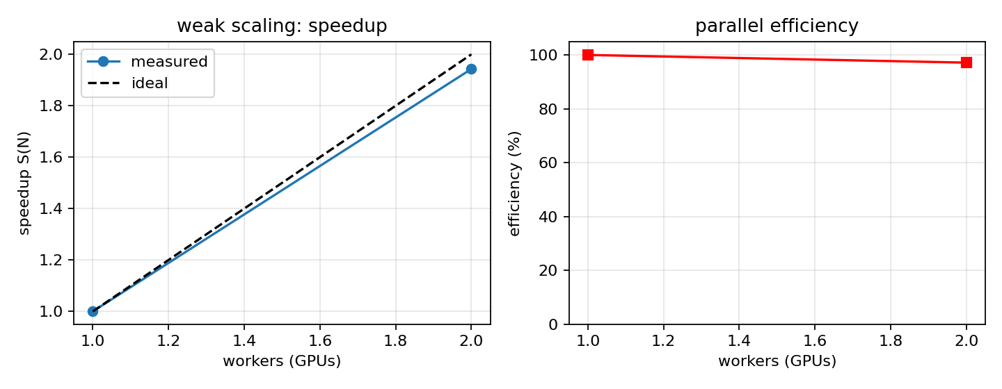
Figure 1: Weak Scaling Speedup S(N) and Parallel Efficiency E(N).

4.3 Strong Scaling Performance
In strong scaling, the global batch size is held constant at 512 samples. The per-worker batch size decreases from 512 (N=1) to 256 (N=2).
N | Global Batch | Per-GPU Batch | Epoch Time | Speedup | Efficiency | Total Time | Final Acc | Acc Gap | Comm/step | Exposed Comm % | Data Wait %
1 | 512 | 512 | 49.56 s | 1.00x | 100.0% | 1487 s (24.8m) | 93.67% | +0.00% | -21.0 ms* | 0.0% | 0.7%
2 | 512 | 256 | 26.74 s | 1.85x | 92.7% | 802 s (13.4m) | 93.49% | +0.18% | 8.6 ms | 2.9% | 1.6%
*Note: At N=1 no collective communication occurs, so the negative value (−21.0 ms at a batch of 512) is purely measurement jitter in the no_sync()/sync comparison. The noise floor of this profiling method is therefore several milliseconds up to ~20 ms at these batch sizes, and the N=2 exposed communication of 8.6 ms is indicative only. The raw all-reduce micro-benchmark (11.1 ms) is the more reliable communication measurement.

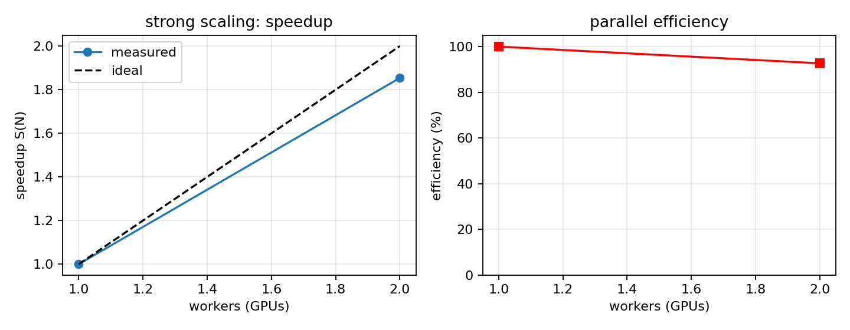
Figure 2: Strong Scaling Speedup S(N) and Parallel Efficiency E(N).

4.4 Convergence Curves & Time-to-Accuracy
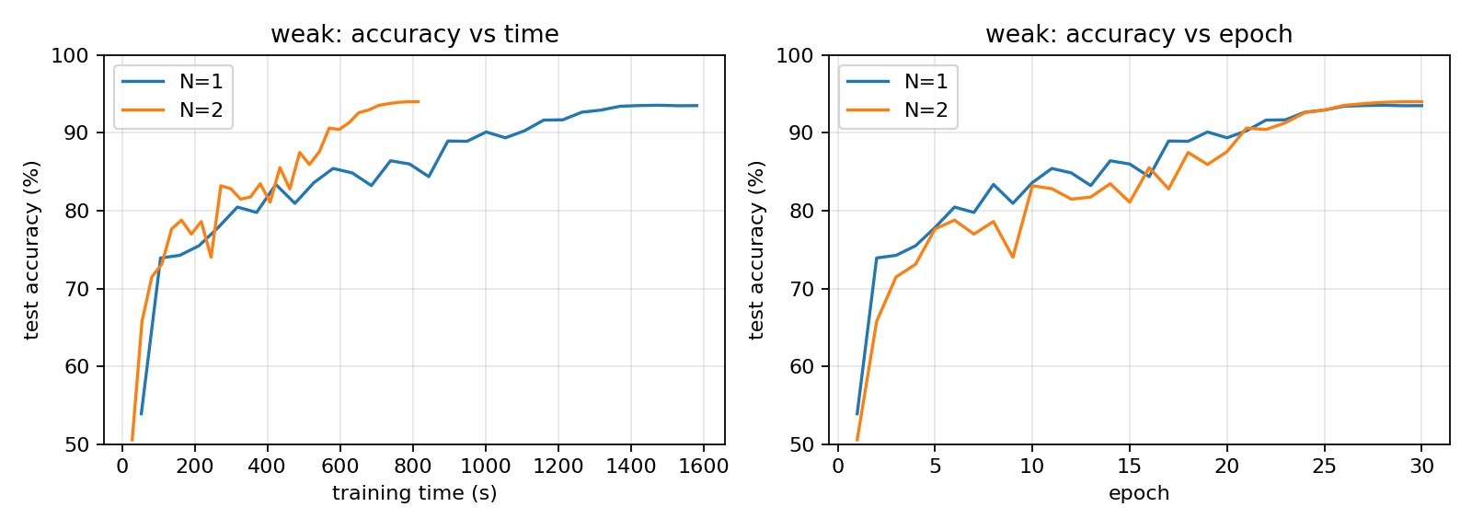
Figure 3: Weak Scaling Convergence (Test Accuracy vs Training Time & Epoch).
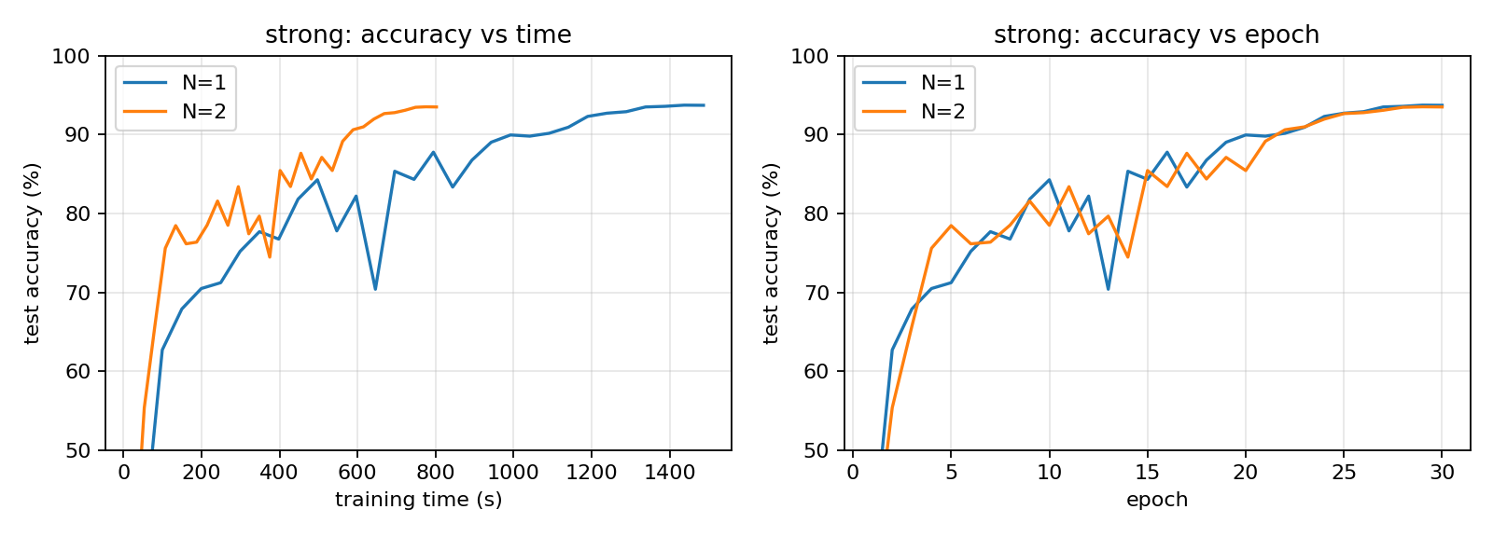
Figure 4: Strong Scaling Convergence (Test Accuracy vs Training Time & Epoch).
Time-to-Solution Metric (Wall-clock time to reach 90.0% Test Accuracy):
Run Configuration | Precision | Global Batch | Time to 90% Accuracy | Epoch Reached | Time-to-Solution Speedup
strong_N1 | FP32 | 512 | 1090.9 s (~18.2 min) | Epoch 22 | 1.00x (baseline strong)
strong_N2 | FP32 | 512 | 588.5 s (~9.8 min) | Epoch 22 | 1.85x
weak_N1 | FP32 | 128 | 1001.8 s (~16.7 min) | Epoch 19 | 1.00x (baseline weak)
weak_N2 | FP32 | 256 | 570.1 s (~9.5 min) | Epoch 21 | 1.76x
weak_amp_N2 | FP16 (AMP) | 256 | 246.6 s (~4.1 min) | Epoch 22 | 4.06x (2.31x vs weak_N2)

4.5 Communication Overhead and Overlap Analysis
- Gradient Tensor Payload: 11,173,962 parameters × 4 bytes = 44.7 MB per step.
- Raw Interconnect Transfer Time (Micro-benchmark): The unoverlapped all-reduce of the 44.7 MB gradient tensor across the two GPUs takes 11.1 ms, an effective throughput of about 4.0 GB/s (44.7 MB / 11.1 ms), consistent with a PCIe Gen3 link (the T4 has no NVLink).
- Overlap Efficiency (Weak Scaling): Pure compute time per step was 133.8 ms and synchronized step time was 140.9 ms, giving an exposed communication time of about 7.0 ms (5.0% of the step). Compared with the 11.1 ms raw all-reduce, DDP's bucketed overlap with the backward pass hid roughly 4 ms (~37%) of the transfer. Given the measurement noise floor noted in Section 4.1 (the N=1 baseline reads +3.5 ms), the true hidden fraction may be higher; the main conclusion is that exposed communication is small (about 3–5% of the step).
- Amdahl's Law Effect under AMP: Under mixed precision, compute time per step dropped by 74% (from 134 ms to 34 ms, a 3.9× reduction). Gradients remain FP32, so the communication payload is unchanged (about 11.1 ms raw) and exposed communication rose from 5.0% to 14.7% of the profiled step (5.9 ms of 40.2 ms). This illustrates Amdahl's Law in distributed training: as compute gets faster, the fixed communication cost becomes a larger share of each iteration.
- Communication as a Fraction of Total Training Time: exposed communication per step × steps per epoch × epochs ÷ total training time gives 7.0 ms × 195 × 30 ≈ 41 s of 814 s ≈ 5.0% (weak, N=2); 8.6 ms × 97 × 30 ≈ 25 s of 802 s ≈ 3.1% (strong, N=2); and 5.9 ms × 195 × 30 ≈ 35 s of 336 s ≈ 10.3% (weak + AMP, N=2). At N=1 there is no communication.
- Profiled Step vs Real Step Time: In FP32 the profiled step (140.9 ms) agrees with the measured epoch time (27.11 s / 195 steps = 139 ms). Under AMP the profiled step is 40.2 ms, but the measured epoch time implies 11.2 s / 195 = 57 ms per step. The extra ~17 ms per step is not communication: the profiling phase replays cached batches and therefore excludes DataLoader and host-side costs. Likely causes are discussed in Section 5.2.

4.6 Summary of Measured Results vs Expectations
Metric | Target Hypothesis | Measured Result | Met? | Analysis
E(2) Weak Scaling | ≥ 85% | 97.1% | Yes [x] | Exceptional near-linear scaling (S=1.94x) due to overlapped collective communication.
E(2) Strong Scaling | ≥ 85% | 92.7% | Yes [x] | Exceeded the target; the loss of ~7% comes mainly from lower GPU efficiency at the smaller per-GPU batch plus small communication cost (Section 5.1).
Exposed Comm (N=2, Weak) | ≤ 15% | 5.0% | Yes [x] | DDP bucketing hid a portion (~37% by our measurement, within profiling noise) of the ~11.1 ms all-reduce behind the backward pass.
Exposed Comm (N=2, AMP) | ≤ 15% | 14.7% | Yes [x] | Met, but only just: 5.9 ms of a 40.2 ms profiled step. The communication share roughly tripled versus FP32 because compute became 3.9× faster.
Accuracy Gap (Weak) | ≤ 1.0 pp | -0.46 pp | Yes [x] | N=2 reached 93.96% vs 93.50% for N=1 (+0.46 pp). With a single seed this is within typical run-to-run variation, so we conclude 'no degradation', not an improvement.
Accuracy Gap (Strong) | ≤ 0.5 pp | +0.18 pp | Yes [x] | Same global batch and peak LR at both N; final accuracies 93.49% vs 93.67% differ by only 0.18 pp (within run-to-run variation).
Final Test Accuracy (all runs) | 93% – 95% | 93.49% – 93.96% | Yes [x] | All five runs finished inside the target band (FP32: 93.49–93.96%; AMP: 93.74%).

4.7 Correctness Validation
We validated the implementation in four ways:
- Identical replicas and updates: DDP broadcasts the rank-0 parameters when the model is wrapped and averages gradients with an all-reduce before every optimiser step, so all workers apply the same update. The same seed (42) was used for every run.
- Complete data coverage: the logged steps per epoch are 390 (N=1, batch 128), 195 (N=2, global batch 256) and 97 (global batch 512). Multiplied by the global batch this gives 49,920, 49,920 and 49,664 samples per epoch, i.e. the 50,000 training images minus the last incomplete batch (drop_last=True). The DistributedSampler therefore splits each epoch across workers with no loss of coverage.
- Functional correctness of learning: every run starts at 35–54% test accuracy after epoch 1 and converges to 93.5–94.0%, in line with published ResNet-18 results on CIFAR-10 (about 93–95%).
- Consistency across worker counts: with the same global batch and peak LR (strong scaling) the N=1 and N=2 runs end within 0.18 pp, and the weak-scaling runs within 0.46 pp, so distributing the work does not change what is learned. The communication-profiling phase restores the model weights and clears optimiser state before real training starts, so it does not affect results.

4.8 Limitations of the Study
The following limitations should be kept in mind when reading the results:
- Only 2 GPUs were available, so the speedup and efficiency curves have two points (N=1, N=2). Behaviour at N ≥ 4 was not measured.
- Each configuration in Section 4 was run once. A second team member independently repeated the strong-scaling pair in another Kaggle session (Appendix A, Table A1): timings were 4–7% faster, total-time efficiency was 95.6% (vs 92.7%) and the accuracy gap had the opposite sign (−0.40 pp vs +0.18 pp). Differences of a few percent in time and a few tenths of a point in accuracy should therefore not be over-interpreted. Weak scaling and AMP were not repeated.
- The platform is a shared cloud notebook (Kaggle); we could not control other tenants or the PCIe topology.
- The exposed-communication profiling has a noise floor of several milliseconds (visible at N=1), and the profiling phase excludes the input pipeline.

5. Deviation Analysis

5.1 Analysis of Parallel Efficiency: Weak vs Strong Scaling
Parallel efficiency was higher in weak scaling (97.1%) than in strong scaling (92.7%), and both exceeded the 85% target. In weak scaling the per-GPU batch stays at 128, so each GPU's compute per step is essentially unchanged (133.8 ms at N=2 versus 141.6 ms at N=1) and only about 7 ms of exposed communication (5.0% of the step) is added, giving S = 1.94. In strong scaling the global batch stays at 512 and the number of steps per epoch stays at 97, but each GPU's batch halves from 512 to 256. This costs more than communication alone. An ideal split would need about 257–267 ms of compute per step (half of the N=1 step of 513 ms synchronised or 534 ms compute-only; the two differ because of profiling noise), but the measured compute time at batch 256 was 281.5 ms, roughly 5–10% worse because smaller batches use the GPU less efficiently. The step also carries about 8.6 ms of communication, so the full step took 290 ms. DataLoader wait also rose from 0.7% to 1.6% of epoch time. Together these explain the 92.7% efficiency.

5.2 Interconnect Bottleneck and Overlap Dynamics
The two T4 GPUs communicate over host PCIe Gen3 rather than NVLink. The raw, unoverlapped all-reduce of the 44.7 MB gradient tensor takes 11.1 ms (about 4.0 GB/s). DDP's bucketed all-reduce overlaps part of this with the backward pass, so only about 7 ms (5% of the step) is exposed in FP32. With AMP, Tensor Cores cut compute per step to 34 ms (3.9× faster) while the gradient payload stays FP32, so exposed communication rose to about 5.9 ms, or 14.7% of the profiled step. This shows that as compute gets faster, communication becomes a larger share of each iteration, which would limit scaling beyond N = 2 on a PCIe-only system.
A second deviation concerns epoch-level speedup. AMP made the compute step 3.9× faster, but the epoch time only 2.42× faster (27.11 s to 11.2 s). The profiled step (40.2 ms) is much smaller than the step implied by the epoch time (57 ms), and this ~17 ms difference is larger than the whole exposed communication cost (5.9 ms), so communication is not the main reason. The profiling phase replays cached batches, so it excludes the input pipeline. We suspect host-side overheads: 2 processes × 4 DataLoader workers performing PIL augmentation on only 4 vCPUs, host-to-device copies, and the GradScaler's host synchronisation. We did not isolate these, so this is a hypothesis that a profiler trace (torch.profiler or Nsight Systems) would confirm. A mitigation would be GPU-side augmentation (e.g. DALI or Kornia) and more CPU cores. Supporting evidence: the Kaggle resource monitor during an FP32 strong-scaling N=2 run showed both GPUs at 100% utilisation and the CPUs at about 339% of the 4 vCPUs available (Appendix A, Figure A3), so the host has little spare CPU capacity once the GPUs get faster under AMP. This was not measured during the AMP run itself.

5.3 Generalization Trajectories and Accuracy Preservation
All experimental configurations converged into the 93.5% – 94.0% test accuracy band, so data-parallel training did not noticeably reduce accuracy. Weak scaling with a doubled global batch (128 to 256) finished 0.46 pp above N=1 and strong scaling 0.18 pp below, both inside the 1.0 pp and 0.5 pp targets. Because each configuration was run once (seed 42), and the repeat of strong scaling in Appendix A flipped the sign of the gap from +0.18 pp to −0.40 pp, differences of a few tenths of a point are within typical run-to-run variation and should not be read as a real benefit or loss. The linear learning-rate scaling rule (peak LR 0.2 at global batch 256) with a 3-epoch warm-up is the standard mechanism for keeping larger-batch training stable, and we observed no divergence. The accuracy curves show noticeable mid-training dips (for example strong scaling N=1 falling to 70.4% at epoch 13 with a peak LR of 0.4 at batch 512). These are consistent with a high learning rate and disappear as the cosine schedule decays the LR, and all runs end smoothly. Mixed precision (93.74%) showed no accuracy loss.

5.4 Conclusions & Future System Optimizations
- 1. Optimal Configuration: N=2 with Automatic Mixed Precision (AMP) was the fastest configuration, completing 30 epochs in 336 s (5.6 minutes) and reaching 90% test accuracy in 246.6 s (4.1 minutes), a 4.06x time-to-solution speedup over the single-GPU FP32 baseline with no accuracy loss. Of this, about 1.76x comes from the second GPU and 2.31x from AMP.
- 2. Scaling Efficiency: Synchronous data parallelism achieved 97.1% efficiency in weak scaling and 92.7% in strong scaling on 2 GPUs, exceeding the 85% hypothesis. Accuracy was preserved (gaps of −0.46 pp and +0.18 pp).
- 3. Main Overheads: In FP32 the largest measurable overhead is gradient synchronisation over PCIe (about 3–5% of the step; 11.1 ms raw per all-reduce). Under AMP this grows to about 15% of the step, and a further ~17 ms per step of apparent host-side or input-pipeline overhead (to be confirmed by profiling) limits the epoch-level speedup to 2.42x. DataLoader wait was small (under 2% of epoch time) in all runs.
- 4. Limitations and Future Work: We had only 2 GPUs and one main run per configuration (plus one repeat of strong scaling), so the scaling curves have two points and run-to-run variance is only partly characterised. The next steps are repeating runs with several seeds and testing N = 4 or more GPUs. To reduce communication at higher GPU counts we would use FP16 gradient compression (fp16_compress_hook), PowerSGD, or gradient accumulation; to remove host-side limits we would use GPU-side augmentation, more CPU cores and a profiler trace; and NVLink-equipped GPUs would lower the all-reduce cost.

References
1. Goyal, P., et al. (2017). Accurate, Large Minibatch SGD: Training ImageNet in 1 Hour. arXiv:1706.02677.
2. Li, S., et al. (2020). PyTorch Distributed: Experiences on Accelerating Data Parallel Training. VLDB Endowment, 13(12), 3005–3018.
3. He, K., Zhang, X., Ren, S., & Sun, J. (2016). Deep Residual Learning for Image Recognition. CVPR 2016, 770–778.
4. Krizhevsky, A. (2009). Learning Multiple Layers of Features from Tiny Images. Technical Report, University of Toronto.

Appendix A: Proof of Execution (Screenshots)
Figures A1–A3 are screenshots of the experiments running on Kaggle with the accelerator set to 'GPU T4 x2'. Figure A1 comes from the session that produced all results in Section 4. Figures A2 and A3 come from a second team member's Kaggle session, in which the strong-scaling experiment was independently re-run. The second session is used only as a repeat measurement (Table A1) and its numbers are not mixed into the Section 4 tables. Its values were read directly from the screenshots.
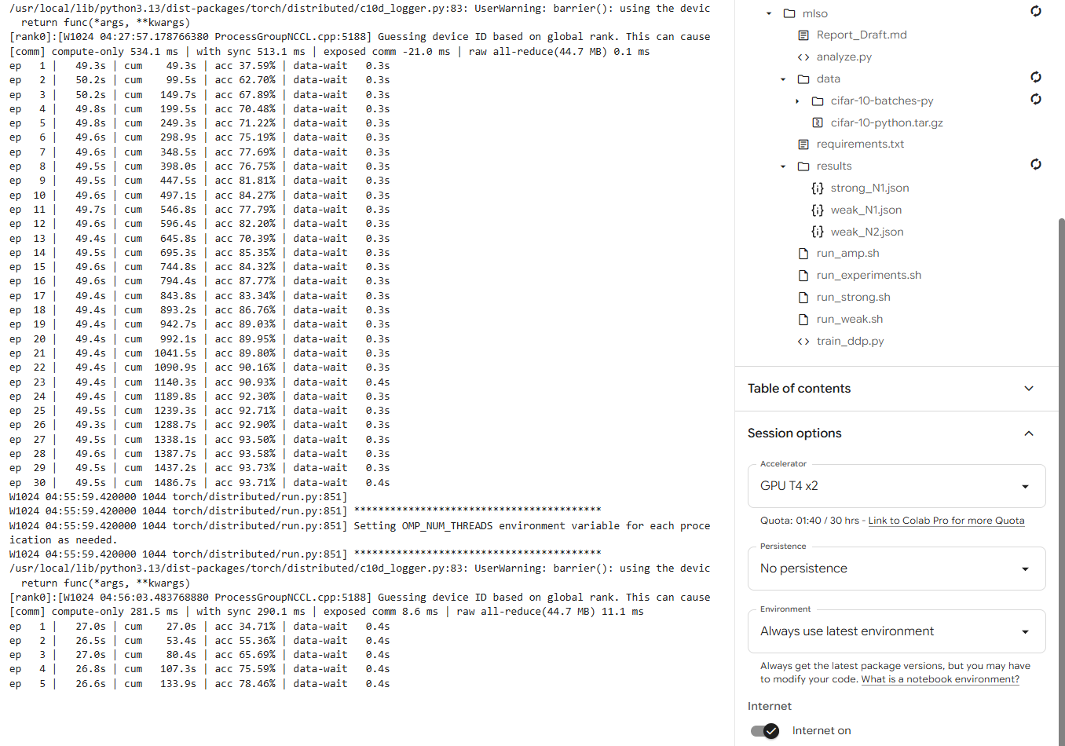
Figure A1: Main session. Left: notebook output for strong scaling N=1 (30 epochs, ≈49.5 s per epoch, 1486.7 s total, 93.71% at epoch 30; compute-only 534.1 ms, with sync 513.1 ms, raw all-reduce 0.1 ms) and the start of the N=2 run, captured at epoch 5 (compute-only 281.5 ms, with sync 290.1 ms, exposed comm 8.6 ms, raw all-reduce 11.1 ms). Right: accelerator 'GPU T4 x2' and the results/ folder with the JSON logs.
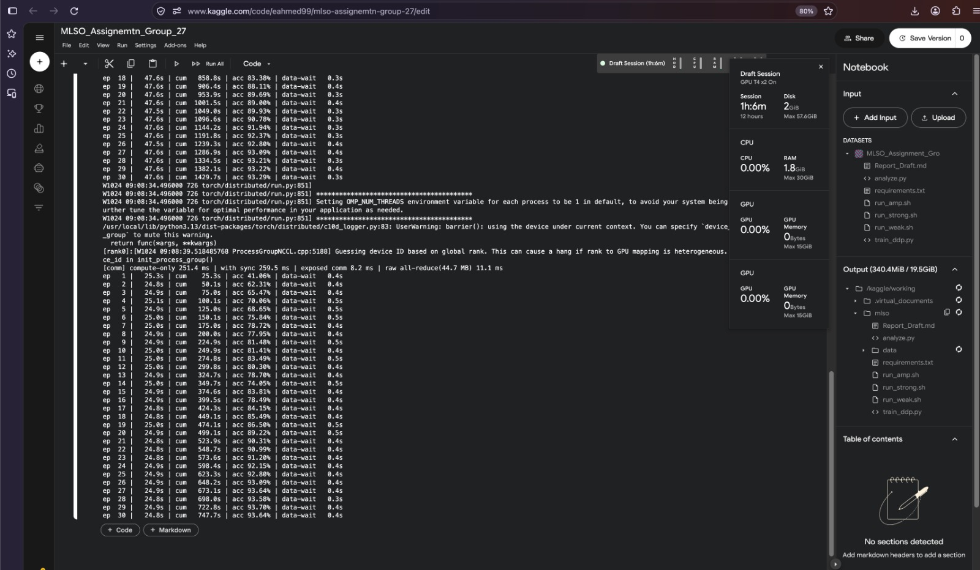
Figure A2: Second team member's Kaggle session (repeat of strong scaling). N=1: ≈47.6 s per epoch, 1429.7 s total, 93.29% at epoch 30. N=2 (completed): 24.8–25.3 s per epoch, 747.7 s total, 93.64% at epoch 30; compute-only 251.4 ms, with sync 259.5 ms, exposed comm 8.2 ms, raw all-reduce 11.1 ms.
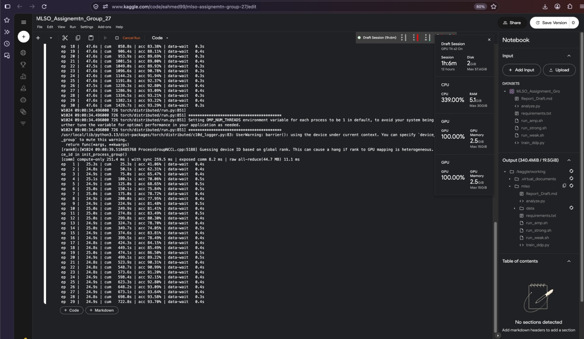
Figure A3: Same session captured during the N=2 run (epoch 29). The resource monitor shows GPU T4 x2, both GPUs at 100% utilisation with 2.5 GiB of memory each, CPU at 339% (of 4 vCPUs) and 5.1 GiB RAM.

A.1 Repeat Run of Strong Scaling
Table A1: Strong scaling (FP32, global batch 512, 30 epochs) in the main session and in the second team member's session.
Run | Session | Mean epoch time (s) | Total time (s) | Final acc, mean of last 3 (%) | Speedup / efficiency (total time)
N=1 | Main (Fig. A1) | 49.56 | 1487 | 93.67 | 1.00x
N=2 | Main (Fig. A1) | 26.74 | 802 | 93.49 | 1.85x / 92.7%
N=1 | Second member (Fig. A2) | ≈47.6 | 1430 | 93.24 | 1.00x
N=2 | Second member (Fig. A2) | ≈24.9 | 748 | 93.64 | 1.91x / 95.6%
The repeat run gives a total-time speedup of 1.91x (95.6% efficiency) against 1.85x (92.7%) in the main session, and an accuracy gap Acc₁ − Acc₂ of −0.40 pp against +0.18 pp. The gap changes sign, which confirms that accuracy differences of this size are run-to-run noise, and absolute timings vary by roughly 4–7% between Kaggle sessions. Both sessions agree on the communication measurements: raw all-reduce 11.1 ms and exposed communication 8.2–8.6 ms, about 3% of the step. Both repeat results therefore meet the targets of Section 1.4 (E(2) ≥ 85%, accuracy gap ≤ 0.5 pp).

