Output of Gemini pro model:

In the magical world of Hogwarts, Harry Potter, an orphaned wizard, embarks on a transformative journey across his first four years. Alongside friends Ron and Hermione, he unravels mysteries involving the Philosopher's Stone, the Chamber of Secrets, and Sirius Black's escape from Azkaban. Faced with dark forces, Harry confronts his destiny and the return of the dark wizard, Voldemort. Themes of friendship, courage, and the ongoing battle between good and evil permeate each year. The Triwizard Tournament in the fourth-year thrusts Harry into a dangerous plot, revealing deeper connections to Voldemort and setting the stage for the escalating conflict between the forces of light and darkness in the wizarding world.

**Performance:**

Based on my research Gemini-pro model is working well when compared with other two models.

Other two models working fine, which has lesser number of pages.

Context length: Falcon-7b and Mistral-7b models context length is 2048

Gemini pro model context Length is 30000

Gemini pro model Output Length is 2000

Gemini Pro Model taking very less time when compared with other 2 models. Falcon Model takes approximately 5 sec to fetch the output by executing 800 words whereas Gemini Pro Model takes approximately 1-2 sec to fetch output for 800 words.

**Model Evaluation Technique:**

I have submitted 25 pages to the GPT-3.5 model, which has generated 25 corresponding summaries. Concurrently, I have furnished the identical set of 25 pages to diverse models, namely Falcon 7B, Gemini Pro, and Mistral 7B and compared the outputs of all these models individually with GPT-3.5 model and calculated rough, Bleu Score and Bert Score. Among all these models, Gemini Pro model yielded the most optimal and efficient output among all the models under consideration.

**Gemini Pro Model of rouge Evaluation:**

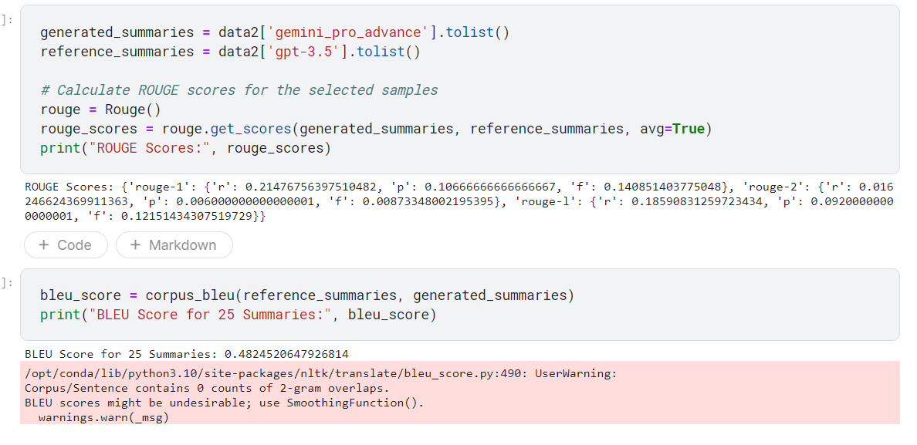

**Gemini Pro Model of Bleu Evaluation:**

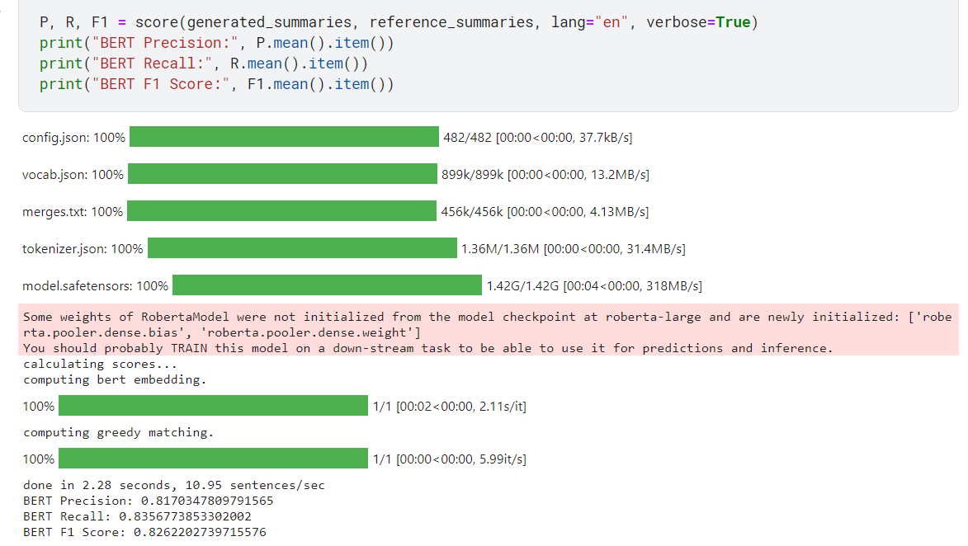

**Falcon-7B output:**

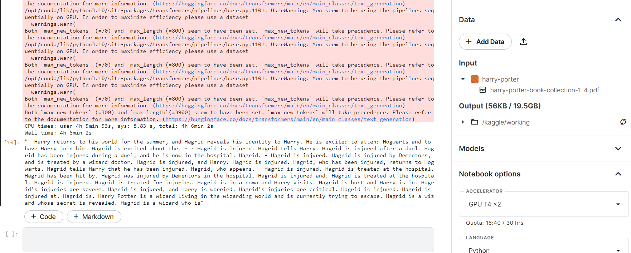

**Falcon-7B model Evaluation:**

