CMR INSTITUTE OF TECHNOLOGY
Bengaluru

PROJECT REPORT
on
TRAFFIC ACCIDENT SEVERITY ANALYTICS
AND PREDICTION
Part 1: Data Engineering Pipeline | Part 2: MLOps Pipeline
Submitted by
Student Name: Madhan Matthew S
USN: 1CR23AI052
Course: Data Engineering and MLOps
Mode: Individual Project
Academic Year: 2026-27
Department: Artificial Intelligence and Machine Learning
CMR INSTITUTE OF TECHNOLOGY, Bengaluru

CERTIFICATE
This is to certify that the project report entitled “Traffic Accident Severity Analytics and Prediction” is a bonafide work carried out by Madhan Matthew S (USN: 1CR23AI052) as an individual project for the course Data Engineering and MLOps during the academic year 2026-27.

Faculty Guide / Course Instructor: ______________________________
Signature: ____________________ Date: ____________________

DECLARATION
I hereby declare that this project report is my original work. All datasets, software libraries, public code, and external references used in the project have been appropriately acknowledged. No private, personally identifiable, or confidential data has been included.

Student Name: Madhan Matthew S
USN: 1CR23AI052
Signature: ____________________________

ACKNOWLEDGEMENT
I express my sincere gratitude to CMR Institute of Technology, Bengaluru, and to the Department of Artificial Intelligence and Machine Learning for providing the environment and resources needed to complete this project.
I am thankful to the course instructor of Data Engineering and MLOps for the guidance, the clear project requirements and the constructive feedback that shaped both parts of this work. I also thank my classmates and family for their encouragement.
Finally, I acknowledge the organisations that publish the open data and tools this project is built on: the UK Department for Transport (STATS19 road safety data), Open-Meteo (historical weather archive) and the open-source communities behind Python, Apache Airflow, PostgreSQL/PostGIS, Streamlit, scikit-learn, LightGBM, MLflow, FastAPI and Docker.

ABSTRACT
Road collisions cause about 100,000 injuries a year in Great Britain, and roughly a quarter of them kill or seriously injure someone (KSI). This project builds an end-to-end data engineering and MLOps solution for traffic accident severity analytics and prediction.
In Part 1, an automated pipeline ingests two years (2023–2024) of public STATS19 collision, vehicle and casualty records from the UK Department for Transport (839,763 rows) and enriches every collision with measured hourly weather from the Open-Meteo archive (1,026,312 hourly rows on 59 grid cells). The data move through raw, staging, cleaned and analytics layers stored as Parquet, are checked by 22 validation rules with a full audit trail, and are loaded into a PostgreSQL/PostGIS star schema with an accident mart. An interactive Streamlit dashboard exposes the patterns, and a leakage-free table of 205,173 collisions is produced for modelling. Apache Airflow orchestrates the pipeline every month. The analysis shows that severe collisions concentrate on unlit, rural, high-speed roads at night, whereas frequent collisions occur in the urban weekday evening rush.
In Part 2, that table feeds a LightGBM severity classifier trained with balanced class weights on a chronological split. On the unseen October–December 2024 test period it reaches a macro-F1 of 0.431 and catches 64.6% of fatal or serious collisions; 83% of fatal collisions are flagged as severe. Experiments are tracked and models versioned in MLflow with a champion/challenger gate, the champion is served through FastAPI in Docker with a Streamlit front end, and a weekly monitor checks data quality, drift, performance and latency against an explicit retraining policy run by Airflow.
Keywords: Road Safety, STATS19, ETL, Data Pipeline, Apache Airflow, PostgreSQL/PostGIS, Streamlit, LightGBM, Class Imbalance, MLOps, MLflow, FastAPI, Drift Monitoring

TABLE OF CONTENTS
1. Introduction
2. Problem Statement and Objectives
3. Data Source and Dataset Description
4. System and Data Architecture
5. Data Ingestion and ETL Pipeline
6. Database Design and Data Quality
7. Data Visualization and Analytics
8. MLOps Pipeline Extension
9. Results and Discussion
10. Conclusion and Future Scope
References
Appendices

Appendix A – Source Code / Repository Details; Appendix B – Airflow DAG / ETL Workflow; Appendix C – Database Schema and Sample Tables; Appendix D – Data Dictionary and Validation Rules; Appendix E – Dashboard Views; Appendix F – MLflow / Deployment / Monitoring Evidence.

1. INTRODUCTION

1.1 Background
Great Britain records about 100,000 road collisions involving personal injury every year, and about a quarter of them kill or seriously injure someone (KSI). Road-safety teams use this information to target enforcement, street lighting, speed management and winter maintenance, so they need to know when, where and under which conditions collisions become severe.
The police collision records (STATS19) describe the road, the light and the weather as the attending officer saw them. They contain no measured temperature, rainfall or wind, and they are spread across three related files (collision, vehicle, casualty) whose column names change between releases. Turning such data into reliable insight needs a repeatable data engineering pipeline. Going one step further, predicting how severe a collision will be from what is known when it is reported needs a machine-learning model that is tracked, versioned, deployed and monitored, which is the purpose of MLOps.

1.2 Project Overview
The project combines police collision records and measured hourly weather into one analytical warehouse, and then builds a severity prediction service on top of it.
- Part 1 (Data Engineering): an automated, auditable pipeline that ingests, validates, cleans and standardises STATS19 and Open-Meteo data, stores it in a PostgreSQL/PostGIS star schema with an accident mart, exposes it through a Streamlit dashboard, and produces a leakage-free model-ready table.
- Part 2 (MLOps): a LightGBM classifier for collision severity (Fatal / Serious / Slight) with experiment tracking and a model registry in MLflow, FastAPI serving in Docker, drift and performance monitoring, and an automated retraining policy.

1.3 Scope
The scope is all police-reported injury collisions in Great Britain for 2023 and 2024: 205,185 collisions, 373,329 vehicles and 261,249 casualties.
- Included in Part 1: extraction, staging, 22-rule validation, transformation, the star schema and accident mart, the dashboard, orchestration with Airflow, and the ml_accident_features table.
- Included in Part 2: the chronological train/validation/test split, the single sklearn inference pipeline, class-weighted LightGBM training, MLflow tracking and registry, FastAPI/Docker/Streamlit serving, monitoring and the retraining policy.
- Boundaries: only injury collisions recorded by the police are covered; there is no traffic-volume exposure data; weather is regional (1° grid); only LightGBM is trained in the final pipeline.

2. PROBLEM STATEMENT AND OBJECTIVES

2.1 Problem Statement
Road-safety teams need to understand the conditions under which collisions become severe, but the public data are fragmented, partly inconsistent between years, and lack measured weather. In addition, the classes are strongly imbalanced (Slight 75.6%, Serious 22.9%, Fatal 1.5%), so a naive model that always predicts “Slight” is 75.6% accurate yet never detects a serious or fatal collision.
The problem is therefore twofold: (1) build a reproducible pipeline and warehouse that turn raw collision and weather data into trustworthy, location- and time-aware analytics; and (2) build, deploy and maintain a severity model that is judged on how many severe collisions it catches rather than on accuracy.

2.2 Objectives
- Ingest the public STATS19 collision, vehicle and casualty files and enrich every collision with hourly measured weather from the Open-Meteo archive.
- Validate, clean and standardise the data with explicit rules and keep a full audit trail of what was extracted and rejected.
- Design a location- and time-aware star schema (date, time, location, road, weather and severity dimensions) with an accident mart for analytics.
- Provide an interactive dashboard that shows when and where severe collisions happen.
- Produce a leakage-free model-ready table and build a severity classifier evaluated with macro-F1 and KSI recall on a chronological split.
- Operationalise the model: experiment tracking, model registry, API deployment in Docker, monitoring and an explicit retraining policy.

2.3 Expected Outcomes
- Pipeline: a monthly Airflow-orchestrated pipeline whose steps are idempotent, logged and verified.
- Analytics: a validated warehouse with 16 reconciled tables and measured weather matched to every collision.
- Dashboard: six KPIs and six analysis tabs with filters for year, nation, urban/rural, police force and severity.
- MLOps: a registered champion model served by an API, with monitoring reports and a documented retraining and rollback procedure.

3. DATA SOURCE AND DATASET DESCRIPTION

3.1 Selected Dataset
Two free, public sources are used. Both contain no personally identifiable information.
Table 3.1: Data sources
Source | Content | Access | Licence
UK Department for Transport – Road Safety Open Data (STATS19) | Collision, vehicle and casualty tables for 2023 and 2024 (about 205k collisions, 373k vehicles, 261k casualties) | Landing page: data.gov.uk/dataset/cb7ae6f0-4be6-4935-9277-47e5ce24a11f/road-safety-data. Files: data.dft.gov.uk/road-accidents-safety-data/dft-road-casualty-statistics-{collision|vehicle|casualty}-{YEAR}.csv | Open Government Licence v3.0
Open-Meteo Historical Weather API (ERA5-based archive) | Hourly temperature, precipitation, rain, snowfall, wind speed and gusts, cloud cover, humidity and WMO weather code | archive-api.open-meteo.com/v1/archive (no API key); docs: open-meteo.com/en/docs/historical-weather-api | CC BY 4.0
OpenStreetMap (optional) | Not used in this version; road type and class already come from STATS19 | – | ODbL (future enrichment)

OpenStreetMap was considered for road-context enrichment (lighting, lanes), but STATS19 already provides road class, road type, speed limit and junction detail for every collision, so it is listed as future work.

3.2 Dataset Attributes
The three STATS19 tables are linked by collision_index:
- Collision: date, time, coordinates, police force, local authority, severity, number of vehicles and casualties, road class and type, speed limit, junction detail and control, light, weather and road-surface conditions, special conditions and hazards, urban/rural, police attendance.
- Vehicle: vehicle type, driver age, and other vehicle details for each vehicle in a collision.
- Casualty: casualty severity, class (driver, passenger, pedestrian), age and related fields.
The weather feed adds measured values for the collision hour at the nearest 1° grid cell: temperature, precipitation, rain, snowfall, wind speed and gusts, cloud cover, relative humidity and the WMO weather code.

3.3 Data Acquisition
STATS19: six files (three tables × two years) are streamed to disk. Every extraction is logged with source, URL, UTC timestamp, status (SUCCESS, CACHED or FAILED), HTTP status, row count, byte size, SHA-256 checksum and local path. The unchanged download is kept as an immutable raw copy under data/raw/stats19/<run_id>/, and an annual file that already exists from an earlier run is reused (logged as CACHED), which keeps monthly refreshes cheap while still writing a raw copy for every run.
Weather: every collision is snapped to a 1° grid cell, giving 59 cells that cover Great Britain. For each (cell, year) the API returns 8,760 hourly readings in Europe/London local time, which matches the STATS19 time field; ten cells are batched per call. The raw JSON responses are also stored under data/raw/. The verified run extracted 839,763 STATS19 rows and 1,026,312 hourly weather rows.

3.4 Data Dictionary
Table 3.2 lists the main attributes with their types, validation rules and sources. The complete data dictionary of the warehouse is generated from the SQLAlchemy schema definition; the model-ready table is reproduced in Appendix D.
Table 3.2: Main attributes
Column | Datatype | Description | Allowed values / rules | Source
collision_index | VARCHAR(20) | DfT unique collision id (primary key) | Not null; unique (DQ001, DQ002) | STATS19
collision_datetime | TIMESTAMP | Local date and time of the collision | Valid dd/mm/yyyy and HH:MM within the extraction years (DQ003–DQ005) | STATS19 (derived)
severity | INTEGER | Collision severity: 1 Fatal, 2 Serious, 3 Slight | Must be 1, 2 or 3 (DQ006) | STATS19
latitude, longitude | FLOAT | WGS84 position of the collision | Present and inside the UK bounding box (DQ007, DQ008) | STATS19
speed_limit | FLOAT | Speed limit of the road (mph) | 15, 20, 30, 40, 50, 60 or 70; otherwise NULL (DQ011) | STATS19
number_of_vehicles | INTEGER | Vehicles involved | ≥ 1 (DQ009) | STATS19
number_of_casualties | INTEGER | Casualties | ≥ 1 (DQ010) | STATS19
light_conditions | VARCHAR(40) | Light condition label | Coded value mapped to a label; unknown codes become “Unknown (code N)” | STATS19 (lookup)
road_surface_conditions | VARCHAR(30) | Police-recorded road surface | As above | STATS19 (lookup)
age_of_driver | INTEGER | Driver age (vehicle table) | 0–110, else NULL; −1 = missing (DQ103) | STATS19
age_of_casualty | INTEGER | Casualty age (casualty table) | 0–110, else NULL (DQ204) | STATS19
temperature_c | FLOAT | Air temperature at 2 m (°C) | −35 to 45 (DQ301) | Open-Meteo
precipitation_mm | FLOAT | Precipitation in the hour (mm) | 0 to 150 (DQ302) | Open-Meteo
wind_speed_kmh | FLOAT | Wind speed at 10 m (km/h) | 0 to 250 (DQ303) | Open-Meteo
humidity_pct | FLOAT | Relative humidity at 2 m (%) | 0 to 100 (DQ304) | Open-Meteo
weather_matched | BOOLEAN | True when an Open-Meteo reading was joined | 100% in the verified run | Derived

4. SYSTEM AND DATA ARCHITECTURE

4.1 Proposed Architecture
Data move through layers from the sources to the warehouse, the dashboard and the MLOps lifecycle. Each layer is saved as Parquet in its own folder per run, so every intermediate state can be inspected and reproduced.
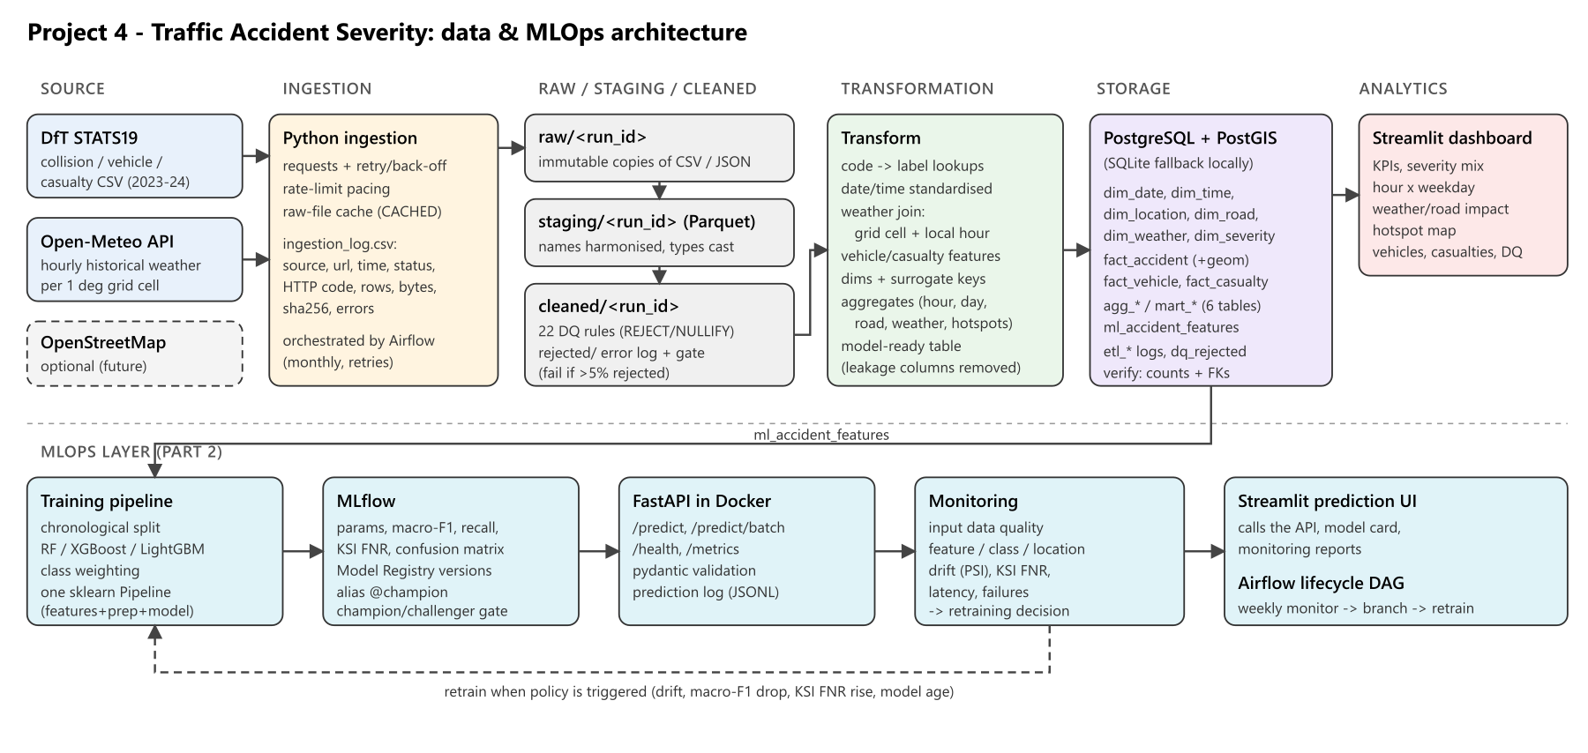
Figure 4.1: Part 1 data pipeline architecture
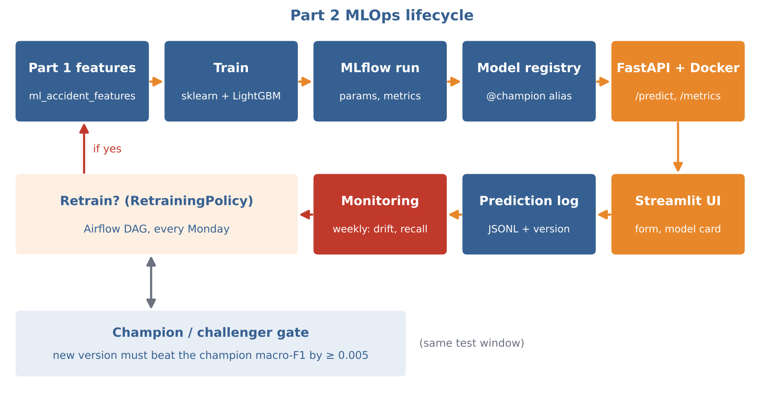
Figure 4.2: Part 2 MLOps lifecycle (train, register, serve, monitor, retrain)

4.2 Architecture Components
Table 4.1: Pipeline layers
Layer | Implementation | Output
Source | DfT CSV files, Open-Meteo REST API | –
Ingestion | Python requests with retry/back-off, rate-limit pacing, checksums; orchestrated by Airflow | data/raw/<source>/<run_id>/, ingestion_log.csv
Raw | immutable copy of each file / API response | CSV, JSON
Staging | column harmonisation, type casting, lineage column | Parquet
Cleaned | 22 data-quality rules, rejected-record log, quality gate | Parquet, rejected_records.csv
Transformation | lookups, date/time standardisation, weather join, vehicle/casualty features, dimensions, aggregates | Parquet (analytics/<run_id>)
Storage | PostgreSQL 16 + PostGIS 3 (SQLite fallback for laptops) | 6 dims, 3 facts, 6 mart tables, ML table, 3 audit tables
Analytics | Streamlit dashboard | 6 KPIs, 6 tabs
MLOps (Part 2) | consumes ml_accident_features | –

Part 2 consumes exactly one artefact from Part 1, the table ml_accident_features, read either from the latest analytics Parquet folder or straight from the warehouse through FEATURES_DATABASE_URL. Columns that are only known after the outcome (casualty severity counts, police attendance) are excluded upstream, so they cannot leak the target.
Design decisions. (1) Layered Parquet files plus a database: the files make every intermediate state inspectable, and the database holds only the analytical and audit layers. (2) Full refresh of the analytical tables: the warehouse is rebuilt from the cleaned layer on every run, so it always matches exactly one pipeline run and is never edited by hand. (3) Raw-file cache for cheap refreshes. (4) A single schema definition (warehouse_schema.py) that generates both the PostgreSQL DDL and the data dictionary, so documentation and database cannot drift apart.

4.3 Technology Stack
Table 4.2: Technology stack
Category | Tools | Used for
Language and data | Python, requests, pandas, Parquet | Ingestion, staging, transformation
Orchestration | Apache Airflow (also a traffic-pipeline CLI) | Monthly ETL DAG and weekly model-lifecycle DAG
Storage | PostgreSQL 16 + PostGIS 3 (SQLite fallback), SQLAlchemy | Star schema, marts, audit tables
Visualisation | Streamlit | Analytics dashboard and prediction UI
Modelling | scikit-learn, LightGBM | Inference pipeline and classifier
MLOps | MLflow (tracking, registry), FastAPI + pydantic, Docker Compose | Experiments, versions, serving, deployment
Quality | pytest | Rule, join, API and drift tests

5. DATA INGESTION AND ETL PIPELINE

5.1 Ingestion Workflow
Each run records, for every extraction, the date and time, source, file or API status, HTTP status, row count, size and checksum in ingestion_log.csv and the etl_ingestion_log table. A failed STATS19 download fails the task (collisions are mandatory) and Airflow retries it twice. A failed weather request is logged as FAILED and the run continues, so affected collisions keep weather_matched = false and still have the police-recorded weather fields. A quota problem therefore degrades the enrichment instead of stopping the warehouse refresh.
Challenge: weather API rate limits
Open-Meteo’s free tier weights a request by locations × days ÷ 14. The first design used a 0.5° grid (192 cells), which would have needed about 10,000 weighted calls, exceeded the per-minute limit and received HTTP 429 (Too Many Requests) responses. The design was changed to a coarser 1° grid (59 cells, about 3,000 weighted calls for two years); the weight of every request is computed and calls are paced to stay under 500 per minute; and the pipeline waits at least 65 seconds after any 429. The verified run fetched 117 cell-year responses with 0 failures in 430 seconds.

5.2 Data Cleaning
Twenty-two rules (Appendix D) cover keys, duplicates, dates, times, the severity domain, missing or out-of-UK coordinates, vehicle and casualty counts, valid UK speed limits, orphaned child records, ages and weather plausibility. Each rule either rejects the row (REJECT) or sets the implausible value to NULL while keeping the row (NULLIFY). Every hit is written to rejected_records.csv and to the dq_rejected_records table with the record key, rule, field, offending value and source file. Staging also parses dates (dd/mm/yyyy) and times (HH:MM), converts blank, NULL or −1 codes to nulls, and casts codes to nullable integers; unparseable values become null so that validation can reject them with a reason.
A quality gate fails the run if more than 5% of collisions are rejected. On the real data 12 collisions without coordinates (DQ007) and the 34 vehicles and casualties attached to them (DQ101, DQ201) were rejected: 46 records out of 1.87 million, a collision reject rate of 0.006%. No duplicates, invalid dates or out-of-range values were found. The DfT data are well curated, so the rules mainly protect future refreshes.

5.3 Transformation
- Standardisation: collision date-time, hour, weekday, month, season and time band; more than 20 coded fields mapped to labels through lookups (an unknown code becomes “Unknown (code N)” instead of an error); police force mapped to nation.
- Weather join: on (weather_cell_id, collision time floored to the hour) with merge(validate=“many_to_one”), so a weather hour can never duplicate a collision. The match rate is 100%. Measured values are also banded (temperature, precipitation, wind).
- Vehicle and casualty features: per collision, whether a pedal cycle, motorcycle, car, bus or goods vehicle was involved; mean and youngest driver age; pedestrian, child, fatal and serious casualty counts.
- Dimensions and facts: dim_date, dim_time, dim_location, dim_road, dim_weather and dim_severity with deterministic surrogate keys; fact_accident, fact_vehicle and fact_casualty.
- Analytical features: collision counts, KSI rates, hour × weekday volumes, hotspot grid counts and the 44-column model-ready table.

5.4 Orchestration
The DAG traffic_accident_etl_dag.py defines ten tasks that run in sequence. It is scheduled at 02:00 on the 1st of each month with catchup=False and max_active_runs=1. Tasks are retried twice; the weather task is retried three times with 30-minute delays because of API quotas. Every task receives the same run_id and exchanges data through run-specific layer folders instead of XCom, so each task is idempotent and can be re-run alone. publish_run_log uses trigger_rule=ALL_DONE, so failed runs are also recorded in the warehouse. The same steps are available as traffic-pipeline run and traffic-pipeline step <name> for environments without Airflow.
Table 5.1: Airflow tasks in execution order
# | Task | Purpose
1 | extract_stats19 | Download six STATS19 files; log source, status, rows, size, SHA-256
2 | stage_stats19 | Harmonise column names, cast types, add lineage column
3 | extract_weather | Fetch hourly weather for 59 grid cells × 2 years with pacing and retry
4 | stage_weather | Stage weather responses as Parquet
5 | validate_and_clean | Apply 22 rules, write reject log, enforce the quality gate
6 | transform | Standardise, join weather, build features and dimensions
7 | build_marts | Build the accident mart and aggregate tables
8 | load_warehouse | Load 16 tables into PostgreSQL/PostGIS (SQLite fallback)
9 | verify_load | Reconcile row counts and referential integrity
10 | publish_run_log | Write the run summary to CSV and database (runs even after a failure)
[Insert Airflow graph-view screenshot of the DAG run here]

5.5 Error Handling and Logging
- Every download, step and rejected record is logged to CSV files and to the database tables etl_ingestion_log, etl_run_log and dq_rejected_records, and is visible on the dashboard.
- Retries and back-off for transient failures; the quality gate stops a run before a broken source file reaches the warehouse.
- The weather source is optional by design: a failure is logged and the run continues without measured weather for the affected cells.
- Recovery is by re-running: tasks are idempotent, raw files are cached, the raw layer is never modified and the analytical tables are rebuilt from the cleaned layer.
- Credentials come only from environment variables (.env, excluded from version control).

6. DATABASE DESIGN AND DATA QUALITY

6.1 Database / Star Schema
The warehouse is a star schema in PostgreSQL 16 with PostGIS 3. Tables are created from the SQLAlchemy metadata with primary keys, foreign keys, indexes and column comments (DDL in sql/schema_postgres.sql). On PostgreSQL the load step adds geometry(Point, 4326) columns with a GiST index to fact_accident and mart_location_hotspots, which enables radius and hotspot queries.
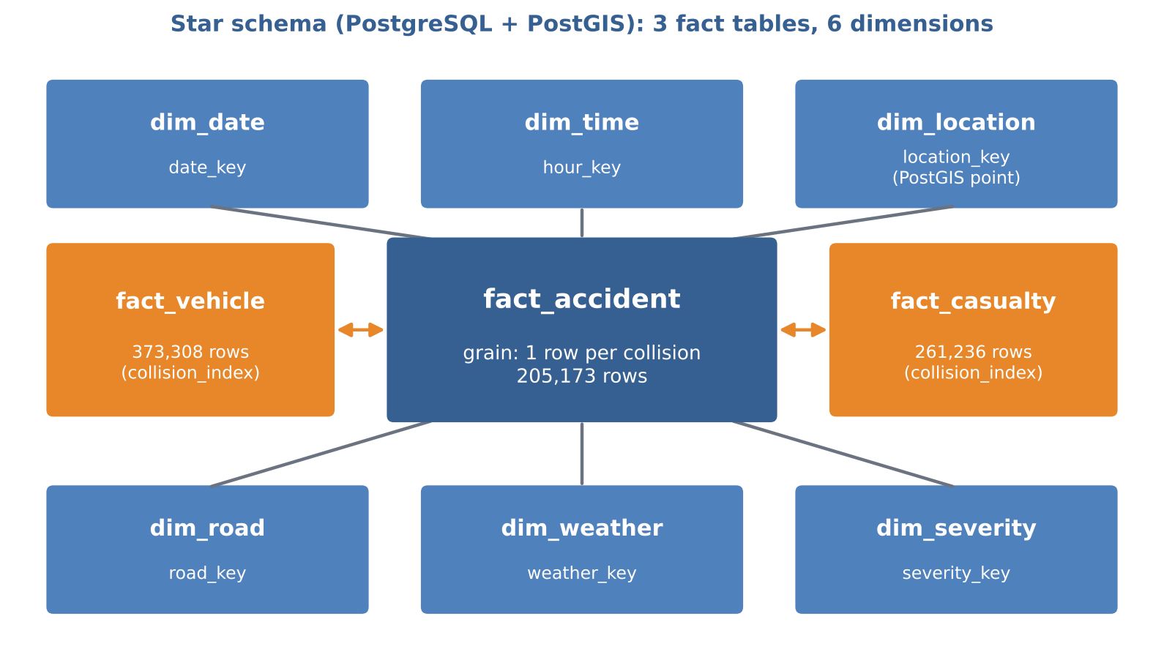
Figure 6.1: Star schema of the accident warehouse
Table 6.1: Fact and dimension tables
Table | Rows | Description
fact_accident | 205,173 | One row per collision: foreign keys to all six dimensions, coordinates, vehicle/casualty counts, driver ages and measured weather
fact_vehicle | 373,308 | One row per vehicle in a collision
fact_casualty | 261,236 | One row per casualty in a collision
dim_date | 731 | Continuous calendar with year, quarter, month, weekday, weekend flag and season
dim_time | 24 | Hour of day with time band (night, morning peak, daytime, evening peak, late evening)
dim_location | 1,071 | Police force, nation, local authority, urban/rural, weather cell
dim_road | 2,071 | Road class, road type, speed limit, junction detail and control
dim_weather | 2,743 | Police-recorded weather and light plus banded measured weather
dim_severity | 3 | Fatal, Serious, Slight

6.2 Raw, Staging, Cleaned and Analytical Layers
- Raw: immutable copy of each downloaded file or API response (CSV, JSON) with checksums; never modified.
- Staging: harmonised column names, cast types and a lineage column (_source_file); Parquet.
- Cleaned: rows that passed the 22 rules, plus the rejected-record log; Parquet.
- Analytics: weather join, standardised fields, features, dimensions, facts, accident mart and the model-ready table; Parquet, then loaded into the warehouse.

6.3 Data Quality Checks
The 22 row-level rules (Appendix D) are complemented by pipeline-level checks that protect the warehouse as a whole.
Table 6.2: Pipeline-level checks
Check | Where | Behaviour
Quality gate | validate_and_clean | The run fails if more than MAX_REJECT_RATE (default 5 %) of collisions are rejected, so a broken source file never reaches the warehouse.
Mandatory source | extract_stats19 | A failed STATS19 download fails the task, and Airflow retries it twice.
Optional source | extract_weather | A failed weather request is logged as FAILED and the run continues with weather_matched = false.
Weather join integrity | transform | merge(validate="many_to_one") guarantees that a weather hour can never duplicate a collision.
Load reconciliation | verify_load | Row counts in Parquet and the database must match for all 16 tables. Every fact_accident.date_key must exist in dim_date.
No manual edits | design | Analytical tables are dropped and rebuilt from the cleaned layer on every run. The raw layer is never modified.

Table 6.3: Rule hits in the verified run
Rule | Rows | Reason
DQ007 | 12 | Collision missing coordinates
DQ101 | 21 | Orphan vehicle (no matching cleaned collision)
DQ201 | 13 | Orphan casualty (no matching cleaned collision)

Duplicate, null, datatype and referential-integrity checks are covered as follows: duplicates by DQ002, DQ102 and DQ202; nulls and datatypes by DQ001, DQ003–DQ010 and staging casts; referential integrity by the orphan rules DQ101 and DQ201 and by verify_load, which also checks that every fact_accident.date_key exists in dim_date. Twelve pytest tests cover the rules, joins, banding, keys and calendar.

6.4 Analytical Data Mart
The accident mart answers the dashboard’s questions without scanning the fact tables, and the model-ready table feeds Part 2.
Table 6.4: Mart and model tables
Table | Rows | Content
agg_accidents_by_hour | 336 | Collisions and KSI by hour of day and weekday
agg_accidents_by_day | 731 | Daily collision counts and severity
agg_accidents_by_road | 331 | Road class, type and speed-limit summaries
agg_condition_impact | 57 | Long table covering 10 factors (light, weather, surface, speed limit and others)
mart_location_hotspots | 8,660 | 0.05° grid cells with counts and KSI rate
agg_vehicle_casualty | 73 | Vehicle category and road-user class against casualty severity
ml_accident_features | 205,173 | Model-ready table, 44 columns, leakage-free (input to Part 2)

7. DATA VISUALIZATION AND ANALYTICS

7.1 Dashboard Tool
Streamlit was chosen for the dashboard. It is free, written in Python like the rest of the pipeline, queries the star schema directly, and supports the interactive filters and the hotspot map needed for this analysis. The same Streamlit application also hosts the Part 2 prediction form, model card and monitoring view.

7.2 Dashboard Views
The dashboard (dashboard/app.py) has sidebar filters (year, nation, urban/rural, police force, severity), six KPIs (collisions, fatal, serious, KSI rate, casualties, weather match rate) and six tabs.
Table 7.1: Dashboard tabs
Tab | Content
Severity distribution | Bar chart and monthly stacked area
Time patterns | Hour × weekday heat map, KSI rate by hour, collisions by weekday
Weather and road conditions | Selectable factor showing volume and KSI rate; KSI rate by speed limit and area
Hotspot map | Adjustable grid and threshold, sized by volume and coloured by KSI rate
Vehicles and casualties | Casualties by vehicle category, KSI share by road-user class, age bands
Pipeline and data quality | Latest step log, ingestion log, rule hits and rejected records
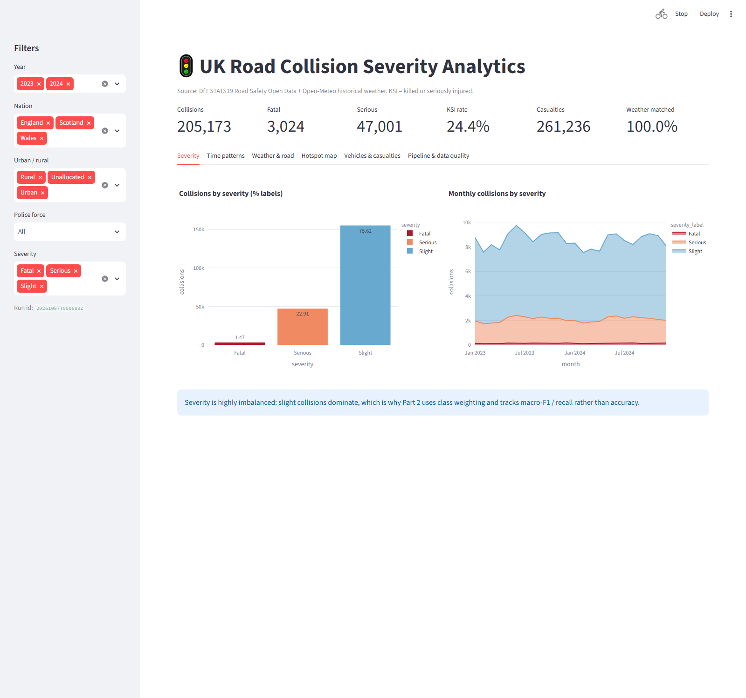
Figure 7.1: Streamlit dashboard – KPIs, filters and severity tab

7.3 Business Insights
Table 7.2: Key findings (2023–2024, 205,173 collisions)
Finding | Evidence
Severity is highly imbalanced | Slight 75.6 %, Serious 22.9 %, Fatal 1.5 % (KSI 24.4 %)
Volume peaks in the weekday evening rush | 15:00–17:59 is the busiest period (≈17–18k collisions per hour of day); Friday is the busiest day (33.6k), Sunday the quietest (23.1k)
Night collisions are fewer but more severe | KSI 30.5 % for 00–05 h (32.6 % at 02:00) vs 21.9 % in the morning peak
Darkness without street lighting is the riskiest light condition | KSI 34.5 % vs 23.3 % in daylight
Rural roads and 60 mph limits are the most severe | rural KSI 29.4 % vs urban 21.9 %; 60 mph KSI 34.3 % vs 19.7 % at 20 mph
Rain increases volume but not severity | measured heavy rain (>2 mm/h) KSI 22.5 % vs 24.6 % when dry, consistent with lower speeds in poor weather
Pedestrians are the most vulnerable road users | 31.3 % of pedestrian casualties are KSI vs 20.2 % of drivers/riders
Hotspots are concentrated in central London | the five busiest 5 km cells are all in the Metropolitan Police area (up to 2,256 collisions)

Interpretation for road safety. The conditions that make collisions severe (unlit, rural, high-speed roads at night) differ from those that make them frequent (urban rush hour). Interventions should therefore be prioritised differently for each, for example lighting and speed management on rural roads versus congestion and pedestrian measures in cities. This distinction also motivates the Part 2 severity model.

8. MLOPS PIPELINE EXTENSION

8.1 Target Definition
Instead of customer churn, the prediction target of this project is collision severity: Fatal, Serious or Slight, predicted from information known when the collision is reported. A collision counts as KSI when it is Fatal or Serious. The classes are highly imbalanced (Slight 75.6%, Serious 22.9%, Fatal 1.5%).
A model that always predicts “Slight” reaches 75.6% accuracy but never catches a fatal or serious collision, and its macro-F1 is only about 0.29. Accuracy is therefore not the target metric. The model is judged on macro-F1 (every class counts equally) and on KSI recall and the KSI false-negative rate (how many killed-or-seriously-injured collisions are caught or missed), because a missed severe collision is the costly error in road safety.

8.2 Feature Engineering
The model uses 35 input features, all known at reporting time:
- Time: hour, month, weekday.
- Location: police force, nation, urban or rural, latitude, longitude.
- Road: first road class, road type, speed limit, junction detail, junction control, special conditions at site, carriageway hazards.
- Police-recorded conditions: light, weather and road surface conditions.
- Measured weather (Open-Meteo): temperature, precipitation, snowfall, wind speed, wind gusts, cloud cover, humidity.
- Collision: number of vehicles and casualties, mean and youngest driver age.
- Road users involved: pedal cycle, motorcycle, car, bus, goods vehicle, pedestrian.
A custom transformer, AccidentFeatureEngineer, adds cyclical hour and month (sine/cosine), a weekend flag, darkness and darkness-unlit flags, wet-or-icy surface, measured rain (> 0.1 mm), freezing (≤ 0 °C), high-speed road (≥ 60 mph), at junction, single vehicle, young driver (< 25), vulnerable road user (pedal cycle, motorcycle or pedestrian), speed × vehicles and casualties per vehicle.
Chronological split. The data are split by time, not at random. A random split would put later months into training, so the model would learn seasonal patterns from the future and the test score would be too optimistic. A chronological split copies real use: learn from the past, predict the future.
Table 8.1: Train / validation / test split
Set | Period | Purpose
Train | Jan 2023 – Jun 2024 (18 months) | Fit the model
Validation | Jul – Sep 2024 | Check during development
Test | Oct – Dec 2024 | Final, unseen evaluation and champion comparison

8.3 Model Development
One scikit-learn Pipeline contains every step, so training and serving run exactly the same code and there is no training/serving skew: (1) AccidentFeatureEngineer; (2) a ColumnTransformer with median imputation for numeric features and one-hot encoding for categorical features, with an infrequent-category bucket so an unseen category in production never crashes the model; (3) an LGBMClassifier (gradient-boosted decision trees) with n_estimators=400, learning_rate=0.05, num_leaves=63, min_child_samples=50, subsample=0.8, colsample_bytree=0.8 and random_state=42. Training is deterministic through fixed seeds and environment-variable configuration, and a data fingerprint is stored as a run tag.
Class imbalance. Balanced per-sample class weights are used: each collision is weighted by n ÷ (number of classes × n in its class). The approximate weights are Slight ≈ 0.44, Serious ≈ 1.5 and Fatal ≈ 22, so missing one fatal collision costs the model about 50 times more than missing a slight one. Weighting was chosen over oversampling (SMOTE) because it adds no synthetic collisions. The deliberate trade-off is more severe predictions, including false alarms: accuracy goes down and recall on the severe classes goes up.
Only LightGBM is trained in the final pipeline; a tracked comparison with XGBoost and random forest is listed as future work.

8.4 Experiment Tracking and Model Registry
Table 8.2: What MLflow logs for every run
What | Logged
Parameters | Split dates, LightGBM hyper-parameters, class weighting
Metrics | Macro-F1, weighted-F1, balanced accuracy, accuracy, per-class recall/precision/F1, KSI recall and KSI false-negative rate (validation and test)
Artefacts | Confusion matrices and classification reports (validation and test), split summary, reference profile
Model | Full inference pipeline with signature and input example

Every training run creates a new version of the registered model traffic-severity-classifier. The @champion alias moves to a new version only when its test macro-F1 beats the current champion’s on the same test window by at least PROMOTION_MIN_DELTA (0.005); the decision is stored as the run tag promotion_decision. On promotion the model is exported to models/champion/ (model.joblib, metadata.json, reference_profile.json). The current champion is version 1 (MLflow run 6d73f5b2636f4c649a80f08f7716fa2f, trained 2026-10-07, decision “promoted (first model)”).
Rollback means moving the alias back to an older version and re-exporting or restarting the service. Versions are never deleted, so every past prediction can be traced to its model version through model_version in the prediction log.
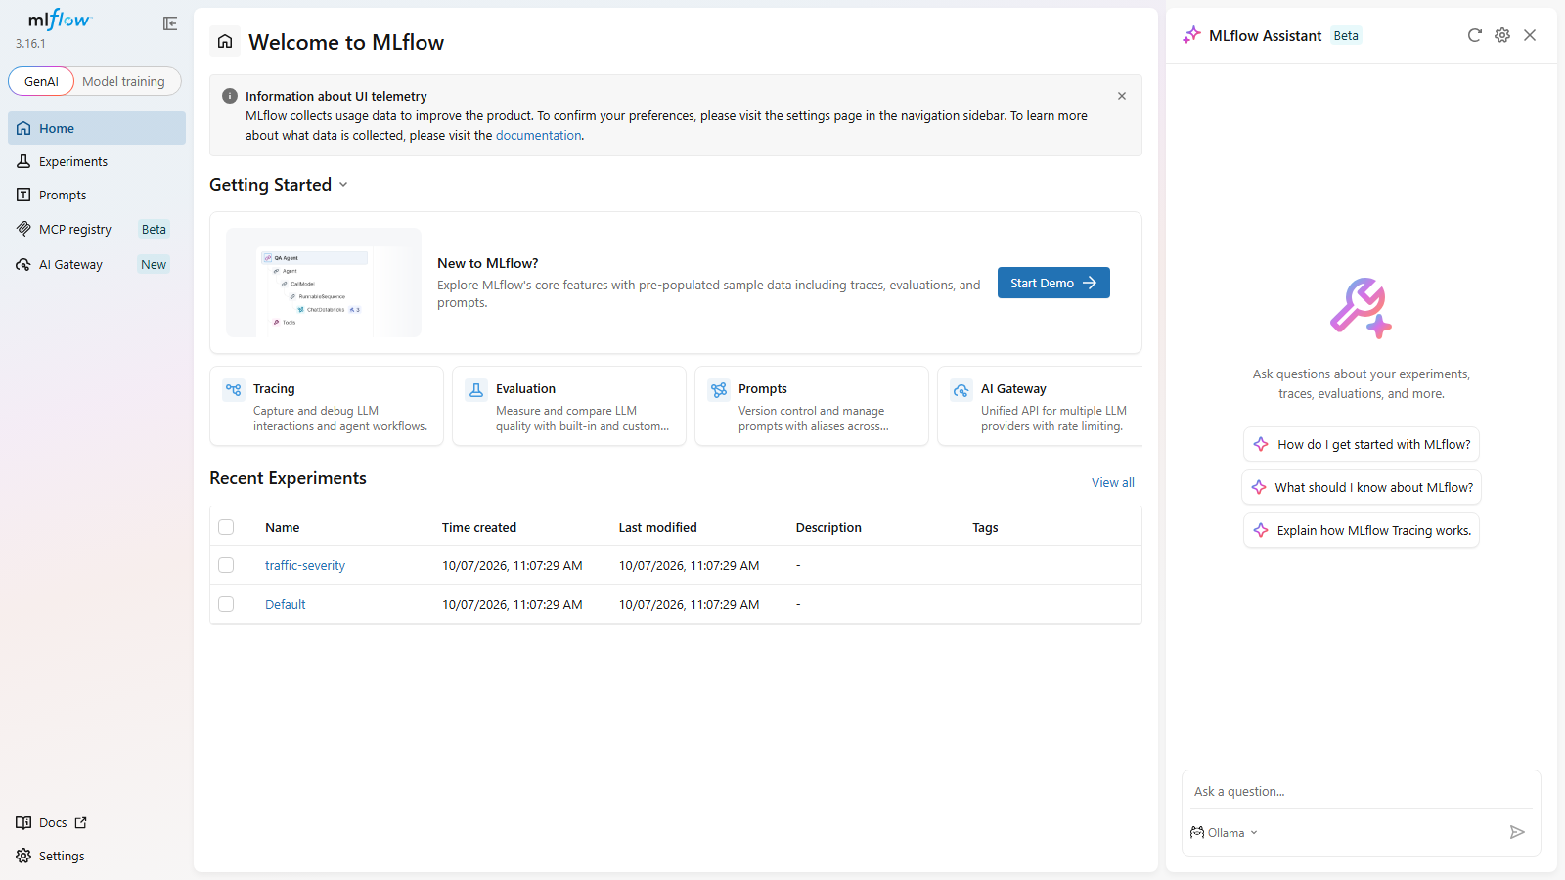
Figure 8.1: MLflow tracking UI

8.5 Deployment
The champion model is served by a FastAPI application and packaged with Docker. Input is validated with pydantic: an invalid payload returns HTTP 422 and is counted as a failure. Every request is logged to logs/predictions.jsonl with its model version, which feeds monitoring. models/champion/ is baked into the Docker image; setting MODEL_URI=models:/traffic-severity-classifier@champion loads the model straight from the registry instead. docker-compose.yml starts three services: the FastAPI service (port 8000), the MLflow server (port 5000) and the Streamlit UI (port 8502), which offers a prediction form that calls the API, a model card and a monitoring view.
Table 8.3: API endpoints
Endpoint | Purpose
POST /predict | One collision → predicted class, class probabilities, KSI probability, model version, latency
POST /predict/batch | Many collisions at once
GET /health | Service status and loaded model version
GET /model-info | Model name, version, run id, training/test windows, features, metrics
GET /metrics | Request count, error count, error rate, p50/p95/p99 latency, predicted class counts
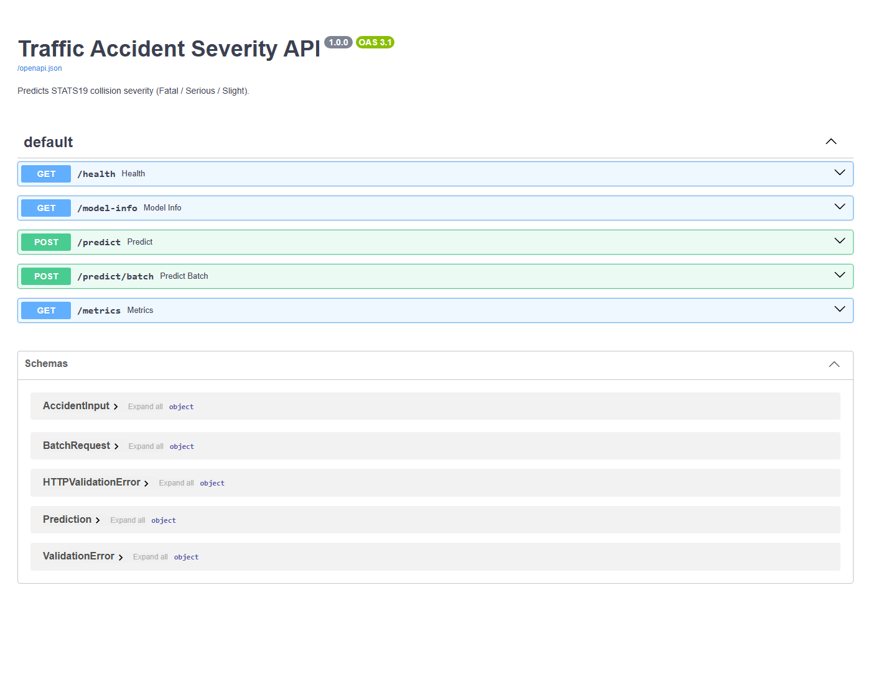
Figure 8.2: FastAPI Swagger UI
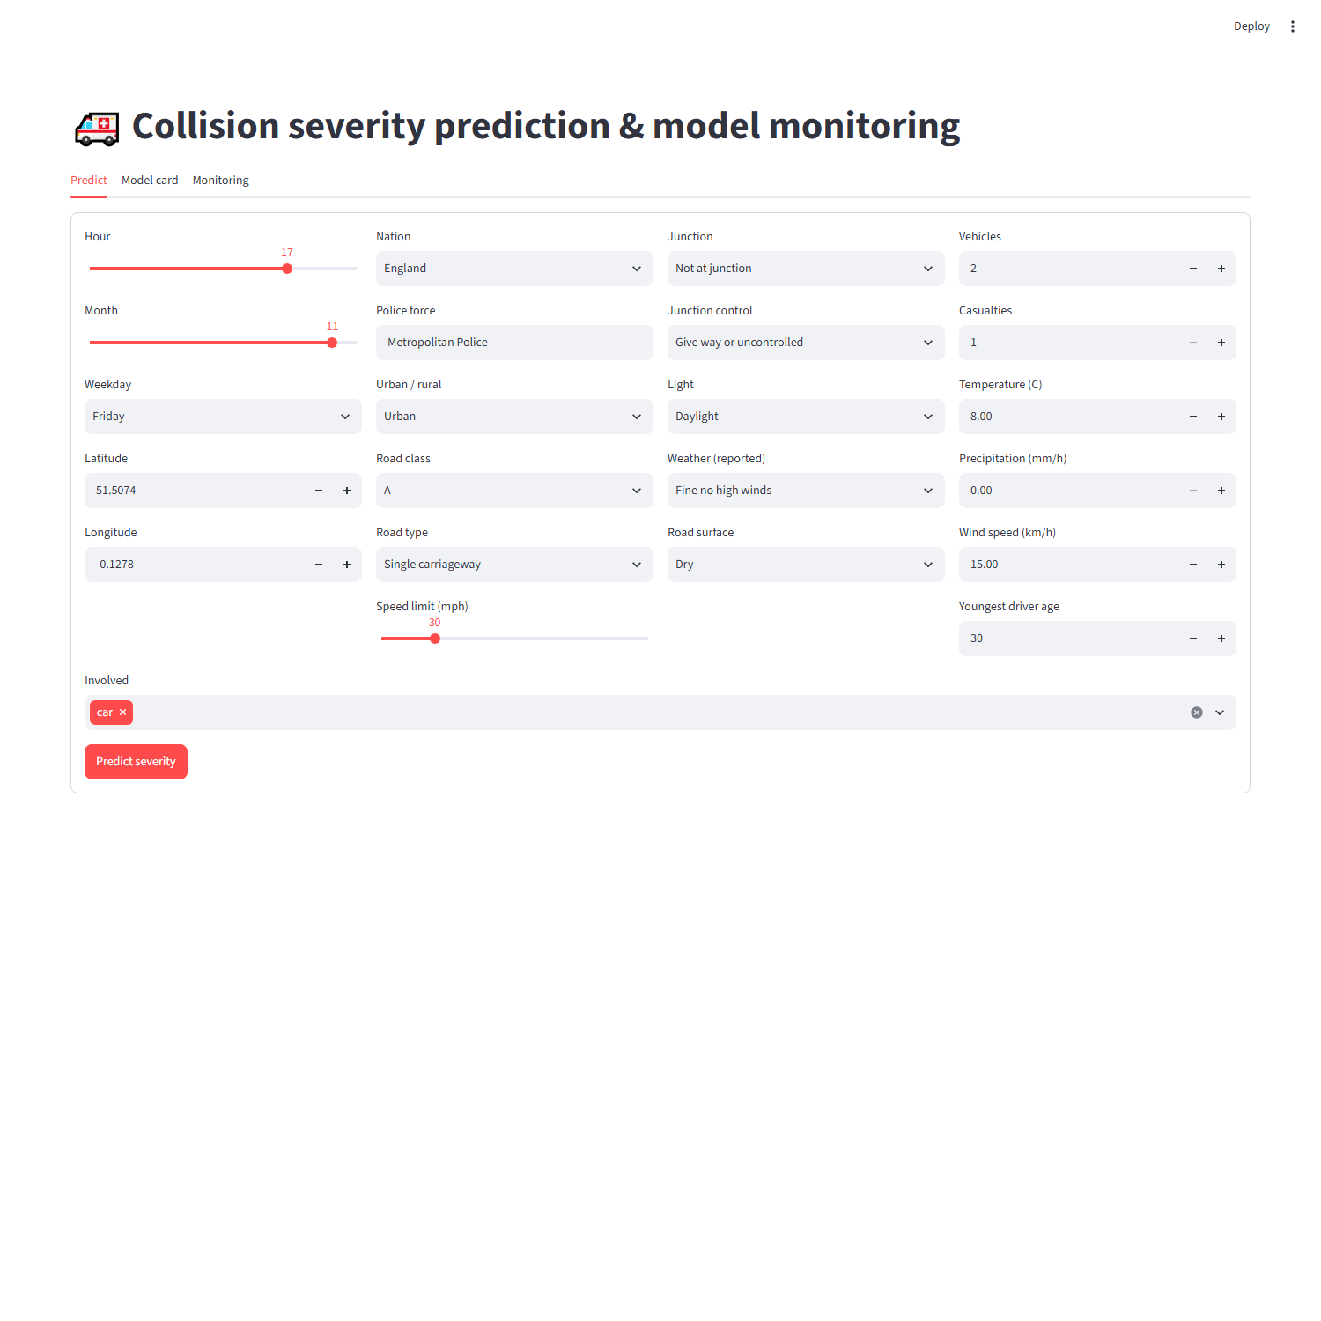
Figure 8.3: Streamlit prediction UI

8.6 Monitoring and Retraining
monitoring.py compares new data with the training reference profile and watches six signals.
Table 8.4: Monitoring signals
Signal | Method | Source
Input data quality | Missing-rate increase, out-of-range numerics, unseen categories | Labelled batch or API log
Feature drift | PSI per feature against the training reference profile | Both
Class drift | PSI of the predicted class mix, plus the actual class mix when labels exist | Both
Location drift | PSI of police-force and nation distributions, plus centroid shift in km | Both
Performance | Macro-F1, per-class recall, KSI false-negative rate against the champion’s baseline | Labelled batch
Latency / failures | p50/p95 latency and error rate (including invalid payloads) | API log and /metrics

PSI (Population Stability Index) = Σ (new % − reference %) × ln(new % ÷ reference %) over the bins. Below 0.1 is stable, 0.1–0.2 a moderate shift and above 0.2 a significant shift.
Retraining policy. Retraining is triggered when any one of these holds (RetrainingPolicy in config.py):
- More than 3 key features have PSI > 0.2.
- Class distribution PSI > 0.1.
- Location (police-force) PSI > 0.2.
- Macro-F1 has dropped by more than 0.05 from the champion baseline.
- The KSI false-negative rate has risen by more than 0.05 (absolute).
- The champion is older than 180 days (scheduled refresh).
These conditions only raise warnings and do not trigger retraining: an input missing-rate increase above 10 points, an API error rate above 2%, or p95 latency above 300 ms. They point to upstream or infrastructure faults, and retraining on broken data would make things worse.
The Airflow DAG severity_model_lifecycle runs every Monday: monitor → branch → retrain or skip. A retrained model goes through the same champion/challenger gate; python -m severity_model.retrain does the same by hand (--force for a scheduled refresh). A model version is retired when it is no longer the champion and a newer champion has been in service for one full monitoring cycle without being rolled back; versions are never deleted.

9. RESULTS AND DISCUSSION

9.1 Pipeline Execution Results
The verified end-to-end run has run_id 20261007T050603Z. All nine recorded steps finished with status SUCCESS: 839,763 STATS19 rows and 1,026,312 weather rows were ingested, 46 records were rejected (collision reject rate 0.006%), the weather match rate was 100%, and 1,061,721 rows were loaded in 51 seconds. verify_load confirmed row counts and referential integrity for all 16 tables. The run log recorded for this execution loaded the warehouse into the SQLite fallback; the same load code targets PostgreSQL/PostGIS when the docker compose stack is used.
Table 9.1: Pipeline run log (run 20261007T050603Z)
Step | Status | Duration (s) | Rows in | Rows out | Message
extract_stats19 | SUCCESS | 0.99 |  | 839763 | 6 STATS19 files extracted
stage_stats19 | SUCCESS | 18.18 | 839763 | 839763 | collisions=205185, vehicles=373329, casualties=261249
extract_weather | SUCCESS | 429.87 |  | 117 | weather cell-years fetched=117 cached=0 failed=0
stage_weather | SUCCESS | 6.13 | 117 | 1026312 | 117 weather files staged
validate_and_clean | SUCCESS | 10.64 | 1866075 | 1866029 | rejected=46 nullified=0 collision_reject_rate=0.006%
transform | SUCCESS | 12.97 | 205173 | 205173 | 10 tables built; weather match rate 100.0%
build_marts | SUCCESS | 5.85 | 205173 | 10188 | agg_accidents_by_hour=336, agg_accidents_by_day=731, agg_accidents_by_road=331, agg_condition_impact=57, mart_location_hotspots=8660, agg_vehicle_casualty=73
load_warehouse | SUCCESS | 51.03 | 1061721 | 1061721 | 16 tables loaded into sqlite
verify_load | SUCCESS | 0.61 |  | 16 | row counts and referential integrity verified

Table 9.2: STATS19 ingestion log
Dataset | Status | Rows | Bytes
collision_2023 | CACHED | 104258 | 19790001
vehicle_2023 | CACHED | 189815 | 20914478
casualty_2023 | CACHED | 132977 | 11012867
collision_2024 | CACHED | 100927 | 19208488
vehicle_2024 | CACHED | 183514 | 20296911
casualty_2024 | CACHED | 128272 | 10439101

Weather: 117 Open-Meteo cell-year responses, 1,026,312 hourly rows, 0 failures. The complete logs (console log, ingestion and run logs, quality_summary.json, rejected_records.csv) are kept in docs/execution_evidence/ of the Part 1 project.

9.2 Dashboard Results
The dashboard (Figure 7.1) confirms the findings of Table 7.2 on the full 205,173 collisions: severity is highly imbalanced (KSI 24.4%, fatal only 1.5%); the weekday evening rush (15:00–17:59) is the busiest period, Friday the busiest day (33.6k) and Sunday the quietest (23.1k); night collisions are fewer but more severe (KSI 30.5% for 00–05 h against 21.9% in the morning peak); darkness without street lighting has a KSI rate of 34.5% against 23.3% in daylight; rural roads (29.4%) and 60 mph limits (34.3%) are the most severe; heavy rain increases volume but not severity (22.5% against 24.6% when dry); pedestrians are the most vulnerable road users (31.3% KSI against 20.2% for drivers and riders); and the five busiest 5 km hotspot cells are all in the Metropolitan Police area of central London.

9.3 Model Results
All results are on the test period October–December 2024, which the model never saw during training.
Table 9.3: Overall test metrics
Metric | Value
Macro-F1 (always-‘Slight’ baseline ≈ 0.29) | 0.431
Weighted-F1 | 0.655
Balanced accuracy | 0.500
Accuracy (always-‘Slight’ baseline 0.756) | 0.621
KSI recall (Fatal + Serious caught) | 0.646
KSI false-negative rate | 0.354

Table 9.4: Per-class test metrics
Class | Precision | Recall | F1
Fatal | 0.094 | 0.298 | 0.143
Serious | 0.332 | 0.555 | 0.416
Slight | 0.853 | 0.647 | 0.736
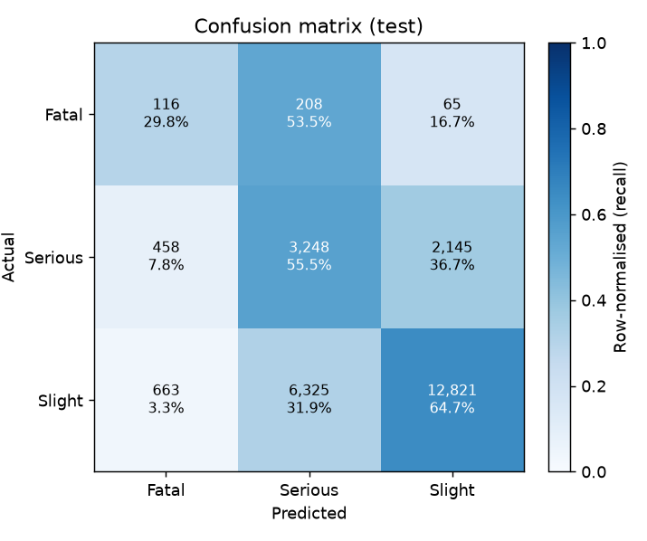
Figure 9.1: Confusion matrix on the test period
- Of 389 fatal collisions, 116 were predicted Fatal and 208 Serious: 324 (83%) were flagged as severe, and only 65 were predicted Slight.
- 3,248 of 5,851 serious collisions were caught (55.5% recall).
- 6,325 slight collisions were predicted Serious. These false alarms are the cost of class weighting and explain the low Fatal precision (about 9%).
- Accuracy (62.1%) is lower than the 75.6% of always predicting “Slight”. That is intentional: the class weights trade accuracy for catching serious and fatal collisions.
Monitoring results
Two monitoring runs show that the monitor stays quiet when nothing has changed and raises the alarm when the data really shift.
Table 9.5: Monitoring runs
Check | Labelled batch (Oct–Dec 2024) | Simulated drift (rural, night, wet)
Rows analysed | 26,342 | 9,361
Decision | No retraining needed | RETRAIN
Feature drift | Temperature only (warning; winter data) | 7 key features with PSI > 0.2: hour, temperature, precipitation, light conditions, urban/rural, road surface, speed limit
Predicted class mix | Fatal 4.7%, Serious 37.5%, Slight 57.8% (unchanged from reference) | Fatal 13.2%, Serious 48.7%, Slight 38.1% (prediction PSI 0.197)
Location drift | – | Police-force PSI 0.817, nation PSI 0.120, centroid shift 43.7 km
Performance | Macro-F1 0.431, stable | –
Warnings | Missing-rate increase on special conditions at site | Missing-rate increase on junction control and special conditions at site

9.4 Discussion
- What worked well: the layered, idempotent design made every run reproducible and inspectable; the quality gate and load verification caught nothing unexpected because the DfT data are well curated, which shows the rules act as safeguards for future refreshes; the single sklearn pipeline removed training/serving skew; and the champion/challenger gate and explicit retraining policy make the model lifecycle automatic and auditable.
- Challenges: the weather API rate limits forced a coarser grid, request weighting and pacing; STATS19 column names changed between releases (accident_* became collision_* in 2024), handled through aliases in staging; the DfT data-guide link was unavailable at build time, so code labels are kept in a lookup module; and the strong class imbalance required class weighting and metrics other than accuracy.
- Lessons learned: design optional sources so that they degrade rather than stop the pipeline; exclude post-outcome columns early to avoid target leakage; split time-ordered data chronologically; and make retraining decisions an explicit, tested policy rather than a judgement call.
- Testing: pytest covers the Part 1 rules, joins, banding, keys and calendar (12 tests), and the Part 2 feature engineering, chronological split, class weights, end-to-end pipeline inference (including unseen categories), metric definitions, PSI and drift detection, and the API (predict, batch, validation errors, metrics, prediction log).

10. CONCLUSION AND FUTURE SCOPE

10.1 Conclusion
The project delivers a complete path from raw public data to a monitored prediction service. Part 1 built an automated Airflow pipeline that combines two open sources into a validated, layered warehouse (PostgreSQL/PostGIS star schema, accident mart, 16 reconciled tables), an interactive dashboard and a leakage-free model-ready table, with a full audit trail and a quality gate. Its analysis shows that severe collisions are driven by darkness, rural high-speed roads and vulnerable road users, while frequent collisions are an urban rush-hour phenomenon.
Part 2 turned that table into a LightGBM severity classifier trained with class weights on a chronological split. On the unseen test period it catches 64.6% of fatal or serious collisions and flags 83% of fatal collisions as severe, with macro-F1 0.431 against about 0.29 for the trivial baseline. Around the model, MLflow tracking and registry with a champion gate, FastAPI in Docker with a Streamlit front end, weekly drift and performance monitoring and an explicit retraining policy form a closed lifecycle. All the stated objectives were therefore achieved.

10.2 Limitations
- The 1° weather grid gives regional rather than street-level weather; a 0.5° grid is supported but needs about three times more API quota or a paid tier.
- STATS19 only covers injury collisions reported to the police, and some severity misclassification is known (the DfT adjusted severity is not used).
- There is no traffic-volume exposure data, so rates are shares of collisions that are severe, not risk per vehicle-km.
- Severity also depends on factors that are not recorded at report time (speed at impact, seatbelt use), which caps achievable performance.
- Probabilities are not calibrated, and Fatal precision is low (about 9%), so there are many false alarms.
- Only LightGBM is trained in the final pipeline, and the analytical tables are fully refreshed rather than loaded incrementally.

10.3 Future Scope
- Probability calibration and threshold tuning for a target KSI recall.
- OpenStreetMap road context (lighting, lanes) as extra features and for the dashboard.
- A tracked comparison with XGBoost and random forest models.
- Incremental loads instead of full refresh, and formal data contracts (Great Expectations-style).
- A finer weather grid with a paid API tier, and canary deployment of new champions.

REFERENCES
- Department for Transport (2025). Road Safety Data. data.gov.uk. Open Government Licence v3.0. https://www.data.gov.uk/dataset/cb7ae6f0-4be6-4935-9277-47e5ce24a11f/road-safety-data
- Zippenfenig, P. (2023). Open-Meteo.com Weather API. Zenodo. CC BY 4.0. https://open-meteo.com
- Hersbach, H. et al. (2020). The ERA5 global reanalysis. Quarterly Journal of the Royal Meteorological Society, 146(730).
- Ke, G. et al. (2017). LightGBM: A highly efficient gradient boosting decision tree. Advances in Neural Information Processing Systems 30.
- Pedregosa, F. et al. (2011). Scikit-learn: Machine learning in Python. Journal of Machine Learning Research, 12, 2825–2830.
- MLflow documentation: Tracking and Model Registry. https://mlflow.org/docs/latest/
- FastAPI documentation. https://fastapi.tiangolo.com
- Apache Airflow documentation. https://airflow.apache.org/docs/
- PostgreSQL and PostGIS documentation. https://www.postgresql.org/docs/ and https://postgis.net/documentation/
- Streamlit documentation. https://docs.streamlit.io
- Docker and Docker Compose documentation. https://docs.docker.com

APPENDICES
Appendix A – Source Code / Repository Details
Appendix B – Airflow DAG / ETL Workflow
Appendix C – Database Schema and Sample Tables
Appendix D – Data Dictionary and Validation Rules
Appendix E – Dashboard Views
Appendix F – MLflow / Deployment / Monitoring Evidence

APPENDIX A – SOURCE CODE / REPOSITORY DETAILS
The project is delivered as two parts, each with its own README.md. The main components are listed below.
Table A.1: Main source files
Path | Purpose
src/traffic_pipeline/ | Part 1 package: ingestion, staging, quality.py (RULES registry), lookups.py, transformation, marts, warehouse_schema.py
dags/traffic_accident_etl_dag.py | Airflow DAG with the ten ETL tasks
sql/schema_postgres.sql | PostgreSQL DDL generated from the SQLAlchemy metadata
dashboard/app.py | Streamlit dashboard (and Part 2 prediction/monitoring pages)
src/severity_model/train.py, features.py, data.py, evaluate.py | Part 2 training, inference pipeline, chronological split and metrics
src/severity_model/api.py | FastAPI service
src/severity_model/monitoring.py, config.py (RetrainingPolicy), retrain.py | Drift monitoring, retraining policy and retraining entry point
dags/severity_model_lifecycle_dag.py | Weekly monitor → branch → retrain-or-skip DAG
Dockerfile, docker-compose.yml | Container image and the three-service stack
docs/execution_evidence/ | Logs and reports from the verified runs

Reproducing Part 1. Run traffic-pipeline run (local, SQLite), or docker compose up (PostGIS + Airflow + dashboard). The data can also be extracted manually, for example:
curl -O https://data.dft.gov.uk/road-accidents-safety-data/dft-road-casualty-statistics-collision-2024.csv
curl "https://archive-api.open-meteo.com/v1/archive?latitude=51.5&longitude=-0.1&start_date=2024-01-01&end_date=2024-01-02&hourly=temperature_2m,precipitation&timezone=Europe%2FLondon"
Reproducing Part 2.
- Run Part 1 so that ml_accident_features.parquet exists (or set FEATURES_DATABASE_URL).
- pip install -r requirements.txt and pip install -e .
- python -m severity_model.train – train, track, register and promote.
- mlflow ui --backend-store-uri sqlite:///mlflow.db --port 5000 – browse experiments.
- uvicorn severity_model.api:app --port 8000, or docker compose up -d --build – serve.
- python -m severity_model.monitoring (add --prediction-log logs/predictions.jsonl or --simulate-drift) – monitor.
- python -m severity_model.retrain – retrain only if the policy says so.

APPENDIX B – AIRFLOW DAG / ETL WORKFLOW
The monthly ETL DAG traffic_accident_etl_dag runs the tasks of Table 5.1 in this order:
extract_stats19 → stage_stats19 → extract_weather → stage_weather → validate_and_clean → transform → build_marts → load_warehouse → verify_load → publish_run_log
Table B.1: DAG settings
Setting | Value
Schedule | 02:00 on the 1st of each month; catchup=False; max_active_runs=1
Retries | 2 per task; the weather task 3, with 30-minute delays (API quota)
run_id | Shared by all tasks ({{ ts_nodash }}Z); data are exchanged through run-specific layer folders, not XCom
Idempotency | Any task can be re-run alone; analytical tables are rebuilt from the cleaned layer
publish_run_log | trigger_rule=ALL_DONE, so failed runs are also recorded
Without Airflow | traffic-pipeline run / traffic-pipeline step <name>

The Part 2 DAG severity_model_lifecycle runs every Monday: monitor → branch → retrain or skip, followed by the champion/challenger gate for a retrained model.

APPENDIX C – DATABASE SCHEMA AND SAMPLE TABLES
Table C.1: Warehouse row counts (run 20261007T050603Z)
Table | Rows
agg_accidents_by_day | 731
agg_accidents_by_hour | 336
agg_accidents_by_road | 331
agg_condition_impact | 57
agg_vehicle_casualty | 73
dim_date | 731
dim_location | 1,071
dim_road | 2,071
dim_severity | 3
dim_time | 24
dim_weather | 2,743
dq_rejected_records | 46
etl_ingestion_log | 130
etl_run_log | 18
fact_accident | 205,173
fact_casualty | 261,236
fact_vehicle | 373,308
mart_location_hotspots | 8,660
ml_accident_features | 205,173

Table C.2: fact_accident columns
Column | Type | Key | Description
collision_index | VARCHAR(20) | PK | DfT unique collision id
date_key | INTEGER | FK → dim_date.date_key | FK dim_date
hour_key | INTEGER | FK → dim_time.hour_key | FK dim_time
location_key | INTEGER | FK → dim_location.location_key | FK dim_location
road_key | INTEGER | FK → dim_road.road_key | FK dim_road
weather_key | INTEGER | FK → dim_weather.weather_key | FK dim_weather
severity_key | INTEGER | FK → dim_severity.severity_key | FK dim_severity
collision_datetime | TIMESTAMP WITHOUT TIME ZONE |  | Local date and time of the collision
latitude | FLOAT |  | WGS84 latitude
longitude | FLOAT |  | WGS84 longitude
lsoa_code | VARCHAR(12) |  | Lower Super Output Area of the collision
number_of_vehicles | INTEGER |  | Vehicles involved
number_of_casualties | INTEGER |  | Casualties
n_pedestrian_casualties | INTEGER |  | Pedestrian casualties
n_fatal_casualties | INTEGER |  | Fatal casualties
n_serious_casualties | INTEGER |  | Seriously injured casualties
n_child_casualties | INTEGER |  | Casualties aged under 16
involves_pedal_cycle | BOOLEAN |  | At least one pedal cycle involved
involves_motorcycle | BOOLEAN |  | At least one motorcycle involved
involves_car | BOOLEAN |  | At least one car/taxi involved
involves_bus | BOOLEAN |  | At least one bus/minibus involved
involves_goods_vehicle | BOOLEAN |  | At least one goods vehicle involved
mean_driver_age | FLOAT |  | Mean age of drivers (known ages only)
youngest_driver_age | FLOAT |  | Youngest driver age
weather_matched | BOOLEAN |  | True when an Open-Meteo reading was joined
temperature_c | FLOAT |  | Air temperature at 2 m (C), Open-Meteo
precipitation_mm | FLOAT |  | Precipitation in the hour (mm), Open-Meteo
rain_mm | FLOAT |  | Rain in the hour (mm), Open-Meteo
snowfall_cm | FLOAT |  | Snowfall in the hour (cm), Open-Meteo
wind_speed_kmh | FLOAT |  | Wind speed at 10 m (km/h), Open-Meteo
wind_gusts_kmh | FLOAT |  | Wind gusts at 10 m (km/h), Open-Meteo
cloud_cover_pct | FLOAT |  | Cloud cover (%), Open-Meteo
humidity_pct | FLOAT |  | Relative humidity at 2 m (%), Open-Meteo
wmo_weather_code | FLOAT |  | WMO weather code, Open-Meteo
police_attended_label | VARCHAR(30) |  | Whether a police officer attended the scene

The remaining dimension, fact and mart tables are documented in the data dictionary generated from warehouse_schema.py (docs/data_dictionary).

APPENDIX D – DATA DICTIONARY AND VALIDATION RULES
Rules are implemented in the RULES registry of quality.py and run in the validate_and_clean step. REJECT removes the row from the cleaned layer; NULLIFY keeps the row but sets the implausible value to NULL.
Table D.1: Validation rules
Rule | Table | Action | Check
DQ001 | collisions | REJECT | collision_index is missing
DQ002 | collisions | REJECT | duplicate collision_index (the first occurrence is kept)
DQ003 | collisions | REJECT | date is missing or not dd/mm/yyyy
DQ004 | collisions | REJECT | date is outside the configured extraction years
DQ005 | collisions | REJECT | time is missing or not HH:MM
DQ006 | collisions | REJECT | severity is not 1/2/3
DQ007 | collisions | REJECT | latitude or longitude is missing
DQ008 | collisions | REJECT | coordinates are outside the UK bounding box (lat 49.8–61.0, lon −8.7–1.9)
DQ009 | collisions | REJECT | number_of_vehicles is missing or < 1
DQ010 | collisions | REJECT | number_of_casualties is missing or < 1
DQ011 | collisions | NULLIFY | speed_limit is not a valid UK limit (15, 20, 30, 40, 50, 60, 70); −1 is treated as missing
DQ101 | vehicles | REJECT | orphan: no matching cleaned collision
DQ102 | vehicles | REJECT | duplicate (collision_index, vehicle_reference)
DQ103 | vehicles | NULLIFY | age_of_driver is outside 0–110; −1 is treated as missing and not logged
DQ201 | casualties | REJECT | orphan: no matching cleaned collision
DQ202 | casualties | REJECT | duplicate (collision_index, casualty_reference)
DQ203 | casualties | REJECT | casualty_severity is not 1/2/3
DQ204 | casualties | NULLIFY | age_of_casualty is outside 0–110
DQ301 | weather | NULLIFY | temperature is outside −35..45 °C
DQ302 | weather | NULLIFY | precipitation is outside 0..150 mm/h
DQ303 | weather | NULLIFY | wind speed is outside 0..250 km/h
DQ304 | weather | NULLIFY | relative humidity is outside 0..100 %

Table D.2: ml_accident_features (model-ready table, input to Part 2)
Column | Type | Description
collision_index | VARCHAR(20) | DfT unique collision id
collision_datetime | TIMESTAMP WITHOUT TIME ZONE | Local date/time (used for the chronological split)
year | INTEGER | Year
month | INTEGER | Month
weekday | VARCHAR(10) | Weekday name
hour | INTEGER | Hour 0-23
latitude | FLOAT | Latitude
longitude | FLOAT | Longitude
weather_cell_id | VARCHAR(16) | Weather grid cell
police_force | VARCHAR(40) | Police force name
nation | VARCHAR(10) | Nation
local_authority_ons_district | VARCHAR(12) | ONS district code
urban_or_rural | VARCHAR(20) | Urban/rural
first_road_class | VARCHAR(20) | Road class
road_type | VARCHAR(40) | Road type
speed_limit | FLOAT | Speed limit (mph)
junction_detail | VARCHAR(40) | Junction type
junction_control | VARCHAR(40) | Junction control
light_conditions | VARCHAR(40) | Light conditions
weather_conditions | VARCHAR(40) | Police-recorded weather
road_surface_conditions | VARCHAR(30) | Road surface
special_conditions_at_site | VARCHAR(40) | Special conditions
carriageway_hazards | VARCHAR(40) | Carriageway hazards
number_of_vehicles | INTEGER | Vehicles involved
number_of_casualties | INTEGER | Casualties
temperature_c | FLOAT | Temperature (C)
precipitation_mm | FLOAT | Precipitation (mm/h)
snowfall_cm | FLOAT | Snowfall (cm/h)
wind_speed_kmh | FLOAT | Wind speed (km/h)
wind_gusts_kmh | FLOAT | Wind gusts (km/h)
cloud_cover_pct | FLOAT | Cloud cover (%)
humidity_pct | FLOAT | Relative humidity (%)
weather_matched | BOOLEAN | Measured weather available
involves_pedal_cycle | BOOLEAN | Pedal cycle involved
involves_motorcycle | BOOLEAN | Motorcycle involved
involves_car | BOOLEAN | Car involved
involves_bus | BOOLEAN | Bus involved
involves_goods_vehicle | BOOLEAN | Goods vehicle involved
pedestrian_involved | BOOLEAN | At least one pedestrian casualty
mean_driver_age | FLOAT | Mean driver age
youngest_driver_age | FLOAT | Youngest driver age
severity | INTEGER | TARGET: 1 Fatal, 2 Serious, 3 Slight
severity_label | VARCHAR(10) | TARGET label

APPENDIX E – DASHBOARD VIEWS
Figure 7.1 shows the KPIs, filters and the severity tab. The six tabs and the questions they answer are summarised below; all of them query the star schema and the accident mart.
Tab | Main tables queried | Question answered
Severity distribution | fact_accident, dim_severity, dim_date | How are collisions split by severity, and how does this change by month?
Time patterns | agg_accidents_by_hour, agg_accidents_by_day | When do collisions happen and when are they most severe?
Weather and road conditions | agg_condition_impact | Which conditions raise volume and which raise KSI rate?
Hotspot map | mart_location_hotspots | Where are the busiest and most severe areas?
Vehicles and casualties | agg_vehicle_casualty | Which road users and vehicles are most at risk?
Pipeline and data quality | etl_run_log, etl_ingestion_log, dq_rejected_records | What did the last run do and what was rejected?

APPENDIX F – MLFLOW / DEPLOYMENT / MONITORING EVIDENCE
Evidence of the Part 2 system (Figures 8.1–8.3 and Tables 9.3–9.5 in the main text), verified locally:
- MLflow: registered model traffic-severity-classifier, champion version 1, run 6d73f5b2636f4c649a80f08f7716fa2f, LightGBM with balanced class weights, trained 2026-10-07, decision “promoted (first model)”.
- GET /health returned {"status": "ok", "model_version": 1}.
- POST /predict for a rural, unlit, wet, 60 mph, single-motorcycle collision at 23:00 returned Serious, with probabilities Fatal 0.217 / Serious 0.542 / Slight 0.241 and KSI probability 0.759.
- POST /predict with {"hour": "late"} returned HTTP 422 and was counted as an error.
- GET /metrics after these checks reported requests, errors, error rate, latency percentiles and predicted class counts. The first request includes model loading time (cold start); warm requests answered in about 130 ms.
- Monitoring: the reports for the labelled batch and the simulated-drift run (Table 9.5) are stored in execution_evidence/.

