Traffic Accident Severity Analytics – Part 1 Report: Data Pipeline
Course: Data Engineering and MLOps Project: 4 – Traffic Accident Severity Analytics and Prediction
Student: Madhan Matthew S (USN 1CR23AI052, 7A AIML) Submission: Part 1 (data pipeline)
---

1. Problem understanding
Every year Great Britain records about 100,000 road collisions involving personal injury. About a quarter of them kill or seriously injure someone (KSI). Road-safety teams need to know when, where and under which conditions collisions become severe, so they can target enforcement, lighting, speed management and winter maintenance.
Police collision records already describe the road, the light and the weather as the officer saw it. They don't include measured weather (temperature, rain intensity, wind), and they are spread across three related files. The goal of Part 1 is a reproducible, automated pipeline that:
- ingests the public STATS19 collision, vehicle and casualty files and enriches every collision with hourly weather from the Open-Meteo archive
- validates, cleans and standardises the data, and keeps a full audit trail of what was extracted and rejected
- stores it in a location- and time-aware analytical warehouse (PostgreSQL/PostGIS star schema plus an accident mart)
- exposes the patterns through an interactive dashboard
- produces a leakage-free model-ready table for the Part 2 severity classifier
Scope: all police-reported injury collisions in Great Britain for 2023 and 2024 (205,185 collisions, 373,329 vehicles, 261,249 casualties).

2. Data sources
Source | Content | Access | Licence
DfT Road Safety Open Data (STATS19) | collision, vehicle and casualty CSVs per year | https://data.dft.gov.uk/road-accidents-safety-data/dft-road-casualty-statistics-<table>-<year>.csv | OGL v3.0
Open-Meteo Historical Weather API | hourly temperature, precipitation, rain, snowfall, wind speed/gusts, cloud cover, humidity, WMO code | https://archive-api.open-meteo.com/v1/archive (no key) | CC BY 4.0

OpenStreetMap was considered for road-context enrichment. STATS19 already provides road class, road type, speed limit and junction detail for every collision, so it was left as future work. docs/data_sources.md gives full access instructions and known limitations, such as the 2024 renaming of accident_* to collision_* columns.

3. Architecture and pipeline design
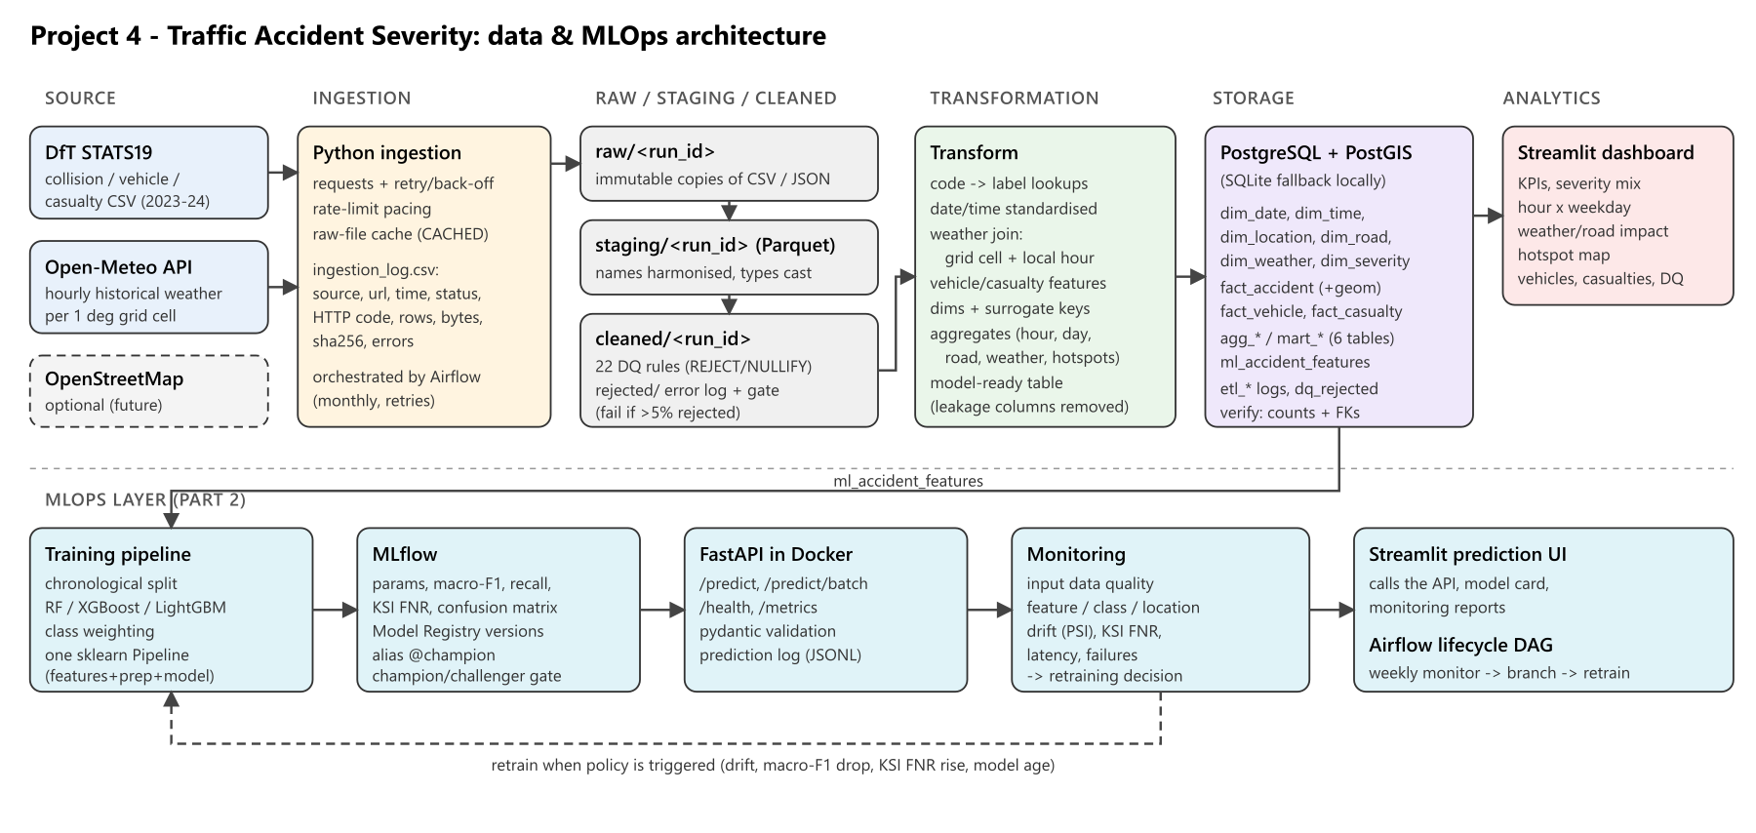
Figure: Pipeline architecture
Layer | Implementation | Output
Source | DfT CSV files, Open-Meteo REST API | –
Ingestion | Python requests with retry/back-off, rate-limit pacing, checksums; orchestrated by Airflow | data/raw/<source>/<run_id>/, ingestion_log.csv
Raw | immutable copy of each file / API response | CSV, JSON
Staging | column harmonisation, type casting, lineage column | Parquet
Cleaned | 22 data-quality rules, rejected-record log, quality gate | Parquet, rejected_records.csv
Transformation | lookups, date/time standardisation, weather join, vehicle/casualty features, dimensions, aggregates | Parquet (analytics/<run_id>)
Storage | PostgreSQL 16 + PostGIS 3 (SQLite fallback for laptops) | 6 dims, 3 facts, 6 mart tables, ML table, 3 audit tables
Analytics | Streamlit dashboard | 6 KPIs, 6 tabs
MLOps (Part 2) | consumes ml_accident_features | –

Orchestration. dags/traffic_accident_etl_dag.py defines ten tasks:
extract_stats19 → stage_stats19 → extract_weather → stage_weather → validate_and_clean → transform → build_marts → load_warehouse → verify_load → publish_run_log
It runs at 02:00 on the 1st of each month, with catchup=False and max_active_runs=1. Tasks are retried twice; the weather task is retried three times with 30-minute delays because of API quotas. Every task receives the same run_id ({{ ts_nodash }}Z) and exchanges data through the run-specific layer folders, not XCom. As a result each task is idempotent and can be re-run on its own. publish_run_log uses trigger_rule=ALL_DONE, so failed runs are also recorded in the warehouse. The same steps are exposed through traffic-pipeline run / traffic-pipeline step <name> for environments without Airflow.
Design decisions
- *Layered files plus a database.* Parquet layers make every intermediate state inspectable and reproducible. The database only holds the analytical and audit layers.
- *Full refresh of analytical tables.* The warehouse is rebuilt from the cleaned layer on every run, so it always matches the output of one pipeline run and is never edited by hand.
- *Raw-file cache.* Annual STATS19 files and weather cell-years that already exist from an earlier run are reused (logged as CACHED). This makes monthly refreshes cheap while still writing a raw copy for every run.
- *Single schema definition.* warehouse_schema.py (SQLAlchemy metadata with column comments) generates the PostgreSQL DDL and the data dictionary, so documentation and database cannot drift apart.

4. Data ingestion
STATS19. Six files (three tables × two years) are streamed to disk. Each extraction is logged with source, URL, UTC timestamp, status (SUCCESS, CACHED or FAILED), HTTP status, row count, byte size, SHA-256 and local path. A failed STATS19 download fails the task, because collisions are mandatory.
Weather. Every collision is snapped to a 1° grid cell, which gives 59 cells covering Great Britain. For every (cell, year), the API is asked for 8,760 hourly readings in Europe/London local time, which matches STATS19 times. Ten cells are batched per call.
Open-Meteo's free tier weights a request by locations × days/14. The first attempt used a 0.5° grid (192 cells), would have needed about 10,000 weighted calls, hit the per-minute limit, and received HTTP 429 responses. The pipeline handled them: it backed off and retried. The design was then changed to:
- a 1° grid, about 3,000 weighted calls for two years
- computing the weight of every request and sleeping long enough to stay under 500 calls per minute
- waiting at least 65 s after any 429
A weather request that still fails is logged as FAILED, and the pipeline continues. Those collisions keep weather_matched = false and still have the police-recorded weather fields. This failure path is part of the design, so a quota problem degrades the enrichment instead of stopping the warehouse refresh.
Verified run `20261007T050603Z`: 6 STATS19 files (839,763 rows, reused from the cache) and 117 weather cell-year responses (1,026,312 hourly rows, 0 failures, 430 s including pacing). See execution_evidence/ingestion_log_20261007T050603Z.csv.

5. ETL, validation and storage

5.1 Staging
- Column names are harmonised across releases (accident_index → collision_index, and so on), and only the needed columns are kept.
- Codes are cast to nullable integers, and blank, NULL or -1 strings become nulls.
- date (dd/mm/yyyy) and time (HH:MM) are parsed. Unparseable values become null, so validation can reject them with a reason.
- A _source_file lineage column is added.

5.2 Validation (cleaned layer)
Twenty-two rules (see validation_rules.md) cover keys, duplicates, dates, times, severity domain, missing or out-of-UK coordinates, vehicle and casualty counts, valid UK speed limits, orphaned child records, ages and weather plausibility. Each rule either rejects the row or nullifies the value. Every hit is written to rejected_records.csv and the dq_rejected_records table with the record key, rule, field, value and source file. A quality gate fails the run if more than 5 % of collisions are rejected.
Results on the real data: 12 collisions without coordinates (DQ007) and the 34 vehicles and casualties attached to them (DQ101/DQ201). That is 46 records in total, a collision reject rate of 0.006 %. No duplicates, invalid dates or out-of-range values were found. The DfT data is well curated, and the rules mainly act as safeguards for future refreshes.

5.3 Transformation
- Standardisation: collision datetime, hour, weekday, month, season and time band. Over 20 coded fields are mapped to labels through lookups.py; an unknown code becomes Unknown (code N) instead of an error. Police force is mapped to its nation.
- Weather join: on (weather_cell_id, collision time floored to the hour). It uses validate="many_to_one", so one weather hour can never duplicate a collision. Match rate: 100 %. Measured values are also banded (temperature, precipitation, wind).
- Vehicle and casualty features: per collision, whether a pedal cycle, motorcycle, car, bus or goods vehicle was involved; mean and youngest driver age; pedestrian, child, fatal and serious casualty counts.
- Dimensions: dim_date (continuous calendar), dim_time (24 hours), dim_location (police force, nation, local authority, urban/rural, weather cell), dim_road, dim_weather (police-recorded plus measured bands) and dim_severity. Keys are deterministic surrogate keys.
- Facts: fact_accident (one row per collision, with coordinates, measures and weather), fact_vehicle, fact_casualty.
- Accident mart: agg_accidents_by_hour, agg_accidents_by_day, agg_accidents_by_road, agg_condition_impact (a long table covering 10 factors), mart_location_hotspots (0.05° grid) and agg_vehicle_casualty.
- Model-ready table: ml_accident_features, 205,173 rows and 44 columns. It contains only information available when a collision is reported. Casualty-severity counts and police attendance are deliberately excluded to prevent target leakage in Part 2.

5.4 Storage
Tables are created from the SQLAlchemy metadata, with primary keys, foreign keys, indexes and column comments; the DDL is in sql/schema_postgres.sql. On PostgreSQL, the load step adds PostGIS geometry(Point, 4326) columns with a GiST index to fact_accident and mart_location_hotspots, which enables radius and hotspot queries. verify_load reconciles Parquet and database row counts for all 16 tables and checks referential integrity. The verified run loaded 1,061,721 rows in 51 s.

6. Visualisation and interpretation
The Streamlit dashboard (dashboard/app.py) queries the star schema. It has sidebar filters (year, nation, urban/rural, police force, severity), six KPIs (collisions, fatal, serious, KSI rate, casualties, weather match rate) and six tabs:
- Severity distribution: bar chart and monthly stacked area
- Time patterns: hour × weekday heat map, KSI rate by hour, collisions by weekday
- Weather and road conditions: selectable factor showing volume and KSI rate; KSI rate by speed limit and area
- Hotspot map: adjustable grid and threshold, sized by volume and coloured by KSI rate
- Vehicles and casualties: casualties by vehicle category, KSI share by road-user class, age bands
- Pipeline and data quality: latest step log, ingestion log, rule hits and rejected records
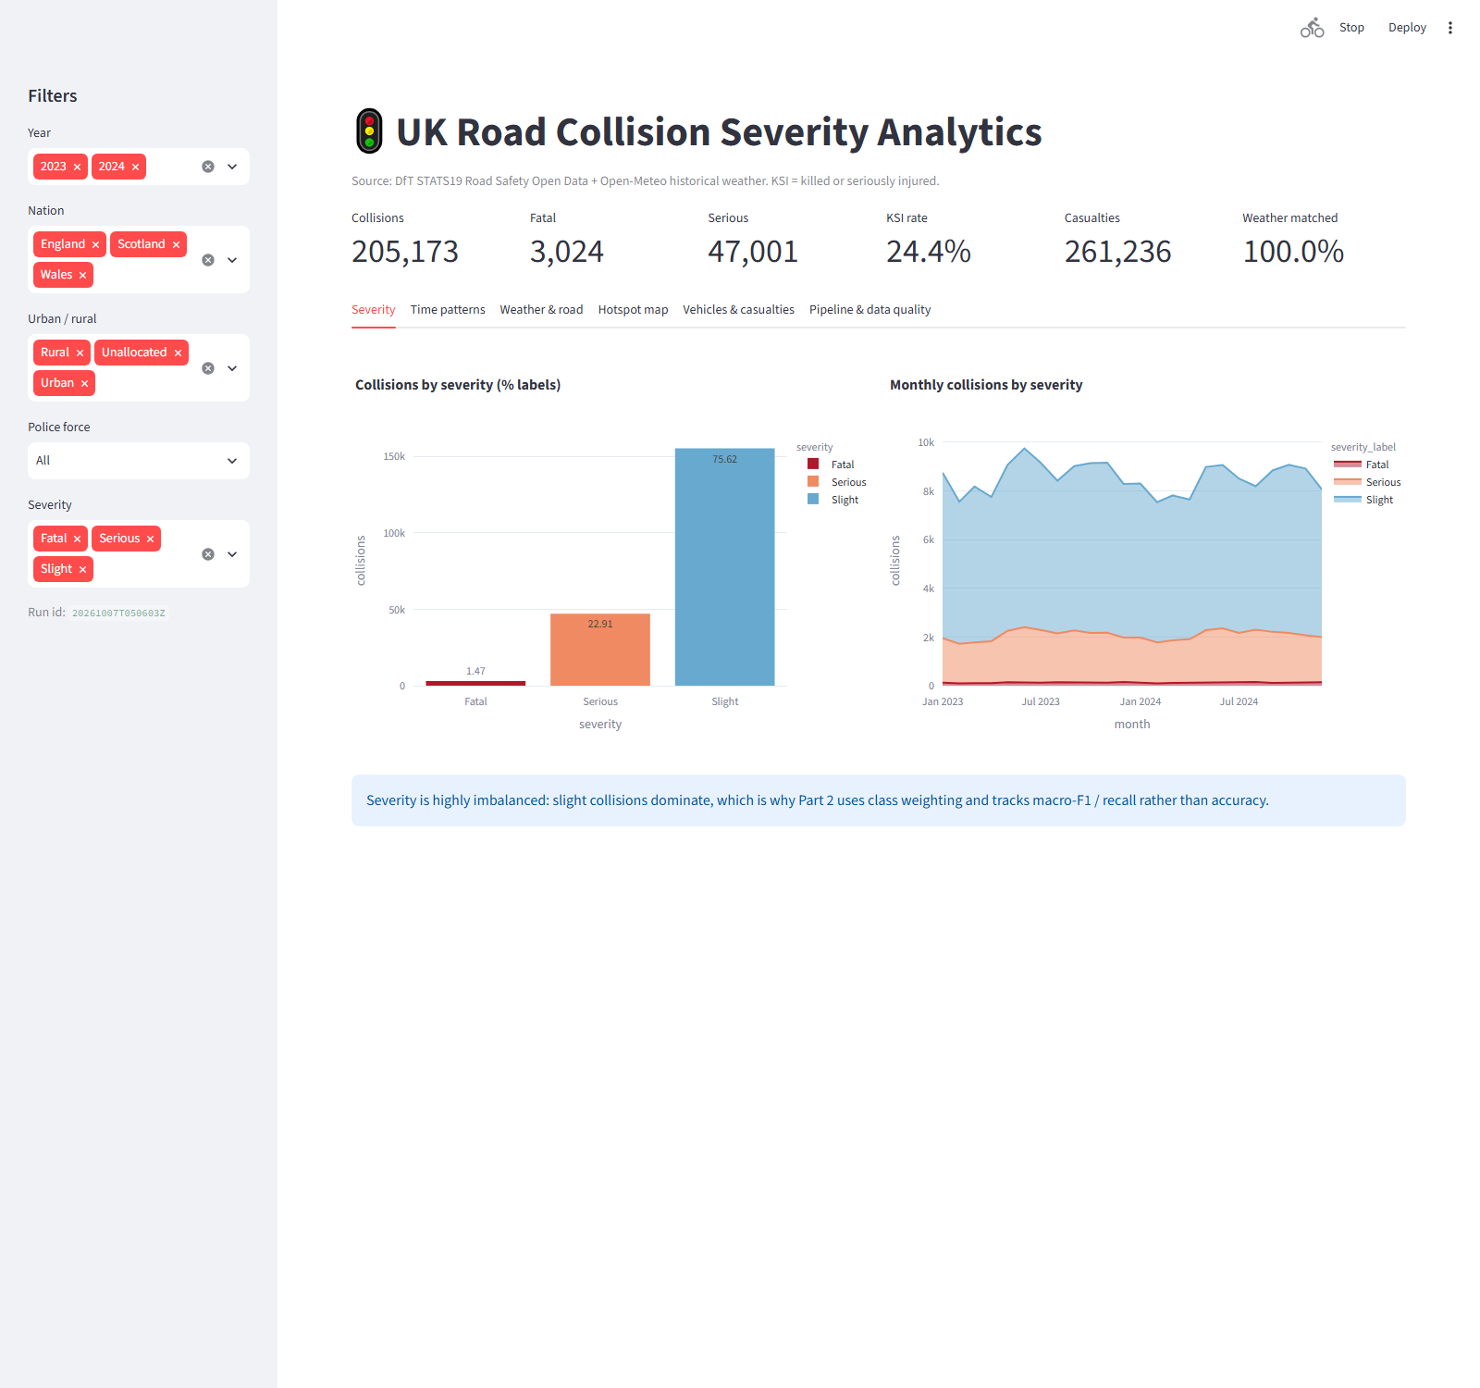
Figure: Streamlit dashboard – KPIs, filters and severity tab
Key findings (2023–2024, 205,173 collisions)
Finding | Evidence
Severity is highly imbalanced | Slight 75.6 %, Serious 22.9 %, Fatal 1.5 % (KSI 24.4 %)
Volume peaks in the weekday evening rush | 15:00–17:59 is the busiest period (≈17–18k collisions per hour of day); Friday is the busiest day (33.6k), Sunday the quietest (23.1k)
Night collisions are fewer but more severe | KSI 30.5 % for 00–05 h (32.6 % at 02:00) vs 21.9 % in the morning peak
Darkness without street lighting is the riskiest light condition | KSI 34.5 % vs 23.3 % in daylight
Rural roads and 60 mph limits are the most severe | rural KSI 29.4 % vs urban 21.9 %; 60 mph KSI 34.3 % vs 19.7 % at 20 mph
Rain increases volume but not severity | measured heavy rain (>2 mm/h) KSI 22.5 % vs 24.6 % when dry, consistent with lower speeds in poor weather
Pedestrians are the most vulnerable road users | 31.3 % of pedestrian casualties are KSI vs 20.2 % of drivers/riders
Hotspots are concentrated in central London | the five busiest 5 km cells are all in the Metropolitan Police area (up to 2,256 collisions)

Interpretation for road safety: the conditions that make collisions *severe* (unlit rural high-speed roads at night) are different from those that make them *frequent* (urban rush hour). Interventions should be prioritised differently for each, and this distinction motivates the Part 2 severity model.

7. Data quality and reliability
- Every extraction, step and rejection is logged as CSV and in database tables, and is visible on the dashboard.
- Analytical tables are rebuilt from code and are never edited by hand.
- Tests (pytest, 12 passing) cover the rules, joins, banding, keys and calendar.
- The quality gate, load verification, retries and cache make reruns safe.
- Credentials only come from environment variables (.env, git-ignored).

8. Limitations and future work
- The 1° weather grid gives regional rather than street-level weather. A 0.5° grid is supported but needs about 3× more API quota, or a paid tier.
- STATS19 only covers injury collisions that police recorded, and some severity misclassification is known (DfT publishes adjusted severity, which is not used here).
- No traffic-volume exposure data, so rates are "share of collisions that are severe", not risk per vehicle-km.
- Future work: OpenStreetMap road context (lighting, lanes), incremental loads instead of full refresh, and Great Expectations-style data contracts.

9. How to reproduce
See README.md: traffic-pipeline run (local, SQLite) or docker compose up (PostGIS + Airflow + dashboard). The evidence for the verified run is in docs/execution_evidence/.

References
- Department for Transport (2025). *Road Safety Data*. data.gov.uk, OGL v3.0.
- Zippenfenig, P. (2023). *Open-Meteo.com Weather API*. Zenodo. CC BY 4.0.
- Hersbach, H. et al. (2020). The ERA5 global reanalysis. *QJRMS* 146(730).

Appendix A – Dataset sources and access instructions
All sources are free, public and contain no personally identifiable information.
Source | What is used | Licence | Access
UK Department for Transport - Road Safety Open Data (STATS19) | Collision, vehicle and casualty tables for 2023 and 2024 (≈205k collisions, ≈373k vehicles, ≈261k casualties) | Open Government Licence v3.0 | Landing page: https://www.data.gov.uk/dataset/cb7ae6f0-4be6-4935-9277-47e5ce24a11f/road-safety-data · Direct files: https://data.dft.gov.uk/road-accidents-safety-data/dft-road-casualty-statistics-{collision|vehicle|casualty}-{YEAR}.csv
Open-Meteo Historical Weather API (ERA5-based archive) | Hourly temperature, precipitation, rain, snowfall, wind speed and gusts, cloud cover, humidity and WMO weather code | CC BY 4.0, free for non-commercial use, no API key | https://archive-api.open-meteo.com/v1/archive?latitude=..&longitude=..&start_date=..&end_date=..&hourly=..&timezone=Europe/London · docs: https://open-meteo.com/en/docs/historical-weather-api
OpenStreetMap (optional) | Not used in this version. Road type and class already come from STATS19. | ODbL | listed as a future enrichment

How the pipeline accesses the data
- extract_stats19 builds each file URL from STATS19_BASE_URL and STATS19_YEARS, then streams the file into data/raw/stats19/<run_id>/. It records the HTTP status, row count, size and SHA-256 in data/logs/ingestion_log.csv. If an earlier run already downloaded the same annual file, that copy is reused and logged as CACHED. DfT republishes annual files rarely; set FORCE_DOWNLOAD=true to download them again.
- extract_weather snaps every collision to a grid cell (WEATHER_GRID_DEG, default 1.0°, which gives 59 cells) and requests one full year of hourly data per cell, 10 cells per call. Requests are timed to stay under the free tier's limit of 600 weighted calls per minute. One cell for one year weighs about 26 calls, so a full 2-year refresh uses about 3,000 of the 10,000 daily allowance. HTTP 429 and 5xx responses are retried with back-off. A request that still fails is logged as FAILED and the run continues. The affected collisions then keep weather_matched = false, and police-recorded weather is still available for them.
- Times are requested in Europe/London local time, which matches the STATS19 time field.

Reproducing the extraction manually
curl -O https://data.dft.gov.uk/road-accidents-safety-data/dft-road-casualty-statistics-collision-2024.csv
curl "https://archive-api.open-meteo.com/v1/archive?latitude=51.5&longitude=-0.1&start_date=2024-01-01&end_date=2024-01-02&hourly=temperature_2m,precipitation&timezone=Europe%2FLondon"

Known limitations
- Since the 2024 release, STATS19 uses collision_* column names; older files use accident_*. Staging handles both through COLUMN_ALIASES.
- The link to the DfT data guide (...data-guide-2024.xlsx) returned 404 when this was built, so code labels are kept in src/traffic_pipeline/lookups.py. A code that isn't in the lookup becomes Unknown (code N) and never breaks the pipeline.
- Weather resolution is about 1° (roughly 70 × 110 km), so it describes regional conditions, not the exact street. You can use a finer grid (WEATHER_GRID_DEG=0.5), but it needs about 3× more API quota.
- STATS19 only covers personal-injury collisions that were reported to the police. Damage-only collisions aren't included.

Appendix B – Validation rules
Rules are implemented in src/traffic_pipeline/quality.py (the RULES registry) and run in the validate_and_clean step, between the staging layer and the cleaned layer. Every rule hit is written to data/rejected/<run_id>/rejected_records.csv and the dq_rejected_records table. Each hit records the record key, rule, field, offending value and source file. Per-rule counts go to quality_summary.json.
- REJECT: the row is removed from the cleaned layer.
- NULLIFY: the row is kept, but the implausible value is set to NULL.
Rule | Table | Action | Check
DQ001 | collisions | REJECT | collision_index is missing
DQ002 | collisions | REJECT | duplicate collision_index (the first occurrence is kept)
DQ003 | collisions | REJECT | date is missing or not dd/mm/yyyy
DQ004 | collisions | REJECT | date is outside the configured extraction years
DQ005 | collisions | REJECT | time is missing or not HH:MM
DQ006 | collisions | REJECT | severity is not 1/2/3
DQ007 | collisions | REJECT | latitude or longitude is missing
DQ008 | collisions | REJECT | coordinates are outside the UK bounding box (lat 49.8–61.0, lon −8.7–1.9)
DQ009 | collisions | REJECT | number_of_vehicles is missing or < 1
DQ010 | collisions | REJECT | number_of_casualties is missing or < 1
DQ011 | collisions | NULLIFY | speed_limit is not a valid UK limit (15, 20, 30, 40, 50, 60, 70); −1 is treated as missing
DQ101 | vehicles | REJECT | orphan: no matching cleaned collision
DQ102 | vehicles | REJECT | duplicate (collision_index, vehicle_reference)
DQ103 | vehicles | NULLIFY | age_of_driver is outside 0–110; −1 is treated as missing and not logged
DQ201 | casualties | REJECT | orphan: no matching cleaned collision
DQ202 | casualties | REJECT | duplicate (collision_index, casualty_reference)
DQ203 | casualties | REJECT | casualty_severity is not 1/2/3
DQ204 | casualties | NULLIFY | age_of_casualty is outside 0–110
DQ301 | weather | NULLIFY | temperature is outside −35..45 °C
DQ302 | weather | NULLIFY | precipitation is outside 0..150 mm/h
DQ303 | weather | NULLIFY | wind speed is outside 0..250 km/h
DQ304 | weather | NULLIFY | relative humidity is outside 0..100 %

Pipeline-level checks
Check | Where | Behaviour
Quality gate | validate_and_clean | The run fails if more than MAX_REJECT_RATE (default 5 %) of collisions are rejected, so a broken source file never reaches the warehouse.
Mandatory source | extract_stats19 | A failed STATS19 download fails the task, and Airflow retries it twice.
Optional source | extract_weather | A failed weather request is logged as FAILED and the run continues with weather_matched = false.
Weather join integrity | transform | merge(validate="many_to_one") guarantees that a weather hour can never duplicate a collision.
Load reconciliation | verify_load | Row counts in Parquet and the database must match for all 16 tables. Every fact_accident.date_key must exist in dim_date.
No manual edits | design | Analytical tables are dropped and rebuilt from the cleaned layer on every run. The raw layer is never modified.

Appendix C – Data dictionary
Generated from src/traffic_pipeline/warehouse_schema.py by scripts/export_schema_and_dictionary.py. PK = primary key, FK = foreign key.

Dimensions

dim_date
Calendar dimension covering every day in the extracted period
Column | Type | Key | Description
date_key | INTEGER | PK | Surrogate key yyyymmdd
full_date | DATE |  | Calendar date
year | INTEGER |  | Calendar year
quarter | INTEGER |  | Quarter 1-4
month | INTEGER |  | Month number 1-12
month_name | VARCHAR(12) |  | Month name
day_of_month | INTEGER |  | Day of month
weekday_num | INTEGER |  | ISO weekday, 1 = Monday ... 7 = Sunday
weekday_name | VARCHAR(10) |  | Weekday name
is_weekend | BOOLEAN |  | True for Saturday/Sunday
season | VARCHAR(10) |  | Meteorological season (Winter = Dec-Feb)

dim_time
Hour-of-day dimension
Column | Type | Key | Description
hour_key | INTEGER | PK | Hour of day 0-23 (UK local time)
hour_label | VARCHAR(5) |  | Hour as HH:00
time_band | VARCHAR(30) |  | Night / morning peak / daytime / evening peak / late evening
is_peak_hour | BOOLEAN |  | 07-09 or 16-18

dim_location
Location dimension (police force, local authority, urban/rural, weather cell)
Column | Type | Key | Description
location_key | INTEGER | PK | Surrogate key
police_force_code | VARCHAR(10) |  | STATS19 police force code
police_force_name | VARCHAR(40) |  | Police force name
nation | VARCHAR(10) |  | England / Wales / Scotland (derived from police force)
local_authority_ons_district | VARCHAR(12) |  | ONS local authority district code
urban_rural_label | VARCHAR(20) |  | Urban / Rural / Unallocated
weather_cell_id | VARCHAR(16) |  | Weather grid cell centre 'lat_lon' used for the Open-Meteo join

dim_road
Road dimension (junk dimension of road attributes)
Column | Type | Key | Description
road_key | INTEGER | PK | Surrogate key
first_road_class_label | VARCHAR(20) |  | Motorway, A(M), A, B, C, Unclassified
road_type_label | VARCHAR(40) |  | Roundabout, single/dual carriageway, slip road, ...
speed_limit_label | VARCHAR(20) |  | Posted speed limit in mph (text, 'Unknown' if invalid)
junction_detail_label | VARCHAR(40) |  | Junction type at the collision site
junction_control_label | VARCHAR(40) |  | Junction control (signals, give way, ...)

dim_weather
Weather and environment dimension (police-recorded + measured weather bands)
Column | Type | Key | Description
weather_key | INTEGER | PK | Surrogate key
weather_conditions_label | VARCHAR(40) |  | Weather recorded by police (STATS19)
road_surface_label | VARCHAR(30) |  | Road surface condition (STATS19)
light_conditions_label | VARCHAR(40) |  | Light conditions (STATS19)
temperature_band | VARCHAR(20) |  | Open-Meteo temperature band at the collision hour
precipitation_band | VARCHAR(30) |  | Open-Meteo precipitation band at the collision hour
wind_band | VARCHAR(30) |  | Open-Meteo wind-speed band at the collision hour

dim_severity
Collision severity dimension
Column | Type | Key | Description
severity_key | INTEGER | PK | 1 Fatal, 2 Serious, 3 Slight
severity_label | VARCHAR(10) |  | Severity label
is_ksi | BOOLEAN |  | Killed or seriously injured (Fatal or Serious)
severity_rank | INTEGER |  | 1 = most severe

Facts

fact_accident
One row per reported road collision (grain: collision)
Column | Type | Key | Description
collision_index | VARCHAR(20) | PK | DfT unique collision id
date_key | INTEGER | FK → dimdate.datekey | FK dim_date
hour_key | INTEGER | FK → dimtime.hourkey | FK dim_time
location_key | INTEGER | FK → dimlocation.locationkey | FK dim_location
road_key | INTEGER | FK → dimroad.roadkey | FK dim_road
weather_key | INTEGER | FK → dimweather.weatherkey | FK dim_weather
severity_key | INTEGER | FK → dimseverity.severitykey | FK dim_severity
collision_datetime | TIMESTAMP WITHOUT TIME ZONE |  | Local date and time of the collision
latitude | FLOAT |  | WGS84 latitude
longitude | FLOAT |  | WGS84 longitude
lsoa_code | VARCHAR(12) |  | Lower Super Output Area of the collision
number_of_vehicles | INTEGER |  | Vehicles involved
number_of_casualties | INTEGER |  | Casualties
n_pedestrian_casualties | INTEGER |  | Pedestrian casualties
n_fatal_casualties | INTEGER |  | Fatal casualties
n_serious_casualties | INTEGER |  | Seriously injured casualties
n_child_casualties | INTEGER |  | Casualties aged under 16
involves_pedal_cycle | BOOLEAN |  | At least one pedal cycle involved
involves_motorcycle | BOOLEAN |  | At least one motorcycle involved
involves_car | BOOLEAN |  | At least one car/taxi involved
involves_bus | BOOLEAN |  | At least one bus/minibus involved
involves_goods_vehicle | BOOLEAN |  | At least one goods vehicle involved
mean_driver_age | FLOAT |  | Mean age of drivers (known ages only)
youngest_driver_age | FLOAT |  | Youngest driver age
weather_matched | BOOLEAN |  | True when an Open-Meteo reading was joined
temperature_c | FLOAT |  | Air temperature at 2 m (C), Open-Meteo
precipitation_mm | FLOAT |  | Precipitation in the hour (mm), Open-Meteo
rain_mm | FLOAT |  | Rain in the hour (mm), Open-Meteo
snowfall_cm | FLOAT |  | Snowfall in the hour (cm), Open-Meteo
wind_speed_kmh | FLOAT |  | Wind speed at 10 m (km/h), Open-Meteo
wind_gusts_kmh | FLOAT |  | Wind gusts at 10 m (km/h), Open-Meteo
cloud_cover_pct | FLOAT |  | Cloud cover (%), Open-Meteo
humidity_pct | FLOAT |  | Relative humidity at 2 m (%), Open-Meteo
wmo_weather_code | FLOAT |  | WMO weather code, Open-Meteo
police_attended_label | VARCHAR(30) |  | Whether a police officer attended the scene

fact_vehicle
One row per vehicle involved in a collision
Column | Type | Key | Description
collision_index | VARCHAR(20) | PK FK → factaccident.collisionindex | FK fact_accident
vehicle_reference | INTEGER | PK | Vehicle number within the collision
date_key | INTEGER | FK → dimdate.datekey | FK dim_date
collision_severity_key | INTEGER | FK → dimseverity.severitykey | Severity of the collision
vehicle_type | VARCHAR(40) |  | Vehicle type label
vehicle_category | VARCHAR(30) |  | Grouped vehicle type
sex_of_driver | VARCHAR(20) |  | Driver sex
age_of_driver | FLOAT |  | Driver age (null if unknown/invalid)
age_band_of_driver | VARCHAR(20) |  | Driver age band
engine_capacity_cc | FLOAT |  | Engine capacity (cc)
age_of_vehicle | FLOAT |  | Vehicle age (years)

fact_casualty
One row per casualty
Column | Type | Key | Description
collision_index | VARCHAR(20) | PK FK → factaccident.collisionindex | FK fact_accident
casualty_reference | INTEGER | PK | Casualty number within the collision
vehicle_reference | INTEGER |  | Vehicle the casualty was in / hit by
date_key | INTEGER | FK → dimdate.datekey | FK dim_date
casualty_severity_key | INTEGER | FK → dimseverity.severitykey | FK dim_severity
casualty_severity | VARCHAR(10) |  | Casualty severity label
casualty_class | VARCHAR(30) |  | Driver or rider / Passenger / Pedestrian
casualty_type_group | VARCHAR(30) |  | Pedestrian or road-user group of the casualty
sex_of_casualty | VARCHAR(20) |  | Casualty sex
age_of_casualty | FLOAT |  | Casualty age
age_band_of_casualty | VARCHAR(20) |  | Casualty age band

Accident mart / aggregates

agg_accidents_by_hour
Collisions by year, weekday and hour
Column | Type | Key | Description
year | INTEGER |  | Year
weekday_num | INTEGER |  | 1 = Monday
weekday_name | VARCHAR(10) |  | Weekday
hour_key | INTEGER |  | Hour 0-23
accidents | INTEGER |  | Number of collisions
fatal | INTEGER |  | Fatal collisions
serious | INTEGER |  | Serious collisions
slight | INTEGER |  | Slight collisions
casualties | INTEGER |  | Total casualties
ksi_rate | FLOAT |  | (fatal + serious) / accidents

agg_accidents_by_day
Daily collision counts with weather
Column | Type | Key | Description
full_date | DATE |  | Date
year | INTEGER |  | Year
weekday_name | VARCHAR(10) |  | Weekday
is_weekend | BOOLEAN |  | Weekend flag
accidents | INTEGER |  | Number of collisions
fatal | INTEGER |  | Fatal collisions
serious | INTEGER |  | Serious collisions
slight | INTEGER |  | Slight collisions
casualties | INTEGER |  | Total casualties
ksi_rate | FLOAT |  | (fatal + serious) / accidents
mean_temperature_c | FLOAT |  | Mean temperature at collision hours
mean_precipitation_mm | FLOAT |  | Mean hourly precipitation at collision hours

agg_accidents_by_road
Collisions by road class, road type, speed limit and urban/rural
Column | Type | Key | Description
first_road_class_label | VARCHAR(20) |  | Road class
road_type_label | VARCHAR(40) |  | Road type
speed_limit_label | VARCHAR(20) |  | Speed limit
urban_rural_label | VARCHAR(20) |  | Urban/rural
accidents | INTEGER |  | Number of collisions
fatal | INTEGER |  | Fatal collisions
serious | INTEGER |  | Serious collisions
slight | INTEGER |  | Slight collisions
casualties | INTEGER |  | Total casualties
ksi_rate | FLOAT |  | (fatal + serious) / accidents

agg_condition_impact
Long-format table: severity profile for each level of each contributing factor
Column | Type | Key | Description
factor | VARCHAR(40) |  | Contributing factor (weather, surface, light, ...)
level | VARCHAR(60) |  | Factor level
accidents | INTEGER |  | Number of collisions
fatal | INTEGER |  | Fatal collisions
serious | INTEGER |  | Serious collisions
slight | INTEGER |  | Slight collisions
casualties | INTEGER |  | Total casualties
ksi_rate | FLOAT |  | (fatal + serious) / accidents

mart_location_hotspots
Collision hotspots on a ~5 km grid
Column | Type | Key | Description
hotspot_id | VARCHAR(24) | PK | Grid cell id
hotspot_lat | FLOAT |  | Cell centre latitude (0.05 deg grid)
hotspot_lon | FLOAT |  | Cell centre longitude (0.05 deg grid)
accidents | INTEGER |  | Number of collisions
fatal | INTEGER |  | Fatal collisions
serious | INTEGER |  | Serious collisions
slight | INTEGER |  | Slight collisions
casualties | INTEGER |  | Total casualties
ksi_rate | FLOAT |  | (fatal + serious) / accidents
police_force_name | VARCHAR(40) |  | Most frequent police force in the cell

agg_vehicle_casualty
Casualties by vehicle category, casualty class and severity
Column | Type | Key | Description
vehicle_category | VARCHAR(30) |  | Vehicle category linked to the casualty
casualty_class | VARCHAR(30) |  | Casualty class
casualty_severity | VARCHAR(10) |  | Casualty severity
casualties | INTEGER |  | Number of casualties

Model-ready table (input to Part 2)

ml_accident_features
Model-ready table for Part 2 (no post-outcome / leakage columns)
Column | Type | Key | Description
collision_index | VARCHAR(20) | PK | DfT unique collision id
collision_datetime | TIMESTAMP WITHOUT TIME ZONE |  | Local date/time (used for the chronological split)
year | INTEGER |  | Year
month | INTEGER |  | Month
weekday | VARCHAR(10) |  | Weekday name
hour | INTEGER |  | Hour 0-23
latitude | FLOAT |  | Latitude
longitude | FLOAT |  | Longitude
weather_cell_id | VARCHAR(16) |  | Weather grid cell
police_force | VARCHAR(40) |  | Police force name
nation | VARCHAR(10) |  | Nation
local_authority_ons_district | VARCHAR(12) |  | ONS district code
urban_or_rural | VARCHAR(20) |  | Urban/rural
first_road_class | VARCHAR(20) |  | Road class
road_type | VARCHAR(40) |  | Road type
speed_limit | FLOAT |  | Speed limit (mph)
junction_detail | VARCHAR(40) |  | Junction type
junction_control | VARCHAR(40) |  | Junction control
light_conditions | VARCHAR(40) |  | Light conditions
weather_conditions | VARCHAR(40) |  | Police-recorded weather
road_surface_conditions | VARCHAR(30) |  | Road surface
special_conditions_at_site | VARCHAR(40) |  | Special conditions
carriageway_hazards | VARCHAR(40) |  | Carriageway hazards
number_of_vehicles | INTEGER |  | Vehicles involved
number_of_casualties | INTEGER |  | Casualties
temperature_c | FLOAT |  | Temperature (C)
precipitation_mm | FLOAT |  | Precipitation (mm/h)
snowfall_cm | FLOAT |  | Snowfall (cm/h)
wind_speed_kmh | FLOAT |  | Wind speed (km/h)
wind_gusts_kmh | FLOAT |  | Wind gusts (km/h)
cloud_cover_pct | FLOAT |  | Cloud cover (%)
humidity_pct | FLOAT |  | Relative humidity (%)
weather_matched | BOOLEAN |  | Measured weather available
involves_pedal_cycle | BOOLEAN |  | Pedal cycle involved
involves_motorcycle | BOOLEAN |  | Motorcycle involved
involves_car | BOOLEAN |  | Car involved
involves_bus | BOOLEAN |  | Bus involved
involves_goods_vehicle | BOOLEAN |  | Goods vehicle involved
pedestrian_involved | BOOLEAN |  | At least one pedestrian casualty
mean_driver_age | FLOAT |  | Mean driver age
youngest_driver_age | FLOAT |  | Youngest driver age
severity | INTEGER |  | TARGET: 1 Fatal, 2 Serious, 3 Slight
severity_label | VARCHAR(10) |  | TARGET label

Audit and data-quality tables

etl_ingestion_log
One row per file or API extraction
Column | Type | Key | Description
run_id | VARCHAR(20) |  | Pipeline run id
source | VARCHAR(30) |  | Source system
dataset | VARCHAR(40) |  | Dataset / file
url | TEXT |  | Source URL
extracted_at_utc | VARCHAR(30) |  | Extraction timestamp (UTC)
status | VARCHAR(10) |  | SUCCESS / CACHED / FAILED / SKIPPED
http_status | VARCHAR(5) |  | HTTP status code
row_count | INTEGER |  | Rows in the extracted file
bytes | INTEGER |  | File size
sha256 | VARCHAR(64) |  | File checksum
local_path | TEXT |  | Raw landing-zone path
message | TEXT |  | Details / error

etl_run_log
One row per pipeline step execution
Column | Type | Key | Description
run_id | VARCHAR(20) |  | Pipeline run id
step | VARCHAR(30) |  | Pipeline step
status | VARCHAR(10) |  | SUCCESS / FAILED
started_at_utc | VARCHAR(30) |  | Start
finished_at_utc | VARCHAR(30) |  | End
duration_s | FLOAT |  | Duration (s)
rows_in | INTEGER |  | Rows read
rows_out | INTEGER |  | Rows written
message | TEXT |  | Details

dq_rejected_records
Rejected-record / error log produced by the data-quality step
Column | Type | Key | Description
run_id | VARCHAR(20) |  | Pipeline run id
table_name | VARCHAR(20) |  | Table the record belongs to
record_id | VARCHAR(60) |  | Business key of the record
rule_id | VARCHAR(6) |  | Validation rule id
action | VARCHAR(8) |  | REJECT (row removed) or NULLIFY (value set to null)
field | VARCHAR(40) |  | Offending field
value | TEXT |  | Offending value
description | TEXT |  | Rule description
source_file | TEXT |  | Raw file the record came from

Appendix D � Execution evidence (run 20261007T050603Z)

Pipeline run log
Step | Status | Duration (s) | Rows in | Rows out | Message
extract_stats19 | SUCCESS | 0.99 |  | 839763 | 6 STATS19 files extracted
stage_stats19 | SUCCESS | 18.18 | 839763 | 839763 | collisions=205185, vehicles=373329, casualties=261249
extract_weather | SUCCESS | 429.87 |  | 117 | weather cell-years fetched=117 cached=0 failed=0
stage_weather | SUCCESS | 6.13 | 117 | 1026312 | 117 weather files staged
validateandclean | SUCCESS | 10.64 | 1866075 | 1866029 | rejected=46 nullified=0 collisionrejectrate=0.006%
transform | SUCCESS | 12.97 | 205173 | 205173 | 10 tables built; weather match rate 100.0%
build_marts | SUCCESS | 5.85 | 205173 | 10188 | aggaccidentsbyhour=336, aggaccidentsbyday=731, aggaccidentsbyroad=331, aggconditionimpact=57, martlocationhotspots=8660, aggvehicle_casualty=73
load_warehouse | SUCCESS | 51.03 | 1061721 | 1061721 | 16 tables loaded into sqlite
verify_load | SUCCESS | 0.61 |  | 16 | row counts and referential integrity verified

Ingestion log (STATS19 files)
Dataset | Status | Rows | Bytes
collision_2023 | CACHED | 104258 | 19790001
vehicle_2023 | CACHED | 189815 | 20914478
casualty_2023 | CACHED | 132977 | 11012867
collision_2024 | CACHED | 100927 | 19208488
vehicle_2024 | CACHED | 183514 | 20296911
casualty_2024 | CACHED | 128272 | 10439101

Weather: 117 Open-Meteo cell-year responses, 1,026,312 hourly rows, 0 failures. Full logs (fullrunconsole.log, ingestion and run logs, qualitysummary.json, rejectedrecords.csv) are in docs/execution_evidence/.

Warehouse row counts and samples (run 20261007T050603Z)
table | rows
aggaccidentsby_day | 731
aggaccidentsby_hour | 336
aggaccidentsby_road | 331
aggconditionimpact | 57
aggvehiclecasualty | 73
dim_date | 731
dim_location | 1,071
dim_road | 2,071
dim_severity | 3
dim_time | 24
dim_weather | 2,743
dqrejectedrecords | 46
etlingestionlog | 130
etlrunlog | 18
fact_accident | 205,173
fact_casualty | 261,236
fact_vehicle | 373,308
martlocationhotspots | 8,660
mlaccidentfeatures | 205,173

