Traffic Accident Severity – Part 2 Report: MLOps Pipeline
Course: Data Engineering and MLOps Project: 4 – Traffic Accident Severity Analytics and Prediction
Student: Madhan Matthew S (USN 1CR23AI052, 7A AIML) Submission: Part 2 (MLOps pipeline)

1. Problem understanding
The model predicts collision severity (Fatal / Serious / Slight) from information known when the collision is reported. The input is the Part 1 table ml_accident_features (205,173 collisions, 2023–2024). The classes are highly imbalanced: Slight 75.6 %, Serious 22.9 %, Fatal 1.5 %.
A model that always predicts "Slight" reaches 75.6 % accuracy but never catches a fatal or serious collision, and its macro-F1 is only about 0.29. Accuracy is therefore not the target metric. The model is judged on macro-F1 (every class counts equally) and KSI recall / KSI false-negative rate (how many killed-or-seriously-injured collisions are caught or missed). A missed severe collision is the costly error for road safety.
Part 2 consumes exactly one artefact from Part 1: ml_accident_features, read from part1_data_pipeline/data/analytics/latest/ or straight from the warehouse through FEATURES_DATABASE_URL. Columns that are only known after the outcome (casualty severity counts, police attendance) are excluded upstream, so they can't leak the target.

2. Architecture and lifecycle
Part 1 ETL (monthly) ──► ml_accident_features ──► train (LightGBM) ──► MLflow run + registry version
│
champion/challenger gate on the same test window
│
alias @champion ──► export models/champion ──► Docker image ──► FastAPI
│
prediction log (JSONL) ◄────────────────────┘
│
weekly monitoring (labelled batch + prediction log) ──► report ──► retrain?

Requirement | Implementation
Predict severity with LightGBM | src/severity_model/train.py
Address class imbalance | balanced per-sample class weights (class_weights())
Track recall, macro-F1, confusion matrices with MLflow | evaluate.py + train.py
One inference pipeline (preprocessing + model) | features.py: Pipeline(AccidentFeatureEngineer → ColumnTransformer → classifier)
Reproducible feature engineering and training | deterministic seeds, configuration by environment variables, data fingerprint tag, python -m severity_model.train
Chronological split | data.chronological_split: train ≤ 2024-06-30 < validation ≤ 2024-09-30 < test
Register and version the model | MLflow Model Registry traffic-severity-classifier, alias @champion
FastAPI + Docker | src/severity_model/api.py, Dockerfile, docker-compose.yml
Streamlit integration | dashboard/app.py: prediction form (calls the API), model card, monitoring view
Monitoring | src/severity_model/monitoring.py: class drift, location drift, false negatives, data quality, latency, failures
Retraining criteria and lifecycle | config.RetrainingPolicy, retrain.py, dags/severity_model_lifecycle_dag.py, docs/model_lifecycle.md

3. Model development

3.1 Data split (chronological)
Set | Period | Purpose
Train | Jan 2023 – Jun 2024 (18 months) | fit the model
Validation | Jul – Sep 2024 | check during development
Test | Oct – Dec 2024 | final, unseen evaluation and champion comparison

A random split would put later months into training, so the model would learn seasonal patterns from the future and the test score would be too optimistic. A chronological split copies real use: learn from the past, predict the future.

3.2 Features
The model uses 35 input features, all known at reporting time:
- Time: hour, month, weekday
- Location: police force, nation, urban or rural, latitude, longitude
- Road: first road class, road type, speed limit, junction detail, junction control, special conditions at site, carriageway hazards
- Conditions (police-recorded): light conditions, weather conditions, road surface conditions
- Measured weather (Open-Meteo): temperature, precipitation, snowfall, wind speed, wind gusts, cloud cover, humidity
- Collision: number of vehicles, number of casualties, mean driver age, youngest driver age
- Vehicles and road users involved: pedal cycle, motorcycle, car, bus, goods vehicle, pedestrian

3.3 Inference pipeline
One sklearn Pipeline contains all steps, so training and serving run exactly the same transformation code (no training/serving skew):
- `AccidentFeatureEngineer` (custom transformer) adds: cyclical hour and month (sine/cosine), weekend flag, darkness and darkness-unlit flags, wet-or-icy surface, measured rain (> 0.1 mm), freezing (≤ 0 °C), high-speed road (≥ 60 mph), at junction, single vehicle, young driver (< 25), vulnerable road user (pedal cycle, motorcycle or pedestrian), speed × vehicles, casualties per vehicle.
- `ColumnTransformer`: median imputation for numeric features; one-hot encoding for categorical features with an infrequent-category bucket, so an unseen category in production never crashes the model.
- `LGBMClassifier` with n_estimators=400, learning_rate=0.05, num_leaves=63, min_child_samples=50, subsample=0.8, colsample_bytree=0.8, random_state=42.

3.4 Class imbalance
Balanced per-sample class weights are used: each collision is weighted by n ÷ (number of classes × n in its class). Approximate weights are Slight ≈ 0.44, Serious ≈ 1.5 and Fatal ≈ 22, so missing one fatal collision costs the model about 50 times more than missing a slight one. Weighting was chosen over oversampling (SMOTE) because it adds no synthetic collisions. The deliberate trade-off is more severe predictions, including false alarms: accuracy goes down and recall on the severe classes goes up.

4. Results (test period, Oct – Dec 2024)
Metric | Value
Macro-F1 | 0.431
Weighted-F1 | 0.655
Balanced accuracy | 0.500
Accuracy | 0.621
KSI recall (Fatal + Serious caught) | 0.646
KSI false-negative rate | 0.354

Class | Precision | Recall | F1
Fatal | 0.094 | 0.298 | 0.143
Serious | 0.332 | 0.555 | 0.416
Slight | 0.853 | 0.647 | 0.736

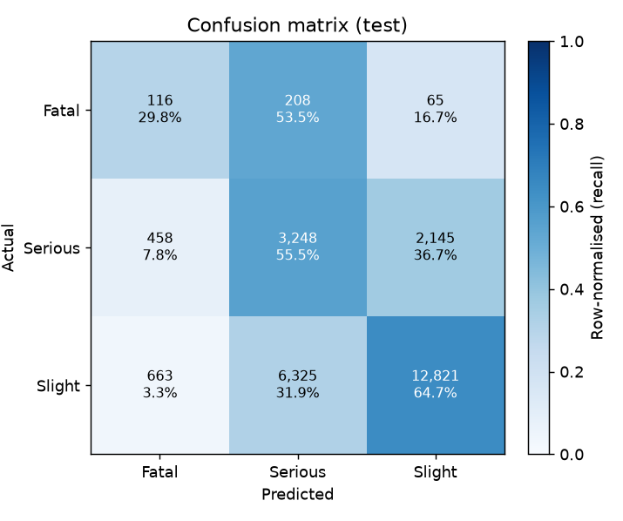
Figure: Confusion matrix on the test period
Interpretation
- Of 389 fatal collisions, 116 were predicted Fatal and 208 Serious: 324 (83 %) were flagged as severe. Only 65 were predicted Slight.
- 3,248 of 5,851 serious collisions were caught (55.5 % recall).
- 6,325 slight collisions were predicted Serious. These false alarms are the cost of class weighting, and they explain the low Fatal precision (≈ 9 %).
- Accuracy (62.1 %) is lower than the 75.6 % of always predicting "Slight". That is intentional: the class weights trade accuracy for catching serious and fatal collisions.

5. Experiment tracking and model registry (MLflow)
What | Logged
Parameters | split dates, LightGBM hyper-parameters, class weighting
Metrics | macro-F1, weighted-F1, balanced accuracy, accuracy, per-class recall/precision/F1, KSI recall and KSI false-negative rate (validation and test)
Artefacts | confusion matrices and classification reports (validation + test), split summary, reference profile
Model | full inference pipeline with signature and input example

Every training run creates a new version of traffic-severity-classifier. The @champion alias moves to a new version only when its test macro-F1 beats the current champion's on the same test window by at least PROMOTION_MIN_DELTA (0.005). The decision is stored as the run tag promotion_decision. On promotion the model is exported to models/champion/ (model.joblib, metadata.json, reference_profile.json).
Current champion: version 1, MLflow run 6d73f5b2636f4c649a80f08f7716fa2f, LightGBM, balanced class weights, trained 2026-10-07, decision "promoted (first model)".
Rollback means moving the alias back (client.set_registered_model_alias(name, "champion", <old version>)), then re-exporting or restarting the service. Versions are never deleted, so every past prediction can be traced to its version through model_version in the prediction log.
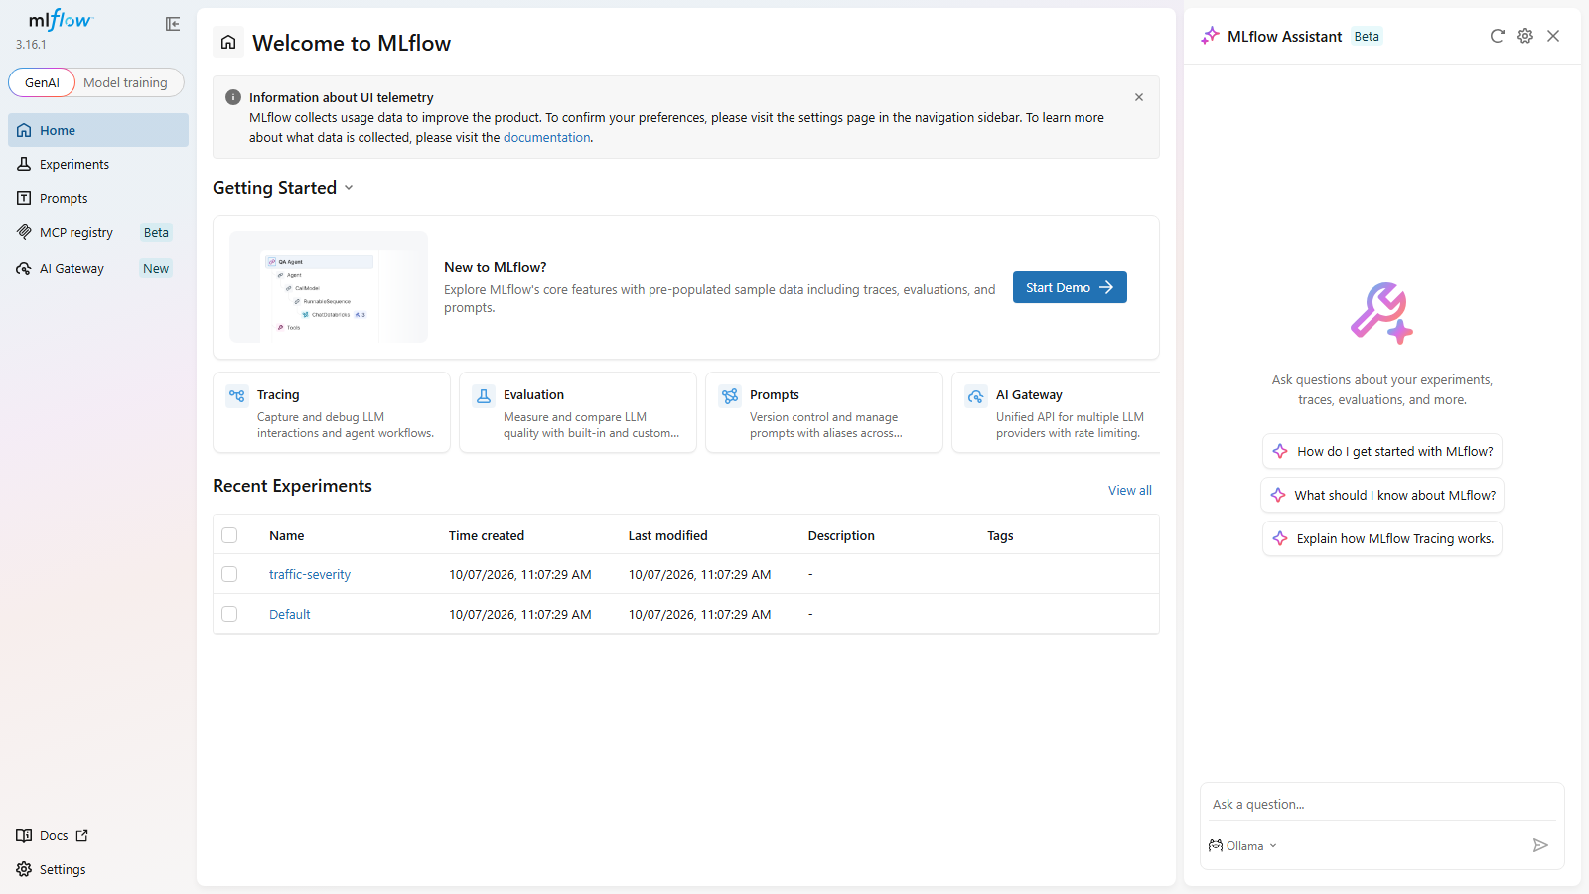
Figure: MLflow tracking UI

6. Deployment (FastAPI, Docker, Streamlit)
Endpoint | Purpose
POST /predict | one collision → predicted class, class probabilities, KSI probability, model version, latency
POST /predict/batch | many collisions at once
GET /health | service status and loaded model version
GET /model-info | model name, version, run id, training/test windows, features, metrics
GET /metrics | request count, error count, error rate, p50/p95/p99 latency, predicted class counts

- Input is validated with pydantic. An invalid payload returns HTTP 422 and is counted as a failure.
- Every request is logged to logs/predictions.jsonl with its model version; this feeds monitoring.
- models/champion/ is baked into the Docker image (Dockerfile). Setting MODEL_URI=models:/traffic-severity-classifier@champion loads straight from the registry instead.
- docker-compose.yml starts three services: FastAPI (port 8000), the MLflow server (port 5000) and the Streamlit UI (port 8502).
Verified locally (execution evidence):
- GET /health → {"status": "ok", "model_version": 1}
- POST /predict for a rural, unlit, wet, 60 mph, single-motorcycle collision at 23:00 → predicted Serious, probabilities Fatal 0.217 / Serious 0.542 / Slight 0.241, KSI probability 0.759
- POST /predict with {"hour": "late"} → HTTP 422, counted as an error
- GET /metrics after the checks → requests, errors, error rate, latency percentiles and predicted class counts reported. The first request includes model loading time (cold start); warm requests answered in about 130 ms.
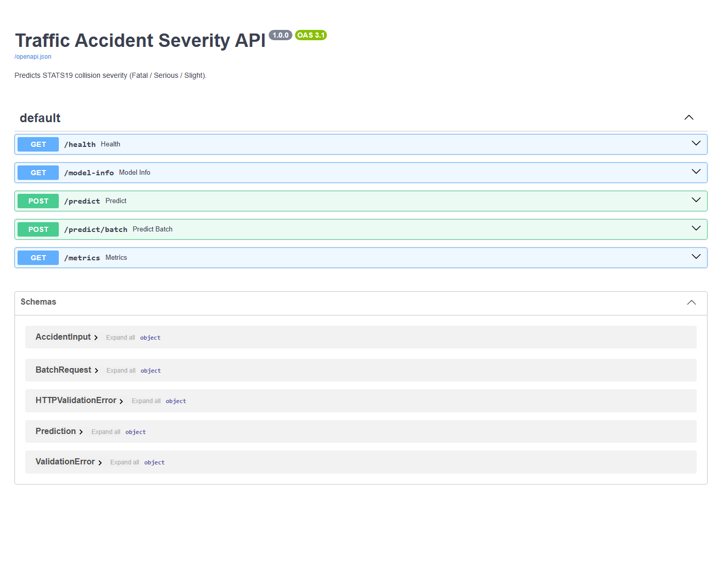
Figure: FastAPI Swagger UI
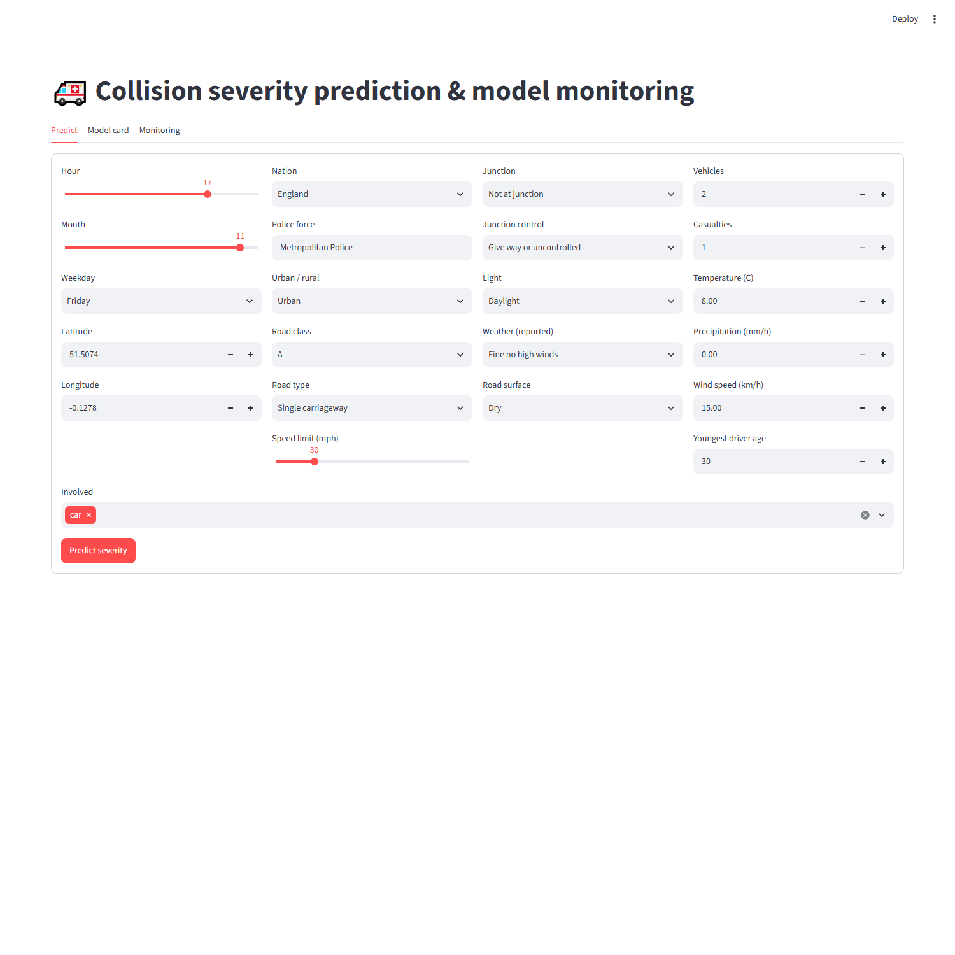
Figure: Streamlit prediction UI

7. Monitoring
monitoring.py compares new data with the training reference profile.
Signal | Method | Source
Input data quality | missing-rate increase, out-of-range numerics, unseen categories | labelled batch or API log
Feature drift | PSI per feature against the training reference profile | both
Class drift | PSI of the predicted class mix, plus the actual class mix when labels exist | both
Location drift | PSI of the police-force and nation distributions, plus centroid shift in km | both
Performance | macro-F1, per-class recall, KSI false-negative rate against the champion's baseline | labelled batch
Latency / failures | p50/p95 latency and error rate (including invalid payloads) | API log and /metrics

PSI (Population Stability Index) = Σ (new % − reference %) × ln(new % / reference %) over the bins. Below 0.1 is stable, 0.1–0.2 is a moderate shift and above 0.2 is a significant shift.
Monitoring runs (execution evidence)
Check | Labelled batch (Oct – Dec 2024) | Simulated drift (rural, night, wet)
Rows analysed | 26,342 | 9,361
Decision | No retraining needed | RETRAIN
Feature drift | temperature only (warning; winter data) | 7 key features with PSI > 0.2: hour, temperature, precipitation, light conditions, urban/rural, road surface, speed limit
Predicted class mix | Fatal 4.7 %, Serious 37.5 %, Slight 57.8 % (unchanged from reference) | Fatal 13.2 %, Serious 48.7 %, Slight 38.1 % (prediction PSI 0.197)
Location drift | – | police-force PSI 0.817, nation PSI 0.120, centroid shift 43.7 km
Performance | macro-F1 0.431, stable | –
Warnings | missing-rate increase on special conditions at site | missing-rate increase on junction control and special conditions at site

The monitor stays quiet when nothing has changed and raises the alarm when the data really shifts. The full reports are in execution_evidence/.

8. Retraining criteria and lifecycle
Retraining is triggered when any of these holds (RetrainingPolicy in config.py):
- more than 3 key features have PSI > 0.2
- class distribution PSI > 0.1
- location (police-force) PSI > 0.2
- macro-F1 has dropped by more than 0.05 from the champion baseline
- KSI false-negative rate has risen by more than 0.05 (absolute)
- the champion is older than 180 days (scheduled refresh)
These conditions only raise warnings and don't trigger retraining: an input missing-rate increase above 10 points, an API error rate above 2 %, or p95 latency above 300 ms. They point to upstream or infrastructure faults, and retraining on broken data would make things worse.
The Airflow DAG severity_model_lifecycle (dags/) runs every Monday: monitor → branch → retrain or skip. A retrained model goes through the same champion/challenger gate. python -m severity_model.retrain does the same by hand (--force for a scheduled refresh).
Retirement: a model version is retired when it is no longer the champion and a newer champion has been in service for one full monitoring cycle without being rolled back. Versions are never deleted.

9. Testing and reproducibility
pytest covers feature engineering, the chronological split, class weights, end-to-end pipeline inference (including unseen categories), the metric definitions, PSI and drift detection, and the API (predict, batch, validation errors, metrics, prediction log).
How to reproduce:
- Run Part 1 so that ml_accident_features.parquet exists (or set FEATURES_DATABASE_URL).
- pip install -r requirements.txt and pip install -e .
- python -m severity_model.train – train, track, register and promote
- mlflow ui --backend-store-uri sqlite:///mlflow.db --port 5000 – browse experiments
- uvicorn severity_model.api:app --port 8000 or docker compose up -d --build – serve
- python -m severity_model.monitoring (add --prediction-log logs/predictions.jsonl or --simulate-drift) – monitor
- python -m severity_model.retrain – retrain only if the policy says so

10. Limitations and future work
- Weather is resolved at the 1° grid, which describes regional rather than street-level conditions.
- Severity also depends on factors that aren't recorded at report time (speed at impact, seatbelt use), which caps achievable performance.
- Probabilities are not calibrated, and Fatal precision is low (≈ 9 %), so there are many false alarms.
- Only LightGBM is trained in the final pipeline.
- Future work: probability calibration and threshold tuning for a target KSI recall; OpenStreetMap road context as extra features; tracked comparison with XGBoost and random forest; canary deployment of new champions.

