ITA0608 - Machine Learning
Experiment No: 11
Title: Credit Score Classification using Machine Learning in Python
AIM:
To implement a Credit Score Classification model using Python and classify customers into different credit score categories based on their financial details.
Algorithm:
- Import the required libraries.
- Load the Credit Score dataset.
- Split the dataset into training and testing sets.
- Train the Decision Tree Classifier.
- Predict the credit score class for the test data.
- Display the Confusion Matrix and Accuracy.
- Predict the class for a new customer.
Code:
import pandas as pd
from sklearn.model_selection import train_test_split
from sklearn.preprocessing import LabelEncoder
from sklearn.tree import DecisionTreeClassifier
from sklearn.metrics import confusion_matrix, accuracy_score, classification_report
# Load Dataset
data = pd.read_csv("credit_score.csv")
print("Dataset:\n")
print(data)
# Encode Target Labels
encoder = LabelEncoder()
data["CreditScore"] = encoder.fit_transform(data["CreditScore"])
# Features and Target
X = data.iloc[:, :-1]
y = data.iloc[:, -1]

# Split Dataset
X_train, X_test, y_train, y_test = train_test_split(
X, y, test_size=0.3, random_state=1
)
# Train Decision Tree Classifier
model = DecisionTreeClassifier(random_state=1)
model.fit(X_train, y_train)
# Predict
y_pred = model.predict(X_test)
# Confusion Matrix
print("\nConfusion Matrix:\n")
print(confusion_matrix(y_test, y_pred))
# Accuracy
print("\nAccuracy :", accuracy_score(y_test, y_pred))
# Classification Report
print("\nClassification Report:\n")
print(classification_report(y_test, y_pred))
# Predict New Customer
new_customer = [[29, 48000, 7500]]
prediction = model.predict(new_customer)
print("\nPredicted Credit Score:")
print(encoder.inverse_transform(prediction))

OUTPUT:
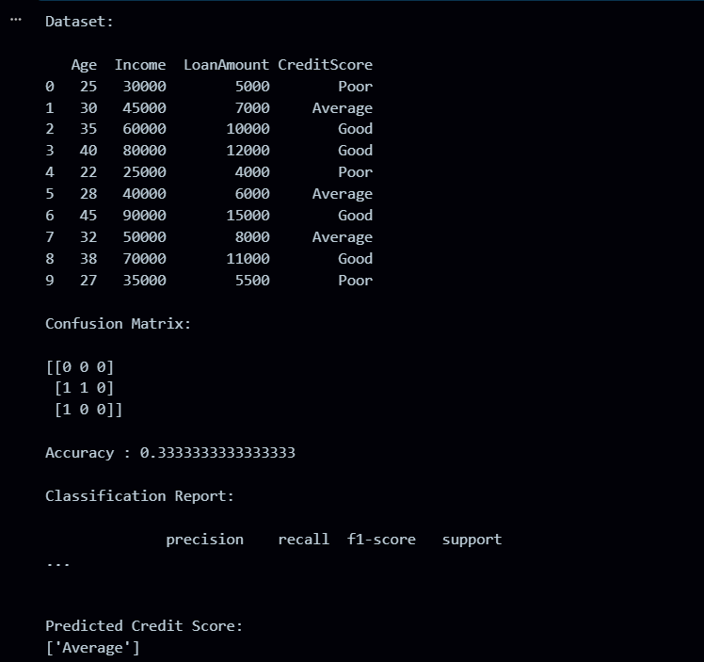
RESULT:
The program was successfully executed.

