ITA0608 - Machine Learning
Experiment No: 10
Title: Implementation of Expectation Maximization (EM) Algorithm in Python
AIM:
To implement the Expectation Maximization (EM) Algorithm in Python and perform clustering using an appropriate dataset.
Algorithm:
- Import the required libraries.
- Load the dataset.
- Split the dataset into training and testing sets (optional for clustering).
- Create a Gaussian Mixture Model (GMM).
- Train the model using the EM algorithm.
- Predict the cluster labels.
- Display the cluster assignments.
- Predict the cluster for a new sample.
Code:
from sklearn.datasets import load_iris
from sklearn.mixture import GaussianMixture
# Load Iris Dataset
iris = load_iris()
X = iris.data
# Create Gaussian Mixture Model
gmm = GaussianMixture(
n_components=3,
covariance_type='full',
random_state=1
)
# Train using Expectation Maximization
gmm.fit(X)
# Predict Cluster Labels
labels = gmm.predict(X)
print("Cluster Labels:\n")
print(labels)
# Probability of each sample belonging to each cluster
print("\nCluster Probabilities:\n")
print(gmm.predict_proba(X))
# Predict a New Sample
sample = [[5.1, 3.5, 1.4, 0.2]]
prediction = gmm.predict(sample)
print("\nPredicted Cluster for New Sample:")
print(prediction[0])

OUTPUT:
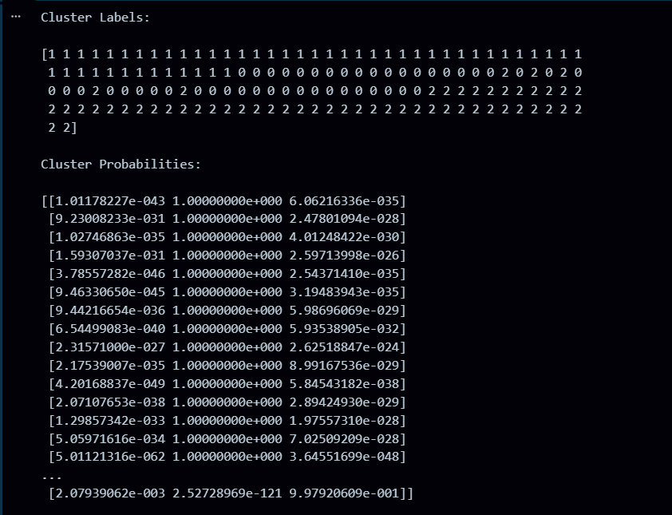
RESULT:
The program was successfully executed.

