ITA0608 - Machine Learning
Experiment No: 6
Title: Implementation of Naïve Bayes Algorithm in Python
AIM:
To implement the Naïve Bayes Algorithm in Python and evaluate its performance using a Confusion Matrix and Accuracy Score.
Algorithm:
- Import the required libraries.
- Load the dataset.
- Split the dataset into training and testing sets.
- Standardize the input features.
- Train the Naïve Bayes classifier.
- Predict the test data.
- Display the Confusion Matrix.
- Calculate the Accuracy Score.
- Predict the class of a new sample.
Code:
from sklearn.datasets import load_iris
from sklearn.model_selection import train_test_split
from sklearn.preprocessing import StandardScaler
from sklearn.naive_bayes import GaussianNB
from sklearn.metrics import confusion_matrix, accuracy_score, classification_report
# Load Iris Dataset
iris = load_iris()
X = iris.data
y = iris.target
# Split dataset
X_train, X_test, y_train, y_test = train_test_split(
X, y, test_size=0.3, random_state=1
)
# Feature Scaling
scaler = StandardScaler()

X_train = scaler.fit_transform(X_train)
X_test = scaler.transform(X_test)
# Create Naïve Bayes Model
model = GaussianNB()
# Train the model
model.fit(X_train, y_train)
# Predict test data
y_pred = model.predict(X_test)
accuracy = accuracy_score(y_test, y_pred)
print("\nAccuracy :", accuracy)
print(classification_report(y_test, y_pred))
# Predict a new sample
sample = [[5.1, 3.5, 1.4, 0.2]]
sample = scaler.transform(sample)
prediction = model.predict(sample)
print("\nPrediction for New Sample:")
print(iris.target_names[prediction[0]])
OUTPUT:
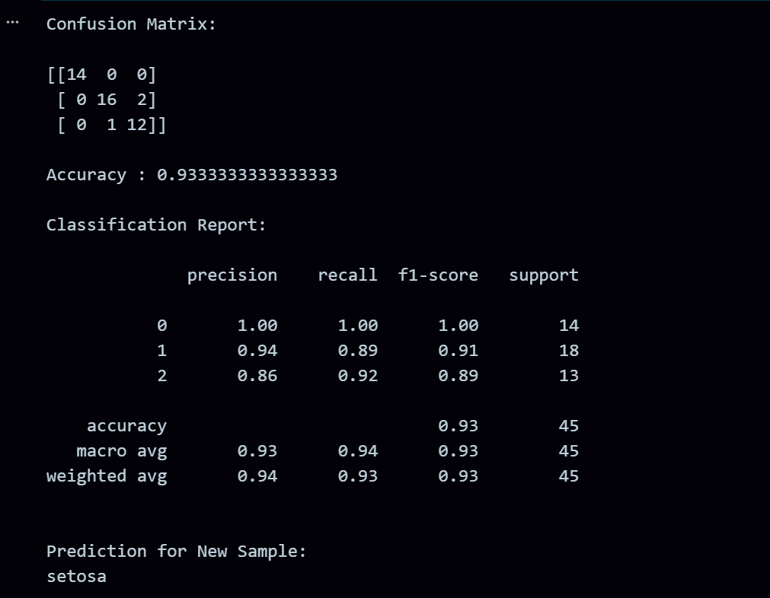
RESULT:
The program was successfully executed.

