ITA0608 - Machine Learning
Experiment No: 7
Title: Implementation of Logistic Regression (LR) Algorithm in Python
AIM:
To implement the Logistic Regression (LR) algorithm in Python and classify data using an appropriate dataset.
Algorithm:
- Import the required libraries.
- Load the dataset.
- Split the dataset into training and testing sets.
- Standardize the features.
- Train the Logistic Regression model.
- Predict the test data.
- Display the confusion matrix and accuracy.
- Predict the class of a new sample.
Code:
from sklearn.datasets import load_breast_cancer
from sklearn.model_selection import train_test_split
from sklearn.preprocessing import StandardScaler
from sklearn.linear_model import LogisticRegression
from sklearn.metrics import confusion_matrix, accuracy_score, classification_report
# Load Dataset
data = load_breast_cancer()
X = data.data
y = data.target
# Split Dataset
X_train, X_test, y_train, y_test = train_test_split(
X, y, test_size=0.3, random_state=1
)
# Feature Scaling
scaler = StandardScaler()
X_train = scaler.fit_transform(X_train)
X_test = scaler.transform(X_test)
# Create Logistic Regression Model
model = LogisticRegression(random_state=1)
# Train the Model
model.fit(X_train, y_train)
# Predict Test Data
y_pred = model.predict(X_test)
# Confusion Matrix
cm = confusion_matrix(y_test, y_pred)
print("Confusion Matrix:\n")
print(cm)
# Accuracy
accuracy = accuracy_score(y_test, y_pred)
print("\nAccuracy :", accuracy)
# Classification Report
print("\nClassification Report:\n")
print(classification_report(y_test, y_pred))
# Predict a New Sample
sample = [X[0]]
sample = scaler.transform(sample)
prediction = model.predict(sample)
if prediction[0] == 1:
print("\nPrediction : Benign")
else:
print("\nPrediction : Malignant")
OUTPUT:
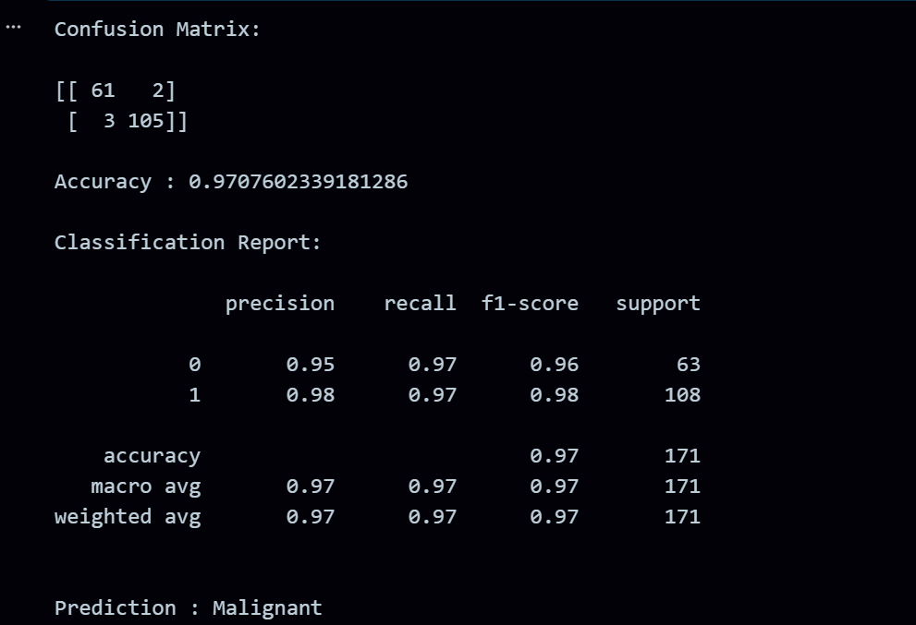
RESULT:
The program was successfully executed.

