ITA0608 - Machine Learning
Experiment No: 8
Title: Implementation of Linear Regression (LR) Algorithm in Python
AIM:
To implement the Linear Regression (LR) algorithm in Python and classify data using an appropriate dataset.
Algorithm:
- Load the dataset.
- Split the dataset into training and testing sets.
- Create a Linear Regression model.
- Train the model using the training dataset.
- Predict the values for the test dataset.
- Calculate the Mean Squared Error (MSE) and R² Score.
- Predict the output for a new sample.
Code:
from sklearn.datasets import load_diabetes
from sklearn.model_selection import train_test_split
from sklearn.linear_model import LinearRegression
from sklearn.metrics import mean_squared_error, r2_score
# Load Dataset
diabetes = load_diabetes()
X = diabetes.data
y = diabetes.target
# Split Dataset
X_train, X_test, y_train, y_test = train_test_split(
X, y, test_size=0.3, random_state=1
)
# Create Linear Regression Model
model = LinearRegression()
# Train the Model
model.fit(X_train, y_train)
# Predict Test Data
y_pred = model.predict(X_test)
# Evaluation
print("Mean Squared Error :", mean_squared_error(y_test, y_pred))
print("R2 Score :", r2_score(y_test, y_pred))
# Predict a New Sample
sample = [X[0]]
prediction = model.predict(sample)
print("\nPredicted Value for New Sample:")
print(prediction[0])
OUTPUT:
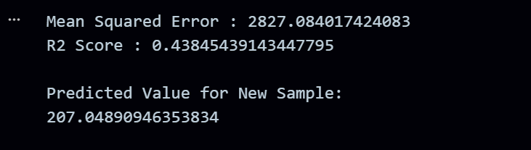
RESULT:
The program was successfully executed.

