ITA0608 - Machine Learning
Experiment No: 9
Title: Comparison of Linear Regression and Polynomial Regression using Python
AIM:
To implement and compare Linear Regression and Polynomial Regression using Python on an appropriate dataset.
Algorithm:
- Import the required libraries.
- Load the dataset.
- Create Linear Regression and Polynomial Regression models.
- Train both models.
- Predict the output values.
- Compare their performance using the R² Score.
- Predict the value for a new sample.
Code:
import numpy as np
from sklearn.linear_model import LinearRegression
from sklearn.preprocessing import PolynomialFeatures
from sklearn.metrics import r2_score
# Sample Dataset
X = np.array([[1], [2], [3], [4], [5], [6], [7], [8], [9], [10]])
y = np.array([2, 5, 10, 17, 26, 37, 50, 65, 82, 101])
# ---------------- Linear Regression ----------------
linear_model = LinearRegression()
linear_model.fit(X, y)
linear_pred = linear_model.predict(X)
print("Linear Regression R2 Score:")
print(r2_score(y, linear_pred))
# ---------------- Polynomial Regression ----------------
poly = PolynomialFeatures(degree=2)

X_poly = poly.fit_transform(X)
poly_model = LinearRegression()
poly_model.fit(X_poly, y
poly_pred = poly_model.predict(X_poly)
print("\nPolynomial Regression R2 Score:")
print(r2_score(y, poly_pred))
# Predict New Sample
new_value = [[11]]
linear_result = linear_model.predict(new_value)
poly_result = poly_model.predict(poly.transform(new_value))
print("\nPrediction for x = 11")
print("Linear Regression :", linear_result[0])
print("Polynomial Regression :", poly_result[0])

OUTPUT:
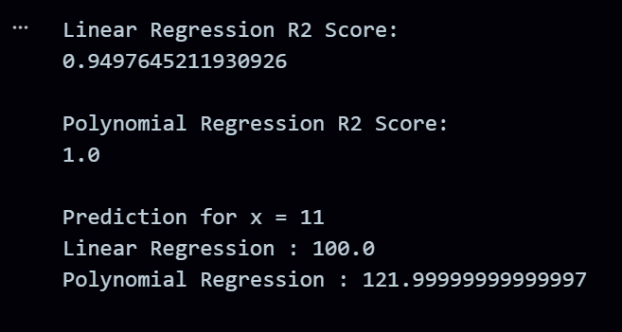
RESULT:
The program was successfully executed.

