ITA0608 - Machine Learning
Experiment No: 16
Title: Comparison of Different Classification Algorithms and Performance Evaluation using Python
AIM:
To compare different classification algorithms in Python and evaluate their performance using the Iris dataset.
Algorithm:
- Import the required libraries.
- Load the Iris dataset.
- Split the dataset into training and testing sets.
- Standardize the features.
- Train different classification models.
- Predict the test data.
- Evaluate each model using:
- Accuracy
- Confusion Matrix
- Classification Report
- Compare the performance of all classifiers.
Code:
from sklearn.datasets import load_iris
from sklearn.model_selection import train_test_split
from sklearn.preprocessing import StandardScaler
from sklearn.metrics import accuracy_score, confusion_matrix, classification_report

from sklearn.linear_model import LogisticRegression
from sklearn.neighbors import KNeighborsClassifier
from sklearn.tree import DecisionTreeClassifier
from sklearn.naive_bayes import GaussianNB
from sklearn.svm import SVC

# Load Dataset
iris = load_iris()

X = iris.data
y = iris.target

# Split Dataset
X_train, X_test, y_train, y_test = train_test_split(
X, y, test_size=0.3, random_state=1
)

# Feature Scaling
scaler = StandardScaler()

X_train = scaler.fit_transform(X_train)
X_test = scaler.transform(X_test)

# Dictionary of Models
models = {
"Logistic Regression": LogisticRegression(max_iter=200),
"K-Nearest Neighbours": KNeighborsClassifier(n_neighbors=3),
"Decision Tree": DecisionTreeClassifier(random_state=1),
"Naive Bayes": GaussianNB(),
"Support Vector Machine": SVC()
}

# Train and Evaluate
for name, model in models.items():

model.fit(X_train, y_train)

y_pred = model.predict(X_test)

print("\n==============================")
print(name)
print("==============================")

print("\nAccuracy:")
print(accuracy_score(y_test, y_pred))

print("\nConfusion Matrix:")
print(confusion_matrix(y_test, y_pred))

print("\nClassification Report:")
print(classification_report(y_test, y_pred))

OUTPUT:
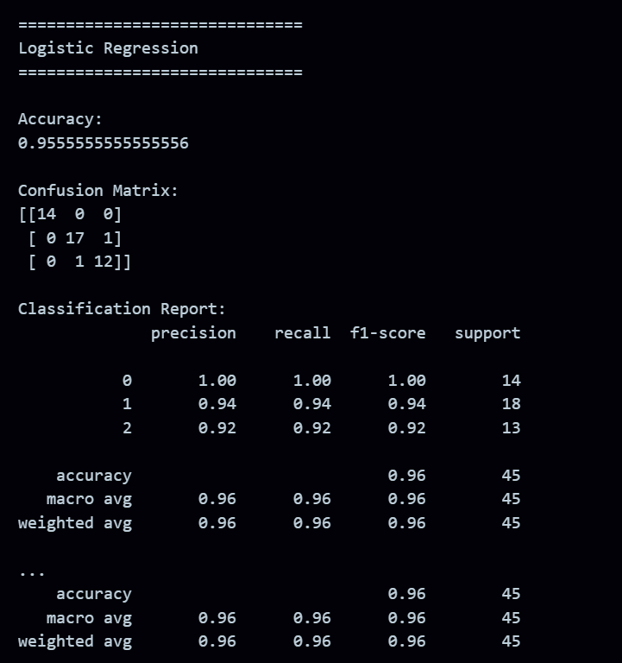
RESULT:
The program was successfully executed.

