ITA0608 - Machine Learning
Experiment No: 17
Title: Mobile Price Prediction using Linear Regression in Python
To implement a Mobile Price Prediction Model using an appropriate Machine Learning algorithm (Linear Regression) in Python and predict the price of a mobile phone based on its specifications.
Algorithm:
- Import the required libraries.
- Load the mobile price dataset.
- Split the dataset into training and testing sets.
- Train the Linear Regression model.
- Predict mobile prices.
- Calculate the Mean Squared Error (MSE) and R² Score.
- Predict the price of a new mobile phone.
Code:
import pandas as pd
from sklearn.model_selection import train_test_split
from sklearn.linear_model import LinearRegression
from sklearn.metrics import mean_squared_error, r2_score

# Load Dataset
data = pd.read_csv("mobile_price.csv")
print("Dataset:\n")
print(data)
# Features and Target
X = data[['RAM', 'Storage', 'Camera', 'Battery']]
y = data['Price']
# Split Dataset
X_train, X_test, y_train, y_test = train_test_split(
X, y, test_size=0.3, random_state=1
)
# Create Linear Regression Model
model = LinearRegression()

# Train Model
model.fit(X_train, y_train)
# Predict Test Data
y_pred = model.predict(X_test)
# Evaluation
print("\nMean Squared Error :", mean_squared_error(y_test, y_pred))
print("R2 Score :", r2_score(y_test, y_pred))
# Predict Price for a New Mobile
new_mobile = [[8, 256, 108, 5000]]
prediction = model.predict(new_mobile)
print("\nPredicted Mobile Price:")
print("₹", round(prediction[0], 2))

OUTPUT:
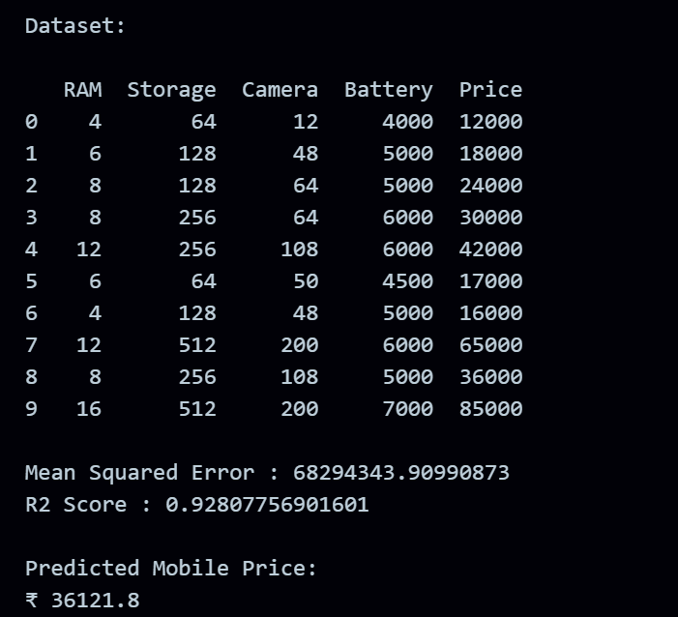
RESULT:
The program was successfully executed.

