ITA0608 - Machine Learning
Experiment No: 19
Title: Implementation of Naïve Bayes Classification for Bank Loan Prediction
AIM:
To implement the Naïve Bayes Classification Algorithm in Python for predicting whether a bank loan should be approved based on customer details.
Algorithm:
- Import the required libraries.
- Load the bank loan dataset.
- Encode the target labels.
- Split the dataset into training and testing sets.
- Standardize the features.
- Train the Gaussian Naïve Bayes classifier.
- Predict the loan status.
- Display the Confusion Matrix and Accuracy.
- Predict the loan status of a new applicant.
Code:
import pandas as pd
from sklearn.model_selection import train_test_split
from sklearn.preprocessing import LabelEncoder, StandardScaler
from sklearn.naive_bayes import GaussianNB
from sklearn.metrics import confusion_matrix, accuracy_score, classification_report

# Load Dataset
data = pd.read_csv("bank_loan.csv")

print("Dataset:\n")
print(data)

# Encode Target Labels
encoder = LabelEncoder()
data["LoanStatus"] = encoder.fit_transform(data["LoanStatus"])

# Features and Target
X = data[['Age', 'Income', 'CreditScore', 'LoanAmount']]
y = data['LoanStatus']

# Split Dataset
X_train, X_test, y_train, y_test = train_test_split(
X, y, test_size=0.3, random_state=1
)

# Feature Scaling
scaler = StandardScaler()
X_train = scaler.fit_transform(X_train)
X_test = scaler.transform(X_test)

# Create Gaussian Naïve Bayes Model
model = GaussianNB()

# Train Model
model.fit(X_train, y_train)

# Predict Test Data
y_pred = model.predict(X_test)

# Confusion Matrix
print("\nConfusion Matrix:\n")
print(confusion_matrix(y_test, y_pred))

# Accuracy
print("\nAccuracy :", accuracy_score(y_test, y_pred))

# Classification Report
print("\nClassification Report:\n")
print(classification_report(y_test, y_pred))

# Predict Loan Status for New Applicant
new_customer = [[33, 55000, 730, 170000]]

new_customer = scaler.transform(new_customer)

prediction = model.predict(new_customer)

print("\nPredicted Loan Status:")
print(encoder.inverse_transform(prediction))

OUTPUT:
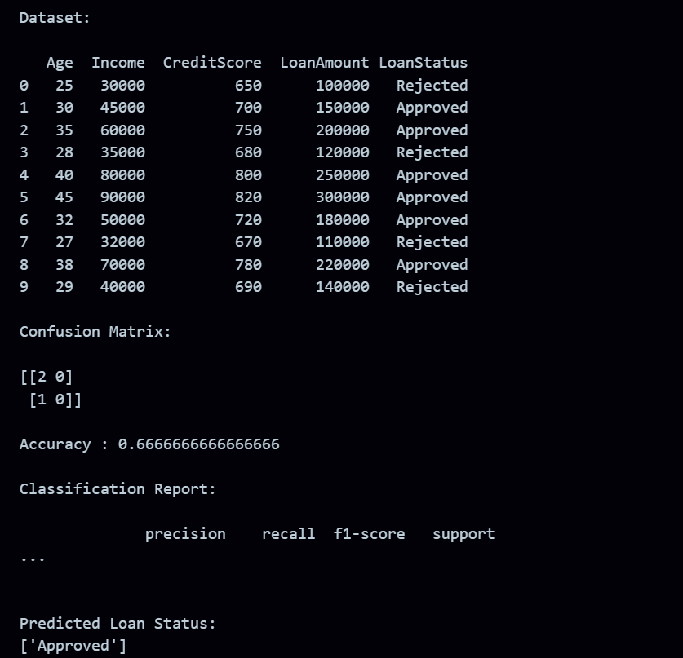
RESULT:
The program was successfully executed.

