ITA0608 - Machine Learning
Experiment No: 20
Title: Future Sales Prediction using Linear Regression in Python
AIM:
To implement a Future Sales Prediction model using a suitable Machine Learning algorithm (Linear Regression) in Python and predict future sales based on historical sales data.
Algorithm:
- Import the required libraries.
- Load the sales dataset.
- Split the dataset into training and testing sets.
- Train the Linear Regression model.
- Predict the sales values.
- Calculate the Mean Squared Error (MSE) and R² Score.
- Predict future sales for a new month.
Code:
import pandas as pd
from sklearn.model_selection import train_test_split
from sklearn.linear_model import LinearRegression
from sklearn.metrics import mean_squared_error, r2_score
# Load Dataset
data = pd.read_csv("sales_data.csv")
print("Dataset:\n")
print(data)
# Features and Target
X = data[['Month']]
y = data['Sales']
# Split Dataset
X_train, X_test, y_train, y_test = train_test_split(
X, y, test_size=0.3, random_state=1
)
# Create Linear Regression Model
model = LinearRegression()
# Train Model
model.fit(X_train, y_train)
# Predict Test Data
y_pred = model.predict(X_test)
# Evaluation
print("\nMean Squared Error :", mean_squared_error(y_test, y_pred))
print("R2 Score :", r2_score(y_test, y_pred))
# Predict Future Sales
future_month = [[13]]
prediction = model.predict(future_month)
print("\nPredicted Sales for Month 13:")
print(round(prediction[0], 2), "Units")

OUTPUT:
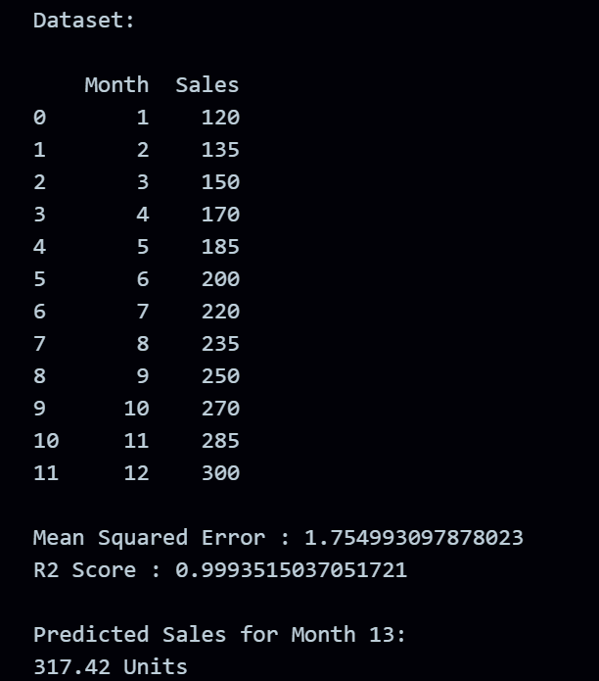
RESULT:
The program was successfully executed.

