ITA0608 - Machine Learning
Experiment No: 1
Title: Implementation of FIND-S Algorithm
AIM:
To implement and demonstrate the FIND-S Algorithm for finding the most specific hypothesis based on a given set of training data samples.
Algorithm
- Read the training dataset.
- Initialize the hypothesis with the most specific values (Ø).
- For each training example:
  - If it is positive (Yes):
    - Compare each attribute with the hypothesis.
    - If the values differ, replace that attribute with "?".
- Ignore all negative examples.
- Display the final hypothesis.

Code:
import csv
# Read the CSV file
with open("trainingdata.csv") as csvFile:
data = list(csv.reader(csvFile))
print("\nTraining Data:\n")
for row in data:
print(row)
# Initialize hypothesis with the first positive example
hypothesis = data[1][:-1]
print("\nInitial Hypothesis:")
print(hypothesis)
# Apply FIND-S Algorithm
for i in range(2, len(data)):
if data[i][-1] == "Yes":
for j in range(len(hypothesis)):
if hypothesis[j] != data[i][j]:
hypothesis[j] = '?'
print("\nFinal Hypothesis:")
print(hypothesis)

OUTPUT:
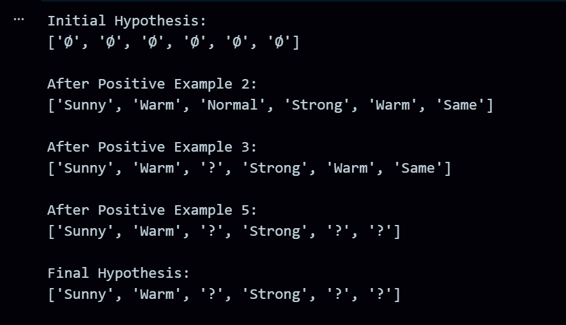
RESULT:
The program was successfully executed.

