ITA0608 - Machine Learning
Experiment No: 2
Title: Implementation of Candidate Elimination Algorithm
AIM:
To implement and demonstrate the Candidate Elimination Algorithm in Python for finding the set of all hypotheses consistent with the given training data samples stored in a CSV file.
Algorithm:
Read the training dataset from the CSV file.
- Initialize:
  - Specific hypothesis (S) with the first positive example.
  - General hypothesis (G) with the most general hypothesis (?).
- For each training example:
  - If the example is Positive (Yes):
    - Generalize S whenever required.
    - Remove inconsistent hypotheses from G.
  - If the example is Negative (No):
    - Specialize G to exclude the negative example while remaining consistent with S.
- Remove duplicate and invalid hypotheses.
- Display the final Specific Boundary (S) and General Boundary (G).

Code:
import csv
with open('trainingdata.csv') as csvFile:
data = list(csv.reader(csvFile))
print("\nTraining Data:\n")
for row in data:
print(row)
concepts = [row[:-1] for row in data[1:]]
target = [row[-1] for row in data[1:]]
# Initialize Specific Hypothesis
specific_h = concepts[0].copy()
# Initialize General Hypothesis
general_h = [['?' for _ in range(len(specific_h))]
for _ in range(len(specific_h))]
print("\nInitial Specific Hypothesis:")
print(specific_h)
print("\nInitial General Hypothesis:")
for row in general_h:
print(row)
# Candidate Elimination Algorithm
for i, h in enumerate(concepts):
if target[i] == "Yes":
for x in range(len(specific_h)):
if h[x] != specific_h[x]:
specific_h[x] = '?'
general_h[x][x] = '?'
elif target[i] == "No":
for x in range(len(specific_h)):
if h[x] != specific_h[x]:
general_h[x][x] = specific_h[x]
else:
general_h[x][x] = '?'

# Remove redundant hypotheses
general_h = [g for g in general_h if g != ['?'] * len(specific_h)]
print("\nFinal Specific Hypothesis:")
print(specific_h)
print("\nFinal General Hypothesis:")
for row in general_h:
print(row)

OUTPUT:
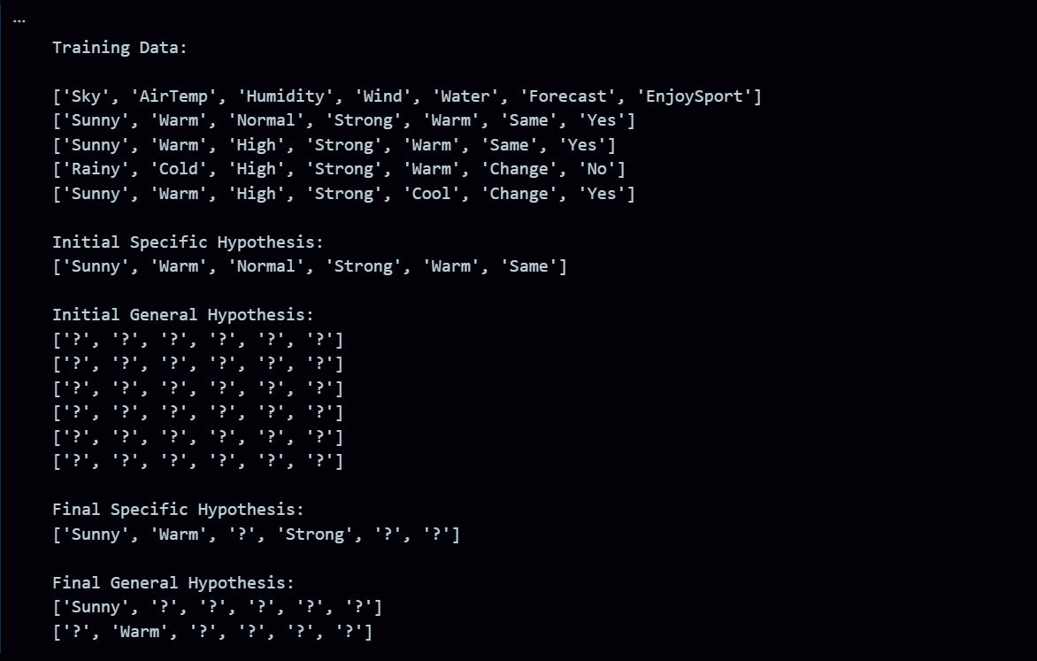
RESULT:
The program was successfully executed.

