ITA0608 - Machine Learning
Experiment No: 3
Title: Implementation of Decision Tree using ID3 Algorithm
AIM:
To implement and demonstrate the Decision Tree based ID3 Algorithm using an appropriate dataset and classify a new sample.
Algorithm:
- Read the dataset from a CSV file.
- Calculate the entropy of the target attribute.
- Compute the Information Gain for every attribute.
- Select the attribute with the highest Information Gain as the root node.
- Repeat the process recursively for every branch until:
- All examples belong to one class, or
- No attributes remain.
- Use the generated tree to classify a new sample
.Code:
import pandas as pd
from sklearn.preprocessing import LabelEncoder
from sklearn.tree import DecisionTreeClassifier, export_text
# Read dataset
data = pd.read_csv("playtennis.csv")
print("Dataset:\n")
print(data)
# Convert categorical data into numerical values
encoder = LabelEncoder()
encoded_data = data.copy()
for column in encoded_data.columns:
encoded_data[column] = encoder.fit_transform(encoded_data[column])
# Features and Target
X = encoded_data.iloc[:, :-1]
y = encoded_data.iloc[:, -1]
# Build Decision Tree using ID3 (Entropy)
model = DecisionTreeClassifier(criterion='entropy')
model.fit(X, y)
# Display Decision Tree Rules
print("\nDecision Tree:\n")
print(export_text(model, feature_names=list(X.columns)))
# New Sample
# Outlook=Sunny, Temperature=Cool, Humidity=High, Wind=Strong
new_sample = [[2, 0, 0, 0]]
prediction = model.predict(new_sample)
if prediction[0] == 1:
print("\nPrediction : Play Tennis = Yes")
else:
print("\nPrediction : Play Tennis = No")

OUTPUT:
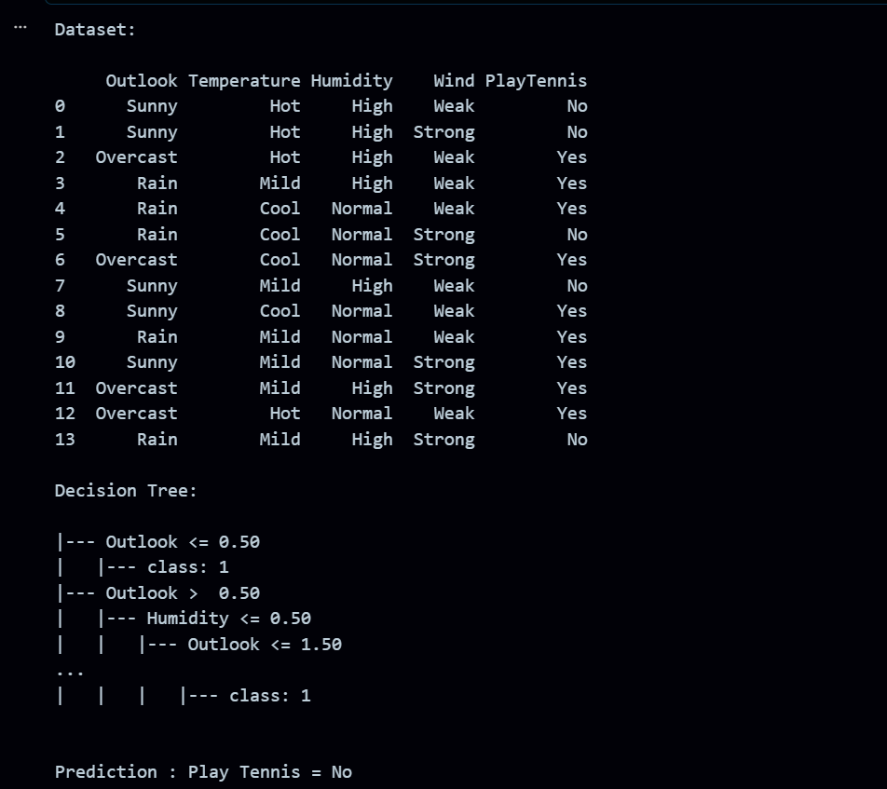
RESULT:
The program was successfully executed.

