ITA0608 - Machine Learning
Experiment No: 14
Title: House Price Prediction using Linear Regression in Python
AIM:
To implement a House Price Prediction Model using Linear Regression in Python and predict the price of a house based on its features.
Algorithm:
- Import the required libraries.
- Load the house price dataset.
- Split the dataset into training and testing sets.
- Train the Linear Regression model.
- Predict house prices.
- Calculate the Mean Squared Error (MSE) and R² Score.
- Predict the price of a new house.
Code:
import pandas as pd
from sklearn.model_selection import train_test_split
from sklearn.linear_model import LinearRegression
from sklearn.metrics import mean_squared_error, r2_score
# Load Dataset
data = pd.read_csv("house_price.csv")
print("Dataset:\n")
print(data)
# Features and Target
X = data[['Area', 'Bedrooms', 'Bathrooms', 'Age']]
y = data['Price']
# Split Dataset
X_train, X_test, y_train, y_test = train_test_split(
X, y, test_size=0.3, random_state=1
)
# Create Linear Regression Model
model = LinearRegression()
# Train Model
model.fit(X_train, y_train)
# Predict Test Data
y_pred = model.predict(X_test)
# Evaluation
print("\nMean Squared Error :", mean_squared_error(y_test, y_pred))
print("R2 Score :", r2_score(y_test, y_pred))
# Predict New House Price
new_house = [[2400, 4, 3, 2]]
prediction = model.predict(new_house)
print("\nPredicted House Price:")
print("₹", round(prediction[0], 2))
OUTPUT:
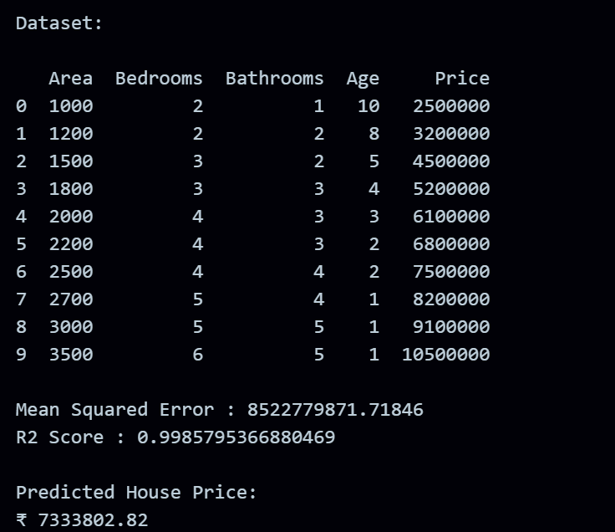
RESULT:
The program was successfully executed.

