ITA0608 - Machine Learning
Experiment No: 15
Title: Iris Flower Classification using Naïve Bayes Classifier
AIM:
To implement the Naïve Bayes Classifier in Python for classifying Iris flower species using the Iris dataset.
Algorithm:
- Import the required libraries.
- Load the Iris dataset.
- Split the dataset into training and testing sets.
- Standardize the features.
- Train the Gaussian Naïve Bayes classifier.
- Predict the flower species.
- Display the Confusion Matrix and Accuracy.
- Predict the species of a new flower.
Code:
from sklearn.datasets import load_iris
from sklearn.model_selection import train_test_split
from sklearn.preprocessing import StandardScaler
from sklearn.naive_bayes import GaussianNB
from sklearn.metrics import confusion_matrix, accuracy_score, classification_report

# Load Iris Dataset
iris = load_iris()

X = iris.data
y = iris.target

# Split Dataset
X_train, X_test, y_train, y_test = train_test_split(
X, y, test_size=0.3, random_state=1
)

# Feature Scaling
scaler = StandardScaler()

X_train = scaler.fit_transform(X_train)
X_test = scaler.transform(X_test)

# Create Gaussian Naïve Bayes Model
model = GaussianNB()

# Train the Model
model.fit(X_train, y_train)

# Predict Test Data
y_pred = model.predict(X_test)

# Confusion Matrix
print("Confusion Matrix:\n")
print(confusion_matrix(y_test, y_pred))

# Accuracy
print("\nAccuracy :", accuracy_score(y_test, y_pred))

# Classification Report
print("\nClassification Report:\n")
print(classification_report(y_test, y_pred))

# Predict New Flower
sample = [[5.1, 3.5, 1.4, 0.2]]

sample = scaler.transform(sample)

prediction = model.predict(sample)

print("\nPredicted Flower Species:")
print(iris.target_names[prediction[0]])

OUTPUT:
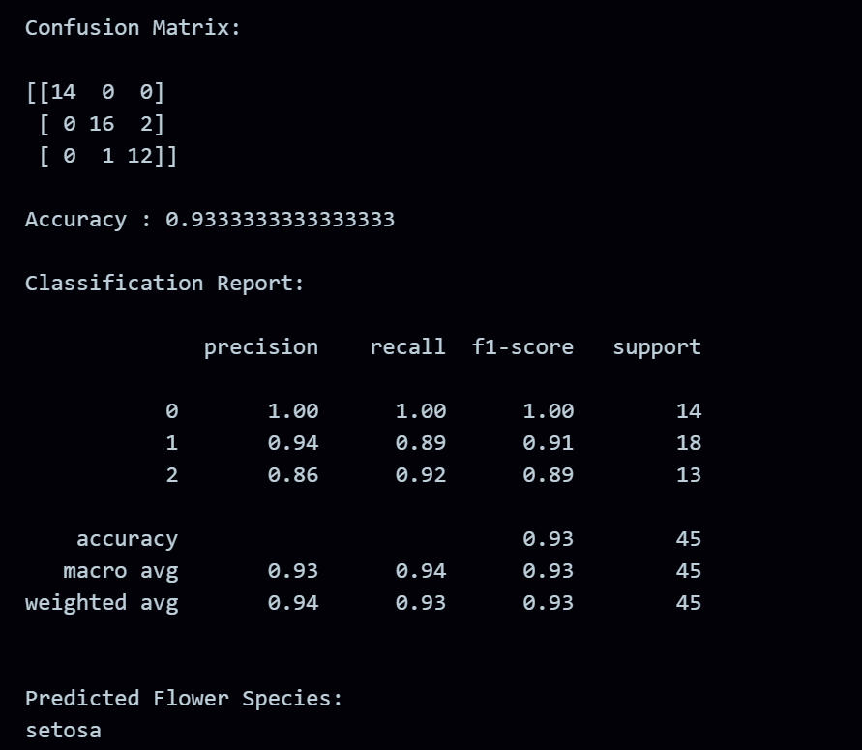
RESULT:
The program was successfully executed.

