ITA0608 - Machine Learning
Experiment No: 5
Title: Implementation of K-Nearest Neighbours (K-NN) Algorithm in Python
AIM:
To implement the K-Nearest Neighbours (K-NN) algorithm in Python and classify a new data sample using an appropriate dataset.
Algorithm:
- Import the required libraries.
- Load the dataset.
- Split the dataset into training and testing sets.
- Normalize the features using StandardScaler.
- Train the K-NN classifier.
- Predict the class labels for the test data.
- Calculate the accuracy.
- Predict the class of a new sample.
Code:
from sklearn.datasets import load_iris
from sklearn.model_selection import train_test_split
from sklearn.preprocessing import StandardScaler
from sklearn.neighbors import KNeighborsClassifier
from sklearn.metrics import accuracy_score, classification_report
# Load Iris Dataset
iris = load_iris()
X = iris.data
y = iris.target
# Split dataset into training and testing
X_train, X_test, y_train, y_test = train_test_split(
X, y, test_size=0.3, random_state=1
)
# Feature Scaling
scaler = StandardScaler()
X_train = scaler.fit_transform(X_train)
X_test = scaler.transform(X_test)
# Create K-NN Classifier
knn = KNeighborsClassifier(n_neighbors=3)
# Train the model
knn.fit(X_train, y_train)
# Predict test data
y_pred = knn.predict(X_test)
# Accuracy
print("Accuracy :", accuracy_score(y_test, y_pred))
print("\nClassification Report\n")
print(classification_report(y_test, y_pred))
# Predict a new sample
sample = [[5.1, 3.5, 1.4, 0.2]]
sample = scaler.transform(sample)
prediction = knn.predict(sample)
print("\nPrediction for New Sample:")
print(iris.target_names[prediction[0]])
OUTPUT:
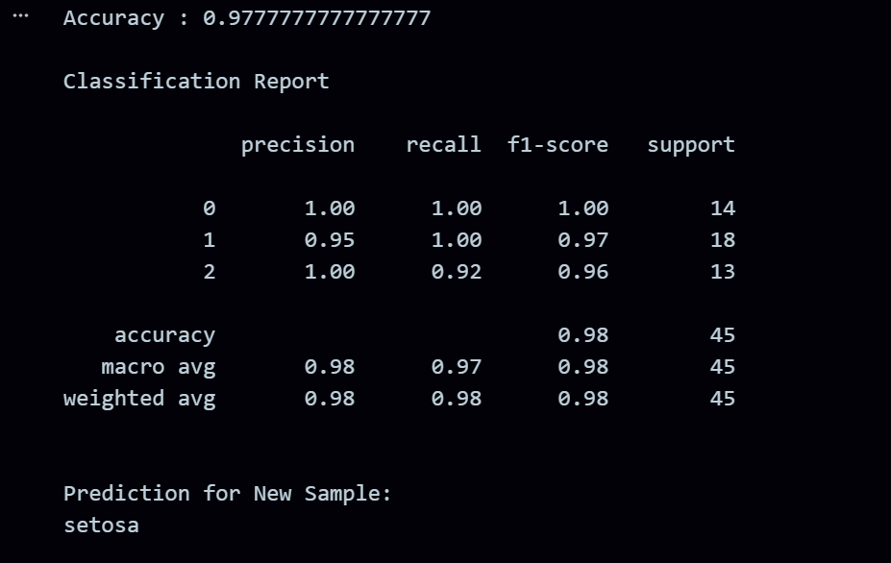
RESULT:
The program was successfully executed.

