<http://robotframework.org/robotframework/>

**Good link to under stand Robot:**

----------------------------------------------------------------

https://twiki.cern.ch/twiki/bin/view/EMI/RobotFrameworkAdvancedGuide#Getting_more_information

<http://robotframework.org/robotframework/latest/RobotFrameworkUserGuide.html#introduction>

### [1.1.1   Why Robot Framework?](http://robotframework.org/robotframework/latest/RobotFrameworkUserGuide.html#id412)

* Enables easy-to-use tabular syntax for [creating test cases](http://robotframework.org/robotframework/latest/RobotFrameworkUserGuide.html#creating-test-cases) in a uniform way.
* Provides easy-to-read result [reports](http://robotframework.org/robotframework/latest/RobotFrameworkUserGuide.html#report-file) and [logs](http://robotframework.org/robotframework/latest/RobotFrameworkUserGuide.html#log-file) in HTML format.
* Is platform and application independent.
* Provides a simple [library API](http://robotframework.org/robotframework/latest/RobotFrameworkUserGuide.html#creating-test-libraries) for creating customized test libraries which can be implemented natively with either Python or Java.
* Provides a [command line interface](http://robotframework.org/robotframework/latest/RobotFrameworkUserGuide.html#id145) and XML based [output files](http://robotframework.org/robotframework/latest/RobotFrameworkUserGuide.html#output-file) for integration into existing build infrastructure (**continuous integration systems**).
* Provides support for Selenium for web testing, Java GUI testing, running processes, Telnet, SSH, and so on.
* Supports creating [data-driven test cases](http://robotframework.org/robotframework/latest/RobotFrameworkUserGuide.html#data-driven-style).
* Has built-in support for [variables](http://robotframework.org/robotframework/latest/RobotFrameworkUserGuide.html#variables), practical particularly for testing in different environments.
* Provides [tagging](http://robotframework.org/robotframework/latest/RobotFrameworkUserGuide.html#tagging-test-cases) to categorize and [select test cases](http://robotframework.org/robotframework/latest/RobotFrameworkUserGuide.html#selecting-test-cases) to be executed.
* Enables easy integration with source control: [test suites](http://robot-framework.readthedocs.org/en/master/autodoc/robot.running.html#robot.running.model.TestSuite) are just files and directories that can be versioned with the production code.
* Provides [test-case](http://robotframework.org/robotframework/latest/RobotFrameworkUserGuide.html#test-setup-and-teardown) and [test-suite](http://robotframework.org/robotframework/latest/RobotFrameworkUserGuide.html#suite-setup-and-teardown) -level setup and teardown.

### [1.1.2   High-level architecture](http://robotframework.org/robotframework/latest/RobotFrameworkUserGuide.html#id413)

Robot Framework is a generic, application and technology independent framework. It has a highly modular architecture illustrated in the diagram below.

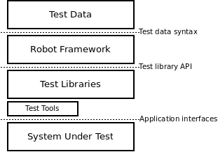

*Robot Framework architecture*

The [test data](http://robotframework.org/robotframework/latest/RobotFrameworkUserGuide.html#creating-test-data) is in simple, easy-to-edit tabular format. When Robot Framework is started, it processes the test data, [executes test cases](http://robotframework.org/robotframework/latest/RobotFrameworkUserGuide.html#id145) and generates logs and reports. The core framework does not know anything about the target under test, and the interaction with it is handled by [test libraries](http://robotframework.org/robotframework/latest/RobotFrameworkUserGuide.html#creating-test-libraries). Libraries can either use application interfaces directly or use lower level test tools as drivers.

### [1.1.3   Screenshots](http://robotframework.org/robotframework/latest/RobotFrameworkUserGuide.html#id414)

Following screenshots show examples of the [test data](http://robotframework.org/robotframework/latest/RobotFrameworkUserGuide.html#creating-test-data) and created [reports](http://robotframework.org/robotframework/latest/RobotFrameworkUserGuide.html#report-file) and [logs](http://robotframework.org/robotframework/latest/RobotFrameworkUserGuide.html#log-file).

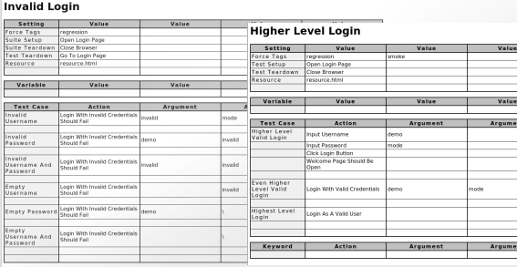

*Test case files*

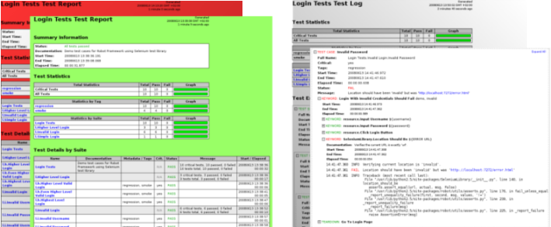

*Reports and logs*