Pending Topics to Learn:

Why Singleton or Global scope is bad? Is there a alternatives?

When we cannot avoid Singleton applications?

What is String interning?

Why Comparing equality of interned strings is a constant-time operation?

Already Used Collection methods:

String :

1. Convert String to char[]

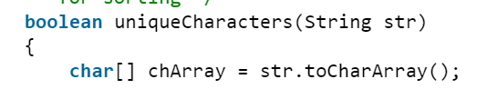

1. Arrays.sort

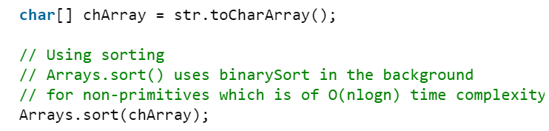

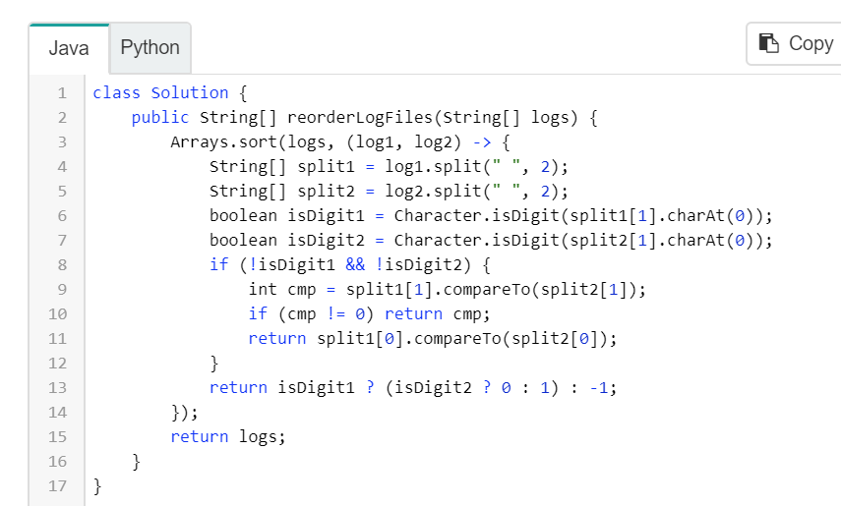

1. Arrays.fill

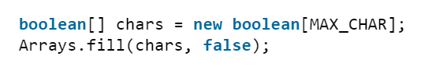

1. HashMap:

getOrDefault:

Map<Character, Integer> charFrequencyMap = new HashMap<>();

charFrequencyMap.getOrDefault(rightChar, 0)

1. Convert primitive int to String:
   1. String.valueOf(int)
2. Character.isDigit - Find character in a String is numeric or not / digit or not

String[] split2 = log2.split(" ", 2);

Character.isDigit(split1[1].charAt(0))