**MANDELBROT SET(OPENMP)**

Mandelbrot Set is a set of points in a complex plane that are quasi-stable (will increase and decrease, but not exceed some limit) when computed by iterating the function over pixels :

Z k+1 = z k + constant

Each pixel then has a real and an imaginary part (complex numbers) which can be fed into an iterative loop of its own:

Z k+1 = z k2 + constant

Initial value of z is zero.

Analysis of Mandelbrot using **static** OPENMP :

We calculate the pixels computed by the processes by shared memory. In static each processor computes fixed number of iterations. The number of corresponding processes increases, the time taken decreases.

1. Image resolution: 500*500

No. Of processes used: 50

Max_iteration: 256

Time analysis: real: 0.090s

usr: 0.067s

sys: 0.026s

2. Image resolution: 500*500

No. Of processes used: 100

Max_iteration: 256

Time analysis: real: 0.088s

usr: 0.056s

sys: 0.032s

Analysis of Mandelbrot using **dynamic** OPENMP:

In dynamic each processor computes different number of iterations (work load sharing). The number of corresponding processes increases, the time taken decreases.

Also, the time is less than the static openmp schedule.

1. Image resolution: 500*500

No. Of processes used: 50

Max_iteration: 256

Time analysis: real: 0.0661s

usr: 0.091s

sys: 0.020s

2. Image resolution: 500*500

No. Of processes used: 100

Max_iteration: 256

Time analysis: real: 0.0703s

usr: 0.057s

sys: 0.029

**ITERATION ANALYSIS**

The iterations are continued until the magnitude of z is greater than 2 or the number of iterations ( count_max ) reaches some arbitrary limit. The pixel is considered to be outside of the set ,breaking the iteration when it goes above the limit.

We color that pixel with a certain color depending on how many iterations it took to determine that it's outset the set.

We observe that a higher the max iteration value ( count_max ) , greater the precision with which we can say whether or not a point is in the set.

Also time to run increases because it's doing more calculations per pixel.

* Number of iterations is 50.

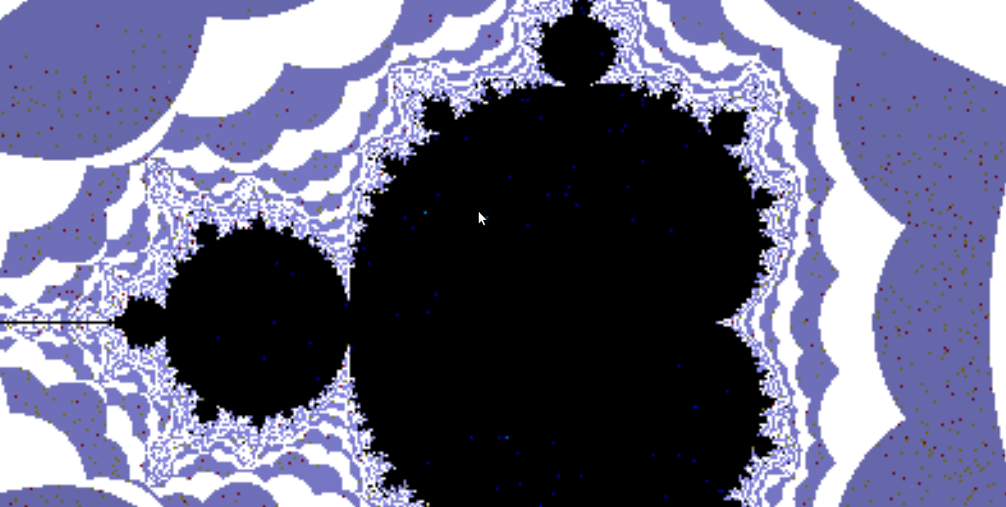

* Number of iterations is 5000.

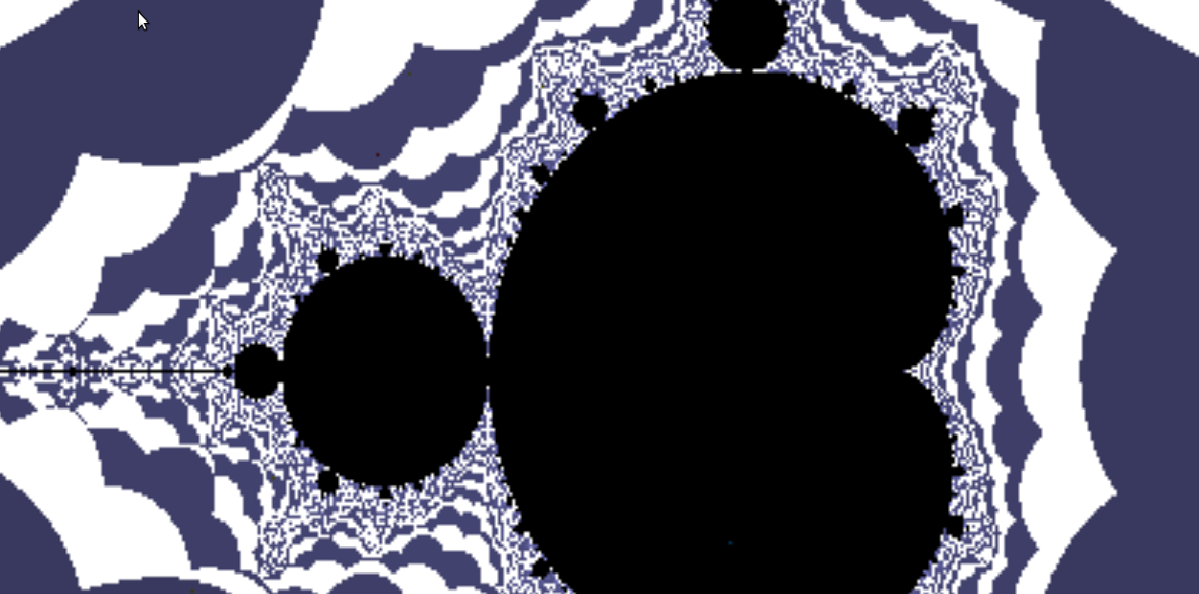

1. With increase in the maximum Iterations value, the detail of the edge of the set gets better.
2. The pixels outside the set are almost all in darker blue color.