Deliverables 1: Plan, Design and Research

1. An overview of the intended application and why you feel it’s valuable
   1. Family
   2. Business
   3. Affordable Travel Admissions
   4. Informative Decisions
2. Set of detailed screen-by-screen design layouts with annotations describing all UI/UX components and all data relevant to the screen
   1. 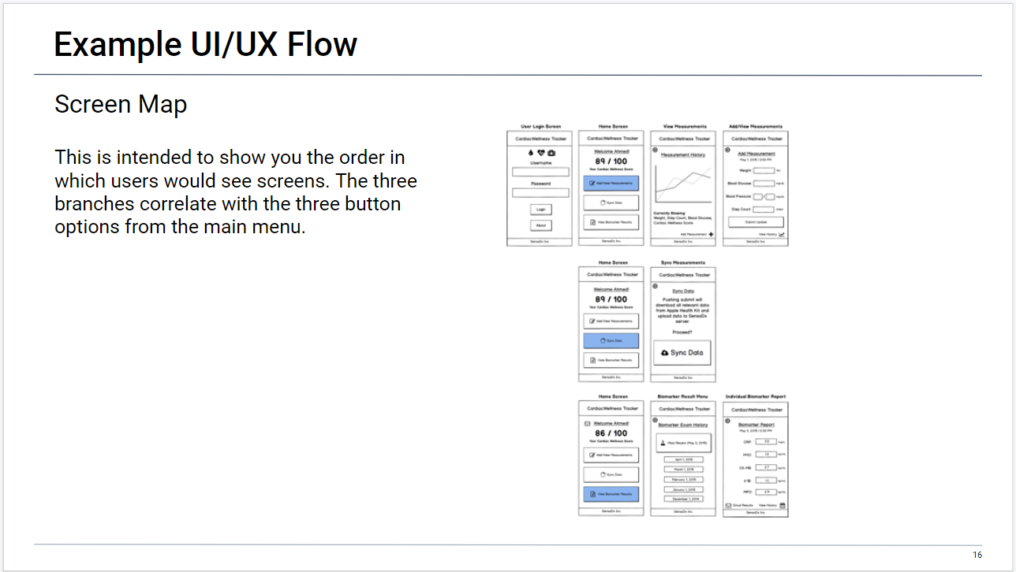
   2. 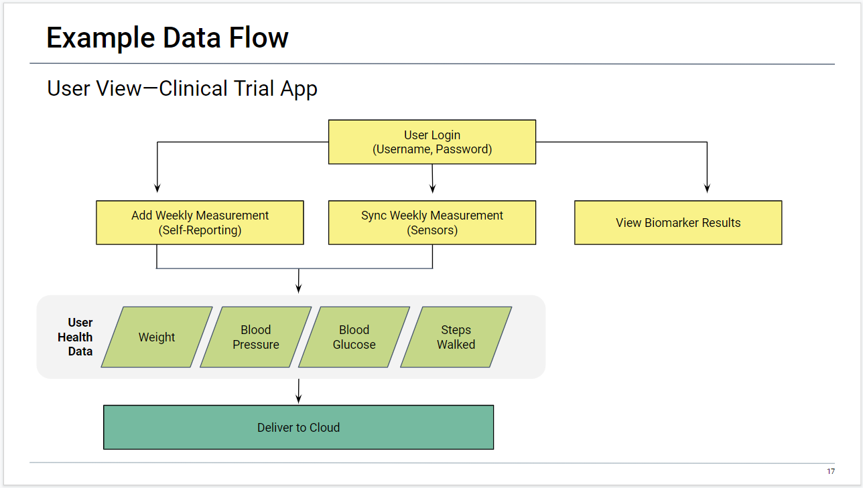
3. A breakdown of roles by group member
   1. Jenn – Frontend support, presentation coordinator support, lead presenter/demonstrator
   2. Kyle – Backend support, lead presentation coordinator, project coordinator support
   3. Tahmeena – Lead Backend, lead project coordinator
   4. Matt – Lead Frontend, backend support
4. A schedule for completion of various tasks.
   1. 11/14 – Assemble Team
   2. 11/17 – Application Decision / Wireframe
   3. 11/19 – Authentication
   4. 11/20 – Tahmeena goes on vacation 11/20 to 11/30
   5. 11/21 – Authentication Routing
   6. 11/24 – Country Selection and Routing
   7. 12/1 – Application of Covid API
   8. 12/3 – Routing to Currency Converter / Presentation Organization
   9. 12/5 – Application of Currency Converter API / Application of Protocol / Presentation Organization
   10. 12/8 – Polishing and Styling / Complete Presentation / Complete Presentation Scripts / Practice Presentation
   11. 12/10 – Presentation Day!
5. A screenshot of your Project Management Board that shows breakdown of tasks, assigned to group members with a schedule