# Enrollnment No. : 2302030430014

Assignment : 1

[Ans 1 : ]

Step 1: click on the “New” button to create a new repository.

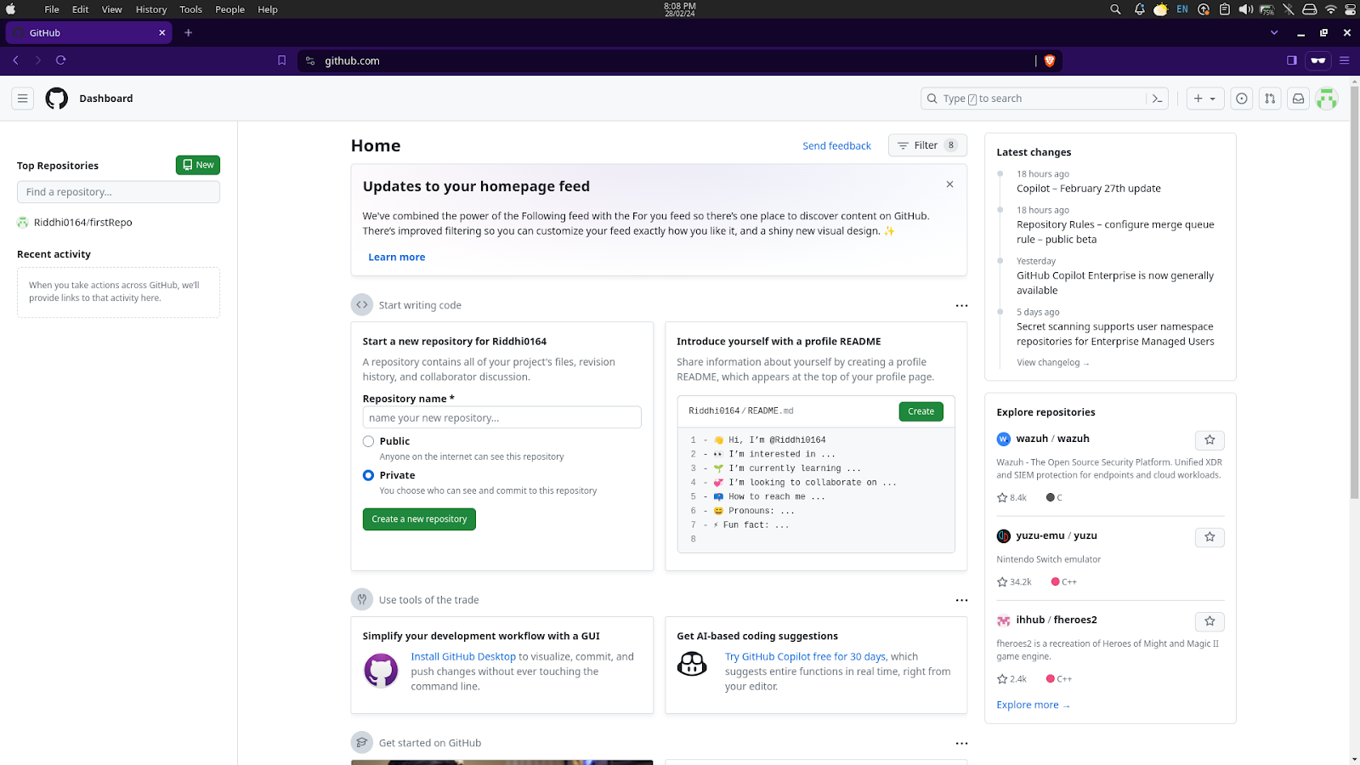

Step 2 : Give the name of the repository. Make it public or private by clicking on the given options. Add a README file if you want to. After that click on the “Create repository” button.

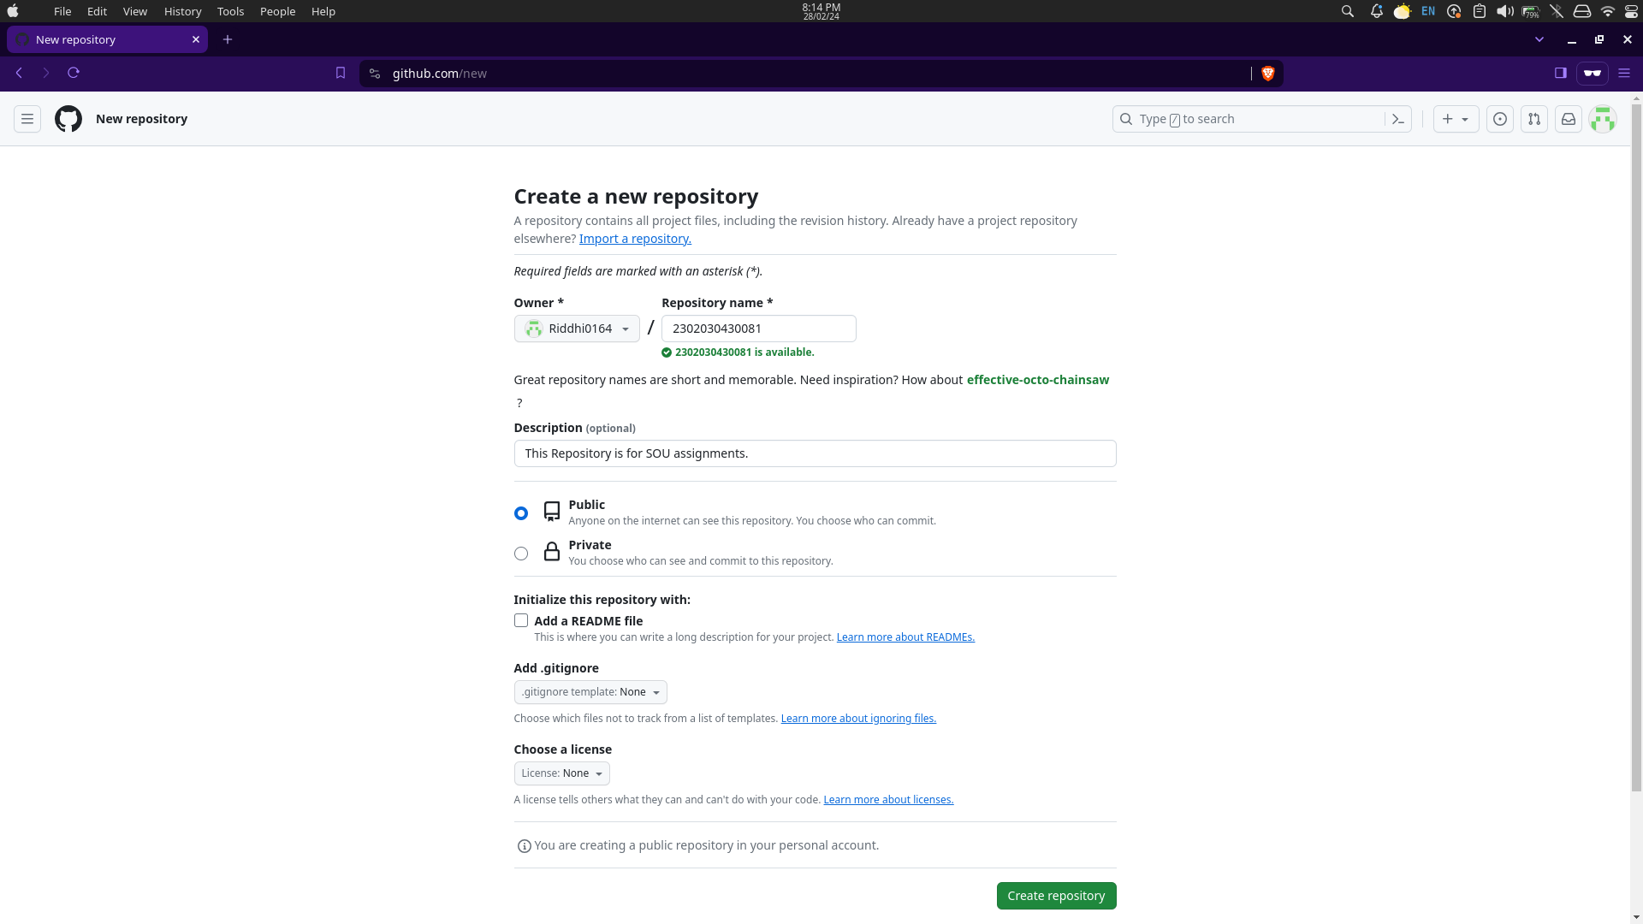

Like that, your GitHub repository has been created successfully.

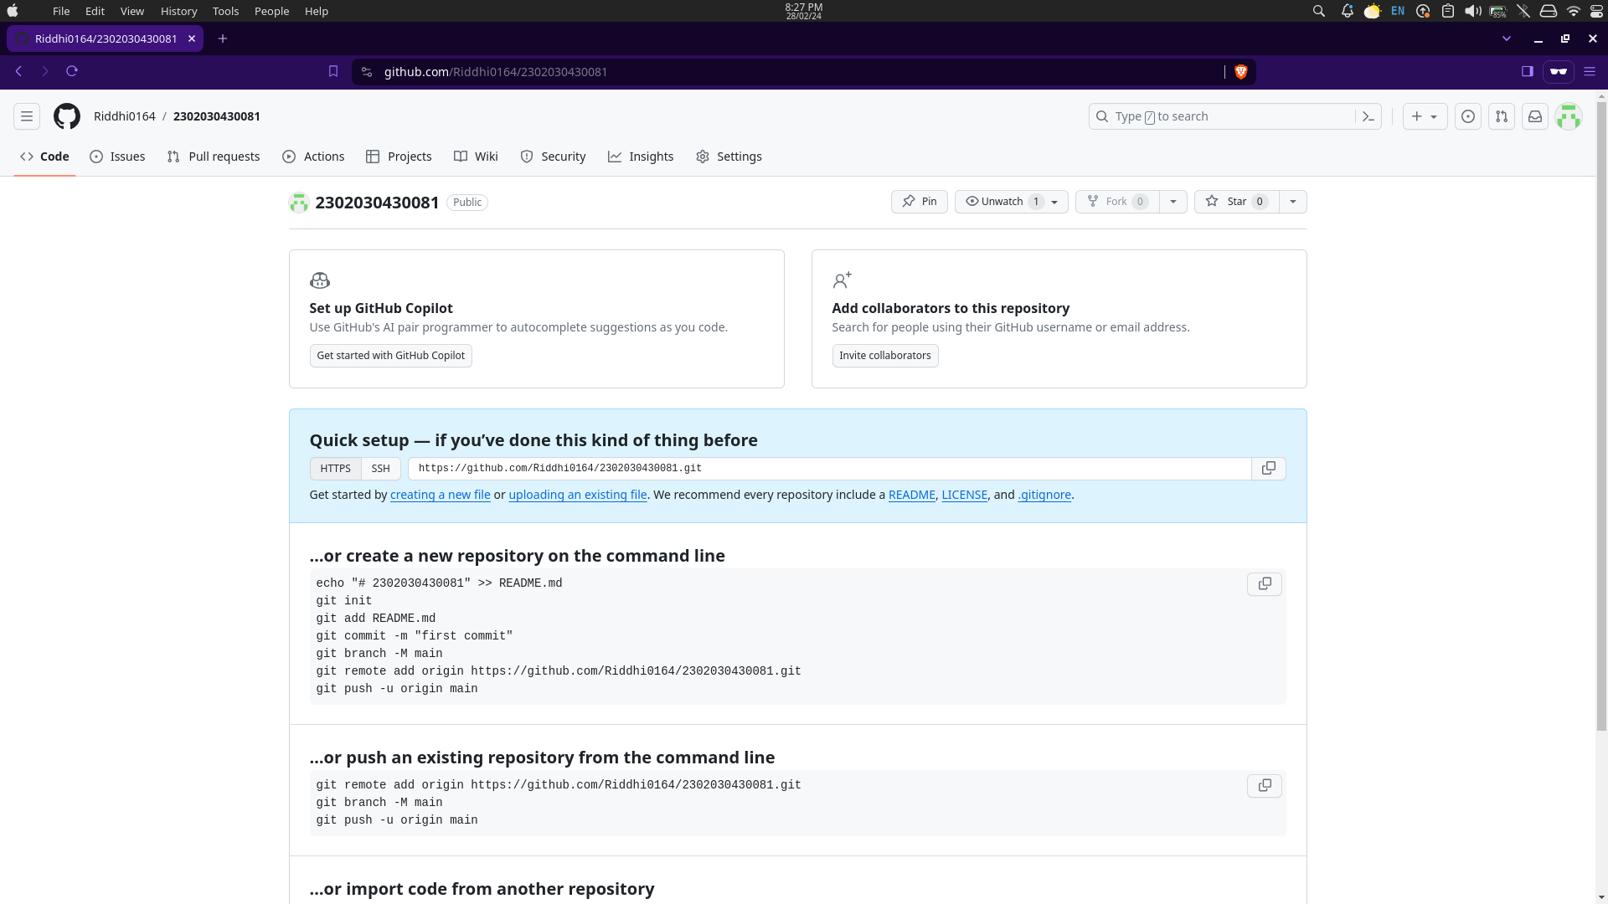

Step 3 : Scroll down and you will see the option for importing code.

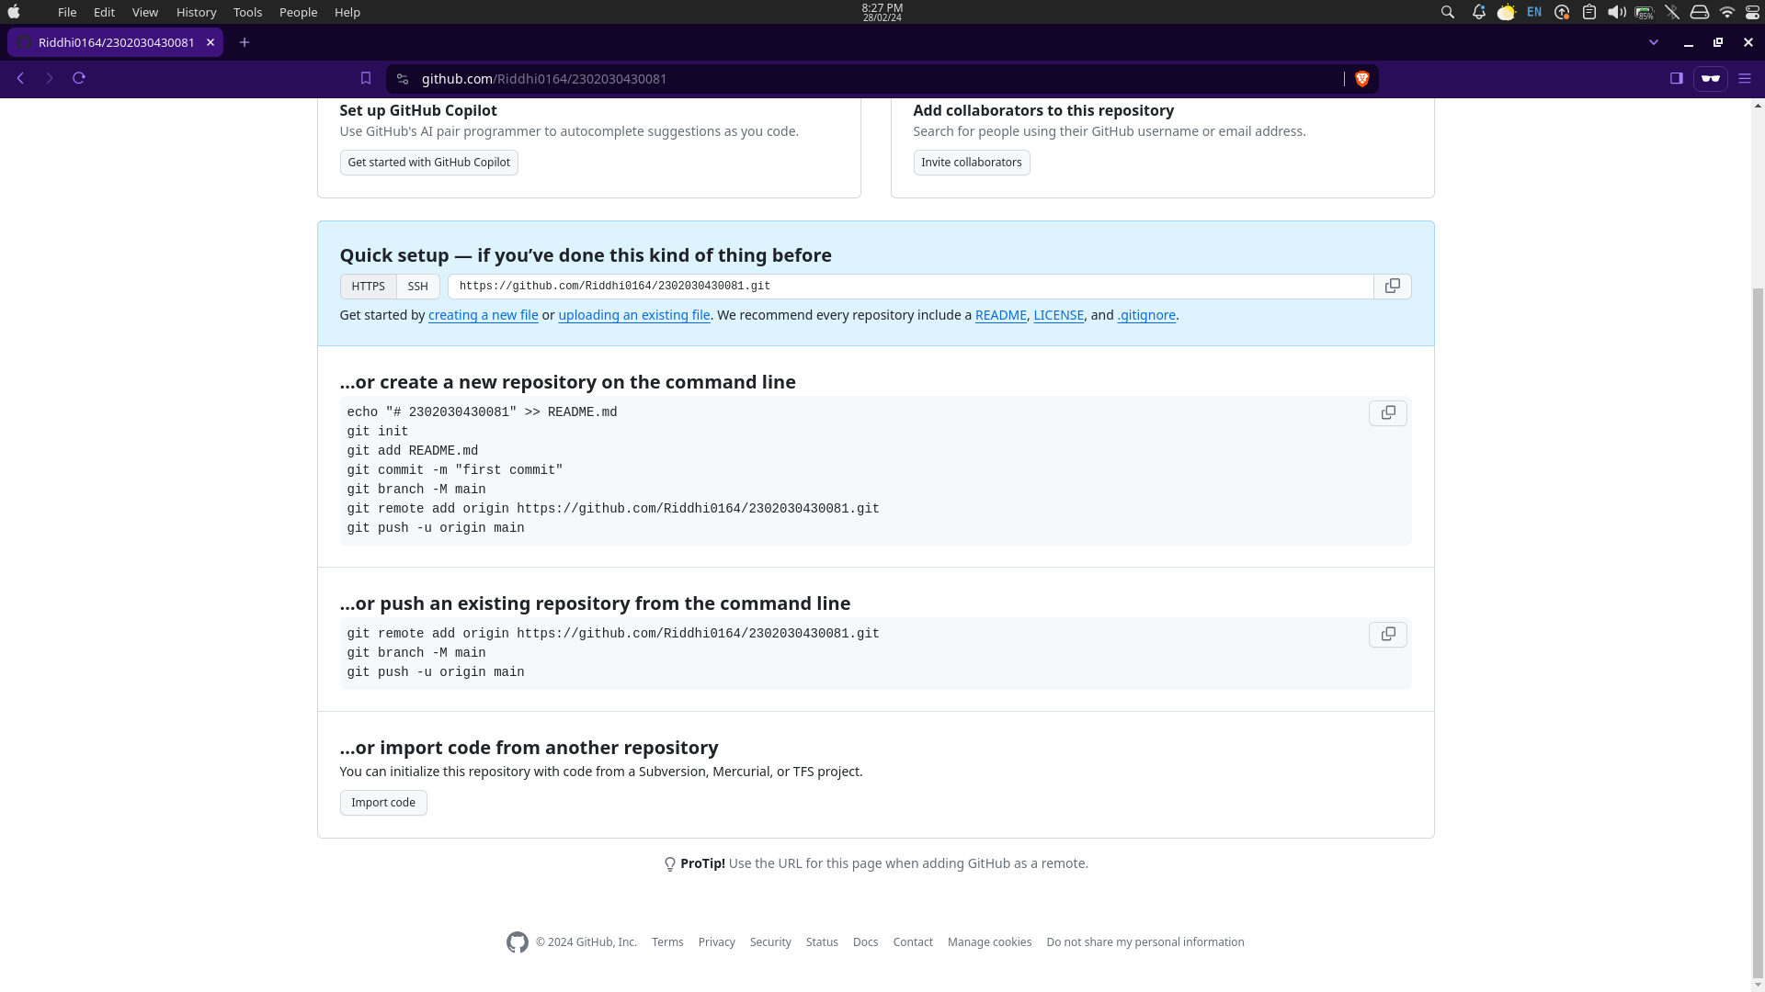

Click on “uploading an existing file” and you can start imporing the code files and folders to your REPO or follow the commands and execute them.

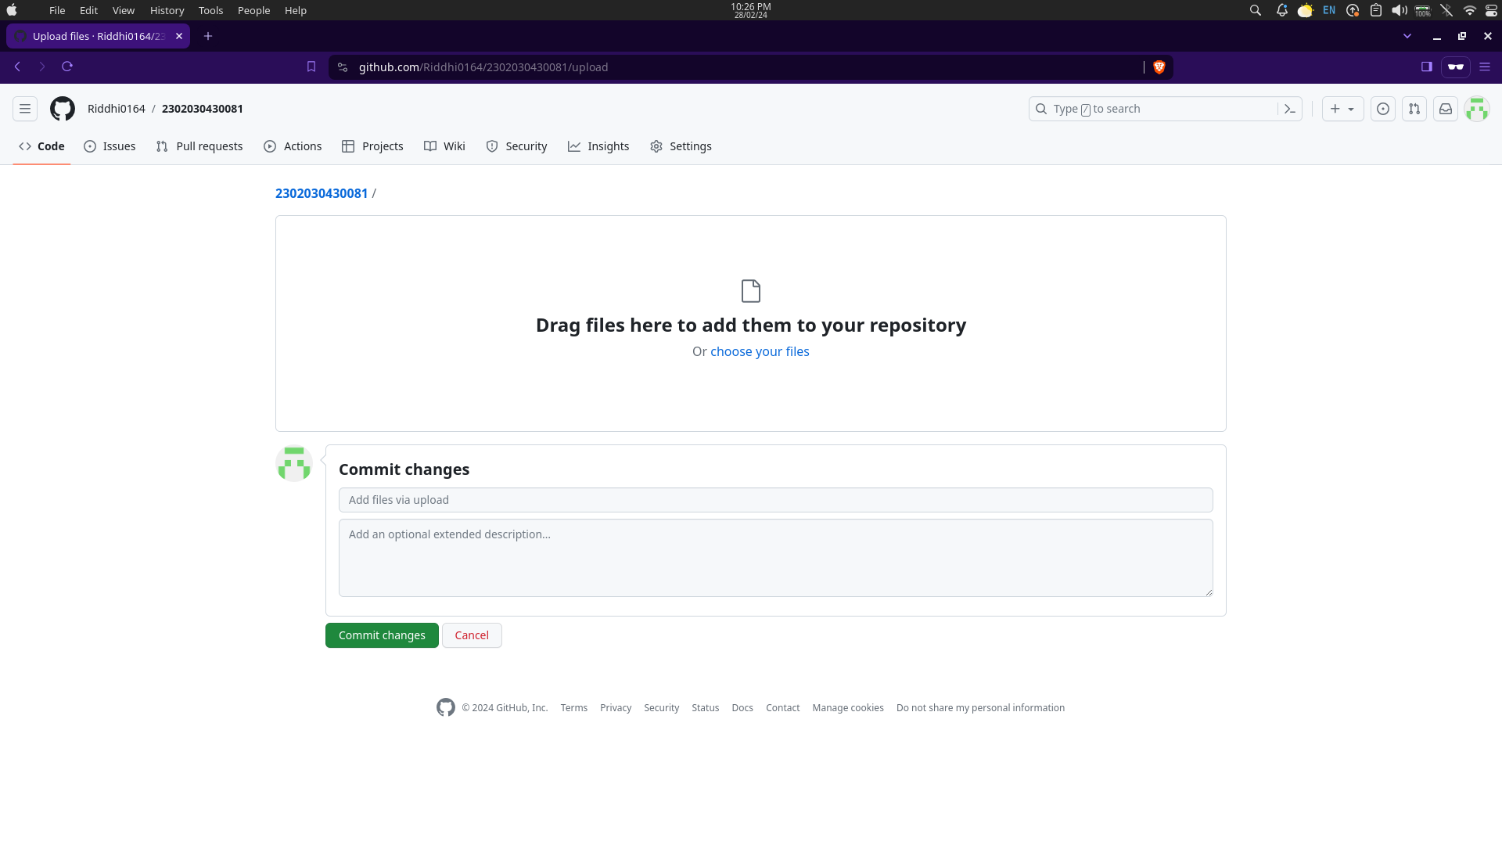

Or you can Click on “choose files” then select files or folders and upload them.