1. Detailed Implementation Report for the Backend Application:

1.1. Express Server (app.mjs):
- Set up an Express server to handle HTTP requests.
- Implemented CORS middleware (cors) to allow cross-origin requests.
- Utilized express.json() middleware to parse JSON requests.
- Configured API routes using the /api prefix.
- Started the server on port 3001.

1.2. API Routes (api.mjs):
- Created an Express Router for API routes.
- Implemented a GET endpoint /repositories to fetch popular repositories.
- Connected the endpoint to the getPopularRepositories controller.

1.3. GitHub Controller (githubController.mjs):
- Used Axios to make HTTP requests to the GitHub API.
- Implemented getPopularRepositories function to handle GET requests.
- Validated the count parameter and returned a 400 response if invalid.
- Fetched popular repositories from the GitHub API.
- Formatted the response to include repository name, stars, URL, and description.
- Handled errors and returned appropriate responses.

2. Functioning Frontend Interface:

2.1. React Application (App.js and TopReps.js):
- The App component is the root component rendering the TopReps component.
- TopReps component fetches and displays popular GitHub repositories.
- Utilizes React hooks (useState and useEffect) for state management.
- Implements a dropdown menu to select the number of repositories to display per page (repoCount).
- Paginates the list of repositories and provides navigation controls for moving between pages.
- Styles the components for a clean and user-friendly interface.

3. Check-in Code in GitHub:
- GitHub Repository Link:
  - https://github.com/madhav16/Github-Top-Repository.
  - https://github.com/madhav16/GitHub-Top-Repository-React-Code
4. Documentation and Code Overview:

4.1 Frontend Overview:
Project Introduction: The project aims to provide users with a user-friendly interface to explore and interact with popular GitHub repositories. Leveraging React on the frontend and Express on the backend, the application fetches data from the GitHub API, allowing users to customize their view of top repositories.
Key Technologies:
- React: Frontend framework for building a dynamic user interface.
- Express: Backend framework for handling API requests and managing server logic.
- Axios: Used for making HTTP requests to the GitHub API.
4.2. Frontend Screenshots:
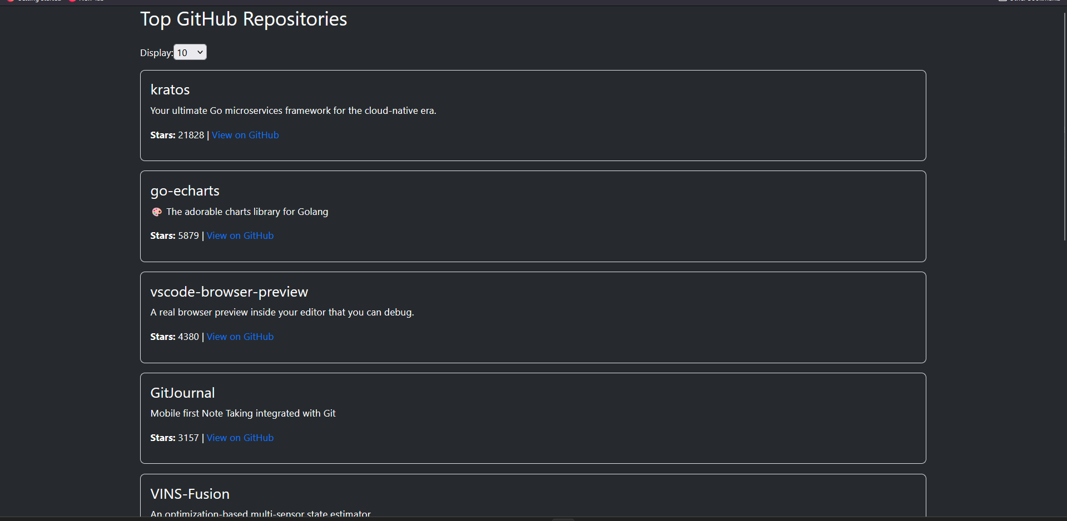
Description: The screenshot above depicts the initial state of the application upon loading. The default setting is configured to display the top 10 GitHub repositories, providing users with a quick overview of the most popular projects. Users can further customize their view by adjusting the repository count using the dropdown menu

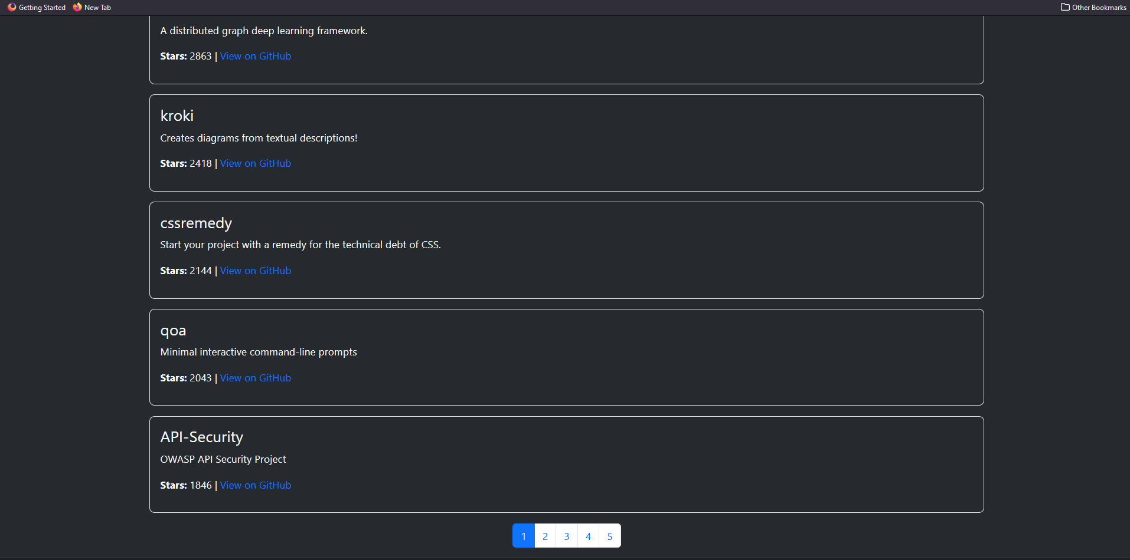

Description: In this screenshot, the user has opted to view 50 repositories per page using the dropdown menu. With this configuration, the application showcases an enhanced interface featuring active pagination controls. Users can seamlessly navigate through multiple pages, allowing for a more streamlined exploration of the extensive list of popular GitHub repositories

4.3 Code Check-in:
Version Control: The project uses Git for version control, allowing for effective collaboration and tracking of changes over time. Commits are made to the repository to document changes and improvements.
Recent Updates: The latest commit includes enhancements to the React components for improved user experience. The server-side code has been optimized for better handling of GitHub API requests.
Instructions for Checking Out the Latest Code: To check out the latest code, clone the repository using the following command:
git clone https://github.com/madhav16/GitHub-Top-Repository-React-Code.git
git clone https://github.com/madhav16/Github-Top-Repository.git

4.4 Conclusion:
Project Success: The implementation of the project has successfully achieved its goal of providing users with a seamless experience in exploring popular GitHub repositories. The integration of React and Express ensures efficient data retrieval and a responsive frontend.
Future Improvements: While the project has met its initial objectives, future enhancements could include additional features such as user authentication, sorting options, and further optimizations for large repository datasets. Collaboration and feedback from the open-source community could contribute to the project's ongoing development.
This structure provides a brief overview of the project, recent updates, and plans for the future. Feel free to adjust the content based on the specific details and achievements of your project.

