Design and Verification of an Overlapping Sequence Detector (1101)
Mealy and Moore FSM Implementation and Comparison in SystemVerilog
VLSI / RTL Design Internship Project
Submitted by: Madhav Purohit
Department of Electronics and Communication Engineering
NIT Hamirpur

Table of Contents
Abstract 3
1. Objective 3
2. Introduction 3
3. Mealy vs Moore Machine 3
4. FSM Design (Mealy Machine) 3
5. RTL Implementation (Mealy Machine) 4
6. Verification Methodology (Mealy Machine) 5
7. Simulation Results (Mealy Machine) 5
8. Moore Machine Implementation 6
8.1 FSM Design 6
8.2 RTL Implementation 7
8.3 Simulation Results 8
9. Comparison: Mealy vs Moore 9
10. Conclusion 10
11. Future Scope 10
References 10
Appendix A: Testbench Code 11
A.1 Mealy Machine Testbench 11
A.2 Moore Machine Testbench 12

Abstract
This report presents the design, RTL implementation, and functional verification of a digital sequence detector that identifies the overlapping occurrence of the bit pattern 1101 within a serial input stream. Both Mealy and Moore finite state machine (FSM) models of the detector were implemented in SystemVerilog, targeting simulation and synthesis on the Xilinx Vivado toolchain. Both designs were verified using self-checking testbenches covering normal detection, overlapping detection, and mid-sequence reset scenarios, and the results were confirmed through waveform analysis and compared against each other.

1. Objective
To design and implement a sequential digital circuit capable of detecting the pattern 1101 in a continuous serial bitstream, including cases where successive occurrences of the pattern overlap, using both Mealy and Moore FSM models, and to verify and compare their correctness through simulation.

2. Introduction
Sequence detectors are a fundamental class of finite state machines used extensively in digital systems for pattern recognition in a serial data stream. Typical applications include frame synchronization in communication protocols, start-bit detection in UART receivers, protocol header identification in networking hardware, and digital watermarking. A sequence detector observes one input bit per clock cycle and asserts an output signal when the target pattern has been observed at the end of the current bit stream.
This project implements a detector for the 4-bit pattern 1101 with overlap detection enabled, meaning that the final bits of one detected occurrence may also serve as the initial bits of the next occurrence, rather than requiring the detector to restart from scratch after every match.

3. Mealy vs Moore Machine
Two standard models exist for implementing finite state machines. In a Mealy machine, the output depends on both the current state and the current input, which allows the design to use fewer states and typically produces the output one clock cycle earlier than an equivalent Moore machine. In a Moore machine, the output depends only on the current state, which generally requires one additional state to represent the pattern being fully matched, but produces a more stable, glitch-free output. This project implements both versions and compares them directly; the Mealy design is presented first (Sections 4-5), followed by the Moore design (Section 8) and a detailed comparison (Section 9).

4. FSM Design (Mealy Machine)
The detector uses five states, S0 through S4, where each state represents the length of the matching prefix of the target sequence 1101 observed so far in the input stream. The complete state transition diagram is shown below, followed by the corresponding state transition table.
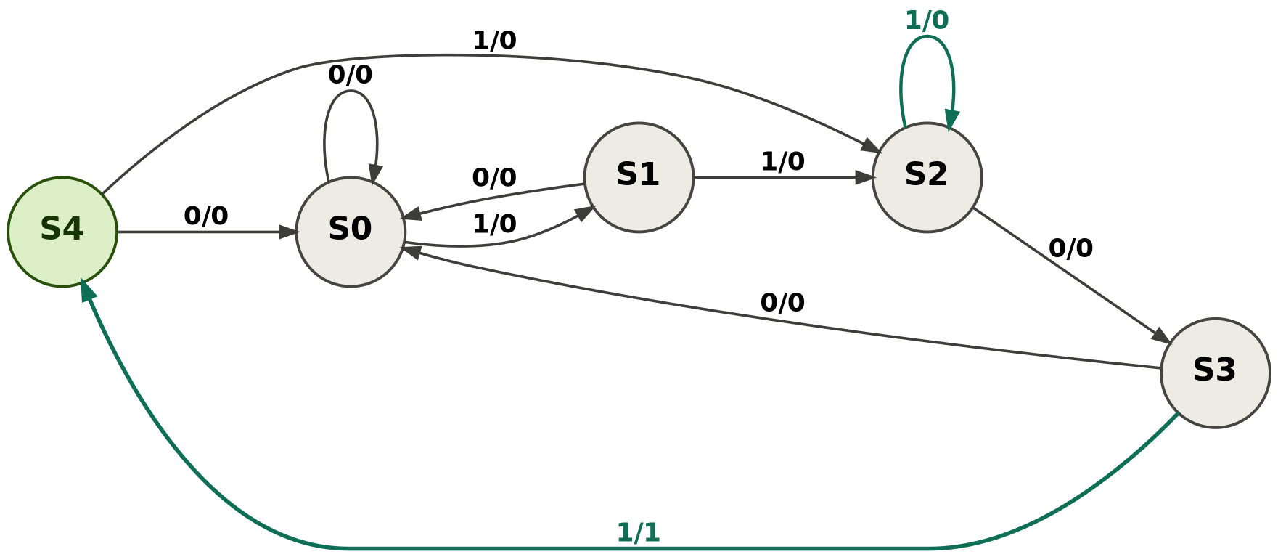
Figure 1: State transition diagram for the Mealy machine implementation (1101 sequence detector)
State transition table:
Present State | Input = 0 → Next / Output | Input = 1 → Next / Output
S0 | S0 / 0 | S1 / 0
S1 | S0 / 0 | S2 / 0
S2 | S3 / 0 | S2 / 0
S3 | S0 / 0 | S4 / 1
S4 | S0 / 0 | S2 / 0

The self-loop on S2 for input 1 is the key mechanism that enables correct overlap handling: when two consecutive 1s are received while in S2 (representing a match of "11"), the state remains at S2 rather than falling back, since the longest matching prefix of the target pattern is still "11".

5. RTL Implementation (Mealy Machine)
The design was described in SystemVerilog using a two-always-block coding style: a synchronous state register and a combinational next-state/output logic block. The complete RTL code is given below.
module seq_detector_mealy (
input logic clk,
input logic rst_n, // active-low reset
input logic din, // serial input bit
output logic dout // high for 1 cycle when "1101" detected
);

typedef enum logic [2:0] {
S0 = 3'b000, S1 = 3'b001, S2 = 3'b010,
S3 = 3'b011, S4 = 3'b100
} state_t;

state_t current_state, next_state;

// State register
always_ff @(posedge clk or negedge rst_n) begin
if (!rst_n) current_state <= S0;
else current_state <= next_state;
end

// Next-state logic
always_comb begin
next_state = current_state;
case (current_state)
S0: next_state = din ? S1 : S0;
S1: next_state = din ? S2 : S0;
S2: next_state = din ? S2 : S3;
S3: next_state = din ? S4 : S0;
S4: next_state = din ? S2 : S0;
default: next_state = S0;
endcase
end

// Output logic (Mealy)
always_comb begin
dout = (current_state == S3) && din;
end

endmodule

6. Verification Methodology (Mealy Machine)
A directed testbench was developed to apply serial bit sequences to the design and monitor the output using the $monitor system task. Three scenarios were exercised:
- Normal detection: a single, non-overlapping occurrence of 1101 within the input stream.
- Overlapping detection: the stream 1101101, in which the pattern occurs twice with shared bits.
- Reset recovery: an asynchronous reset asserted mid-sequence, followed by a fresh, correctly detected sequence.

7. Simulation Results (Mealy Machine)
The design was simulated in Vivado using the behavioral simulator. The waveform below shows the clk, rst_n, din, and dout signals across the full test duration.
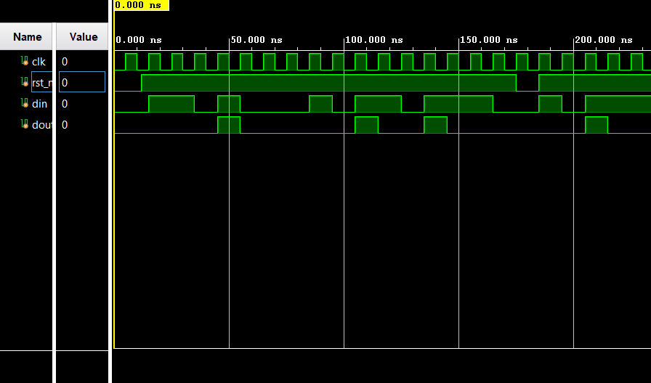
Figure 2: Simulation waveform for the Mealy machine implementation
Four assertions of dout are observed across the simulation: one for the normal detection case, two closely spaced assertions for the overlapping case, and one further assertion following the mid-sequence reset. This matches the expected behavior for all three test scenarios, confirming that the design correctly detects both isolated and overlapping occurrences of the target pattern and recovers correctly after an asynchronous reset.

8. Moore Machine Implementation
To compare both FSM models for the same detection problem, an equivalent Moore machine version of the sequence detector was also designed and implemented. Unlike the Mealy version, output here depends only on the current state, which requires one additional state, S5, to represent a completed match.

8.1 FSM Design
The Moore machine uses six states, S0 through S5. States S0 to S4 track the matching prefix exactly as in the Mealy design, while S5 is a dedicated "match complete" state whose output is permanently 1 while the machine remains there. From S5, the next input is used to resume prefix tracking for overlap detection, transitioning to S2 on a 1 or S3 on a 0.
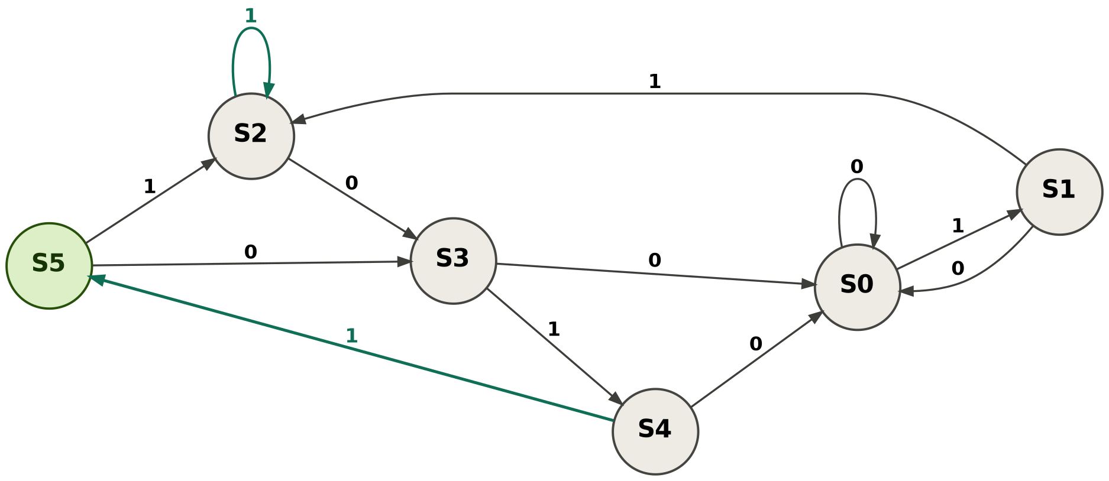
Figure 3: State transition diagram for the Moore machine implementation
State transition table:
Present State | Output | Input = 0 → Next | Input = 1 → Next
S0 | 0 | S0 | S1
S1 | 0 | S0 | S2
S2 | 0 | S3 | S2
S3 | 0 | S0 | S4
S4 | 0 | S0 | S5
S5 | 1 | S3 | S2

8.2 RTL Implementation
The Moore machine follows the same two-always-block coding structure as the Mealy design, with the output now generated purely from the current state.
module seq_detector_moore (
input logic clk,
input logic rst_n, // active-low reset
input logic din, // serial input bit
output logic dout // high for 1 cycle when "1101" detected
);

typedef enum logic [2:0] {
S0 = 3'b000, S1 = 3'b001, S2 = 3'b010,
S3 = 3'b011, S4 = 3'b100, S5 = 3'b101
} state_t;

state_t current_state, next_state;

// State register
always_ff @(posedge clk or negedge rst_n) begin
if (!rst_n) current_state <= S0;
else current_state <= next_state;
end

// Next-state logic
always_comb begin
next_state = current_state;
case (current_state)
S0: next_state = din ? S1 : S0;
S1: next_state = din ? S2 : S0;
S2: next_state = din ? S2 : S3;
S3: next_state = din ? S4 : S0;
S4: next_state = din ? S5 : S0;
S5: next_state = din ? S2 : S3;
default: next_state = S0;
endcase
end

// Output logic (Moore)
always_comb begin
dout = (current_state == S5);
end

endmodule

8.3 Simulation Results
The Moore design was simulated using the same three test scenarios as the Mealy version (normal detection, overlapping detection, and mid-sequence reset), so that the two implementations could be directly compared.
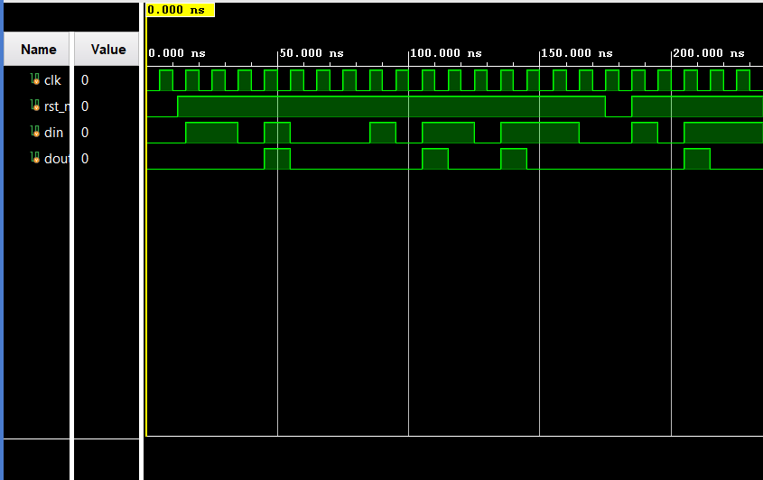
Figure 4: Simulation waveform for the Moore machine implementation
As with the Mealy version, four assertions of dout are observed, confirming correct detection across all three scenarios. The key difference is timing: each dout assertion in the Moore waveform occurs one clock cycle later than the corresponding assertion in the Mealy waveform, since the output is only updated after the state register transitions to S5.

9. Comparison: Mealy vs Moore
Aspect | Mealy machine | Moore machine
Number of states | 5 (S0-S4) | 6 (S0-S5)
Output depends on | State and input | State only
Output timing | Same clock cycle as match | One clock cycle delayed
Output stability | Can glitch with input changes | Stable, glitch-free
Hardware cost | Slightly lower | Slightly higher (extra state)

Both implementations correctly detect the overlapping pattern 1101 and recover cleanly from a mid-sequence reset. The Mealy machine responds faster, asserting dout in the same cycle as the matching input bit, which is useful when low latency matters. The Moore machine trades one cycle of latency for a more stable, predictable output that changes only on clock edges, which is often preferred in larger synchronous systems where glitch-free control signals are important.

10. Conclusion
Both Mealy and Moore finite state machines for detecting the overlapping pattern 1101 were successfully designed, implemented in SystemVerilog, and verified through simulation. Both designs correctly handle normal detection, overlapping sequences, and reset recovery, as confirmed by waveform analysis, and differ primarily in output timing and stability as summarized in the comparison above. Both designs are synthesizable and suitable for further hardware implementation.

11. Future Scope
- Synthesize the design in Vivado to obtain area, timing, and power reports.
- Extend the design to a parameterizable sequence detector for arbitrary bit patterns.

References
1. IEEE Standard for SystemVerilog, IEEE Std 1800-2017.
2. Xilinx Vivado Design Suite User Guide: Simulation, UG900.
3. S. Palnitkar, Verilog HDL: A Guide to Digital Design and Synthesis, Pearson Education.

Appendix A: Testbench Code
This appendix contains the complete testbench code used to verify both the Mealy and Moore implementations of the sequence detector. The same three test scenarios (normal detection, overlapping detection, and mid-sequence reset) are applied in both testbenches to allow a direct comparison of results.

A.1 Mealy Machine Testbench
module seq_detector_tb;

logic clk;
logic rst_n;
logic din;
logic dout;

// Instantiate DUT
seq_detector_mealy dut (
.clk(clk),
.rst_n(rst_n),
.din(din),
.dout(dout)
);

// Clock generation: 10ns period
initial clk = 0;
always #5 clk = ~clk;

// Test sequence
initial begin
$display("Time\tdin\tdout");
$monitor("%0t\t%b\t%b", $time, din, dout);

rst_n = 0;
din = 0;
#12;
rst_n = 1;

// Test 1: normal detect -> stream contains 1101
send_bit(0); send_bit(1); send_bit(1); send_bit(0);
send_bit(1); // dout should go high here
send_bit(0); send_bit(0);
#10;

// Test 2: overlapping detect -> 1 1 0 1 1 0 1
send_bit(1); send_bit(1); send_bit(0);
send_bit(1); // first "1101" detected here
send_bit(1); send_bit(0);
send_bit(1); // overlapping "1101" detected here again
#10;

// Test 3: reset in the middle of a partial match
send_bit(1); send_bit(1); send_bit(0);
rst_n = 0; // reset while mid-sequence
#10;
rst_n = 1;
send_bit(1); send_bit(1); send_bit(0);
send_bit(1); // should still detect correctly after reset

#20;
$display("Simulation complete.");
$finish;
end

// Task to apply one bit for one clock cycle
task send_bit(input logic b);
din = b;
@(posedge clk);
endtask

endmodule

A.2 Moore Machine Testbench
The Moore testbench follows the same structure and test sequence as the Mealy testbench above, with the DUT instantiation changed to reference seq_detector_moore. The complete listing is given below.
module seq_detector_moore_tb;

logic clk;
logic rst_n;
logic din;
logic dout;

// Instantiate DUT
seq_detector_moore dut (
.clk(clk),
.rst_n(rst_n),
.din(din),
.dout(dout)
);

// Clock generation: 10ns period
initial clk = 0;
always #5 clk = ~clk;

// Test sequence — identical to the Mealy testbench for direct comparison
initial begin
$display("Time\tdin\tdout");
$monitor("%0t\t%b\t%b", $time, din, dout);

rst_n = 0;
din = 0;
#12;
rst_n = 1;

// Test 1: normal detect -> stream contains 1101
send_bit(0); send_bit(1); send_bit(1); send_bit(0);
send_bit(1); // match completes here -> dout high on NEXT cycle
send_bit(0); send_bit(0);
#10;

// Test 2: overlapping detect -> 1 1 0 1 1 0 1
send_bit(1); send_bit(1); send_bit(0);
send_bit(1); // first match
send_bit(1); send_bit(0);
send_bit(1); // overlapping second match
#10;

// Test 3: reset in the middle of a partial match
send_bit(1); send_bit(1); send_bit(0);
rst_n = 0; // reset while mid-sequence
#10;
rst_n = 1;
send_bit(1); send_bit(1); send_bit(0);
send_bit(1); // should still detect correctly after reset

#20;
$display("Simulation complete.");
$finish;
end

// Task to apply one bit for one clock cycle
task send_bit(input logic b);
din = b;
@(posedge clk);
endtask

endmodule

