Transfer data between MySQL and HDFS (Import and Export) using Sqoop.

1. Exporting Data from HDFS to MySQL
2. We will be using employee_dat.txt file in HDFS to load in MySQL.

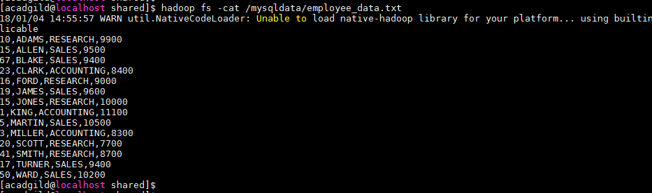

1. Create table employee in MySQL.

**create table employee**

**(empid int(6),**

**empname varchar(30),**

**deptname varchar(30),**

**salary float);**

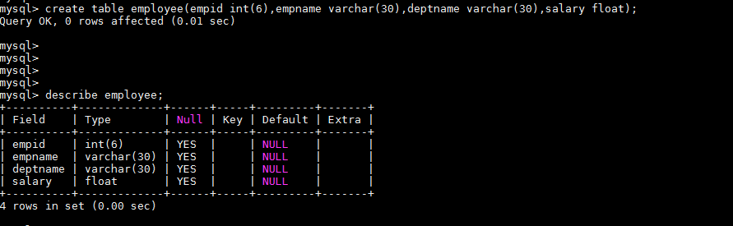

1. Sqoop command to export data from HDFS to Mysql:

**sqoop export --connect jdbc:mysql://localhost/mydatabase --username madhav --password madhav@123 --table employee --export-dir /mysqldata/ --m 1**

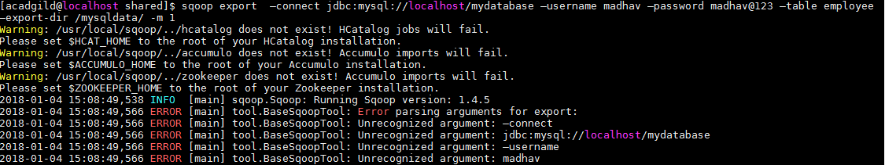

1. Check the data in employee table.

**select * from employee;**

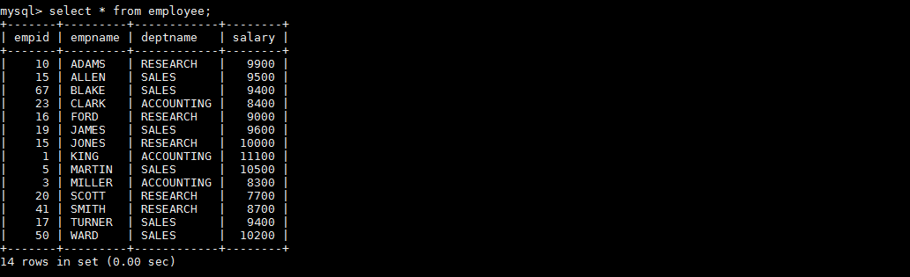

Importing Data from MySQL to HDFS

1. sqoop import command to import data from MySQL to HDFS:

**sqoop import --connect jdbc:mysql://localhost/mydatabase --username madhav --password madhav@123 --table employee --m 1 --target-dir /output_empdata**

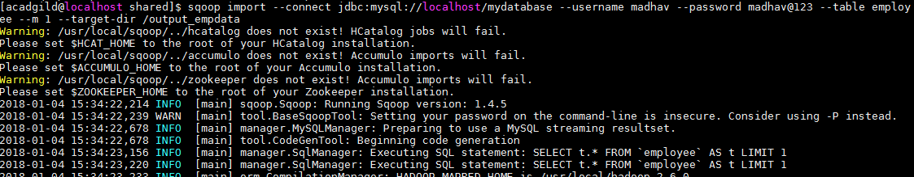

1. Verify the imported data :

**hadoop fs -cat /output_empdata/part-m-00000**

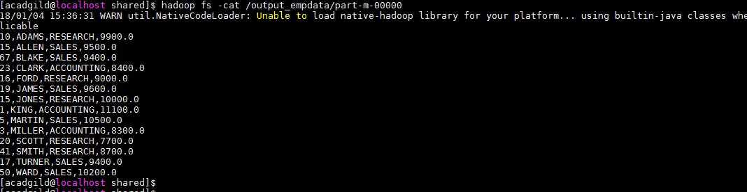

1. **Transfer data between MySQL and Hive (Import and Export only selected columns) using Sqoop**

Importing Data from MySQL to Hive

1. Use below command to import data from MySQL to hive :

**sqoop import --connect jdbc:mysql://localhost:3306/mydatabase --username root -P --columns empid,empname --table employee --target-dir /myhive --fields-terminated-by "," --hive-import --create-hive-table --hive-table myhivedb.employee_data -m 1**

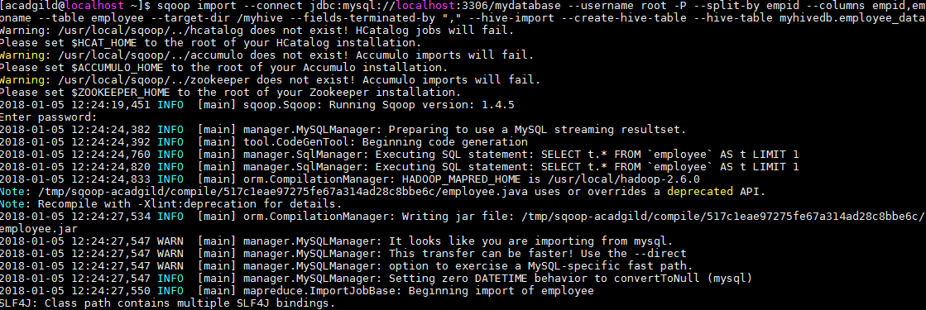

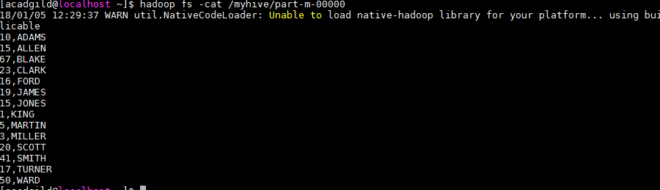

1. Creating employee table in Hive:

**CREATE EXTERNAL TABLE EMPLOYEE_DATA**

**(**

**EMPID INT,**

**EMPNAME VARCHAR(30)**

**)**

**ROW FORMAT DELIMITED**

**FIELDS TERMINATED BY ','**

**LINES TERMINATED BY '\n'**

**LOCATION**

**'hdfs://localhost:9000/myhive' ;**

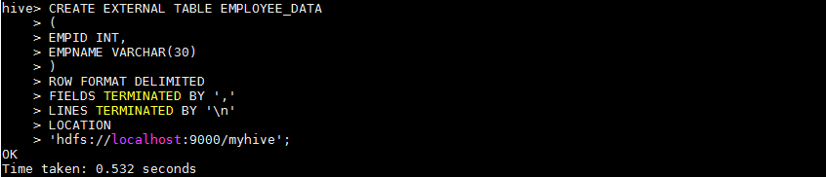

1. SELECT * FROM EMPLOYEE_DATA;

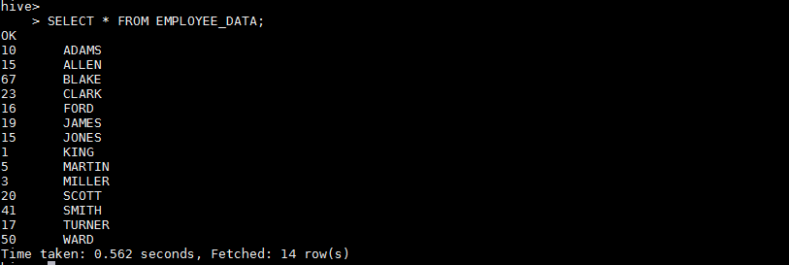

Exporting Data from MySQL to Hive

1. Create table **employee_details** in MySQL

**create table employee_details**

**(**

**empid int(5),**

**empname varchar(30)**

**);**

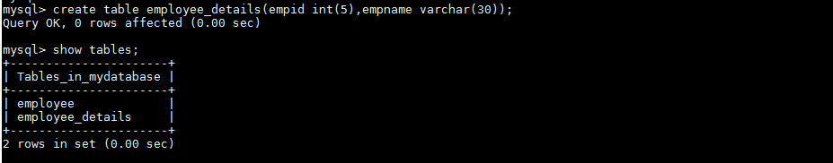

1. Use below Sqoop command to export data from Hive to MySQL :

**sqoop export \**

**--connect jdbc:mysql://localhost:3306/mydatabase \**

**--username madhav \**

**--password madhav@123 \**

**--table employee_details \**

**--direct \**

**--export-dir /myhive**

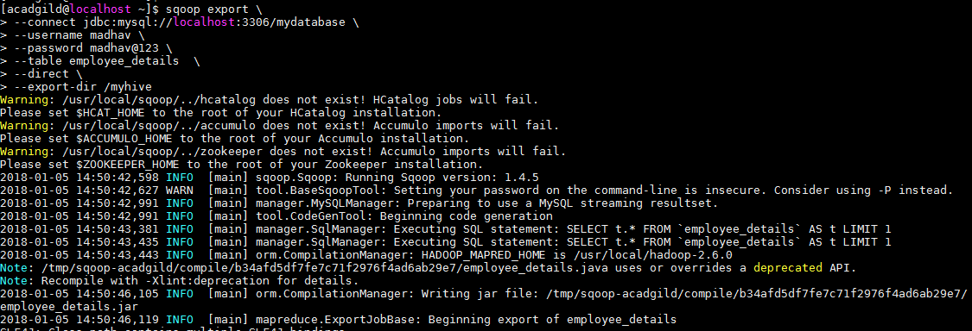

1. Check the data in MySQL **:**

**select * from employee_details;**

