**INCREMENTAL LOAD IN HIVE TABLE USING SQOOP**

1. Create **employees** table in hive if it doesn’t exists :

**create external table if not exists employees**

**(empid int,**

**empname varchar(30),**

**salary int**

**)**

**row format delimited**

**fields terminated by ','**

**location '/sqoop_emp_data1';**

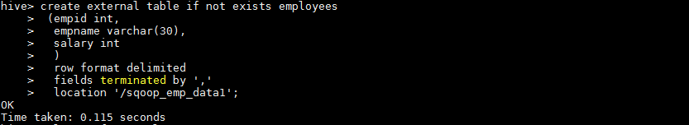

1. Perform first time load :

**sqoop import \**

**--connect jdbc:mysql://localhost/mydatabase \**

**-username root -P \**

**--table employees \**

**--target-dir /sqoop_emp_data1 \**

**--fields-terminated-by "," \**

**--hive-import --hive-table myhivedb.employees**

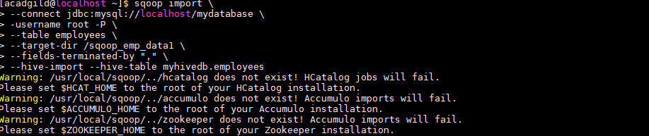

1. Check the data in hive **employees** table :

**Select * from employees;**

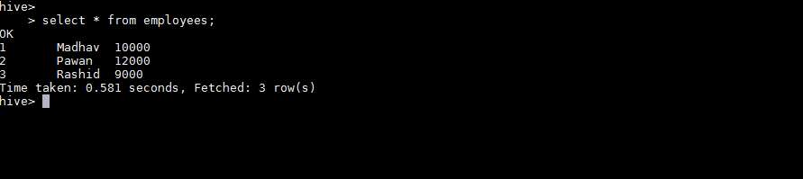

1. Reinsert some data in MySQL to perform incremental load :

**insert into employees values(4,"Sameer",20000),(5,"Prabhat",11000);**

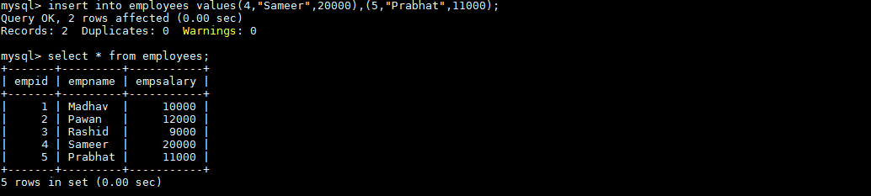

1. Perform Incremental load using Sqoop :

**sqoop import \**

**--connect jdbc:mysql://localhost/mydatabase \**

**--username root -P \**

**--table employees \**

**--target-dir /sqoop_emp_data1 \**

**--fields-terminated-by "," \**

**--hive-import --hive-table myhivedb.employees \**

**--incremental append \**

**--check-column empid \**

**--last-value 3**

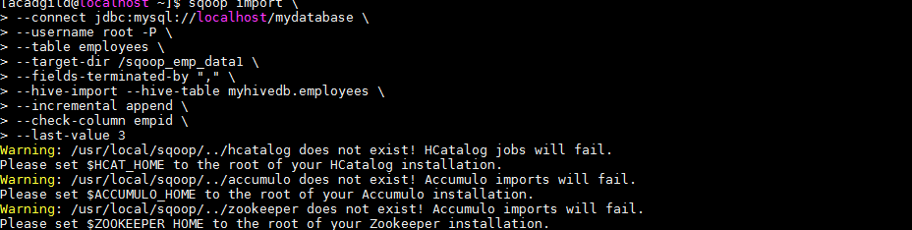

1. Now check the data again in hive table :

**Select * from employees;**

