1. Login to Twitter

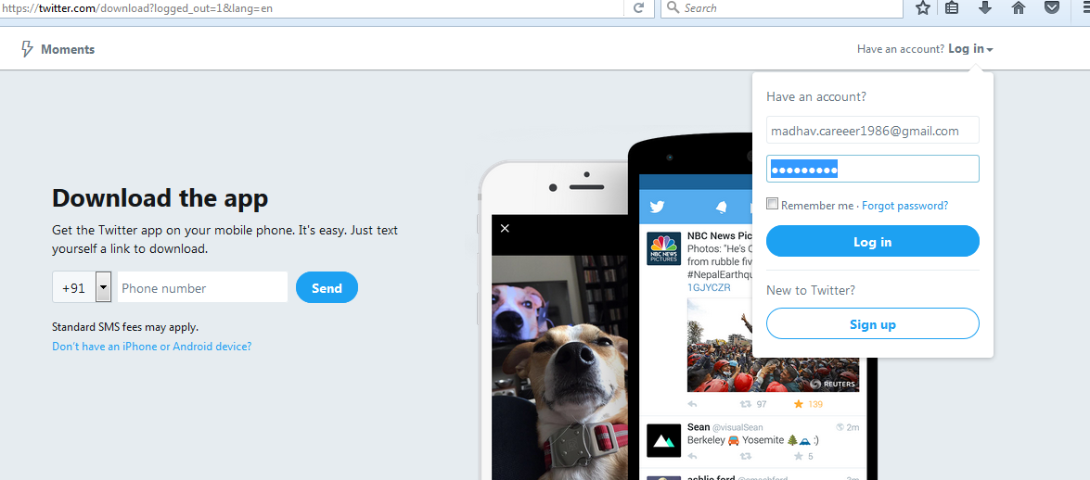

1. Go to the following link and click the ‘create new app’ button**.**

[**https://apps.twitter.com/app**](https://apps.twitter.com/app)

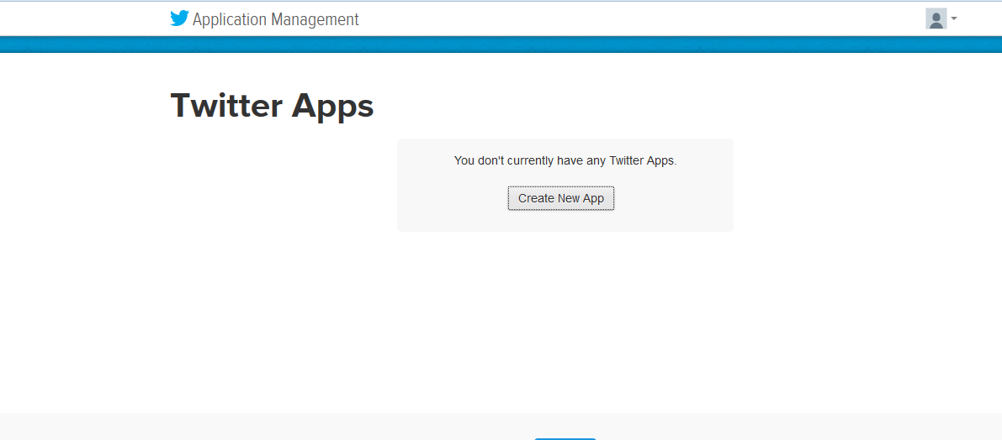

1. Enter the necessary details :

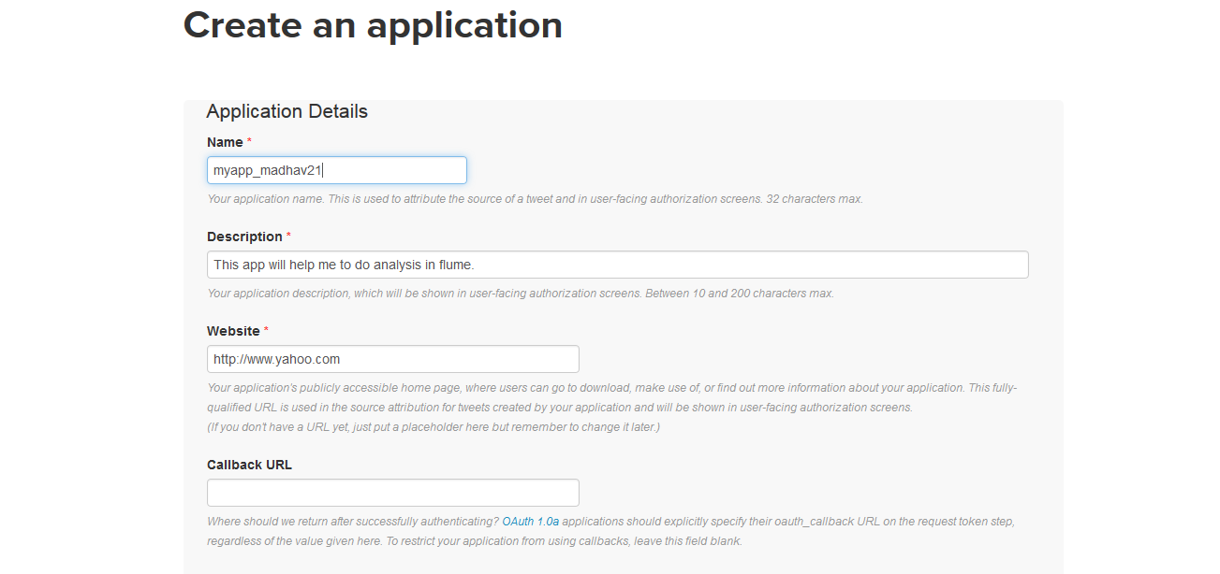

1. Accept the developer agreement and select the 'create your Twitter application' button.

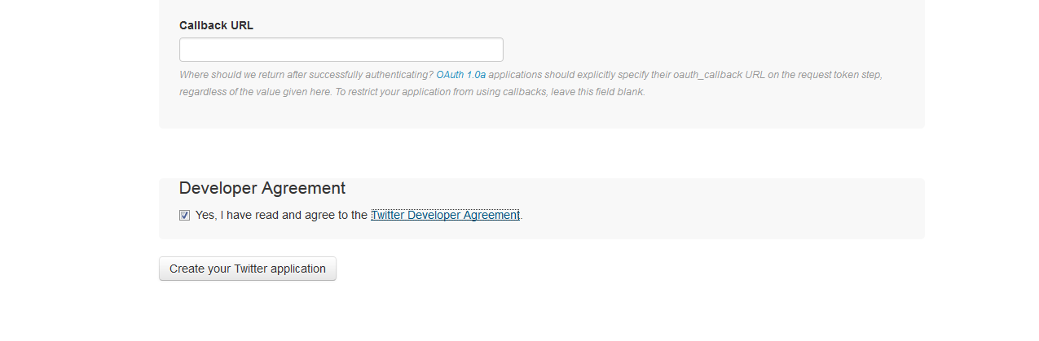

1. Select the 'Keys and Access Token' tab.

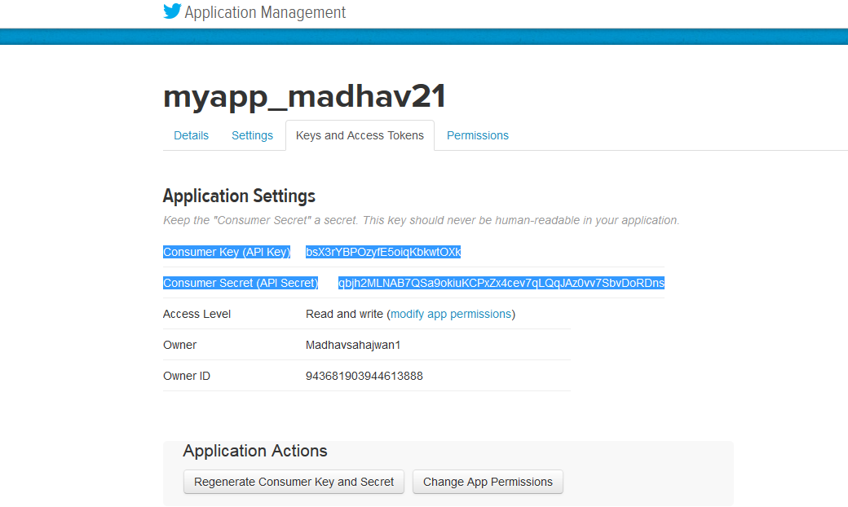

1. Copy the consumer key and the consumer secret code.
2. Scroll down further and select the 'create my access token' button.

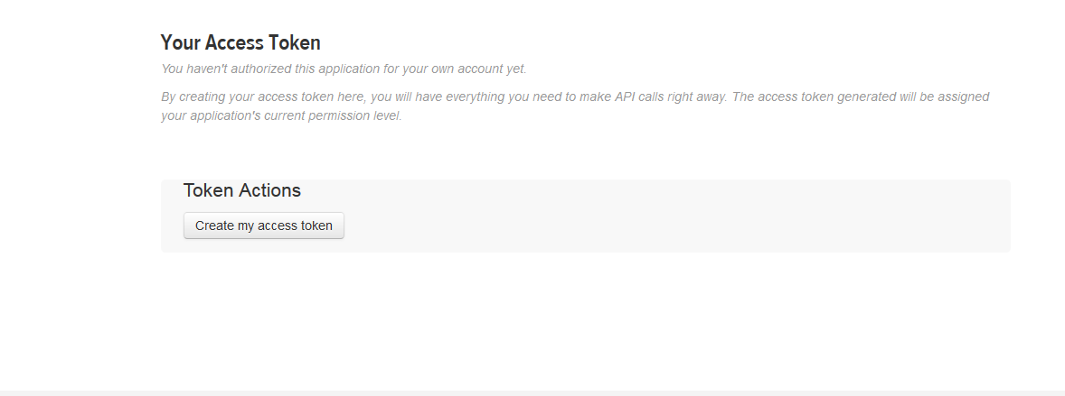

1. Now, you will receive a message stating "that you have successfully generated your application access token".

Copy the Access Token and Access token Secret code.

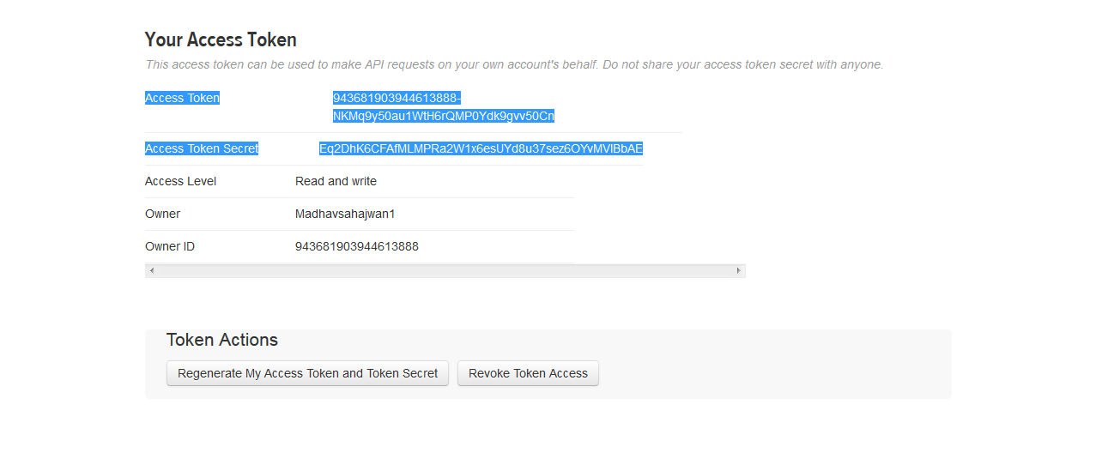

1. Make sure you have below jars placed in your $FLUME_HOME/lib directory:

**twitter4j-core-X.XX.jar**

**twitter4j-stream-X.X.X.jar**

**twitter4j-media-support-X.X.X.jar**

1. Create flume configuration file and make the changes accordingly:

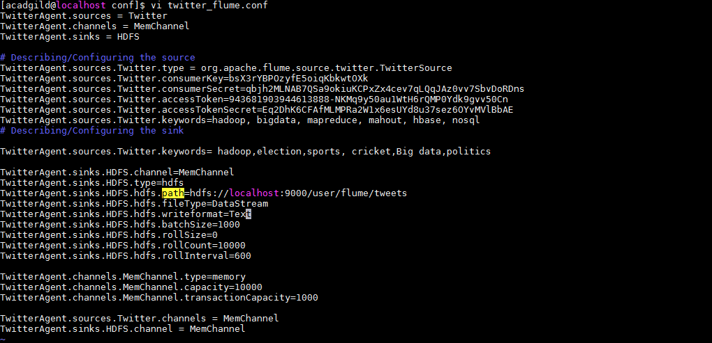

1. Create a new directory where twitter tweets will be stored :

**hadoop fs -mkdir -p /user/flume/tweets**

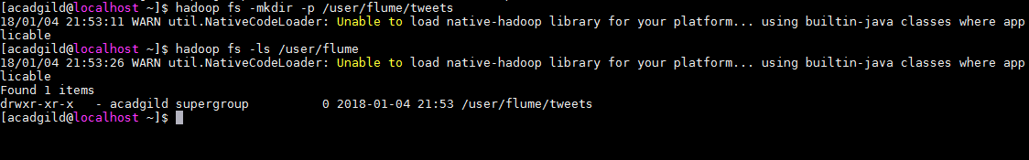

1. For fetching data from Twitter, Use the below command to fetch the twitter tweet data into the HDFS cluster path :

**flume-ng agent -n TwitterAgent -f /usr/local/flume/conf/twitter_flume.conf**

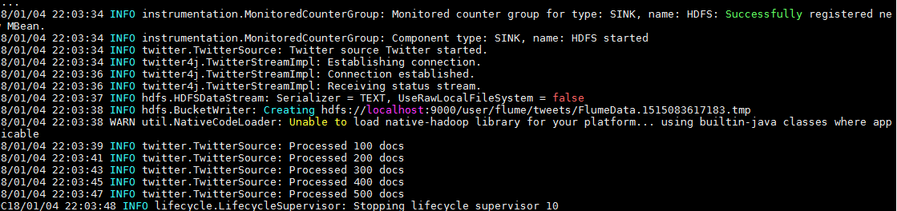

Once, the tweet data started streaming it into the given HDFS path we can use ‘Ctrl+c’ command to stop the streaming process.

1. Check the contents of tweet data by using below command :

**hadoop fs -ls /user/flume/tweets**

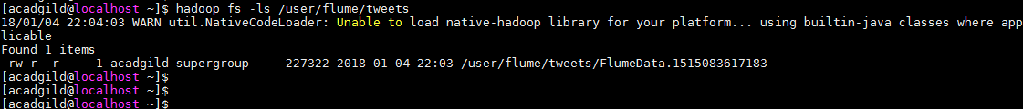

1. Check the contents of tweets data using below command :

**hadoop fs -cat /user/flume/tweets/FlumeData.1515083617183**

