Open the virtual box and follow the steps

1. Click on File -> Import Appliance

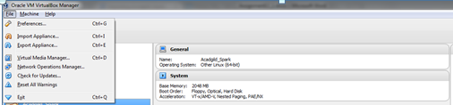

2. Provide the path of AcadGild Spark VM

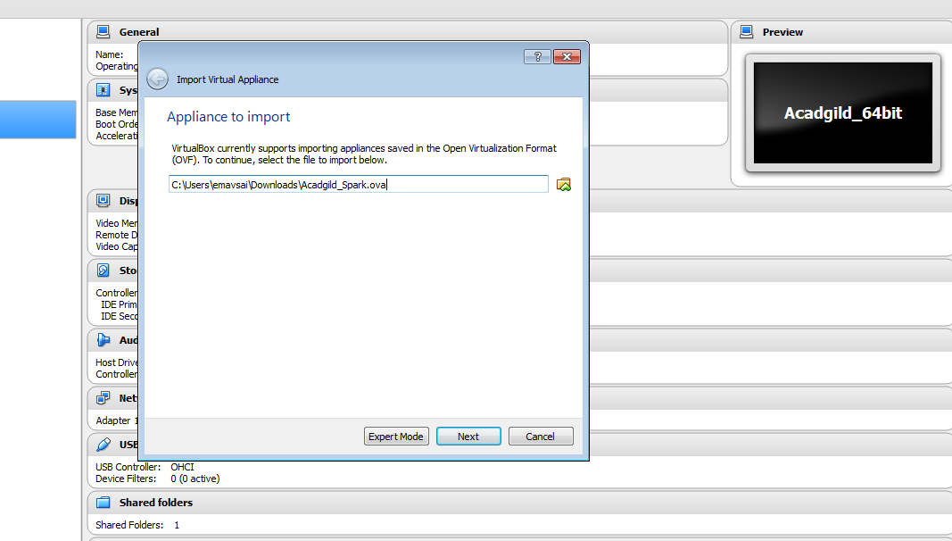

3. Click on Import button

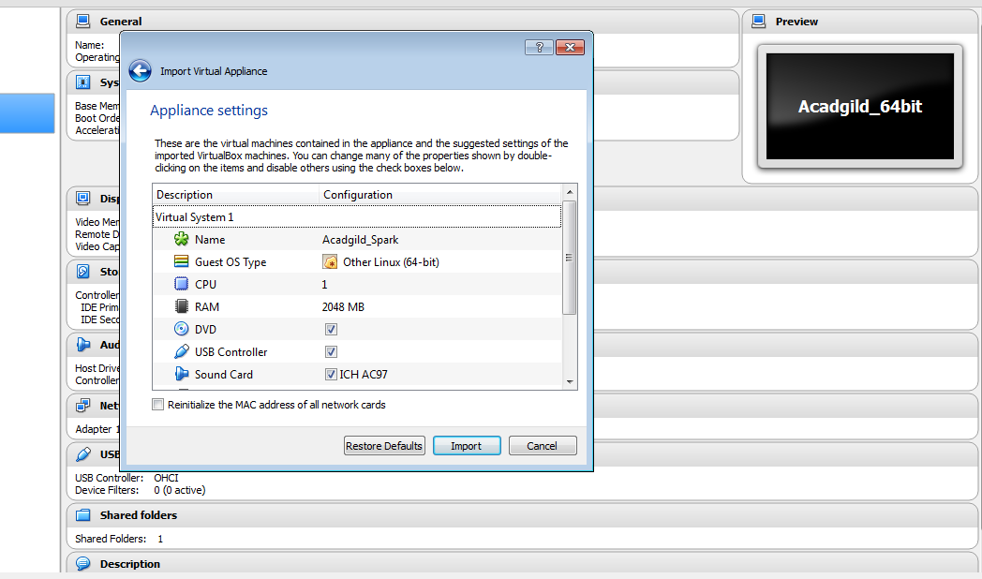

4. Import will start

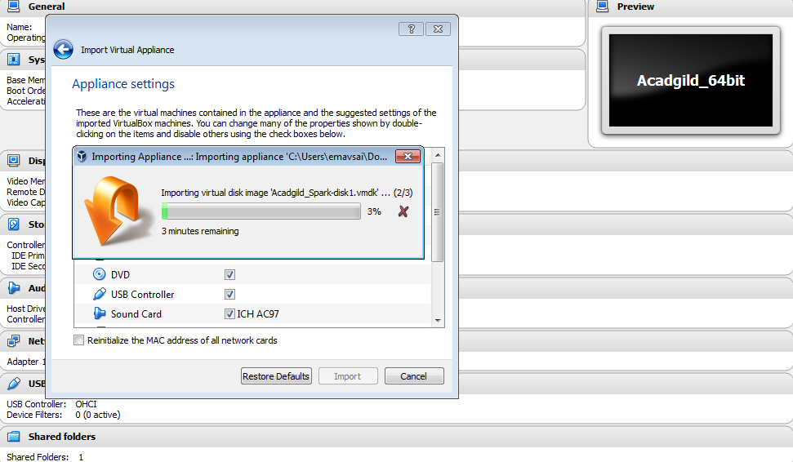

5. Once the import is finished, click on **start** button

Give the password as **acadgild**

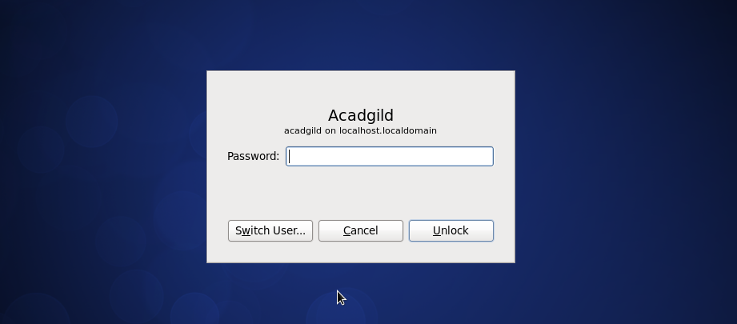

6. Type **jps** command to check the list of daemons

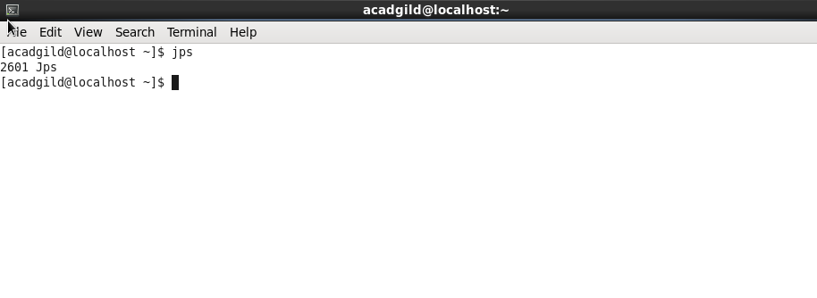

7. Starting Hadoop Daemons (NameNode, DataNode, ResoureManager, NodeManager, JobHistoryServer)

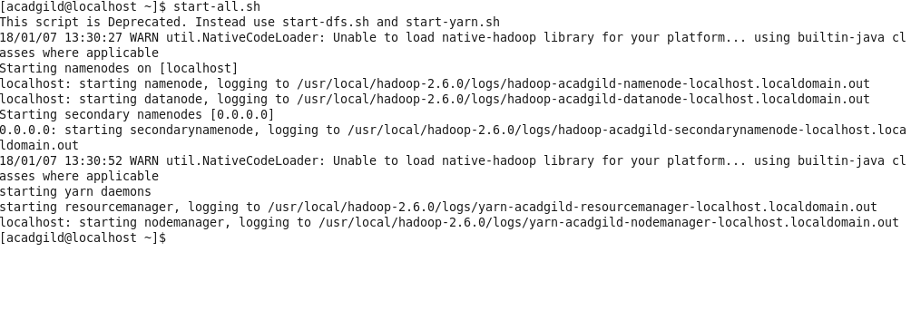

8. Start spark daemons (master, worker)

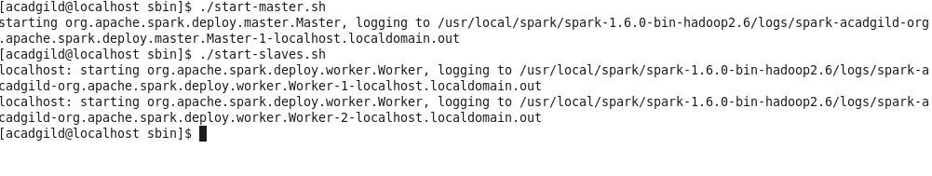

9. Check the daemons using **jps** command:

