1. find count of all strings with length 4

**val list = List("alpha", "gamma", "omega", "zeta", "beta")**

**val str_len_four = list.count(str=>str.length==4)**

**print(str_len_four)**

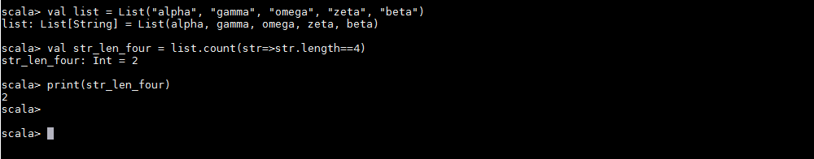

1. convert the list of string to a list of integers, where each string is mapped to its

Corresponding length

**val str_len_map = list.map(str=>(str,str.length()))**

**print(str_len_map)**

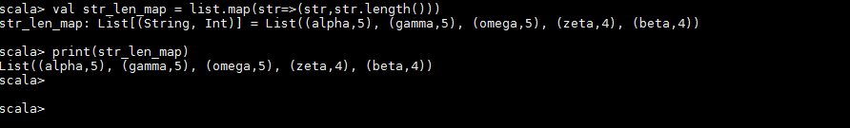

1. find count of all strings which contain alphabet 'm'

**val boolean_list=list.map(s=>s.contains("m")).filter(b=>(b==true)).length**

**print(boolean_list)**

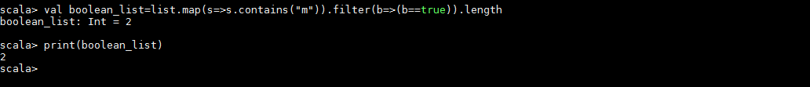

1. find the count of all strings which start with the alphabet 'a'

**val startsWith_a = list.filter(_.startsWith("a")).length**

**print(startsWith_a)**

