1. Create a list of tuples, where the 1st element of the tuple is an int and the second

element is a string.

Example - ((1, "alpha"), (2, "beta"), (3, "gamma"), (4, "zeta"), (5, "omega"))

**For the above list, print the numbers where the corresponding string length is 4**

**val list_tuple = ((1, "alpha"), (2, "beta"), (3, "gamma"), (4, "zeta"), (5, "omega"))**

**for (value <- list_tuple)**

**{**

**if (value._2.length==4)**

**println(value._1)**

**}**

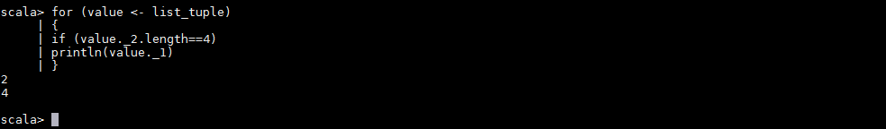

1. **find the average of all numbers, where the corresponding string contains alphabet 'm'**

**Or alphabet ‘z’.**

**val list = List((1, "alpha"), (2, "beta"), (3, "gamma"), (4, "zeta"), (5, "omega"))**

**val list_contains_mz = list.map(s=>(s._1,s._2.contains("m")||s._2.contains("z")))**

**val list_true_sum = list_contains_mz.filter(s=>s._2==true).map(m=>m._1).sum**

**val list_true_len = list_contains_mz.filter(s=>s._2==true).length**

**val result = list_true_sum/list_true_len**

**print(result)**

