Given a list of numbers - List[Int] (1, 2, 3, 4, 5, 6, 7, 8, 9, 10)

1. find the sum of all numbers

**val list = sc.parallelize(List(1, 2, 3, 4, 5, 6, 7, 8, 9, 10))**

**val sum = list.sum.toInt**

**println(sum)**

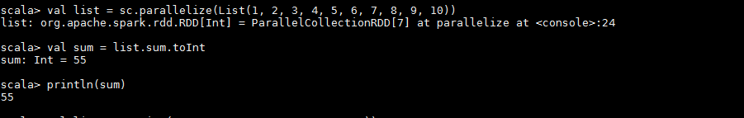

1. find the total elements in the list

**val list = sc.parallelize(List(1, 2, 3, 4, 5, 6, 7, 8, 9, 10))**

**val length = list.count**

**println(length)**

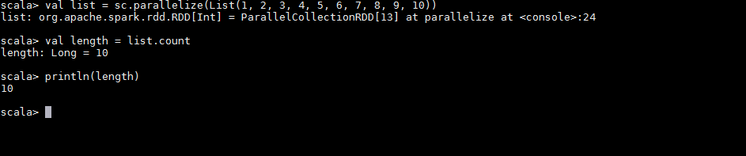

1. calculate the average of the numbers in the list

**val list = sc.parallelize(List(1, 2, 3, 4, 5, 6, 7, 8, 9, 10))**

**val sum = list.sum**

**val length = list.count**

**val result = sum/length**

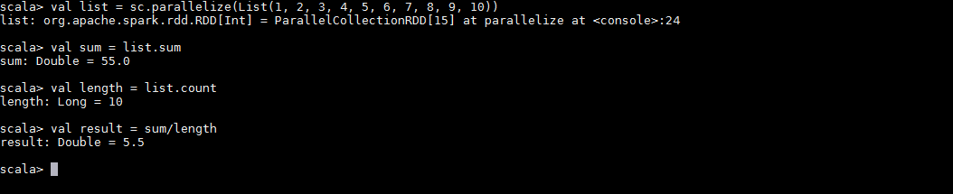

1. find the sum of all the even numbers in the list

**val list = sc.parallelize(Array(1, 2, 3, 4, 5, 6, 7, 8, 9, 10))**

**val evenNumbers = list.filter(x=>(x%2==0))**

**val sum = evenNumbers.sum**

**println(sum)**

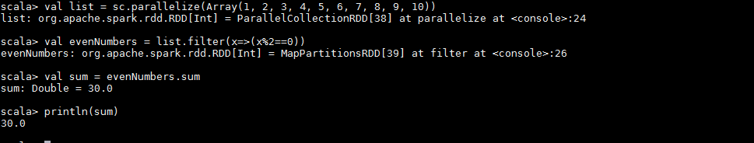

1. find the total number of elements in the list divisible by both 5 and 3

**val list = sc.parallelize(Array(1, 2, 3, 4, 5, 6, 7, 8, 9, 10))**

**val numberDivisibility = list.filter(x=>(x%3==0&&x%5==0)).count**

**println(numberDivisibility)**

