Create a file having below sample document data:

**This-is-my-first-assignment.**

**It-will-count-the-number-of-lines-in-this-document.**

**The-total-number-of-lines-is-3**

1. Write a program to read a text file and print the number of rows of data in the document.

**val docRDD = sc.textFile("/home/acadgild/inputdir/doc.txt")**

**docRDD.count**

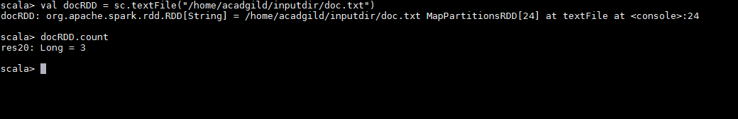

1. Write a program to read a text file and print the number of words in the document.

**val empRDD = sc.textFile("/home/acadgild/inputdir/doc.txt")**

**val splitRDD = empRDD.flatMap(x=>x.split(","))**

**splitRDD.count**

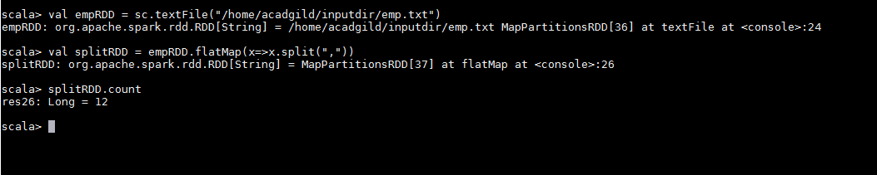

1. We have a document where the word separator is -, instead of space. Write a spark

Code, to obtain the count of the total number of words present in the document.

**val docRDD = sc.textFile("/home/acadgild/inputdir/doc.txt")**

**val splitRDD = docRDD.flatMap(x=>x.split("-"))**

**splitRDD.count**

