Given a dataset of college students as a text file (name, subject, grade, marks) :

**Problem Statement 1:**

1. Read the text file, and create a tuple rdd.

**val studentRDD = sc.textFile("/home/acadgild/inputdir/student_dataset.txt")**

**val tupleRDD = studentRDD.map(line=>line.split(",")).map(array=>(array(0),array(1),array(2),array(3).toInt,array(4).toInt))**

**tupleRDD.collect**

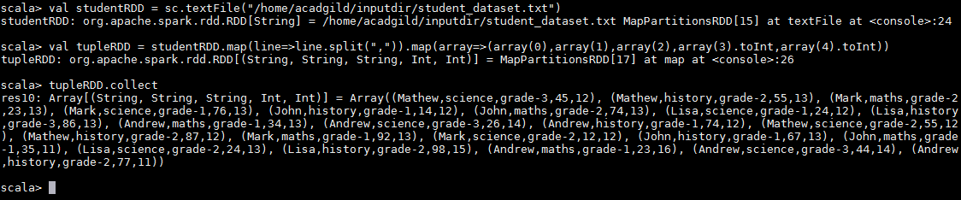

1. Find the count of total number of rows present.

**val studentRDD = sc.textFile("/home/acadgild/inputdir/student_dataset.txt")**

**val tupleRDD = studentRDD.map(line=>line.split(",")).map(array=>(array(0),array(1),array(2),array(3).toInt,array(4).toInt))**

**tupleRDD.count**

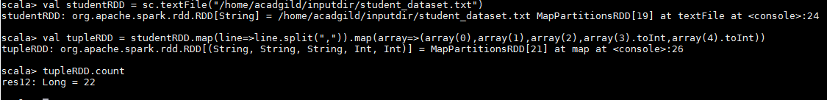

1. What is the distinct number of subjects present in the entire school

**val studentRDD = sc.textFile("/home/acadgild/inputdir/student_dataset.txt")**

**val tupleRDD = studentRDD.map(line=>line.split(",")).map(array=>(array(0),array(1),array(2),array(3).toInt,array(4).toInt))**

**val subjectRDD = tupleRDD.map(x=>x._2)**

**subjectRDD.distinct.collect**

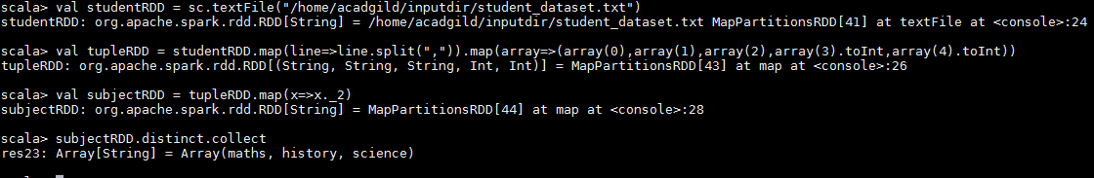

1. What is the count of the number of students in the school, whose name is Mathew and

marks is 55.

**val studentRDD = sc.textFile("/home/acadgild/inputdir/student_dataset.txt")**

**val tupleRDD = studentRDD.map(line=>line.split(",")).map(array=>(array(0),array(1),array(2),array(3).toInt,array(4).toInt))**

**tupleRDD.map(x=>(x._1,x._4)).filter(x=>(x._1=="Mathew" && x._2==55)).count**

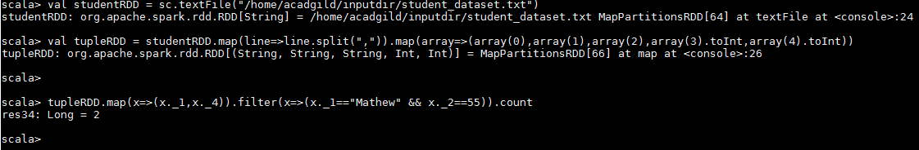

**Problem Statement 2:**

1. What is the count of students per grade in the school?

**val studentRDD = sc.textFile("/home/acadgild/inputdir/student_dataset.txt")**

**val tupleRDD = studentRDD.map(line=>line.split(",")).map(array=>(array(2),1))**

**tupleRDD.reduceByKey((x,y)=>(x+y)).collect**

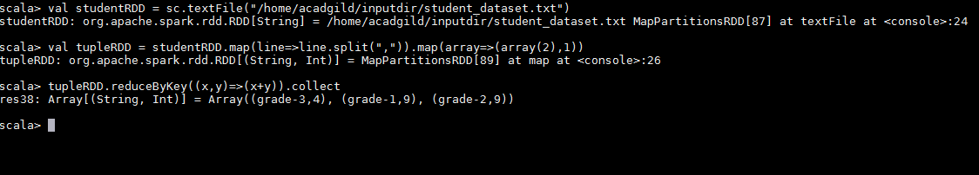

1. Find the average of each student (Note - Mathew is grade-1, is different from Mathew in some other grade!)

**val studentRDD = sc.textFile("/home/acadgild/inputdir/student_dataset.txt")**

**val tupleRDD = studentRDD.map(line=>line.split(",")).map(array=>( array(0), array(2),array(3).toInt))**

**val mapStudent_Grade = tupleRDD.map(x=>((x._1,x._2),1)).reduceByKey((x,y)=>(x+y))**

**val mapStudent_Marks = tupleRDD.map(x=>((x._1,x._2),x._3))**

**mapStudent_Marks.join(mapStudent_Grade).map(x=>(x._1,(x._2._1.toFloat/x._2._2.toFloat))).collect**

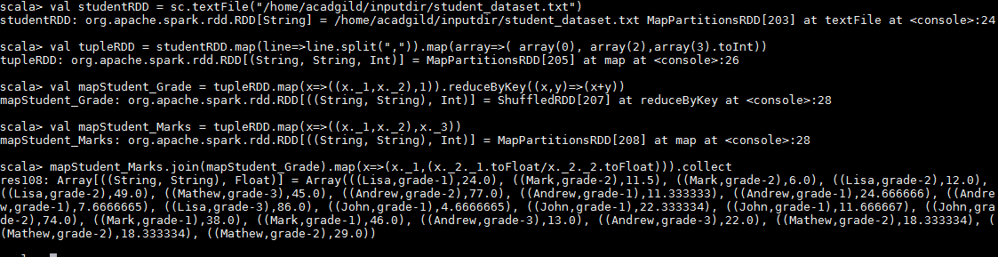

1. What is the average score of students in each subject across all grades?

**val studentRDD = sc.textFile("/home/acadgild/inputdir/student_dataset.txt")**

**val tupleRDD = studentRDD.map(line=>line.split(",")).map(array=>( array(1), array(3).toInt))**

**val summ = tupleRDD.reduceByKey((x,y)=>(x+y))**

**val cnt =tupleRDD.map(x=>(x._1,1)).reduceByKey((x,y)=>(x+y))**

**summ.join(cnt).map(x=>(x._1,(x._2._1.toFloat/x._2._2.toFloat))).collect**

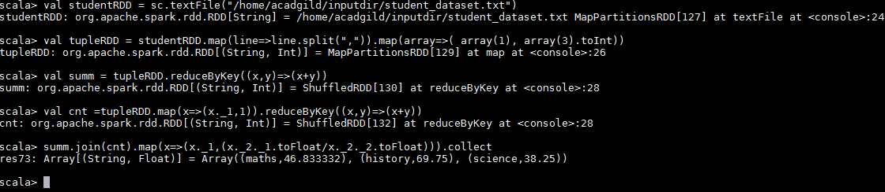

1. What is the average score of students in each subject per grade?

**val studentRDD = sc.textFile("/home/acadgild/inputdir/student_dataset.txt")**

**val tupleRDD = studentRDD.map(line=>line.split(",")).map(array=>(array(0),array(1),array(2),array(3).toInt))**

**val mapStudent_Grade_Subjects = tupleRDD.map(x=>((x._1,x._2,x._3),1)).reduceByKey((x,y)=>(x+y))**

**val mapStudent_Grade_Marks = tupleRDD.map(x=>((x._1,x._2,x._3),x._4)).reduceByKey((x,y)=>(x+y))**

**mapStudent_Grade_Subjects.join(mapStudent_Grade_Marks).map(x=>(x._1,(x._2._2.toFloat/x._2._1.toFloat))).collect**

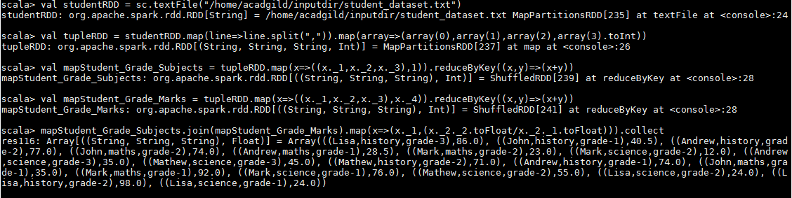

1. For all students in grade-2, how many have average score greater than 50?

**val studentRDD = sc.textFile("/home/acadgild/inputdir/student_dataset.txt")**

**val tupleRDD = studentRDD.map(line=>line.split(",")).map(array=>(array(0),array(2),array(3).toInt))**

**val Student_Grade2 = tupleRDD.map(x=>(x._1,x._2,x._3,(x._2=="grade-2"))).filter(x=>(x._4==true))**

**val Student_Grd2_Total = Student_Grade2.map(x=>(x._1,x._3)).reduceByKey((x,y)=>(x+y))**

**val Student_Grd2_Cnt = Student_Grade2.map(x=>(x._1,1)).reduceByKey((x,y)=>(x+y))**

**Student_Grd2_Total.join(Student_Grd2_Cnt).map(x=>(x._1,(x._2._1.toFloat/x._2._2.toFloat))).collect**

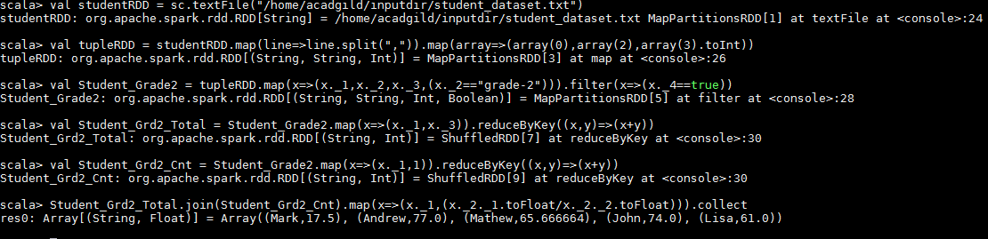

**Problem Statement 3:**

Are there any students in the college that satisfy the below criteria :

1. Average score per student_name across all grades is same as average score per

student_name per grade.

**val studentRDD = sc.textFile("/home/acadgild/inputdir/student_dataset.txt")**

**val tupleRDD = studentRDD.map(line=>line.split(",")).map(array=>(array(0),array(3).toInt))**

**val Student_Total = tupleRDD.reduceByKey((x,y)=>(x+y))**

**val Student_Count = tupleRDD.map(x=>(x._1,1)).reduceByKey((x,y)=>(x+y))**

**val Student_avg = Student_Total.join(Student_Count).map(x=>(x._1,(x._2._1.toFloat/x._2._2.toFloat)))**

**val tupleRDD1 = studentRDD.map(line=>line.split(",")).map(array=>(array(0),array(2),array(3).toInt))**

**val Student_Total1 = tupleRDD1.map(x=>((x._1,x._2),x._3)).reduceByKey((x,y)=>(x+y))**

**val Student_Count1 = tupleRDD1.map(x=>((x._1,x._2),1)).reduceByKey((x,y)=>(x+y))**

**val Student_avg1 = Student_Total1.join(Student_Count1).map(x=>(x._1._1,(x._2._1.toFloat/x._2._2.toFloat)))**

**Student_avg.intersection(Student_avg1).collect**

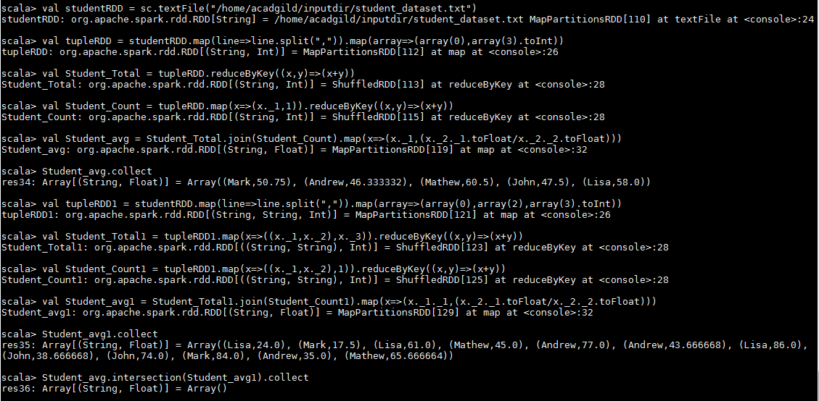

**There are no students who satisfy the criteria.**