Create a dataframe with 1 to 100 and save as parquet file.

Create RDD with numbers from 1 to 100 using below command :

**val numrdd = sc.parallelize(1 to 100)**

now convert numrdd to Data Frame using toDF **:**

**val numDF = numrdd.toDF**

finally save the DF in parquet format using below command:

**numDF.write.format("parquet").save("numbers.parquet")**

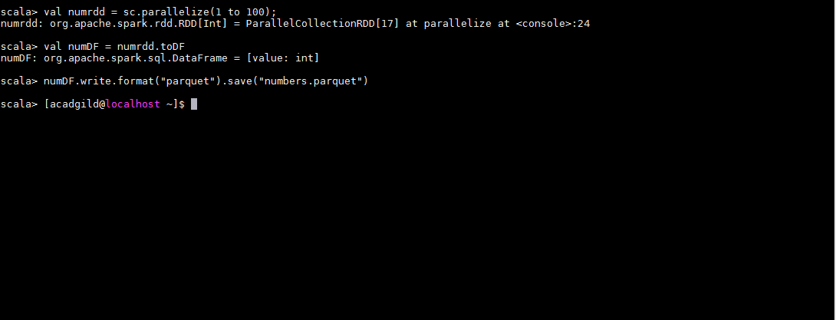

Now check the file on the disk

