1. **pwd** : prints the present working directory



1. **vi** : to create new file and edit the existing files

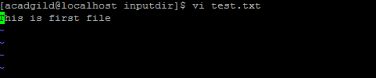

1. **touch** : to create file of 0 bytes

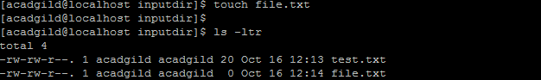

1. **mkdir** : to create new directory

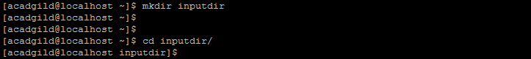

1. **rm** : to remove a file



1. **ls** : for listing of files



1. **echo** : to print any message on terminal



1. **cat :** to view the contents of file



1. **who :** to check the users who are logged on the machine



1. **cd** : to change the directory



1. **date** : to print the system date



1. **cal** : to show the calendar, by default it shows calendar of current month

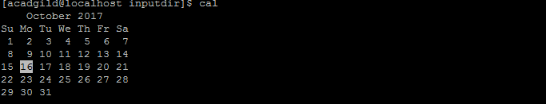

1. **mv** : to move the file or rename the file



1. **cp** : to copy the file

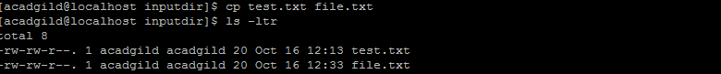

1. which : to identify the location of executables(commands)

