1. Check whether /user/acadgild directory exists or not in the HDFS.

hadoop fs –ls /user/acadgild

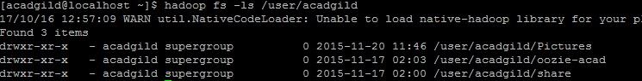

1. Creating directory /user/acadgild/hadoop.

hadoop fs –mkdir /user/acadgild/hadoop

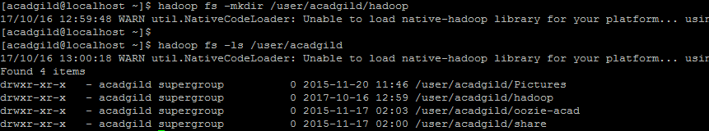

1. Creating 0 bytes file word-count.txt

hadoop fs –touchz /user/acadgild/hadoop/word-count.txt

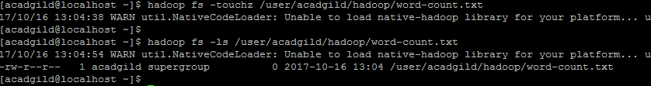

4. Appending content to the file word-count.txt whatever we type on screen.

