1. Creating file max-temp.txt in local FS :

vi max-temp.txt



1. Putting the file on HDFS at /user/acadgild/hadoop :

hadoop fs –put max-temp.txt /user/acadgild/hadoop

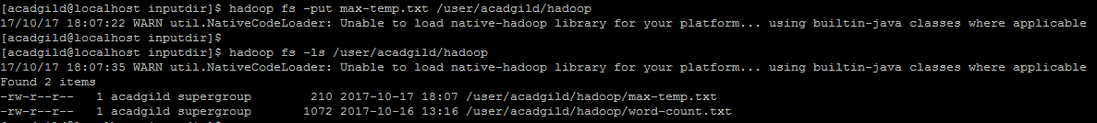

1. Changing the permission of the file /user/acadgild/hadoop/max-temp.txt, such that only the owner and the group members have full control over the file. Others do not have any control over it :

hadoop fs –chmod 770 /user/acadgild/hadoop/max-temp.txt

