1. CONCAT

student_name_concat = FOREACH student_details GENERATE CONCAT (firstname,' ',lastname);



1. TOKENIZE

student_name_tokenize = FOREACH student_name_concat GENERATE TOKENIZE($0,' ');

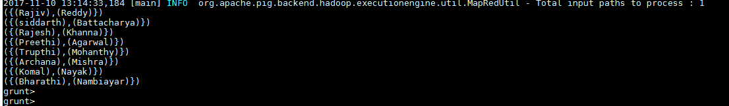

1. SUM

student_city_group = GROUP student_details by city;

student_gpa_sum = FOREACH student_city_group GENERATE (student_details.city),**SUM(student_details.gpa);**

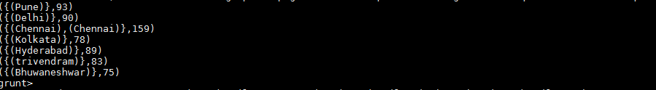

1. MIN

student_group = GROUP student_details all;

student_min_age = FOREACH student_group GENERATE **MIN(student_details.age);**





1. MAX

student_group = GROUP student_details all;

student_max_age = FOREACH student_group GENERATE **MAX(student_details.age)**;





1. LIMIT

student_limit = LIMIT student_details 5;

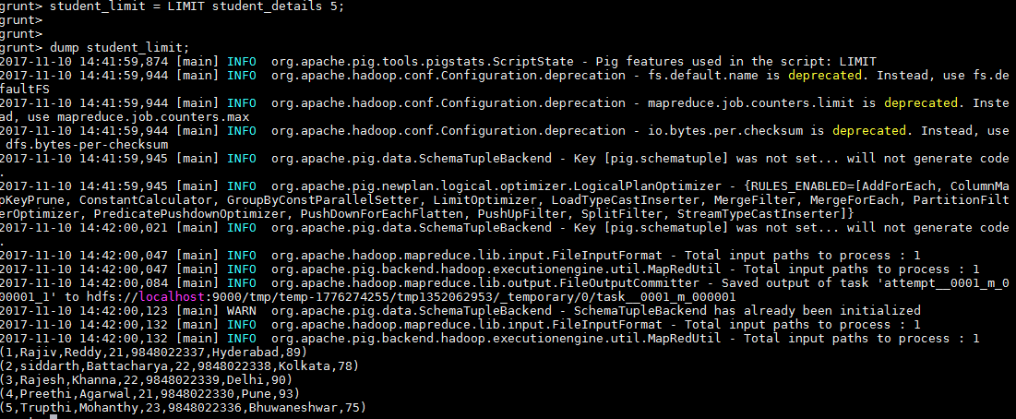

1. STORE

STORE student_limit into '/pig_output' using PigStorage(',');

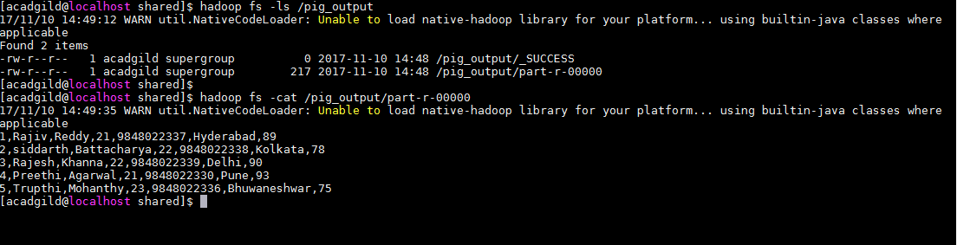

1. DISTINCT

student_distinct_data = DISTINCT student_data;

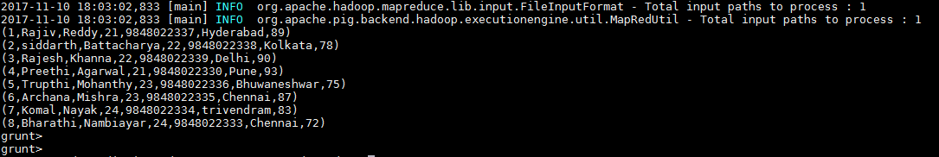

1. FLATTEN

student_flatten_data = FOREACH student_city_group GENERATE FLATTEN($1);

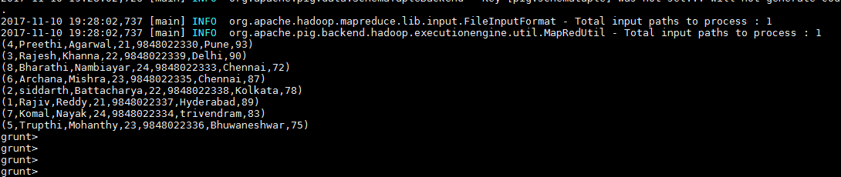

1. ISEMPTY

emp_details = LOAD '/pig_data/emp.txt' USING PigStorage(',') as (empid:int,empname:chararray,deptid:int);

dept_details = LOAD '/pig_data/dept.txt' USING PigStorage(',') as (deptid:int,deptname:chararray);

cogroup_data = cogroup emp_details by deptid,dept_details by deptid;

is_emptydata = FILTER cogroup_data by IsEmpty(emp_details);



