**Program to implement wordcount using Pig.**

1. input_file = LOAD '/pig_data/words.txt' using PigStorage as (line:chararray);

dump input_file;

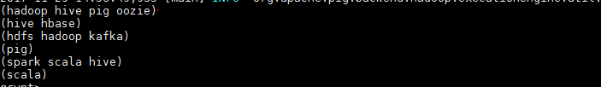

1. words = FOREACH input_file GENERATE FLATTEN(TOKENIZE(line,' ')) as word;

dump words;

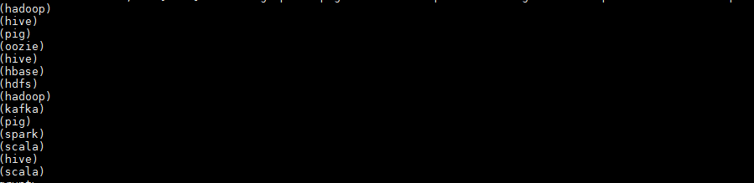

1. words_grouped = GROUP words_tokenize by word;

dump words_grouped;

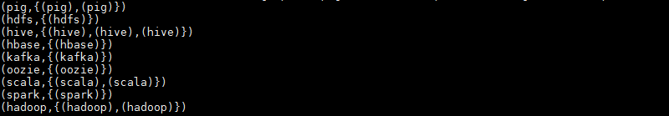

1. words_count = FOREACH words_grouped GENERATE group,COUNT(words_tokenize);

dump words_count;

