Loading the Pokemon Data Set in Pig.

**Load_Data = LOAD '/home/acadgild/pig_input_assignment5/Pokemon.csv' USING PigStorage(',') AS(Sno:int,Name:chararray,Type1:chararray,Type2:chararray,Total:int,HP:int,Attack:int,Defense:int,spAtk:int,SpDef:int,Speed:int);**

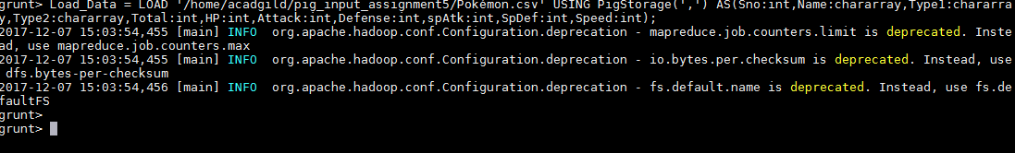

Ques 1: Find the list of players that have been selected in the qualifying round (DEFENCE>55).

**selected_list = FILTER Load_Data by Defense > 55;**

**dump selected_list;**



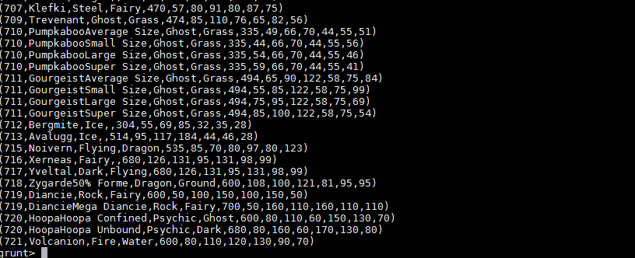

#### Ques 2: State the number of players taking part in the competition after getting selected in the qualifying round.

**group_selcted_list = Group selected_list All;**

**count_selcted_list = foreach group_selcted_list GENERATE COUNT(selected_list);**

**dump count_selcted_list;**

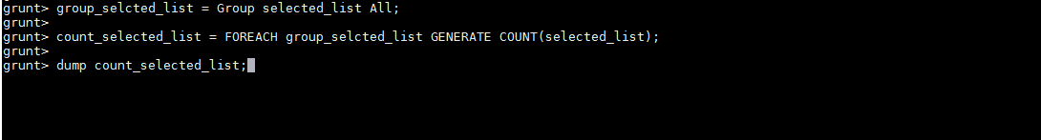



#### Ques 3: Using random() generate random numbers for each Pokémon on the selected list.

#### random_include1 = FOREACH selected_list GENERATE RANDOM(),Name,Type1,Type2,Total,HP,Attack,Defense,spAtk,SpDef,Speed;

#### dump random_include1;

#### 

#### 

#### Ques 4: Arrange the new list in a descending order according to a column randomly.

#### random1_desending = ORDER random_include1 BY $0 DESC;

#### dump random1_desending;

#### 

#### 

#### Ques 5: Now on a new relation again associate random numbers for each Pokémon and arrange in descending order according to column random.

**random_include2 = foreach selected_list GENERATE RANDOM(),Name,Type1,Type2,Total,HP,Attack,Defense,spAtk,SpDef,Speed;**

**random2_desending = ORDER random_include2 BY $0 DESC;**

**dump random2_desending;**

#### 

#### 

#### Ques: From the two different descending lists of random Pokémons, select the top 5 Pokémons for 2 different players.

#### limit_data_random1_descending = LIMIT random1_descending 5;

#### dump limit_data_random1_descending;

#### 

#### 

#### limit_data_random2_descending = LIMIT random2_desending 5;

#### dump limit_data_random2_descending;

#### 

#### 

#### Ques: Store the data on a local drive to announce for the final match. By the name player1 and player2 (only show the NAME and HP).

#### filter_only_name1 = foreach limit_data_random1_descending Generate ($1,HP);

#### dump filter_only_name1;

#### 

#### 

#### filter_only_name2 = foreach limit_data_random2_descending Generate ($1,HP);

#### dump filter_only_name2;

#### 

#### 

#### STORE filter_only_name1 INTO '/home/acadgild/pig_input_assignment5/player1.txt';

#### 

#### STORE filter_only_name2 INTO '/home/acadgild/pig_input_assignment5/player2.txt';

#### 